Modelcall API:
http://127.0.0.1:35253/upload
body
{
"command": "model_call",
"data": {
"text": “{model input}"
}
}

Example：
Upload
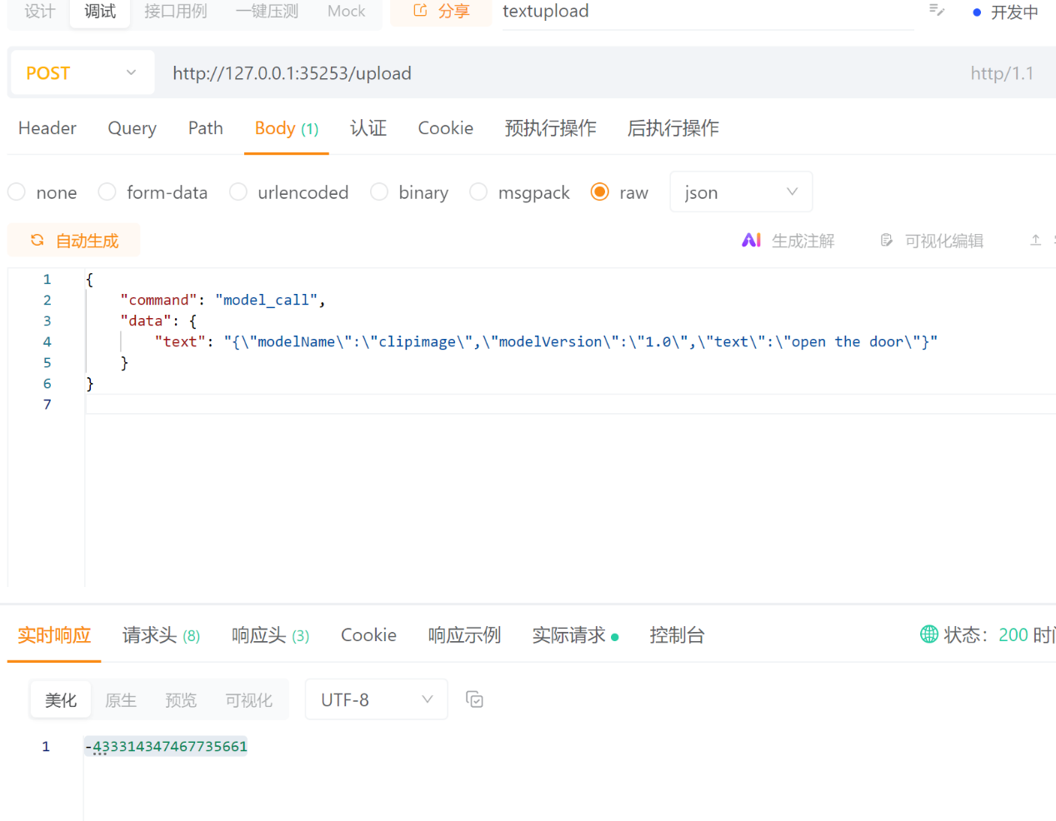

Commit：
Fileata is the id from upload
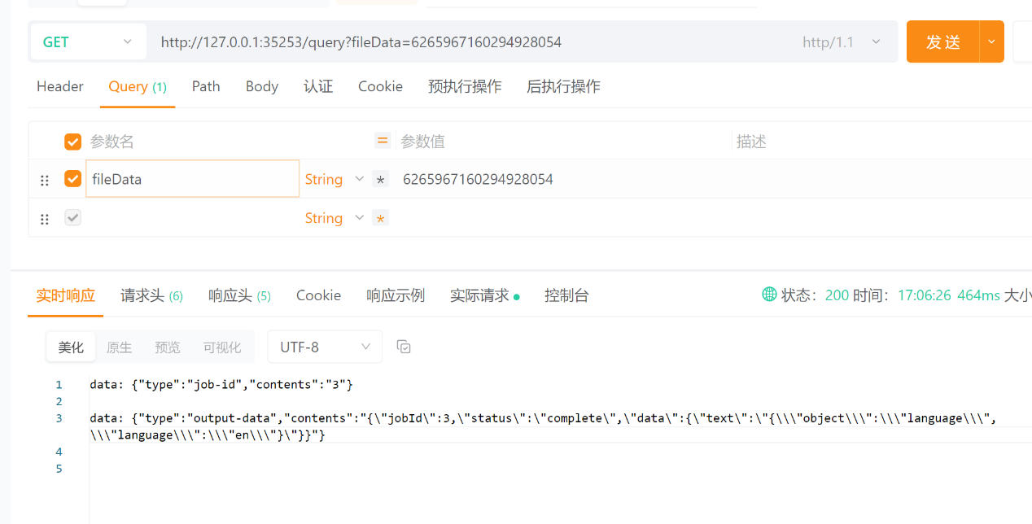

Output:
data:
{"type":"output-data","contents":"{"jobId":2,"status":"in_progress","data":{"text": {“model_output”}}}”}

LLM Interface
Need to strict following OpenAI Format:
input：
{
"modelName": "llm",
"modelVersion":"1.0",
"prompt":”json string”//the OpenAI format, JOSN Dump
}

Output：
{
"I am phi-4”
}

Example:
Stream: false
Input:
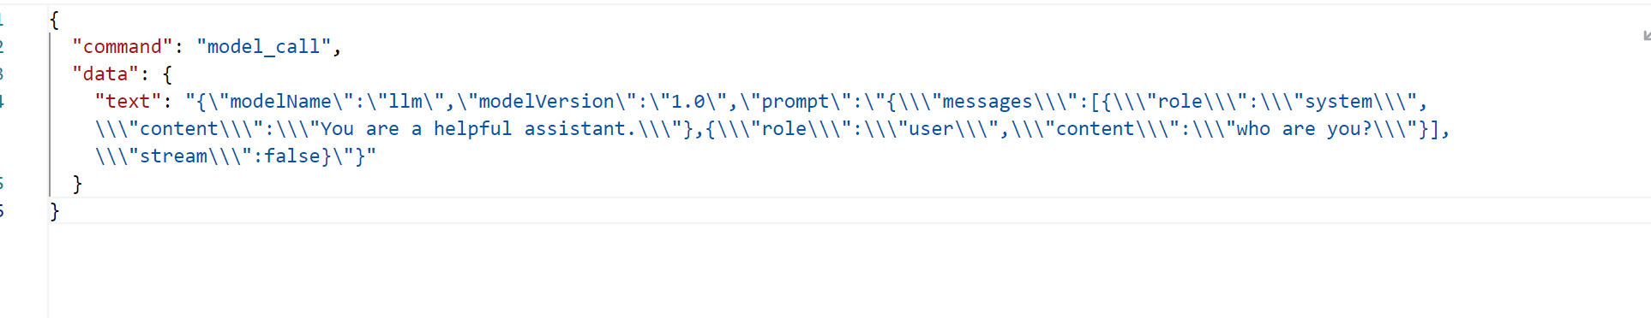
Output:
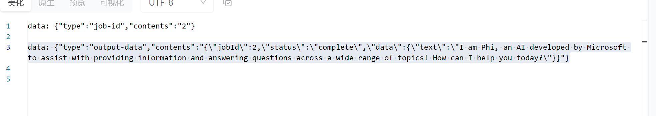
Stream: true
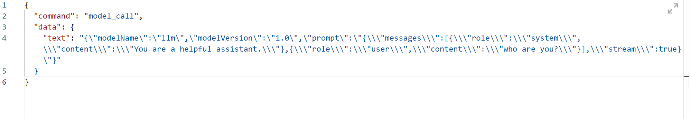
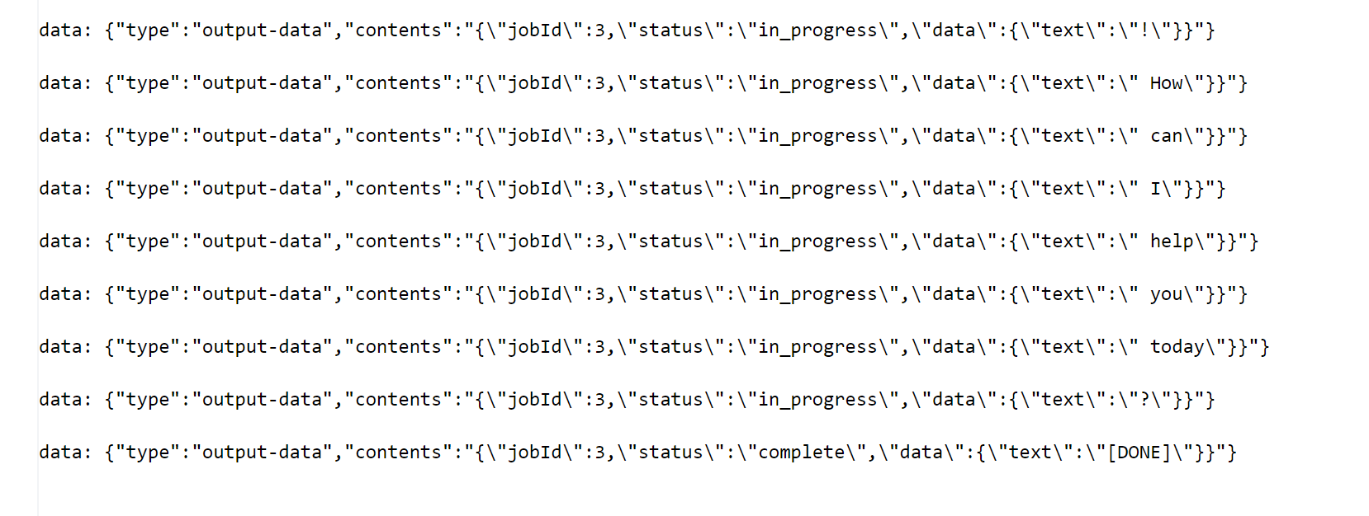

embedding
Input:
{
"modelName": "me5s",
“modelVersion”:”1.0”
"text":" the test text”.
“action”:”embedding”
}

Output:
{
"object": "embedding",
"embedding": [ 0.0023064255, -0.009327292, .... (1536 floats total for ada-002) -0.0028842222, ]
}

Intents
Input:
{
"modelName": "me5s",
“modelVersion”:”1.0”
"text":" the test text”.
“action”:”intents”
}

Output:
{
"object": "intents",
"intents":
{
"MS":{
"topN_intents":["general_generation","work_assistant_twitter_generation","work_assistant_product_proposal_document_generation"],
"topN_intents_confidence":[0.9998840093612671,9.144979412667453e-05,1.2882996998087037e-05]
}
}

Domain
Input:
{
"modelName": "me5s",
“modelVersion”:”1.0”
"text":" the test text”.
“action”:”domain”
}

Output:
{
"object": " domain ",
" domain ":
{
"MS":{
"topN_domin":["general_generation","work_assistant_twitter_generation","work_assistant_product_proposal_document_generation"],
"topN_domin_confidence":[0.9998840093612671,9.144979412667453e-05,1.2882996998087037e-05]
}
}

CopyNet
Input:
{
"modelName": "me5s",
“modelVersion”:”1.0”
"text":" the test text”.
“action”:”copynet”
}

Output:
{
"object": " copynet ",
"copynet：[\\\"Open the AINow\\\",\\\"open Google Chrome\\\"]
}

Rewrite_juge
Input:
{
"modelName": "me5s",
“modelVersion”:”1.0”
"text":" the test text”.
“action”:”retrieval”
}

Output:
{
"object": " retrieval",
" retrieval":true/false
}

Language
Input:
{
"modelName": "me5s",
“modelVersion”:”1.0”
"text":" the test text”.
“action”:”language”
}

Output:
{
"object": " language ",
"language ":”en”
}

CLIP Text
Input:
{
"modelName": "cliptext",
“modelVersion”:”1.0”
"text":" the dog”
}

Output:
{
"object": "emb_text",
"emb_text": [ 0.0023064255, -0.009327292, .... (1536 floats total for ada-002) -0.0028842222, ]
}

CLIP Image
Input:
{
"modelName": "clipimage",
“modelVersion”:”1.0”
"image_url":" c:\\\\test.jpg”
}

Output:
{
"object": "emb_image",
"emb_image": [ 0.0023064255, -0.009327292, .... (1536 floats total for ada-002) -0.0028842222, ]
}

Layout:
Input:
{
"modelName": "layout",
“modelVersion”:”1.0”
"image_url":" c:\\\\test.jpg”
}

Output:
{
"object": "layout",
"layout": [{”box”:[0,0,100,100],”score”:0.9]}]
}

Text Det:
Input:
{
"modelName": "textdet",
“modelVersion”:”1.0”
"image_url":" c:\\\\test.jpg”
}

Output:
{
"object": "text_det",
"text_det": [{“label”:”text”,”box”:[0,0,100,100],”score”:0.9]}]
}

Text to Image
Input:
{
"modelName": "creatorzone",
"modelVersion": "1.0",
"data": {
"data": {
"prompt": "a lovely cat.",
"imgNumber": 2,
"cfgScale": 2.5,
"outputHeight": 512,
"outputWidth": 512,
"steps": 4
}
},
"action": "generate"
}

Output:
status:in_progress data:{"code":0,"message":"success","data":{"prompt":"a lovely cat.","imgNumber":2,"cfgScale":2.5,"outputHeight":512,"outputWidth":512,"steps":4,"imgOutputPath":["C:/ProgramData/Lenovo/Modelmgr/img/1760943057_0.png"],"errorCode":0}}

status:in_progress data:{"code":0,"message":"success","data":{"prompt":"a lovely cat.","imgNumber":2,"cfgScale":2.5,"outputHeight":512,"outputWidth":512,"steps":4,"imgOutputPath":["C:/ProgramData/Lenovo/Modelmgr/img/1760943057_0.png", "C:/ProgramData/Lenovo/Modelmgr/img/1760943057_1.png"],"errorCode":0}}

status:in_progress data:[DONE]

status:complete data:[DONE]

Creator Zone Generate (Image to Image):

Input:
{
"modelName": "creatorzone",
"modelVersion": "1.0",
"data": {
"data": {
"initImg": "D:/CreatorZone/InitImg/Image1.png",
"prompt": "a dog",
"imgNumber": 2,
"strength": 0.7,
"outputHeight": 512,
"outputWidth": 512,
"steps": 4,
"language": 2
}
},
"action": "generate"
}

Output:
status:in_progress data:{"code":0,"message":"success","data":{"initImg":"D:/CreatorZone/InitImg/Image1.png","prompt":"a dog","imgNumber":4,"strength":0.7,"outputHeight":512,"outputWidth":512,"steps":4,"language":2,"imgOutputPath":["C:/ProgramData/Lenovo/Modelmgr/img/1760943057_0.png"],"errorCode":0}}

status:in_progress data:{"code":0,"message":"success","data":{"initImg":"D:/CreatorZone/InitImg/Image1.png","prompt":"a dog","imgNumber":4,"strength":0.7,"outputHeight":512,"outputWidth":512,"steps":4,"language":2,"imgOutputPath":["C:/ProgramData/Lenovo/Modelmgr/img/1760943057_0.png", "C:/ProgramData/Lenovo/Modelmgr/img/1760943057_1.png"],"errorCode":0}}

status:in_progress data:[DONE]

status:complete data:[DONE]

Creator Zone Generate (Controlnet):
Input:
{
"modelName": "creatorzone",
"modelVersion": "1.0",
"data": {
"data": {
"controlNetImgPath": "D:/quantum/test.png",
"controlNetType": "canny",
"controlNetstrength": 0.8,
"prompt": "a cat",
"imgNumber": 2,
"outputHeight": 1024,
"outputWidth": 1024,
"steps": 8,
"language": 2
}
},
"action": "generate"
}

Output:
status:in_progress data:{"code":0,"message":"success","data":{"controlNetImgPath":"D:/quantum/test.png","controlNetType":"canny","controlNetstrength":0.8,"errorCode":0,"imgNumber":2,"imgOutputPath":["C:/ProgramData/Lenovo/Modelmgr/img/1767062682_0.png"],"language":2,"outputHeight":1024,"outputWidth":1024,"prompt":"a cat","steps":8}}

status:in_progress data:{"code":0,"message":"success","data":{"controlNetImgPath":"D:/quantum/test.png","controlNetType":"canny","controlNetstrength":0.8,"errorCode":0,"imgNumber":2,"imgOutputPath":["C:/ProgramData/Lenovo/Modelmgr/img/1767062682_0.png","C:/ProgramData/Lenovo/Modelmgr/img/1767062682_1.png"],"language":2,"outputHeight":1024,"outputWidth":1024,"prompt":"a cat","steps":8}}

status:in_progress data:[DONE]

status:complete data:[DONE]

Stop Creator Zone Generate:
Input:
{
"modelName": "creatorzone",
"modelVersion": "1.0",
"data": {},
"action": "stop_generate"
}

Output:
{
"object": "generate",
"data": [
{
“code”: 0,
“message”: “success”
}
]
}

Error Code List:

Error ID | Model Service
1 | 未授权
2 | Unable to load clip model from（无法加载clip model）
400 | Invalid request（无效请求）
401 | AUTH Failed（验证失败）
404 | File Not Found（文档未找到）
500 | Internal Server Error（内部服务链接错误）
2000 | Nlp service is not running. （NLP服务未运行）
2001 | Nlp service is running. （NLP服务运行中）
4014 | Clip img size > 50M, failed! （clip图片大于50M）
4030 | Text det model load failed! （text det 模型加载失败）
4031 | Layout model init failed! （layout模型初始化失败）
4032 | Layout model unload failed, because nlp is running. （layout模型卸载失败，因为nlp任务还在进行）
10001 | Can't use unloaded model to inference（不能使用未加载模型进行推理）/  LLM is performing inference （模型正在进行推理中）/  CAN'T get lock to inference （模型正在进行推理中）
10002 | Request body error, not found prompt（请求体中未找到prompt字段）
10003 | Request body error, json invalid（请求体Json格式错误）
10004 | Model is running generation, can't be unloaded! （模型正在运行推理，无法被卸载）
10005 | Unload model failed! （模型卸载失败）
10006 | LLM completion error! （大语言模型非流式推理失败）
10007 | Parse result error, json invalid! （结果解析失败，Json格式错误）
10008 | LLM model is not exists! （大语言模型不存在）
10009 | LLM interface can't work! （llm对象不存在，大模型无法正常工作）
10010 | Clip img emb extract failed!（clip图片embedding提取失败）
10011 | Memory not enough(显存不够，无法加载大模型)
10021 | creatorzone input data is not valid json format
10022 | creatorzone API_Interface failed
10023 | creatorzone server is not init.
10024 | creatorzone API_LoadModel failed
10025 | creatorzone model is not loaded.
10026 | creatorzone API_UnloadModel failed
10027 | creatorzone API_ControlNetGenerate faile
10028 | creatorzone Generate callback is null.
10029 | creatorzone API_Generate failed.
10030 | creatorzone API_Stop failed.
10031 | creatorzone API_Destory failed.
10032 | creatorzone API_QueryLoadStatus failed.
10033 | process init body exception: {}
10034 | creatorzone output data is not valid json format
10035 | creatorzone init failed! errorCode:
10036 | creatorzone API_OVCache failed.
10050 | Could not find LLM model！ （模型文件不存在）
10051 | Could not find MMProj model！（多模态文件不存在）
10052 | Could not find Catalog file! （catalog文件不存在)
10053 | Get available model exception! (读取cat 异常)
10054 | Parse generate info failed (api_checkModelStatus 异常)
10055 | Model is not available! (模型校验失败)
10056 | Model is checking (模型正在校验中)
10300 | Me5s model load failed! （me5s模型加载失败）
20001 | CAN'T get the lock, please retry later（me5s锁获取失败）
20002 | Run Me5s classifier error! （me5s classfier运行失败）
20003 | CAN'T find the file param. （nlp参数解析失败）
30001（已弃用） | Reranker model is not exists! （Reranker模型不存在）
30002（已弃用） | Reranker vocab is not exists! （Reranker vocab不存在）
30003 | Reranker model load failed! （Reranker模型加载失败）
30004 | Reranker input text file is not exists! （Reranker输入文本文件不存在

