(c) 2013, Skytree Inc.



Multidimensional Scaling

Multidimensional scaling (MDS) receives a matrix of similarities or dissimilarities among a set of objects and outputs a configuration of points in a metric space. Assume we have a table of distances between towns taken from the pairwise distance table of a highway map. Imagine that we toss a set of poker chips onto a table and measure the distance between every pair of chips. Then we move the chips around so that the distances between the chips are more closely related to the numbers in the table. If we move the chips correctly, we should end up with a map in which each poker chip represents a town and each is in its correct position relative to the others. This is what MDS tries to do.

Let’s define the model more formally. Given a configuration of points in a metric space, we can compute a symmetric matrix of pairwise distances on all pairs of points. By definition, the diagonal of this matrix is zero and the off–diagonal elements are positive. Now suppose we invert this condition and say that we are given a metric and a distance matrix D and wish to compute a matrix X containing the coordinates of points in the metric space that can be used to reproduce these distances. Young and Householder (1938) did this for a Euclidean space. Take any pair of points and apply the cosine rule for triangles:

d_{jk}² = d_{ij}² + d_{ik}² –2d_{ij}d_{ik}cosθ_{jik}

So,

d_{ij}d_{ik}cosθ_{jik} = (d_{ij}² + d_{ik}² –d_{jk}²)/2

The term left of the equality is the scalar product x_{j}'x_{k}, where the vector x_{j} contains the coordinates for point j relative to any point i. Renaming the right–hand quantity, we have

x_{j}'x_{k} = w_{jk}

Thus, we may take any point i represented in D and use its distances to the other points to create a scalar products matrix

W = X'X

A singular value decomposition of W yields X, which contains the coordinates for the set of points. Point i will be at the centroid of the configuration.

Now suppose the distances contain random error. Torgerson (1952) devised a least–squares solution by centering W at the centroid of all the points (as opposed to an arbitrarily selected data point i). Torgerson coined the term multidimensional scaling (MDS) for this procedure, as an extension of the unidimensional scaling model used by psychophysicists for almost a century earlier.

Dissimilarity data often contain an additive constant, a condition that violates the identity axiom and produces bad fits with Torgerson’s model. Messick and Abelson (1956) offered a solution to the additive constant problem, allowing users to apply Torgerson’s method to dissimilarity data of the form

d* = c + ad + e .

That is, a dissimilarity d* is assumed in this model to be a function of an additive constant c, a multiple of a distance d, plus random error e. After estimating and subtracting the additive constant, we can apply Torgerson’s method to these adjusted dissimilarities. Torgerson’s method with the additive constant adjustment is now called classic MDS.

Torgerson’s MDS model is linear. Because psychological similarity or dissimilarity data often consist of ranks, psychologists were anxious to relax the linearity requirement. Roger Shepard solved this problem in the early 1960s (Shepard, 1962). Shepard’s iterative algorithm was sui generis; it offered a simple computational method for achieving a feasible solution to the problem.

Shepard had developed his ideas while a graduate student at Yale working with his adviser Robert Abelson. He took a position at Bell Labs and met the mathematician Joseph Kruskal (brother of the statistician William Kruskal). Kruskal (1964) recast Shepard’s scheme as a least squares problem. Kruskal regressed distances between points in the spatial configuration onto the observed dissimilarities. He developed a loss function based on residuals from this regression and used a gradient method to find a solution with (locally) minimum loss. Kruskal’s linear regression version of this algorithm became known as metric MDS. Kruskal also included a monotonic regression method in his scheme. The monotonic version of his algorithm became known as nonmetric MDS.

Other significant contributors to the MDS literature were Louis Guttman, Forrest Young, Jan deLeeuw, and J. Douglas Carroll. Young and Hamer (1987), Cox and Cox (1994), and Borg and Groenen (1997) cover this literature in more detail. The classic, metric, and nonmetric MDS models have been rediscovered, modified, and renamed many times over the last few decades (e.g., Sammon, 1969), perhaps because it has so many applications in various fields.

Distance Metrics

Kruskal’s algorithm had one other elegant aspect. He implemented the Minkowski (power) metric function for computing distances between points and thus extended the model to non–Euclidean spaces. This metric has a form similar to the Euclidean, which is:

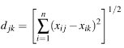

The Minkowski metric has a more general exponent:

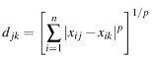

where p ≥ 1.

The following figure shows how the values of p affect the distance locus (isodensity contours) of a point. For p = 2, the locus set is a collection of circles. For p = 1 (the city block or taxicab metric) it is a collection of diamonds. And for p = ∞ (the absolute metric, in which only one dimension contributes to a distance), it is a collection of squares. These metrics are not only of academic interest. If you think your dissimilarities are due to a simple additive process, then you should use the city block metric. If, in rare circumstances, you think one dimension should always dominate the others (as in preference data), then you should consider using the absolute metric.

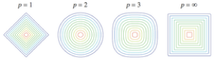

Input Data

The original motivation for MDS was to fit a matrix of dissimilarities or similarities to a metric space. Since its origins, however, MDS has had many other applications. A popular application is to compute a distance matrix on the columns of a rectangular matrix using a metric distance function (Euclidean, cosine, Jaccard, power, etc.). Then one uses MDS to project the original variables into a low–dimensional (usually 2D) space. This approach is an alternative to principal components (SVD) analysis. If the projection is intrinsically nonlinear for a given dataset, then MDS can get a better view than PC. The advantage of PC in linear cases, however, is the simplicity of interpreting simple linear projections.

Another recent application is to use MDS for laying out network graphs. A Second Opinion offers this option when you input network graphs. For pointwise data, however, a related alternative is nonlinear manifold mapping. You can choose that option in the same GO menu where you chose MDS.

Assumptions

We rely on several assumptions when computing MDS.

•The data (similarities/dissimilarities) are representable in a metric space by distances between points.
•This means that
•distance(A, A) = 0.
•distance(A, B) = distance(B, A).
•distance(A, C) ≤ distance(A, B) + distance(B, C)
•The Shepard residuals are based on a single random distribution.

The restriction on the Shepard residuals is not mentioned often in the MDS literature, but it is an important one, even if the regression function is monotonic. We do not ordinarily think of MDS as having restrictive statistical assumptions. Although we do not require normality in the Shepard residuals, we want to see homogeneity if we are to expect that the MDS configuration is a reasonable representation of the similarities/dissimilarities in the matrix decomposed by MDS. Although the Shepard residuals cannot be independent (by definition), they should behave, and we should interpret them, as if they were ordinary regression residuals.

The metric assumptions are quite restrictive. You can read more about these issues in Tversky (1977). Tversky argued that, for many datasets, the MDS metric assumptions are inappropriate. For example, he observed that many would agree (in the 1970s at least), that Miami is similar to Havana, Havana is similar to Moscow, but Miami is not similar to Moscow. In this important paper, Tversky advised researchers to consider other models of similarity, such as additive trees. You can run your similarity/dissimilarity data through the Hierarchical Cluster module of Adviser (in the Reduce menu) to get an idea of what Tversky meant. You can also read more about Amos Tversky, one of the most important psychologists of the 20th century, in Liabson & Zeckhause (1998) and in Kahneman (2011).

The Data Analysis

This analysis was computed from the /Users/lelandwilkinson/lw/AA/data/text/novels.uri dataset on Feb 16, 2016 4:04 PM. The input dataset contained 19 rows.. The function used to compute the MDS symmetric input matrix was: SpearmanCorrelation.

Table 1. One

 | Dimension 1 | Dimension 2 | Badness of Fit
benjaminbunny | 1.366 | 2.116 | 0.077
tristramshandy | –1.041 | 1.183 | 0.043
ulysses | 3.063 | 0.690 | 0.063
vanityfair | –0.329 | 0.143 | 0.021
lordjim | 0.304 | –0.792 | 0.052
moby | 0.043 | –0.729 | 0.103
sonsandlovers | 0.850 | –0.786 | 0.091
wizardofoz | 1.648 | –0.707 | 0.054
madamebovary | 0.567 | –0.171 | 0.046
AliceInWonderland | 1.280 | 0.688 | 0.050
bleakhouse | –0.337 | –0.018 | 0.034
silasmarner | –0.635 | –0.424 | 0.062
jude | –0.447 | –1.041 | 0.052
warandpeace | –0.492 | –0.727 | 0.062
Middlemarch | –0.864 | –0.423 | 0.034
frankenstein | –1.127 | –0.115 | 0.038
sensesensibility | –1.581 | 0.246 | 0.032
prideprejudice | –1.570 | 0.247 | 0.034
gulliver | –0.698 | 0.618 | 0.057

Figure 1 shows the configuration resulting from the MDS iterations. The metric used for computing this figure was Euclidean.

Figure 1. Configuration.

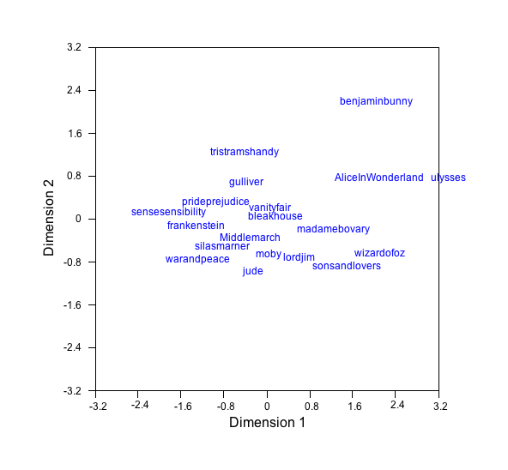

Figure 2 shows the configuration resulting from the MDS iterations with the plotting symbols sized according to badness of fit. A larger symbol signifies that a point lies in a higher–dimensional space and cannot be located accurately in two dimensions. If several of the plotting symbols are unusually large, you should not assume your solution is a good representation of your data.

Figure 2. Influence Configuration.

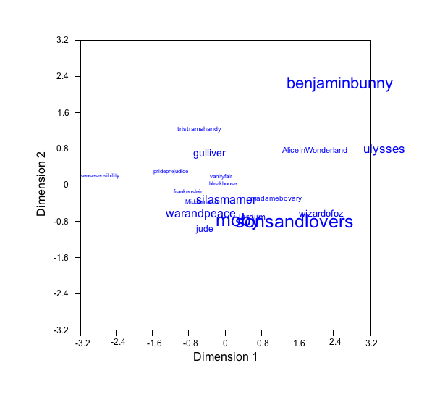

Figure 3 shows the Shepard diagram for the MDS solution. This diagram is a scatterplot of the similarities or dissimilarities plotted against the distances in the MDS configuration shown in Figure 1. The regression type for computing this diagram was monotonic. The stress for this regression was 0.163. For a solution with low stress, we look for all the points to be close to the fitted curve represented by the red line. If the curve is substantially nonlinear, then we note that an MDS will differ from the corresponding principal components analysis, because principal components is a linear projection.

Figure 3. Shepard diagram.

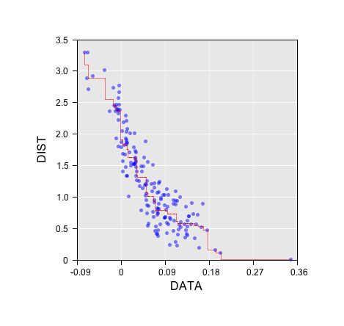

Figure 4 contains a dot plot of the residuals from the Shepard diagram. We do not expect these residuals to be normally distributed, but we do expect them to be relatively symmetric around zero. If this dot plot is severely asymmetric, the MDS model may not be appropriate for your data or you may need to try a different regression function or metric.

Figure 4. Dot plot of residuals.

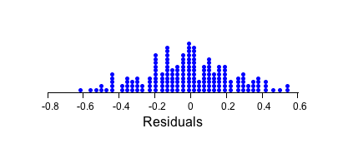

Conclusion

There are two primary diagnostic graphs for assessing the goodness of your MDS solution. The Shepard diagram (Figure 3) is the most important. This plot reveals the underlying response function relating similarities/dissimilaries to distances in the MDS configuration plot. For most datasets, the smoother in this plot will approximate an increasing (or decreasing if the data are similarities) monotonic function. For perceptual data in psychology (matrices of similarity or dissimilarity judgments among objects), this curve is informative because it provides information about the perceptual function. For derived similarities/dissimilarities, the Shepard diagram may also be nonlinear. In any case, one hopes to see points in the graph close to the red fitted curve.

The second useful graph is the influence plot (Figure 2) whose symbols are sized according to the badness of fit (contribution to stress). Most MDS programs do not produce this plot. If you see unusually large symbols in this plot, those points have distances to other points that require higher dimensions to represent accurately.

References

Borg, I. and Groenen, P. (2005). Modern Multidimensional Scaling: Theory and Applications (2nd ed.). New York: Springer–Verlag.

Cox, T.F., and Cox, M.A.A. (1994). Multidimensional Scaling. London: Chapman & Hall.

Kahneman, D. (2011). Thinking, Fast and Slow. New York: Farrar, Straus and Giroux.

Kruskal, J.B. (1964). Multidimensal scaling by optimizing goodness of fit to a nonmetric hypothesis. Psychometrika, 29, 1–27.

Liabson, D. and Zeckhauser, R. (1998). Amos Tversky and the ascent of behavioral economics. Journal of Risk and Uncertainty, 16, 7–47.

Shepard, R.N. (1962). The analysis of proximities: Multidimensional scaling with an unknown distance function. I. Psychometrika, 27, 125–139.

Tversky, A. (1977). Features of similarity. Psychological Review, 84, 327–352.

Young, F.W. and Hamer, R.M. (1987). Multidimensional Scaling: History, Theory, and Applications. Hillsdale, NJ: Lawrence Erlbaum.

