Create a module that implements a NOT gate.

This circuit is similar to [wire](https://hdlbits.01xz.net/wiki/wire), but with a slight difference. When making the connection from the wire in to the wire out we're going to implement an inverter (or "NOT-gate") instead of a plain wire.

Use an assign statement. The assign statement will *continuously drive* the inverse of in onto wire out.

[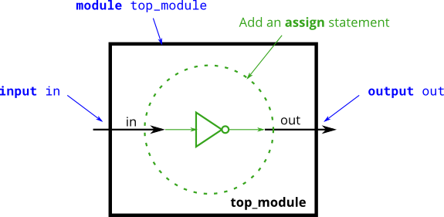](https://hdlbits.01xz.net/wiki/File:Notgate.png)