Create a module that implements a NOR gate. A NOR gate is an OR gate with its output inverted. A NOR function needs two operators when written in Verilog.

An assign statement drives a wire (or "net", as it's more formally called) with a value. This value can be as complex a function as you want, as long as it's a *combinational* (i.e., memory-less, with no hidden state) function. An assign statement is a *continuous assignment* because the output is "recomputed" whenever any of its inputs change, forever, much like a simple logic gate.

[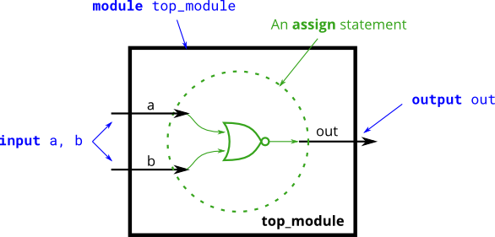](https://hdlbits.01xz.net/wiki/File:Norgate.png)