1.

a)

img = double(rgb2gray(imread('building.jpg')));

figure; imagesc(img); axis image; colormap(gray);

[Ix,Iy] = imgradientxy(img);

g = fspecial('gaussian', 3, 0.6);

Ix2 = conv2(Ix.^2, g, 'same');

Iy2 = conv2(Iy.^2, g, 'same');

Ixy = conv2(Ix.*Iy, g, 'same');

R = (Ix2.*Iy2 - Ixy.^2)./(Ix2 + Iy2);

figure; imagesc(Ix2); axis image; colormap(gray);

figure; imagesc(Iy2); axis image; colormap(gray);

figure; imagesc(Ixy); axis image; colormap(gray);

%figure; imagesc(M); axis image; colormap(gray);

figure; imagesc(R); axis image; colormap(gray);

[r,c] = NonMaximaSup(R, 40, 0.2);

figure, imagesc(img), axis image, colormap(gray),hold on

plot(c, r, 'ro'), title('Corners detected');

hold off;

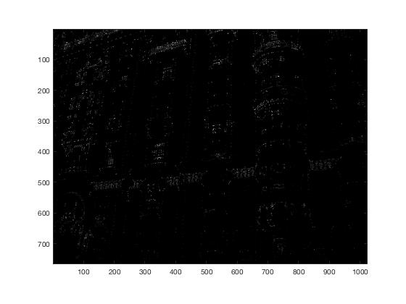

b)

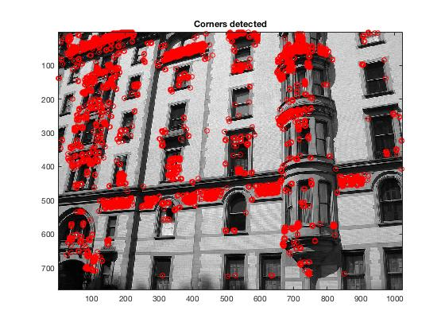

function [r,c] = NonMaximaSup(cornerness, radius, threshold)

% perform non-maximal suppression using ordfilt

n = ordfilt2(cornerness, radius*2, strel('disk', radius).Neighborhood);

% set threshold of the maximum value

t = threshold*max(n(:));

% find local maxima greater than threshold

[r,c] = find(n>=t);

end

c)

d)

2.

a)

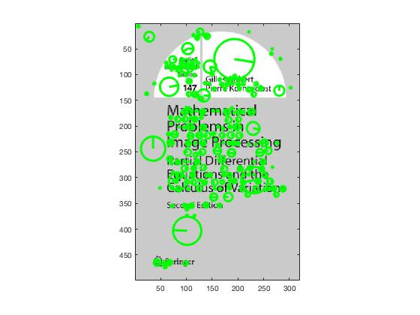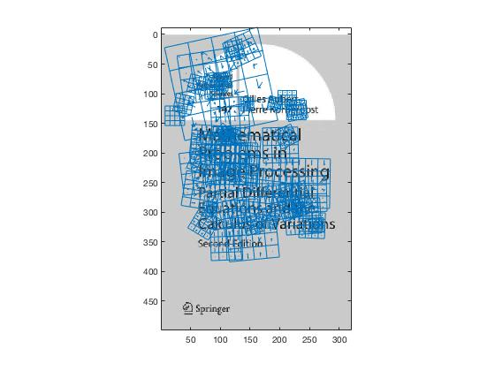

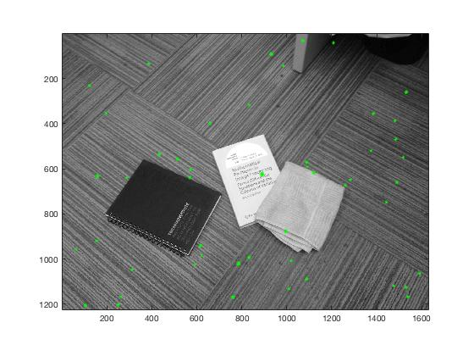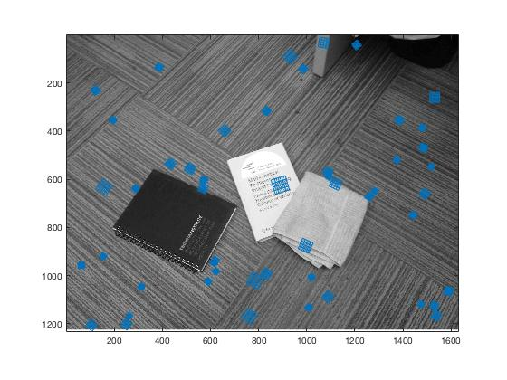

I = imread('book.jpg');

I = single(rgb2gray(I)) ;

Ib = imread('findbook.jpg');

Ib = single(rgb2gray(Ib)) ;

[f,d] = vl_sift(I) ;

[fb, db] = vl_sift(Ib) ;

b)

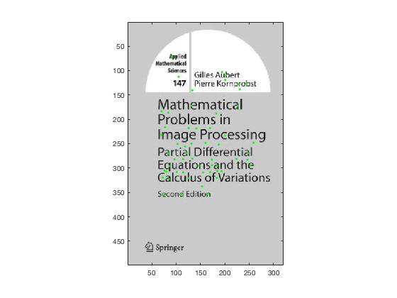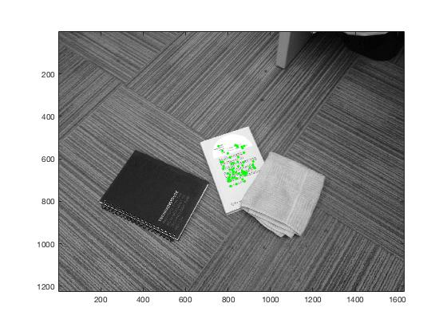

d = double(d);

db = double(db);

euc= pdist2(d', db', 'euclidean');

sorted = sort(euc, 2);

ratios=sorted(:,1)./sorted(:,2);

%copy_f(:,129)= ratios';

%matches = sortrows(copy_f', 129)';

threshold = 0.6;

matches = zeros(size(find(ratios<=threshold),1), 3);

for i = 1:size(euc,1)

if ratios(i) < threshold

matches(i,1) = ratios(i);

matches(i,2)= i;

matches(i,3)=find(euc(i,:)==sorted(i,1));

end

end

matches( ~any(matches,2), : ) = [];

matching_points = zeros(size(matches,1), 5);

c) & d)

k = 1 k = 2

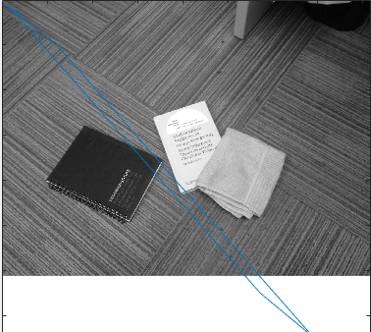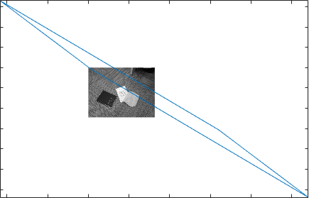

k = 4 k =12

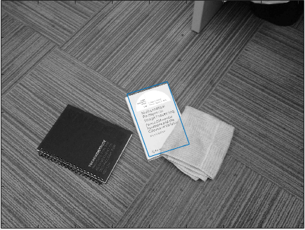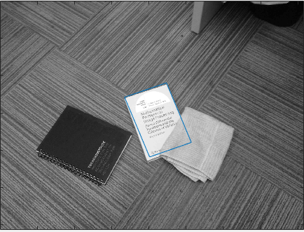

k = 40 k = 75

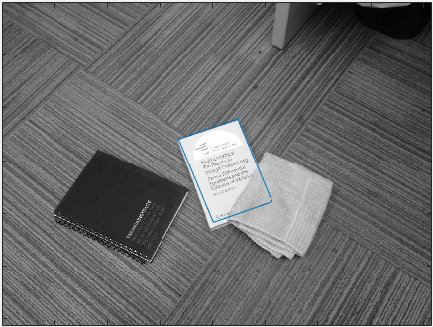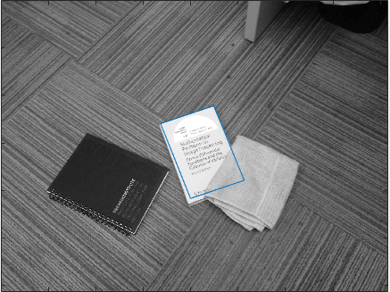

for i = 1:size(matches,1)

matching_points(i,1) = matches(i,1);

matching_points(i,2:3) = [f(1,matches(i,2)) f(2,matches(i,2))];

matching_points(i,4:5) = [fb(1,matches(i,3)) fb(2,matches(i,3))];

end

mmk = matching_points';

figure, imagesc(I), axis image, colormap(gray),hold on

plot(mmk(2,:),mmk(3,:),'g.') ;

hold off;

figure, imagesc(Ib), axis image, colormap(gray),hold on

plot(mmk(4,:),mmk(5,:),'g.') ;

hold off;

matching_pointss = sortrows(matching_points, 1);

k = 1;

fg = figure;imagesc(I);axis image;hold on;colormap gray;

drawnow;

[x,y] = ginput(4);

while (k)

k = size(matching_pointss, 1);

k = input(sprintf('Enter a value for k between 1 and %d\n',k));

P = [];

Pp = [];

for i = 1:k

x1 = matching_pointss(i,2);

y1 = matching_pointss(i,3);

x2 = matching_pointss(i,4);

y2 = matching_pointss(i,5);

P(size(P,1)+1,:) = [x1 y1 0 0 1 0];

P(size(P,1)+1,:) = [0 0 x1 y1 0 1];

Pp(size(Pp,1)+1,:) = x2;

Pp(size(Pp,1)+1,:) = y2;

end

penny = (P'*P)'*inv((P'*P)*(P'*P)');

affine = penny*P'*Pp;

O = [];

for i = 1:size(x)

O(size(O,1)+1,:) = [x(i) y(i) 0 0 1 0];

O(size(O,1)+1,:) = [0 0 x(i) y(i) 0 1];

end

transform = O*affine;

yr = transform(2:2:length(transform));

xr = transform(1:2:length(transform));

xr= [xr' xr(1)];

yr= [yr' yr(1)];

figure, imagesc(Ib), axis image, colormap(gray),hold on

plot(xr,yr);

hold off;

end