Postman I started from the initial porduct page and will update all.

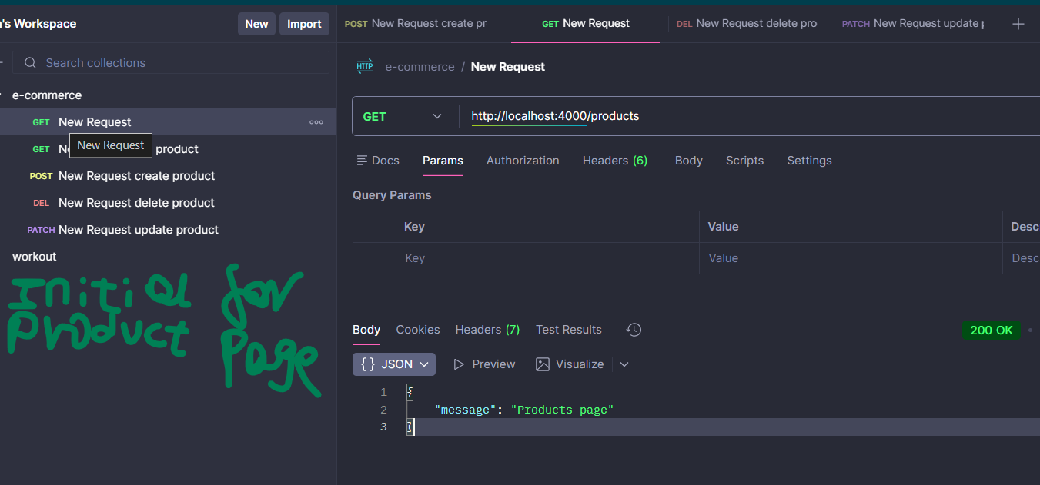

Get all Products
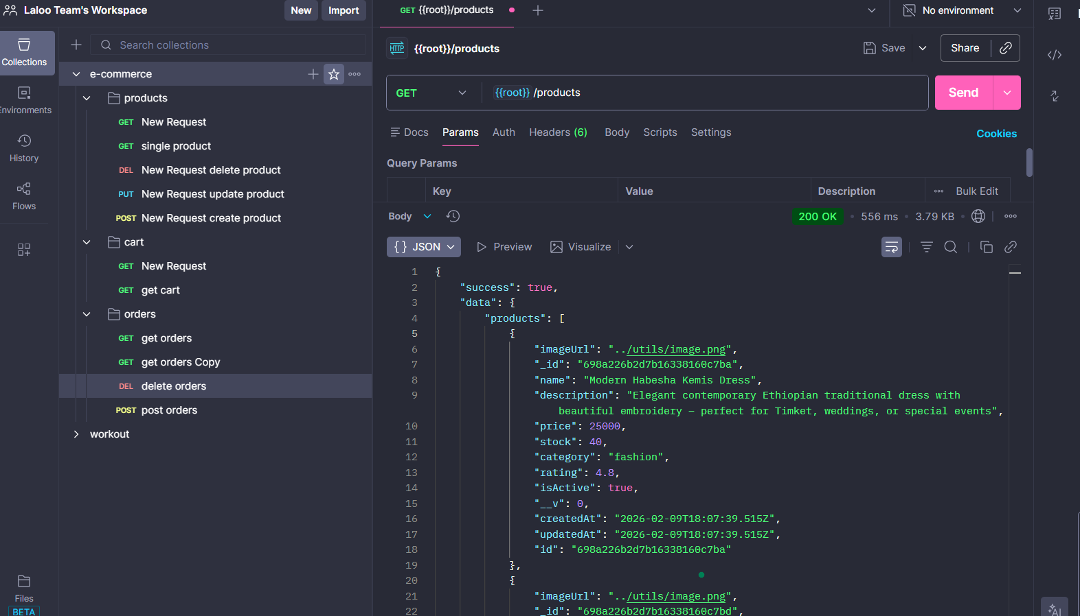

Get some products by id

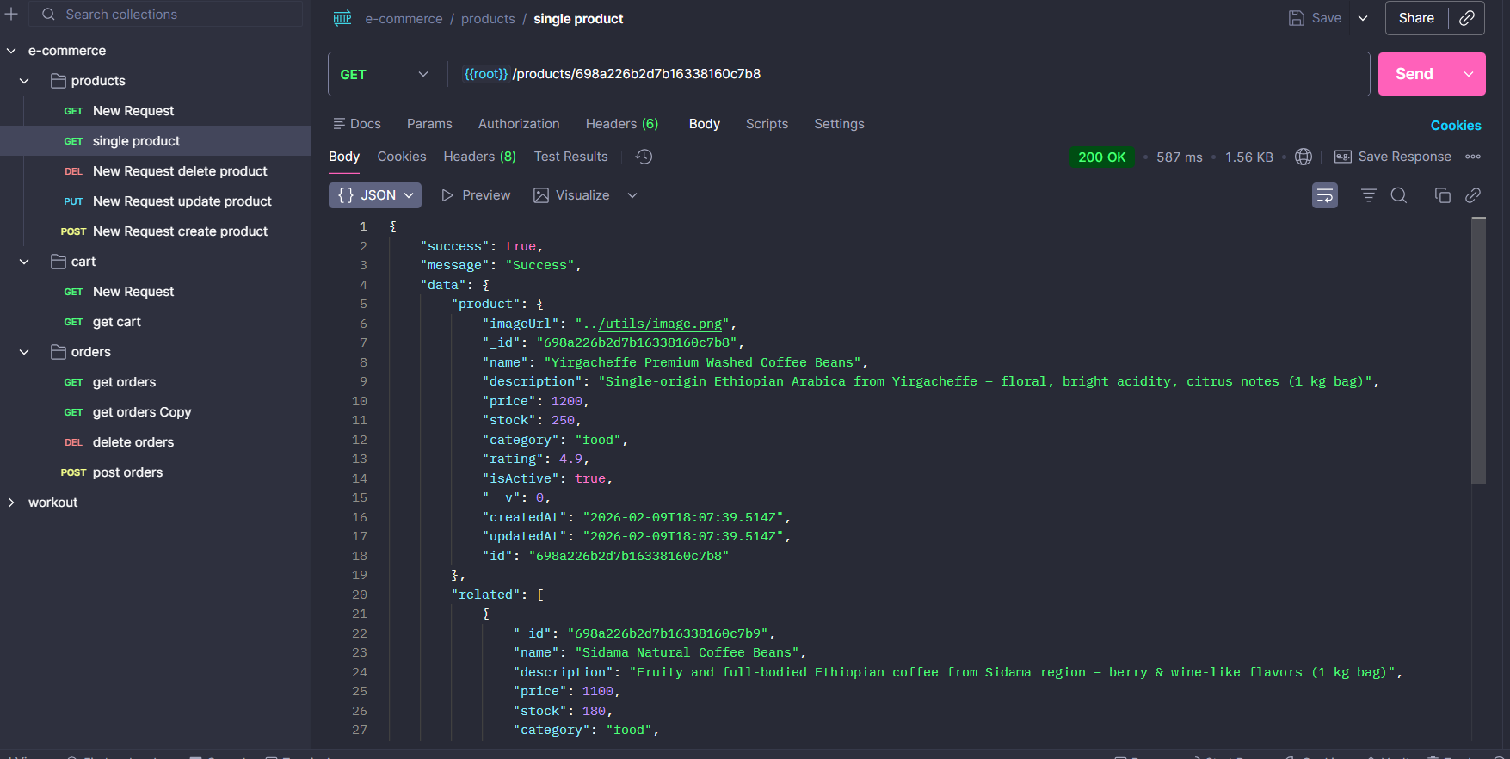

Create new Product

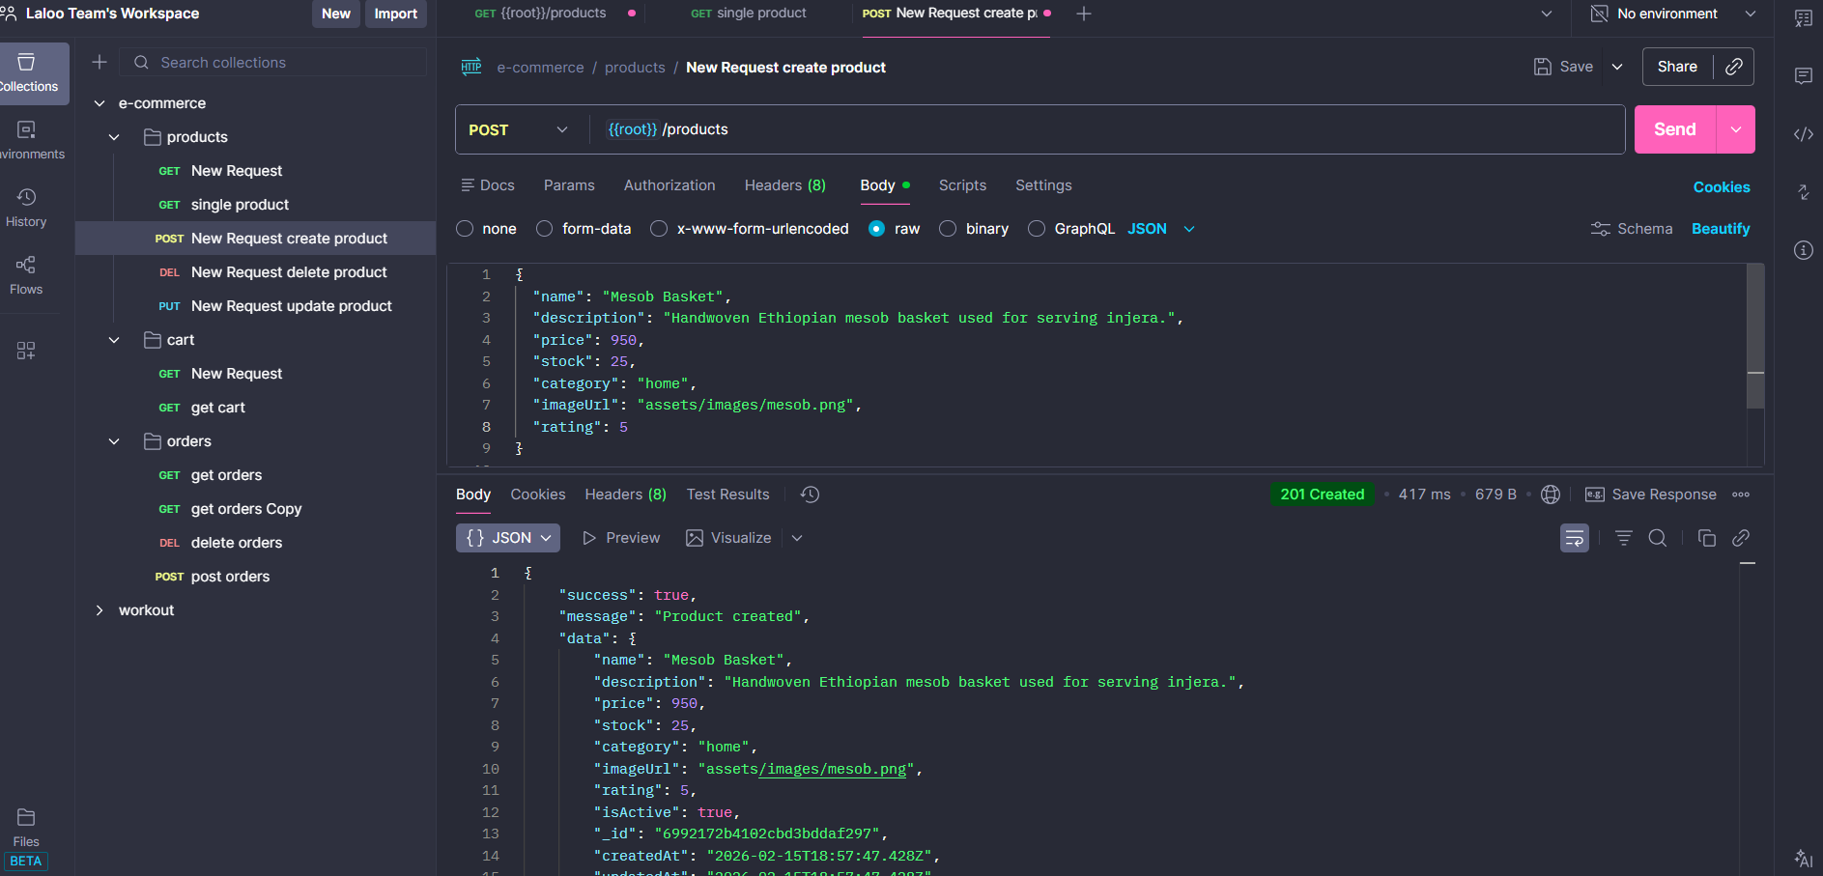

Update Single Product by Id
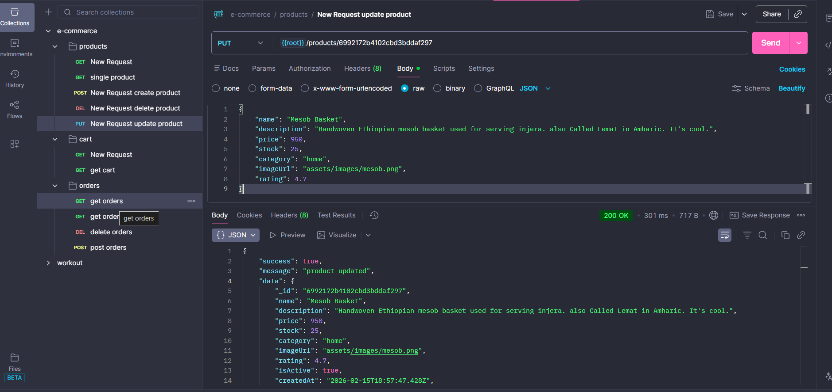

Delete Product

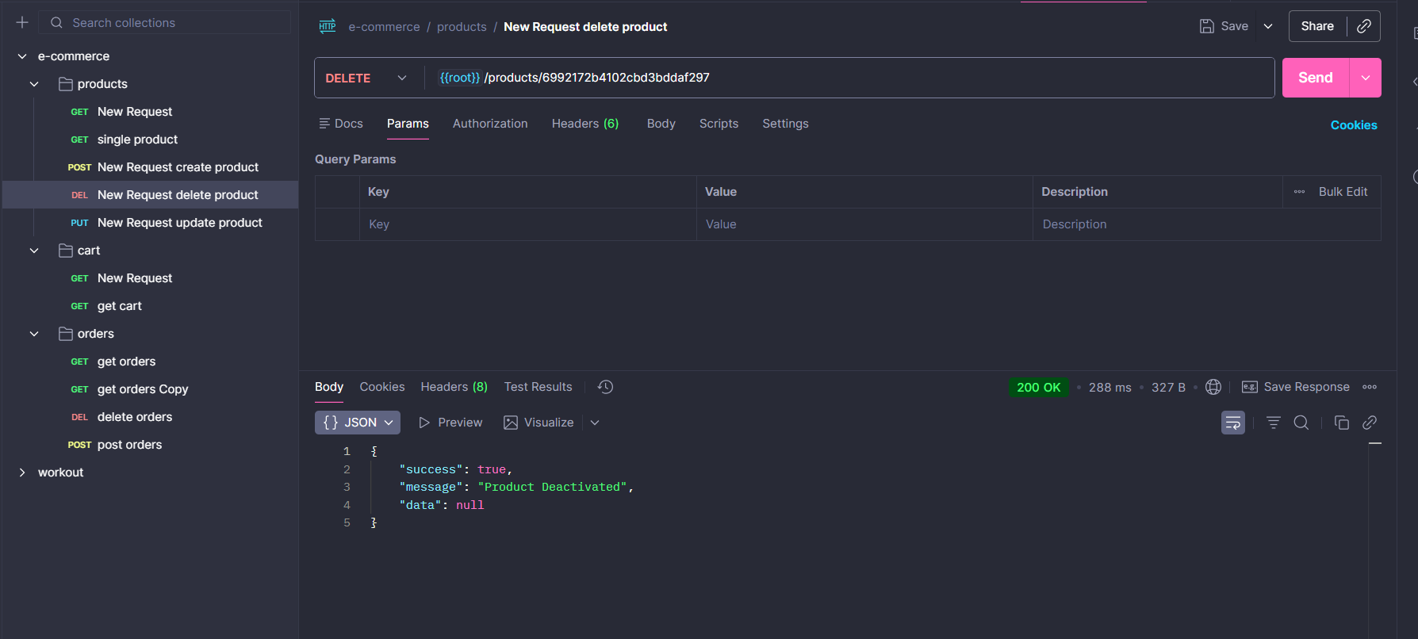

Cart

Cart does
router.get("/" , getCart)
router.get("/summary" , getCartSummary)
router.post("/", addToCart);
router.put("/:productId" , updateCartItem)

router.delete("/:productId", removeFromCart);
router.delete("/" , clearCart)
Routes

