

PlayStore Capstone

Project Title: Playstore Capstone 2020.

Developer: Samir Benzada.

Tools: RapidApi, Apache Kafka, Apache Spark, MongoDB.

Start Project: Monday, August 10, 2020.

Duration: 4 Days.

Business Case:

Ingest Play store List of all Mobile Applications, I want to have a list of the Best Applications for Free only.
I’m gonna Filter them by price (Free) and get only the applications with a rate between 4 and 5 stars.
I also will Sort them by rate where the best ones will be on top of the list.

Tools

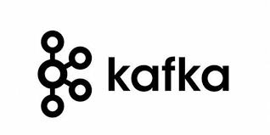


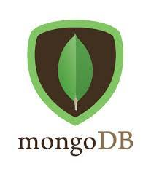



PlayStore Rest-API Link:

https://rapidapi.com/etd.youssef/api/api-playstore

Kafka Producer:

from kafka import KafkaClient
from kafka import KafkaProducer
import requests
from json import dumps
import json

producer = KafkaProducer(bootstrap_servers='localhost:9092')

myheaders = {
"x-rapidapi-host": "***********************",
"x-rapidapi-key": "*************************",
"useQueryString": '****'
}

x= requests.get('https://api-playstore.p.rapidapi.com/****************', headers=myheaders)
t = x.json()

Spark-Streaming:

from pyspark.streaming.kafka import KafkaUtils
from pyspark.streaming import StreamingContext
from pyspark import SparkContext
from pyspark.sql import SparkSession
import json
from json import loads

sc = SparkContext(appName="playstore")
ssc = StreamingContext(sc, 5)

ks = KafkaUtils.createDirectStream(ssc, ['play_apps'], {'metadata.broker.list': 'localhost:9096'})

result1 = ks.map(lambda x: json.loads(x[1])

result1.pprint()

Data Transformation:

.flatMap( lambda text: text.split( ' ' ))
.filter( lambda word: word.lower() )
.filter(lambda word: re.sub('[^a-z]', ' ', word))
.map( lambda word: ( word, 1 ) )

Database:

MongoDB

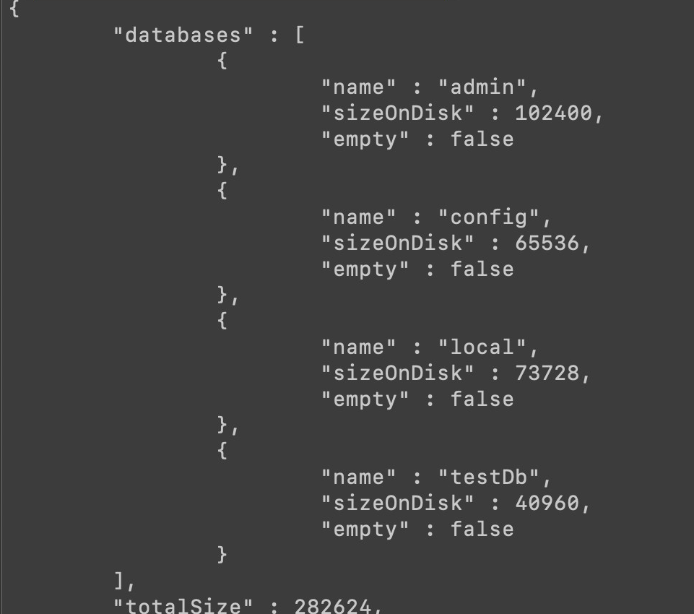

Schema:

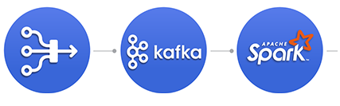

Kafka :

Kafka is a distributed streaming platform that is used publish and subscribe to streams of records.
Kafka is used for fault tolerant storage.
Kafka replicates topic log partitions to multiple servers.
Kafka is designed to allow your apps to process records as they occur.
Kafka is fast and uses IO efficiently by batching and compressing records.
Kafka is used for decoupling data streams.
Kafka is used to stream data into data lakes, applications, and real-time stream analytic systems.

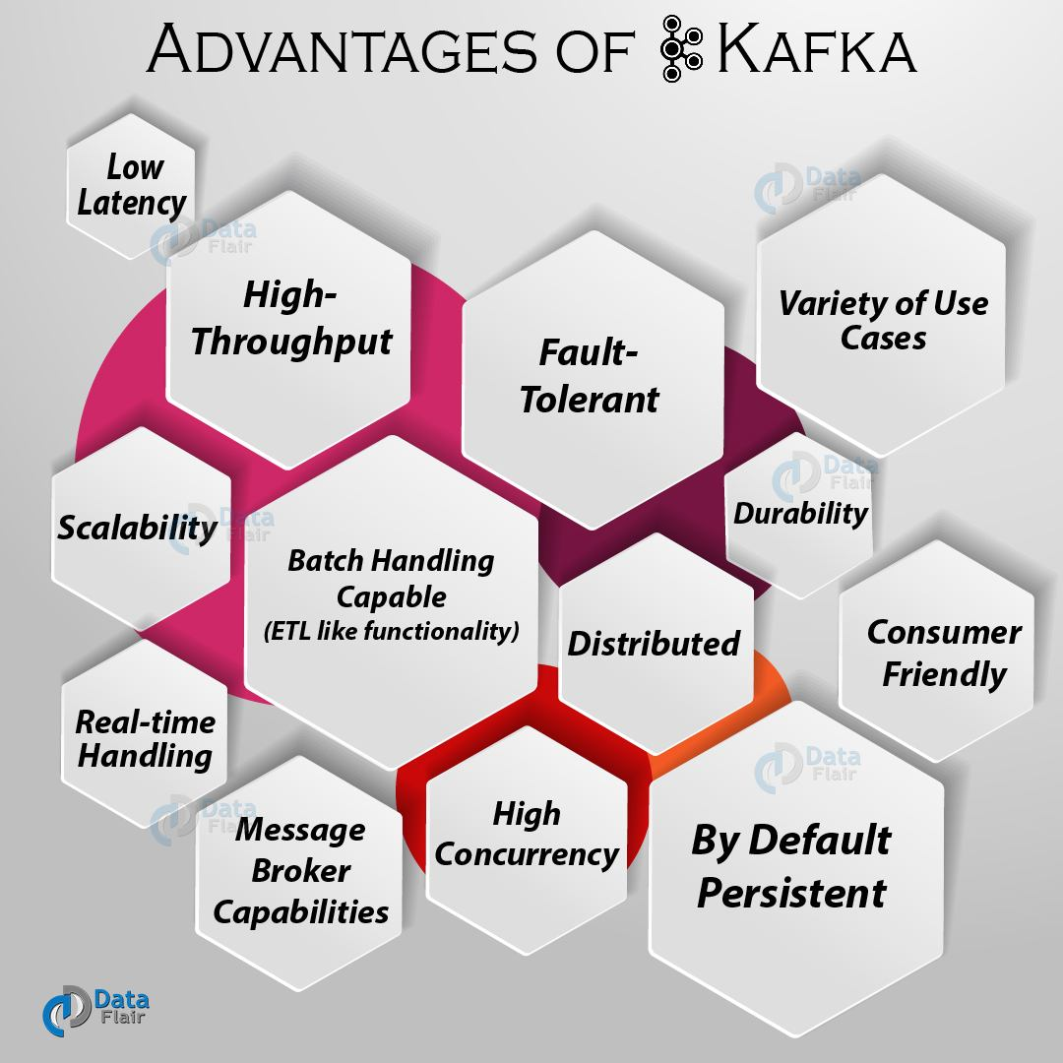

Spark:

Apache Spark is a data processing framework that can quickly perform processing tasks on very large data sets, and can also distribute data processing tasks across multiple computers, either on its own or in tandem with other distributed computing tools.

Speed
Run workloads 100x faster. Apache Spark achieves high performance for both batch and streaming data, using a state-of-the-art DAG scheduler, a query optimizer, and a physical execution engine.

Ease of Use
Write applications quickly in Java, Scala, Python, R, and SQL. Spark offers over 80 high-level operators that make it easy to build parallel apps. And you can use it interactively from the Scala, Python, R, and SQL shells.

Generality
Combine SQL, streaming, and complex analytic. Spark powers a stack of libraries including SQL and DataFrames, Mllib for machine learning, GraphX, and Spark Streaming. You can combine these libraries seamlessly in the same application.

Runs Everywhere
Spark runs on Hadoop, Apache Mesos, Kubernetes, standalone, or in the cloud. It can access diverse data sources. You can run Spark using it’s standalone cluster mode, on EC2, on Hadoop YARN, on Mesos, or on Kubernetes. Access data in HDFS, Alluxio, Apache Cassandra, Apache Hbase, Apache Hive, and hundreds of other data sources.
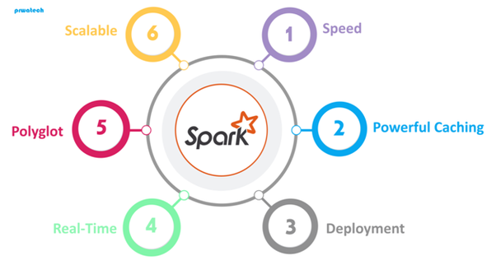

MongoDB:

MongoDB is an object-oriented, simple, dynamic, and scalable NoSQL database.
It is based on the NoSQL document store model.
The data objects are stored as separate documents inside a collection instead of storing the data into the columns and rows of a traditional relational database.

Advantages of using MongoDB

- Schema less. MongoDB is a document database in which one collection holds different documents. Number of fields, content and size of the document can differ from one document to another.

- Structure of a single object is clear.

- No complex joins.

- Deep query-ability. MongoDB supports dynamic queries on documents using a document-based query language that's nearly as powerful as SQL.

- Tuning.

- Ease of scale-out. MongoDB is easy to scale.

- Conversion/mapping of application objects to database objects not needed.

- Uses internal memory for storing the (windowed) working set, enabling faster access of data.

