1. Divide and Conquer (14)

Given a binary tree T, please give an O(n) algorithm to invert binary tree.

For example below, inverting the left binary tree, we get the right binary tree.

1. Dynamic Programming

Given two sequences, Find the length of the common subsequense(LCS).

Note：A subsequence is different from a substring, for the former need NOT be consecutive of the original sequence. For example, for “ABCD” and “AEFC”, the longest common subesequence is “AC”, and the length of it is 2.

Please describe the optimal substructure and DP equation.

1. Greedy

Suppose you were to drive from Beijing to Xizang. With a full gas tank, you can travel at most m km. And you have a map that gives distances between gas stations along the route. Let d1<d­­2<...<dn be the locations of all the n gas stations along the route where di is the distance from Beijing to the gas station. You can assume that the distance between neighboring gas stations is at most m km.

Give the most efficient algorithm you can find to determin at which gas stations you should stop so that the number of time you stop is minimized, and prove that your strategy yields an optimal solution. Be sure to give the time complexity of your algorithm respect to n.

1. Linear Programming

An express company needs to deliver goods to its five users. The company wants to upload 1, 2, 3, 4 and 8units of goods at five users whose userID are 1, 2, 3, 4 and 5 respectively. The company hax a total of four trucks, and the trucks 1 to 4 have a load of 2, 6, 8 and 11 units. The cost of truck i dispatching once is Ci­­. Due to delivery time restrictions, one truck can neither deliver goods to booth users A and C at the asame time, nor deliver goods to both B and D at the same time. Please give a delivering plan to minimize the cost.

1. Formulate this problem as an interger linear programming problem and explain every variable and constraints.
2. If truck i charges the users j for the additional charge Kij, then how should the problem be formulated?

Notece: Absolute value (|\*|) shall never appear in a Linear Programming(LP) formulation, since it is not a linear operation. Nerther shall other non-linear operations, such as max(), etc. If you want to use your own notation, Please explain it first.

1. Network Flow

Given n numbers [a1, a2...an], numbers can be negative or positive.

You can perform the following operation any number of times (possible zero)

·Select a positive interger xi assign 0 to ALL ai satisfied i is divisible by x. (ax = 0, a2x = 0, a3x = 0 ...)

By optimally performing the operation, what is the maximum sum of N numbers can be obtained? (Exanple, 6 numbers [1, 2, -6, 4, 5, 3], answer is 12).

1. Subarray Sum

Giver an array of positive intergers and an interger k,

1. Please find whether there are two numbers in the array such that they add up to k, and the time complexity of your algorithm should be better than O(n­2);
2. Please find whether there is a continuous subarray whose sum equals to k, and the time complexity of your algorithm should be better than O(n2);
3. Please find whether there is a subsequence (Not necessarily continuous) whose sum equals to k;
4. Please construct a array of shortest length that the set of sums of all subsequences covers all the intergers beteween l and k.

Example that if k=4, the shortest array can be [1, 2, 3] because that sum of subsequence [1] equals 1, sum of subsequence [2] equals 2, sum of subsequence [1, 2] queals 3, and sum of subsequence [1, 3] equals 4. The subsequence sums can cover intergers from 1 to 4.

1. Granph

You are given an undireted weighred graph consisting of n vertices and m edgeas, each of edges has a weight. You are also given two vertices s and t in the graph.

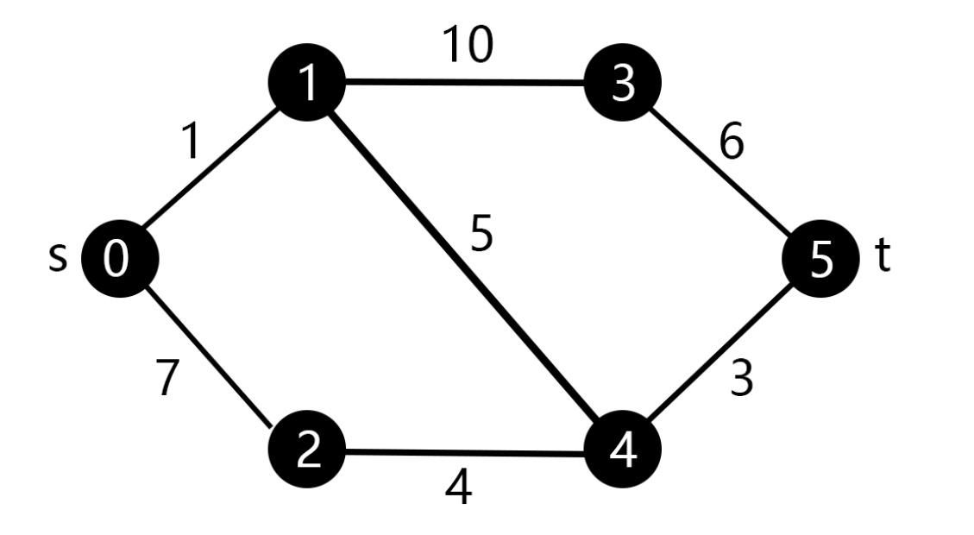 For example, a graph G consistinf of 6 vertices and 7 edges with different weights is shownm s is the vertice labelled 0 and t is the vertice labelled 5.

* 1. Please find whether there is a path from s to t that the maximum weight of edges in the path is at most W. Example that given ω= 6 in G, the path 0->1->4->5 is satisfied because the maximum edge weight is 5 (1->4).
  2. You need to find a path from s to t that the maximum weight W of edges in the path is minimized. Please calculate tthe minimum value of W.

Example that there are 3 paths from s to t in G: 0 ->1 ->3 ->5, 0 ->1 ->4 ->5 and 0 ->2 ->4 ->5, the maximum edge weights in these paths is 10, 5 and 7, so the minimum value of W is 5.

* 1. Please find the shortest path from s to t and the path goes through at most k points (Not including s and t).