[SOMAIYA VIDYAVIHAR UNIVERSITY LOGO]
Sahay - Mental Health Support Platform
A Mobile Application for Accessible Psychiatric Care
Submitted in Partial Fulfillment of Requirements
for the Degree of
Bachelor of Computer Applications
By
Lalmohammad Patel
Seat No: 31011123042
Guide
______________
Somaiya School of Basic and Applied Sciences
Somaiya Vidyavihar University
Vidyavihar, Mumbai - 400 077
2023-26

Somaiya Vidyavihar University
Somaiya School of Basic and Applied Sciences
Certificate
This is to certify that the project report on dissertation entitled "Sahay" is Bonafide record of the dissertation work done by Lalmohammad Patel in the year 2025-26 under the guidance of ______________, Department of Computer Science in partial fulfillment of requirement for the Bachelor of Computer Applications degree in Somaiya School of Basic and Applied Sciences of Somaiya Vidyavihar University.

____________________________ | ____________________________
Guide / Co-Guide | Programme Coordinator

____________________________ | ____________________________
Head of Department | Director

Date:
Place: Mumbai-77
Bachelor of Computer Applications 2023-26 Batch

Somaiya Vidyavihar University
Somaiya School of Basic and Applied Sciences
Certificate of Approval of Examiners
This is to certify that the project report on dissertation entitled "Sahay" is Bonafide record of the dissertation work done by Lalmohammad Patel in partial fulfillment of requirement for the Bachelor of Computer Applications degree of Somaiya Vidyavihar University.

____________________________ | ____________________________
External Examiner / Expert | Internal Examiner / Guide

Date:
Place: Mumbai-77
Bachelor of Computer Applications 2023-26 Batch

Somaiya Vidyavihar University
Somaiya School of Basic and Applied Sciences
DECLARATION
I declare that this written report submission represents the work done based on my and / or others' ideas with adequately cited and referenced the original source. I also declare that I have adhered to all principles of academic honesty and integrity as I have not misinterpreted or fabricated or falsified any idea/data/fact/source/original work/ matter in my submission.
I understand that any violation of the above will be cause for disciplinary action by the college and may evoke the penal action from the sources which have not been properly cited or from whom proper permission is not sought.

______________________________

Signature of the Student
Lalmohammad Patel
Name of the Student
Seat No: 31011123042

Date:
Place: Mumbai-77
Bachelor of Computer Applications 2023-26 Batch

EXECUTIVE SUMMARY
Mental health disorders affect over 150 million Indians, yet less than 10% have access to professional psychiatric care. The stigma surrounding mental health, high consultation costs, lack of awareness about available services, and geographical barriers to reaching specialists create a massive gap between those who need help and those who actually receive it. Traditional in-person therapy remains inaccessible to the majority of the population, particularly youth, college students, and individuals in semi-urban areas who form the most vulnerable demographic.
Sahay (meaning 'help' or 'support' in Hindi/Marathi) is proposed and developed as a comprehensive mobile application to bridge this critical gap in mental health infrastructure. The platform creates a unified ecosystem connecting three distinct user roles: Clients (patients seeking mental health support), Psychiatrists (licensed medical professionals), and Administrators (platform moderators responsible for quality assurance). The application is built using React Native (v0.79) with Expo SDK 53 for cross-platform mobile deployment, Firebase Authentication for secure multi-method identity management, and Supabase (PostgreSQL) for real-time database operations and cloud storage.
Through this application, clients can browse a directory of admin-verified psychiatrists, view their specializations, years of experience, session pricing, and patient ratings, then book and pay for video consultation sessions directly through the app. When human professionals are unavailable, an AI-powered chatbot (powered by Google Gemini) provides 24/7 preliminary mental health support, offering immediate conversational assistance for users in distress. The curated Self-Care module offers mood-based YouTube video resources organized into five emotional categories (Happy, Sad, Anxious, Angry, Neutral) for daily mental wellness maintenance. Critically, clients can choose to remain completely anonymous using system-generated aliases, ensuring a privacy-first approach that eliminates the stigma barrier entirely.
A major technical achievement is the multi-layered authentication system supporting three distinct sign-in methods: email/password registration with Firebase email verification (featuring auto-polling, resend cooldown, and skip functionality), Google OAuth for seamless one-tap sign-in, and anonymous browsing for stigma-free exploration. Psychiatrists undergo a rigorous 3-step digital onboarding process requiring credential entry, professional profile creation, and medical license image upload, followed by admin verification before being approved to offer services on the platform.
The Admin Dashboard provides real-time analytics on platform activity including pending applications, registered clients, approved psychiatrists, and active sessions, along with a complete application review workflow featuring license image viewing and approve/reject actions. In this report, an exhaustive study on the system architecture, component design, database state management, and real-time interface rendering is presented. The implementation successfully demonstrates how mobile technology can democratize access to mental health services, making professional psychiatric help available to anyone with a smartphone.
Keywords: Mental Health Platform, Telepsychiatry, React Native, Firebase Authentication, Supabase, Video Consultation, AI Chatbot, Anonymous Access, Self-Care Resources.

Contents
List of Figures
List of Tables
1 Introduction
1.1 Introduction and Background of the Project
1.2 Objectives of Project and Problem Statement
1.3 Scope, Advantages, and Applicability of Project
1.4 Organization of the Report
2 Survey of Technologies
2.1 Existing Technologies
2.2 Technology Implemented for the Project
3 Requirement and Analysis
3.1 Problem Statement with Major Modules
3.2 Feasibility Study
3.3 Software Requirement Specification
3.3.1 Functional Requirements
3.3.2 Non-functional Requirements
3.4 System Software and Hardware Requirements
3.5 SDLC Model
3.6 Project Scheduling
4 System Design
4.1 System Architecture
4.2 Use Case Diagram
4.3 Data Flow Diagram
4.4 Activity Diagrams
4.5 ER Diagram
4.6 Project System Screens
5 Implementation and Testing
5.1 Algorithms and Major Modules of the Project
5.2 Testing Approaches
5.3 Test Cases and Test Results
6 Results and Discussion
7 Conclusion and Future Work
References

List of Figures
Figure No. | Title
4.1 | System Architecture Diagram
4.2 | Use Case Diagram - Sahay System
4.3a | Level 0 DFD (Context Diagram)
4.3b | Level 1 DFD
4.4a | Activity Diagram - Client Registration Flow
4.4b | Activity Diagram - Session Booking Flow
4.4c | Activity Diagram - Psychiatrist Onboarding Flow
4.5 | ER Diagram - Database Schema
4.6.1 | Screenshot - WelcomeScreen
4.6.2 | Screenshot - LoginScreen
4.6.3 | Screenshot - RegisterScreen
4.6.4 | Screenshot - EmailVerificationScreen
4.6.5 | Screenshot - ClientHomeScreen
4.6.6 | Screenshot - FindPsychScreen
4.6.7 | Screenshot - SessionRequestScreen
4.6.8 | Screenshot - PaymentScreen
4.6.9 | Screenshot - SessionWaitingScreen
4.6.10 | Screenshot - VideoCallScreen
4.6.11 | Screenshot - ChatScreen (AI)
4.6.12 | Screenshot - SelfCareScreen
4.6.13 | Screenshot - OnboardingScreen
4.6.14 | Screenshot - PsychHomeScreen
4.6.15 | Screenshot - SessionQueueScreen
4.6.16 | Screenshot - EditProfileScreen
4.6.17 | Screenshot - ChatScreen (Psych)
4.6.18 | Screenshot - VideoCallScreen (Psych)
4.6.19 | Screenshot - AdminDashboard
4.6.20 | Screenshot - PsychApplications
4.6.21 | Screenshot - ApplicationDetail

List of Tables
Table No. | Title
3.1 | Functional Requirements
3.2 | Non-Functional Requirements
3.3 | Hardware and Software Requirements
3.4 | Project Schedule
5.1 | Test Cases and Results

1. Introduction

1.1 Introduction and Background of the Project
Mental health has emerged as one of the most pressing public health challenges in India and globally. According to the World Health Organization (WHO), India accounts for nearly 15% of the global mental health burden, with an estimated 150 million people requiring active mental health interventions. Despite this staggering need, India has fewer than 0.3 psychiatrists per 100,000 people — one of the lowest ratios globally — creating an enormous gap between demand and supply of psychiatric services.
The COVID-19 pandemic further exacerbated this crisis dramatically. Prolonged lockdowns, social isolation, economic uncertainty, and grief led to a sharp rise in anxiety disorders, clinical depression, post-traumatic stress, and substance abuse, particularly among young adults aged 18-30 and college students who form one of the most vulnerable demographics. A 2021 study by the Indian Psychiatry Journal found that prevalence of moderate-to-severe depression among Indian college students increased by 38% during the pandemic period.
The traditional model of psychiatric care relies heavily on in-person consultations at hospitals or private clinics, which present multiple significant barriers. These include: geographical distance from qualified professionals in rural and semi-urban areas, prohibitively high consultation fees ranging from INR 500 to INR 3000 per session, long waiting times of weeks or months for appointments, and — most critically — the persistent social stigma associated with seeking mental health treatment. Many individuals, particularly in Indian society, avoid seeking help due to fear of judgment from family, friends, and colleagues.
Sahay (meaning 'help' or 'support' in Hindi and Marathi) is a mobile application designed to systematically dismantle each of these barriers. Built with modern cross-platform technologies, Sahay creates a secure, accessible, private, and affordable bridge between individuals seeking mental health support and licensed psychiatrists. The platform introduces three key innovations: (1) anonymous access through system-generated aliases to eliminate stigma, (2) AI-powered preliminary support via a chatbot for immediate 24/7 assistance, and (3) video-based telepsychiatry for consultations from the safety and comfort of one's home.
The application ecosystem supports three distinct user roles — Clients, Psychiatrists, and Administrators — each with dedicated interfaces, workflows, and permissions. Clients can discover verified professionals, book sessions, make payments, and access self-care resources. Psychiatrists manage their professional profiles, accept session requests, and conduct video consultations. Administrators oversee platform quality by reviewing psychiatrist applications, monitoring platform metrics, and managing user accounts.

1.2 Objectives of Project and Problem Statement
Problem Statement:
To design and develop a cross-platform mobile application that provides secure, affordable, and stigma-free access to licensed psychiatric professionals through real-time video consultations, supplemented by AI-powered conversational support and curated mood-based self-care resources, while ensuring quality through admin-verified psychiatrist onboarding and multi-method secure authentication.
Objectives:
- To create a secure multi-role authentication system supporting email/password registration with email verification, Google OAuth single sign-on, and anonymous access with system-generated aliases.
- To implement a real-time video consultation booking system with session request workflow, integrated simulated payment processing (UPI and card), and push notification alerts.
- To develop an AI-powered mental health chatbot using Google Gemini API that provides 24/7 contextual conversational support with maintained conversation history.
- To curate a self-care resource module with mood-based video filtering across five emotional categories (Happy, Sad, Anxious, Angry, Neutral) with in-app YouTube playback.
- To build a comprehensive psychiatrist onboarding pipeline with 3-step credential verification, license image upload to cloud storage, and admin review workflow.
- To develop an admin dashboard with real-time platform analytics, psychiatrist application review, and user management capabilities.
- To implement robust input validation, error handling, and user experience refinements across all 22 application screens.

1.3 Scope, Advantages, and Applicability
Scope:
Sahay is designed to serve college students, young professionals, and urban/semi-urban populations in India who may lack access to affordable and stigma-free psychiatric care. The platform focuses on the Indian market with UPI-based payment integration, INR pricing (INR 99 - INR 499 per session), and culturally sensitive content. The current scope covers individual video consultations, AI chat support, and curated self-care resources. Future iterations may expand to include group therapy, prescription management, and multi-language support.
Advantages:
- Privacy-First Design: Anonymous browsing with system-generated aliases eliminates the stigma barrier entirely, encouraging first-time users and repeat visits.
- 24/7 Availability: AI chatbot powered by Google Gemini provides immediate conversational support when human professionals are unavailable, ensuring no user is left without help.
- Geographical Accessibility: Video consultations via Daily.co WebRTC eliminate the need for physical travel, making specialist psychiatric care accessible from any location with internet connectivity.
- Quality Assurance: Admin-verified psychiatrist onboarding with license image review ensures only qualified, licensed professionals offer services on the platform.
- Proactive Wellness: Mood-based self-care video resources enable users to maintain daily mental wellness without requiring professional sessions.
- Cross-Platform: Single codebase using React Native serves both Android and iOS platforms, maximizing reach while minimizing development complexity.
- Affordable: Session pricing between INR 99-499 is significantly lower than typical in-person psychiatric consultation fees.
Applicability:
The application is applicable to multiple sectors: university student wellness programs where counseling centers are overwhelmed, corporate employee assistance programs (EAPs) seeking scalable digital mental health solutions, government mental health outreach initiatives under the National Mental Health Programme, NGOs working in mental health awareness, and individual users seeking private, professional psychiatric consultation without the social overhead of visiting a clinic.

1.4 Organization of the Report
This report is organized into seven chapters that systematically document the complete software development lifecycle of the Sahay application:
- Chapter 1: Introduction — Presents the project background, problem statement, objectives, scope, advantages, and applicability.
- Chapter 2: Survey of Technologies — Reviews existing mental health applications in the market and documents the technology stack selected for implementation.
- Chapter 3: Requirement and Analysis — Details the problem decomposition into major modules, feasibility study, software requirement specification (functional and non-functional), hardware/software requirements, SDLC model, and project scheduling.
- Chapter 4: System Design — Presents UML diagrams including system architecture, use case diagram, data flow diagrams (Level 0 and Level 1), activity diagrams for key workflows, entity-relationship diagram, and screenshots/placeholders for all 22 application screens.
- Chapter 5: Implementation and Testing — Documents core algorithms, authentication flow, session booking flow, email verification module, testing approaches, and comprehensive test case results.
- Chapter 6: Results and Discussion — Discusses the key results achieved, limitations encountered, and observations from testing.
- Chapter 7: Conclusion and Future Work — Summarizes project outcomes and outlines nine areas for future enhancement.

2. Survey of Technologies

2.1 Existing Technologies
The mental health technology space has grown significantly in recent years, with several noteworthy applications attempting to address the accessibility gap. A thorough survey of existing solutions was conducted to identify gaps that Sahay aims to fill:
BetterHelp / Talkspace (International):
These are subscription-based online therapy platforms primarily targeting the US and European markets. BetterHelp charges approximately $260-$400 per month for unlimited messaging and weekly video sessions. While comprehensive, the pricing model makes these platforms entirely inaccessible to the Indian demographic. Additionally, therapists on these platforms are primarily counselors, not psychiatrists, and the platforms do not offer anonymous access.
Practo (India):
Practo is India's leading healthcare platform offering doctor consultations across specialties. While it includes mental health professionals, Practo is primarily a general healthcare marketplace. It lacks dedicated mental health features such as AI chatbot support, mood-based self-care resources, anonymous access, or specialized psychiatrist onboarding verification.
Wysa / Woebot (AI-Focused):
These are AI-only chatbot applications using Cognitive Behavioral Therapy (CBT) techniques. While effective for mild anxiety and stress management, they fundamentally lack the ability to provide human professional consultation. They cannot prescribe medication, conduct clinical assessments, or handle severe mental health conditions. Sahay bridges this gap by combining AI support with access to licensed psychiatrists.
YourDOST (India):
YourDOST is an Indian emotional wellness platform offering text-based chat with counselors and life coaches. However, it does not offer video consultations with psychiatrists, does not have anonymous access, and lacks self-care resource curation. Its counselors are not necessarily licensed medical professionals.
Gap Analysis:
None of the existing platforms combine all six features that Sahay offers in a single application: (1) anonymous access, (2) verified psychiatrist video consultations, (3) AI chatbot support, (4) mood-based self-care resources, (5) affordable INR-based pricing, and (6) admin-verified quality assurance. Sahay fills this gap by creating a comprehensive, India-focused mental health ecosystem in one unified mobile application.

2.2 Technology Implemented for the Project
Frontend Framework:
- React Native (v0.79): An open-source, cross-platform mobile application framework developed by Meta. Enables writing a single TypeScript/JavaScript codebase that compiles to native Android and iOS applications, significantly reducing development time and maintenance overhead.
- Expo SDK 53: A comprehensive development platform built on top of React Native that simplifies the build process, provides managed native modules (camera, notifications, image picker), and enables over-the-air updates without app store submissions.
- TypeScript: A statically-typed superset of JavaScript that catches type errors during development, improves code documentation through type annotations, and enhances IDE autocompletion and refactoring support.
- React Navigation (v7): The industry-standard routing library for React Native applications, providing stack-based, tab-based, and drawer navigation with smooth native-like transitions.
Backend and Database:
- Supabase: An open-source Firebase alternative built on PostgreSQL. Provides real-time database subscriptions, RESTful API auto-generation, row-level security policies, cloud storage for file uploads (license images), and Edge Functions for serverless computing.
- PostgreSQL: The world's most advanced open-source relational database, used via Supabase for structured data storage with ACID compliance, complex queries, and referential integrity.
Authentication:
- Firebase Authentication: Google's managed identity platform supporting email/password registration, Google OAuth 2.0 single sign-on, anonymous authentication, and email verification with customizable templates. Handles token management, session persistence, and security rules.
External APIs and Services:
- Google Gemini AI: Google's latest large language model API, used to power the AI mental health chatbot with context-aware, empathetic conversational responses.
- Daily.co: A WebRTC-based video calling infrastructure service providing low-latency, high-quality peer-to-peer video connections with room management APIs.
- Expo Notifications: Push notification service for real-time alerts when session requests are received, accepted, or status changes occur.
Development and Deployment Tools:
- VS Code / Cursor IDE: Primary development environments with TypeScript language server, ESLint, and Prettier integration.
- Git + GitHub: Distributed version control and cloud-hosted repository for code collaboration, branching, and release management.
- Android Studio: Required for Android native builds, emulator testing, and generating release APK/AAB files.
- Gradle: Build automation tool for compiling, testing, and packaging the Android application.

3. Requirement and Analysis

3.1 Problem Statement with Major Modules
Design and develop a mobile application 'Sahay' that provides a secure, multi-role platform for mental health support, connecting clients with verified psychiatrists through real-time video consultations, supplemented by AI-powered chat support and curated self-care resources.
The application is decomposed into the following major modules:
- Authentication Module: Supports three sign-in methods — email/password with Firebase email verification (auto-polling, 60-second resend cooldown, skip option), Google OAuth 2.0 for one-tap sign-in, and anonymous access with system-generated aliases (e.g., 'User_a3x9k7'). Implements role-based navigation routing to Client, Psychiatrist, or Admin interfaces.
- Client Module: Encompasses psychiatrist discovery with search and filter capabilities, detailed psychiatrist profile viewing, session booking workflow, payment processing (UPI and card with real-time validation), video consultation via WebRTC, AI chatbot for 24/7 support, and mood-filtered self-care video resources with in-app YouTube player.
- Psychiatrist Module: Includes a 3-step professional onboarding flow (credentials, profile, license upload), session queue management with accept/reject actions, online/offline availability toggle, profile editing (bio, specialization, experience, pricing), and ratings dashboard.
- Admin Module: Features a real-time analytics dashboard showing pending applications, approved psychiatrists, registered clients, and active sessions. Includes a complete psychiatrist application review workflow with license image viewing and approve/reject functionality.
- Communication Module: Handles real-time video calls via Daily.co WebRTC with room creation and participant management, and push notifications via Expo Notifications for session status updates.

3.2 Feasibility Study
Technical Feasibility:
React Native with Expo provides a mature, well-documented, and actively maintained framework for building production-quality cross-platform mobile applications. The framework is backed by Meta and used in production by applications such as Facebook, Instagram, Walmart, and Bloomberg. Firebase Authentication is Google's managed identity service with 99.95% uptime SLA, handling all cryptographic operations, token management, and threat detection automatically. Supabase provides a fully managed PostgreSQL database with automatic REST API generation, real-time subscriptions, and row-level security. Daily.co provides enterprise-grade WebRTC infrastructure with global media servers, ensuring low-latency video calls regardless of participant location. All selected technologies have extensive documentation, active community support, and proven production reliability.
Economic Feasibility:
The entire technology stack operates within free-tier pricing during development and early launch, making the project economically viable for a student initiative with zero infrastructure cost. Specifically: Supabase Free Tier provides 500MB database storage, 1GB file storage, and 2GB bandwidth; Firebase Spark Plan provides free authentication for unlimited users; Daily.co Free Tier provides 2,000 video minutes per month; and Google Gemini API provides a free tier with sufficient requests for development and testing. Production scaling costs are predictable and usage-based, with Supabase Pro at $25/month and Daily.co Scale at $0.004/minute.
Operational Feasibility:
The application requires only a smartphone with basic internet connectivity (4G or Wi-Fi). The user interface follows Material Design principles and is designed for intuitive navigation by users with basic smartphone literacy. Psychiatrists can manage their entire practice — from onboarding to session management — entirely from the mobile application without requiring any desktop software or specialized hardware. Administrators can review applications and monitor platform health from any device.

3.3 Software Requirement Specification

3.3.1 Functional Requirements
Req ID | Description | Priority
FR-01 | System shall support email/password registration with Firebase email verification | High
FR-02 | System shall support Google OAuth 2.0 single sign-on | High
FR-03 | System shall support anonymous access with auto-generated aliases | High
FR-04 | Clients shall search and filter psychiatrists by name, specialization, online status | High
FR-05 | Clients shall book video sessions with online psychiatrists | High
FR-06 | System shall process simulated payments via UPI and card with validation | Medium
FR-07 | System shall provide real-time video calling via Daily.co WebRTC | High
FR-08 | System shall provide AI chatbot via Google Gemini for 24/7 support | Medium
FR-09 | System shall display mood-based self-care videos with in-app player | Medium
FR-10 | Psychiatrists shall complete 3-step onboarding with license upload | High
FR-11 | Admins shall review, approve, or reject psychiatrist applications | High
FR-12 | System shall send push notifications for session status updates | Medium
FR-13 | System shall support password reset via Firebase email | Medium
FR-14 | Psychiatrists shall toggle online/offline availability status | High
FR-15 | Clients shall rate psychiatrists after completed sessions | Low

3.3.2 Non-functional Requirements
Req ID | Description | Category
NFR-01 | Any screen shall load within 3 seconds on 4G network | Performance
NFR-02 | All data in transit shall be encrypted using TLS/SSL | Security
NFR-03 | Auth tokens shall be persisted securely via AsyncStorage | Security
NFR-04 | Application shall support Android 7.0+ (API Level 24) | Compatibility
NFR-05 | UI shall be responsive across 360dp to 428dp screen widths | Usability
NFR-06 | Video calls shall maintain stable connection at 720p | Performance
NFR-07 | Application shall handle network errors gracefully with user feedback | Reliability
NFR-08 | Source code shall follow TypeScript strict mode for type safety | Maintainability

3.4 System Software and Hardware Requirements
Category | Requirement | Specification
Dev OS | Operating System | Ubuntu Linux 22.04+ / Windows 10+
Dev IDE | Code Editor | VS Code / Cursor with TypeScript extensions
Dev Runtime | Node.js | v18.0+ with npm package manager
Dev SDK | Mobile Framework | Expo SDK 53, React Native 0.79
Dev Build | Build Tools | Android Studio, Gradle 8.x, ADB
Client HW | Smartphone | Android 7.0+ (API 24), 2GB+ RAM
Client HW | Peripherals | Camera and microphone for video calls
Client NW | Network | 4G LTE or Wi-Fi for video streaming
Server | Database | Supabase Cloud (managed PostgreSQL)
Server | Auth | Firebase Cloud (managed authentication)
Server | Video | Daily.co Cloud (managed WebRTC infra)
Server | AI | Google Gemini API (managed LLM service)

3.5 SDLC Model
The project follows the Agile Development methodology with iterative sprints, each focused on a specific functional module. Agile was selected because mental health application requirements evolve rapidly based on user feedback, and the iterative nature allows continuous testing and refinement of the user experience to ensure the application feels safe, supportive, and non-clinical.
Sprint Breakdown:
- Sprint 1 (2 weeks): Project initialization, Firebase configuration, authentication system implementation (email, Google, anonymous sign-in), Supabase schema design and user table setup.
- Sprint 2 (3 weeks): Client module — home screen with mood selector, psychiatrist discovery with search/filter, session request workflow, profile viewing.
- Sprint 3 (2 weeks): Psychiatrist module — 3-step onboarding with validation, session queue with accept/reject, online/offline toggle, profile editing.
- Sprint 4 (2 weeks): Admin module — analytics dashboard, application review workflow with license image viewing, approve/reject actions.
- Sprint 5 (2 weeks): Communication module — Daily.co video calling integration, Google Gemini AI chatbot, Expo push notifications for session updates.
- Sprint 6 (2 weeks): Self-care module, email verification with auto-poll and skip, comprehensive bug fixes, input validation audit, and production build generation.

3.6 Project Scheduling
The project was developed over a period of approximately 4 months (January - April 2026):
Phase | Duration | Weeks | Deliverable
Requirement Analysis | Jan 2026 | 2 | SRS Document, Use Cases
System Design | Jan - Feb 2026 | 3 | UML Diagrams, ER Schema
Frontend Development | Feb - Mar 2026 | 5 | 22 UI Screens
Backend Integration | Mar 2026 | 3 | API Integration, DB Setup
Testing & Bug Fixes | Apr 2026 | 2 | Bug-free Application
Documentation | Apr 2026 | 1 | Final Project Report

4. System Design

4.1 System Architecture
The Sahay application follows a modern client-server architecture with the mobile application serving as the primary client, communicating with multiple cloud-based backend services through RESTful APIs and WebSocket connections. The architecture is designed for scalability, security, and minimal operational overhead by leveraging managed cloud services.
The React Native mobile application serves as the unified frontend for all three user roles (Client, Psychiatrist, Admin), with role-based navigation determining which screens and features are accessible to each user. The application communicates with Firebase for all authentication operations, Supabase for database CRUD operations and file storage, Google Gemini for AI chatbot responses, and Daily.co for WebRTC video call room management.
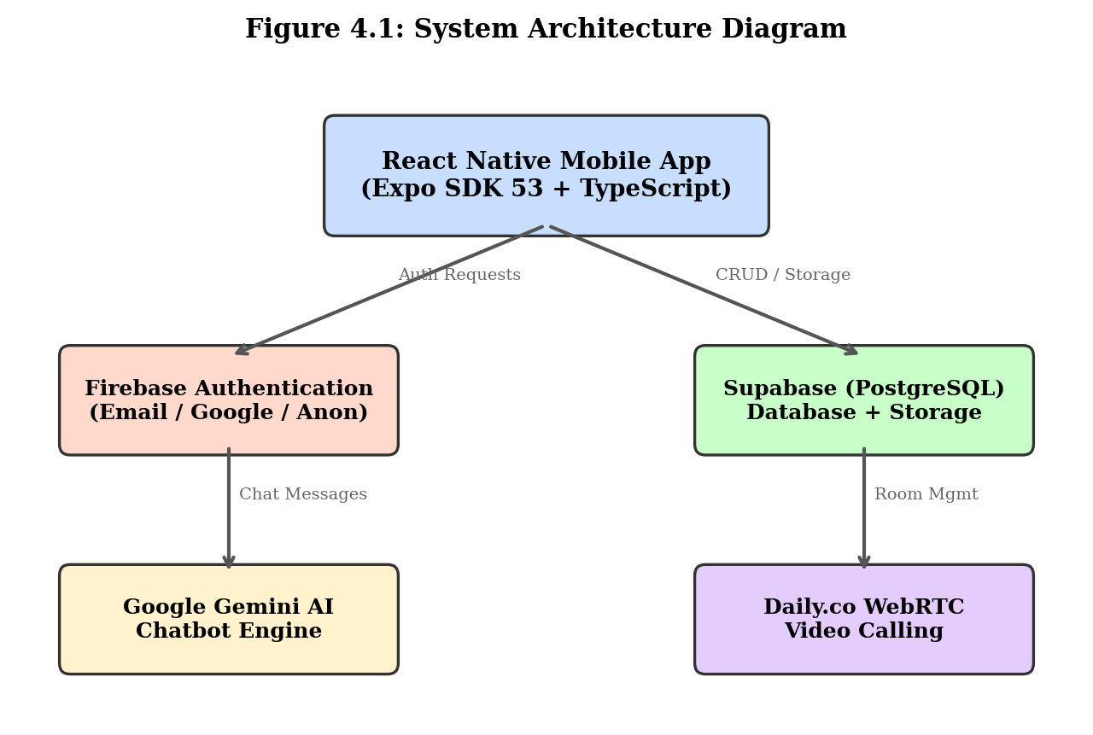
Figure 4.1: System Architecture Diagram

4.2 Use Case Diagram
The Sahay system supports three primary actors, each with distinct capabilities within the system. The Use Case Diagram below illustrates the relationship between actors and system functionality.
Actor: Client (Patient)
- Register with email/password or Google OAuth
- Browse anonymously with system-generated alias
- Verify email address through Firebase link
- Search and filter psychiatrists by name, specialization, and online status
- View detailed psychiatrist profiles (bio, experience, rating, price)
- Book video consultation sessions
- Process payment via UPI or card
- Join real-time video calls with psychiatrist
- Chat with AI-powered mental health chatbot
- Browse mood-based self-care video resources
- Rate psychiatrist after completed session
Actor: Psychiatrist (Doctor)
- Register and complete 3-step onboarding (credentials, profile, license)
- Upload medical license image for verification
- Toggle online/offline availability status
- View and manage pending session requests (accept/reject)
- Conduct video consultations with clients
- Edit professional profile (bio, specialization, experience, pricing)
- View session statistics and patient ratings
Actor: Administrator
- View real-time platform analytics (clients, psychiatrists, sessions)
- Review pending psychiatrist applications with license images
- Approve or reject psychiatrist applications
- Monitor active sessions on the platform
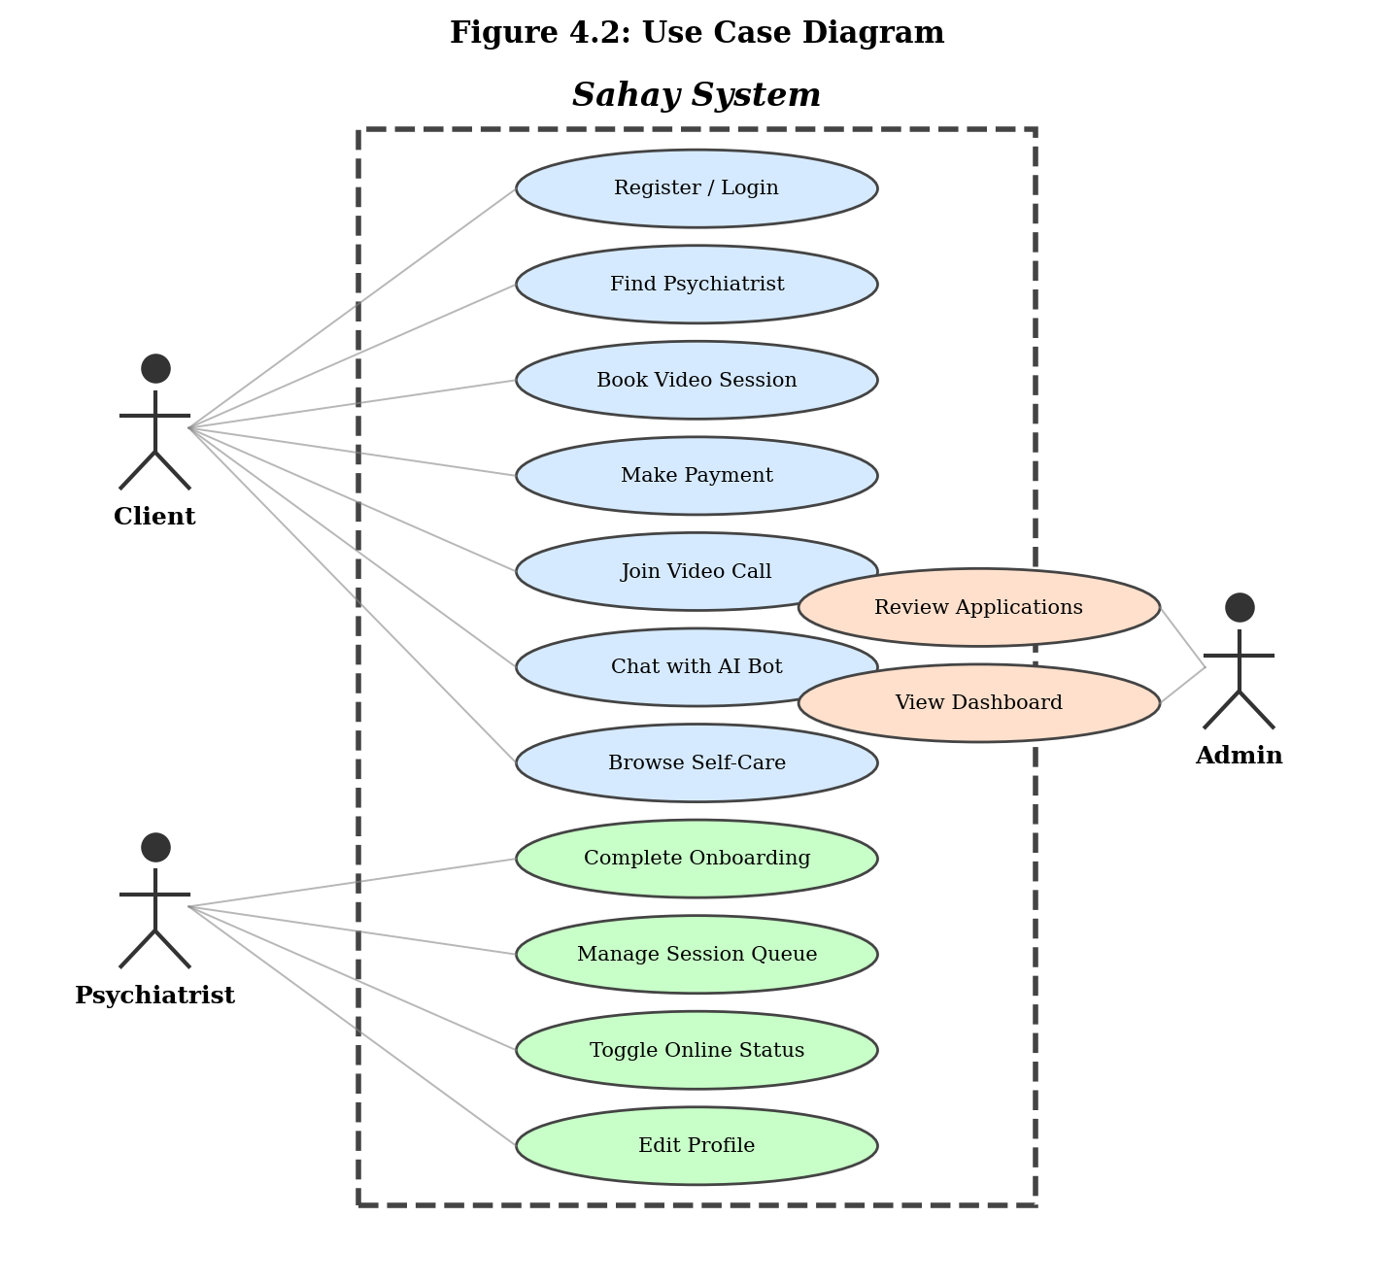
Figure 4.2: Use Case Diagram

4.3 Data Flow Diagram
Level 0 — Context Diagram:
The Level 0 DFD shows the Sahay system as a single process interacting with three external entities: Client, Psychiatrist, and Admin. Data flows include authentication credentials, session requests, payment data, onboarding information, and approval decisions.
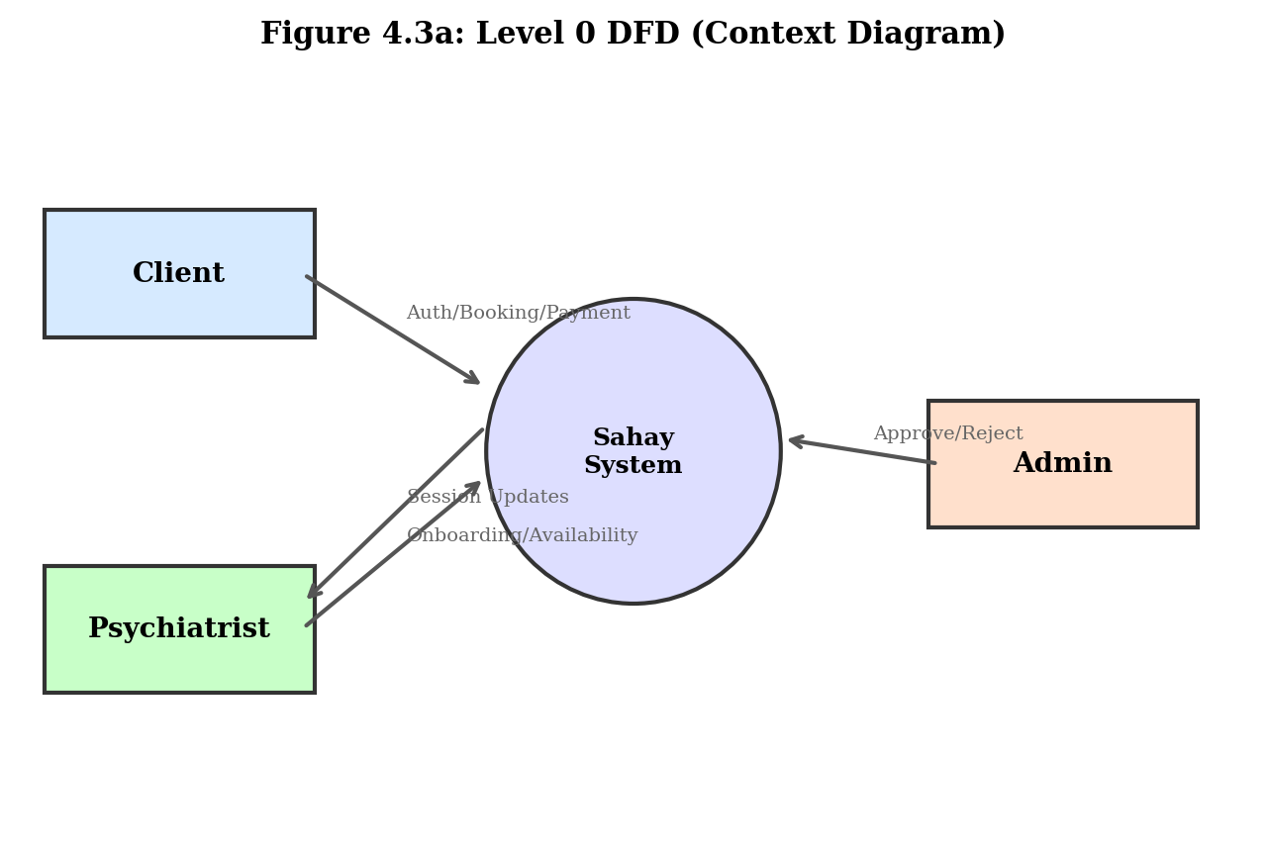
Figure 4.3a: Level 0 DFD (Context Diagram)
Level 1 — Detailed DFD:
The Level 1 DFD decomposes the Sahay system into five major processes with their associated data stores:
- P1: Authentication Process — Handles user registration, login (email/Google/anonymous), email verification, and password reset. Reads and writes to D1: Users data store.
- P2: Session Management Process — Manages session booking, payment processing, status updates (pending/active/completed), and video room creation. Reads from D3: Psychiatrists, writes to D2: Sessions.
- P3: Psychiatrist Verification Process — Processes onboarding form data, stores license images in Supabase Storage, and creates pending application records. Writes to D3: Psychiatrists.
- P4: AI Support Process — Receives chat messages from Client, forwards to Google Gemini API, maintains conversation context, and returns empathetic responses.
- P5: Self-Care Process — Retrieves curated YouTube video URLs from internal dataset, filters by selected mood category, and serves video metadata to the client for in-app playback.
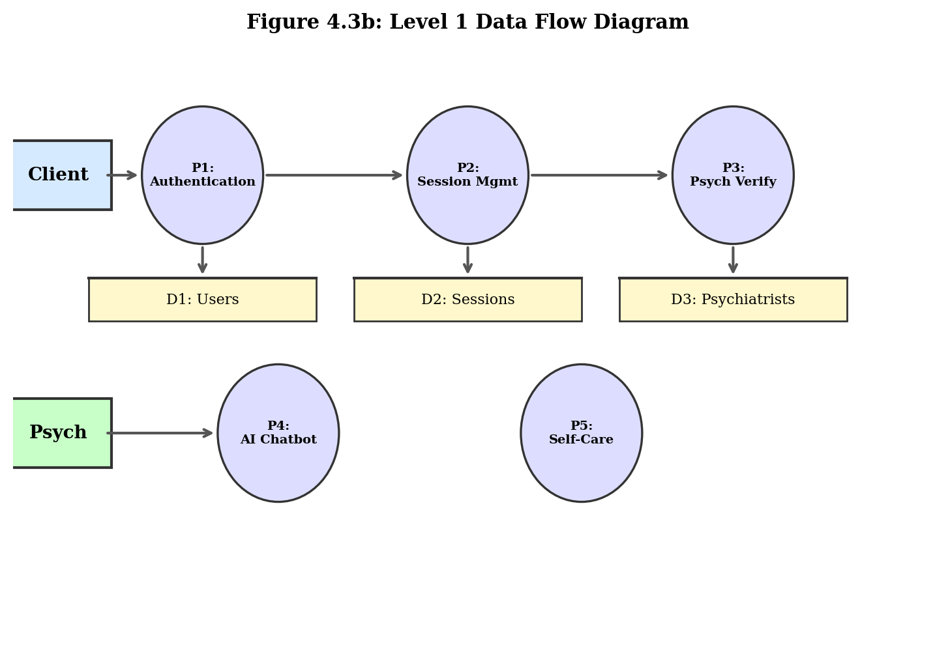
Figure 4.3b: Level 1 Data Flow Diagram

4.4 Activity Diagrams
Activity Diagram: Client Registration Flow
Start → Open App → Select 'Create Account' → Choose Role (Client/Psychiatrist) → Enter Email and Password → Validate Input (email format, password ≥6 chars, confirm match) → [Valid?] → Yes: Create Firebase Account → Send Verification Email → Show Verification Screen → [Auto-poll every 5s] → [Verified?] → Yes: Create Supabase User Record → Navigate to Home → End. No: Show Validation Errors → Return to Form. Skip Option: Mark as verified locally → Proceed to Home.
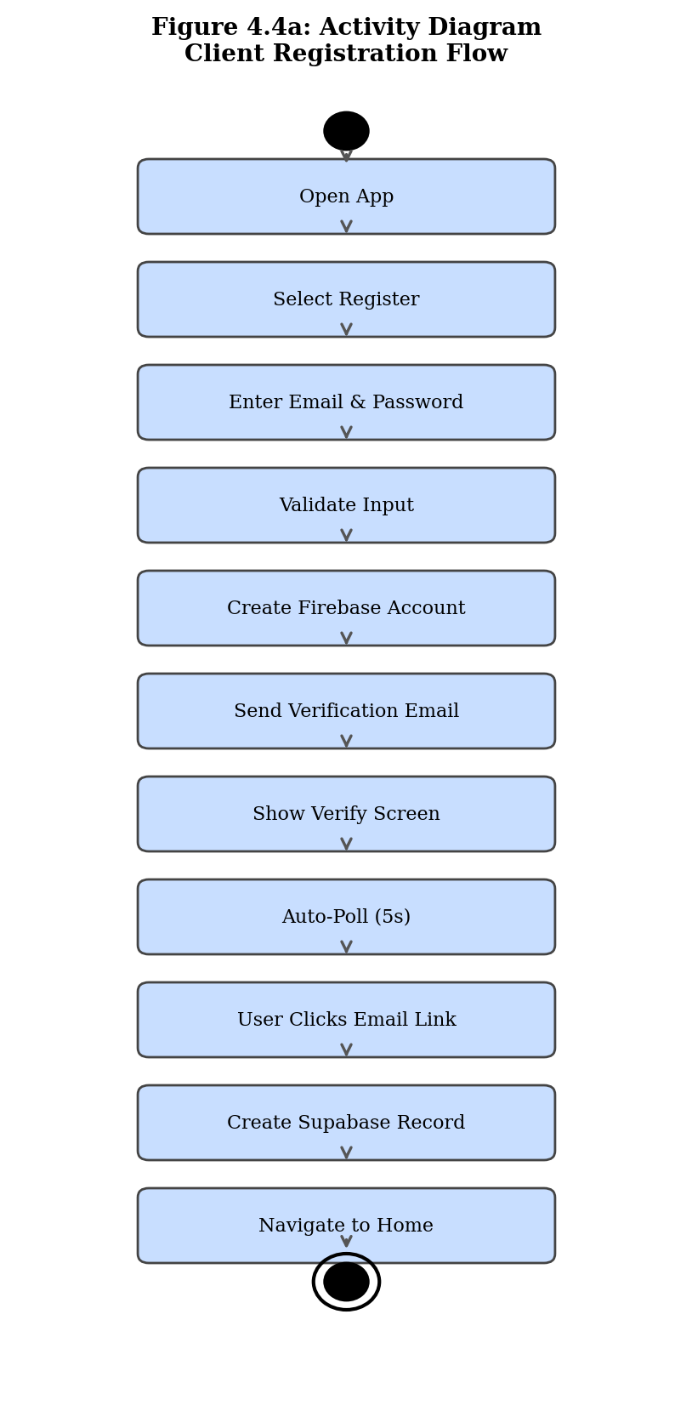
Figure 4.4a: Activity Diagram - Client Registration
Activity Diagram: Session Booking Flow
Start → Browse FindPsychScreen → Search/Filter psychiatrists → Select Online Psychiatrist → View Profile on SessionRequestScreen → Choose 'Video Session' → Navigate to PaymentScreen → Select Payment Method (UPI/Card) → Enter Payment Details → [Validate: UPI has @, Card 16 digits + future expiry + 3-digit CVV] → [Valid?] → Yes: Process Payment (1.5s simulated) → Create Session Record (status: pending) → Send Push Notification to Psychiatrist → Navigate to SessionWaitingScreen → [Poll every 3s] → [Accepted?] → Yes: Join Daily.co Video Room → Conduct Session → End Session → Rate Psychiatrist → End.
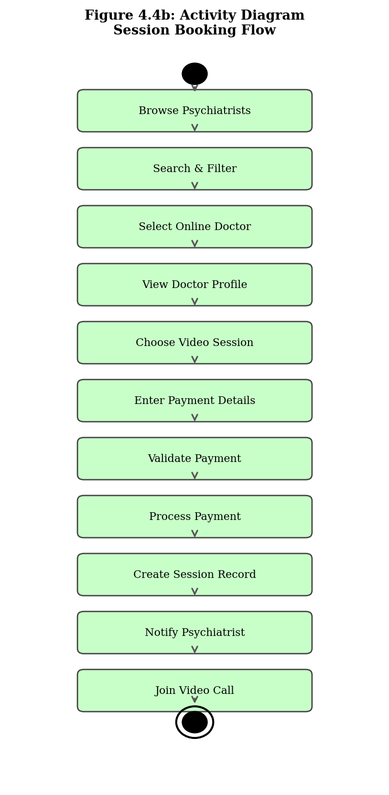
Figure 4.4b: Activity Diagram - Session Booking
Activity Diagram: Psychiatrist Onboarding Flow
Start → Register with email/password → Navigate to OnboardingScreen → Step 1: Enter Full Name + License Number (≥5 chars) → [Valid?] → Yes: Proceed to Step 2 → Enter Specialization + Experience (0-50 years) + Bio (≥20 chars) + Price (₹99-₹499) → [Valid?] → Yes: Proceed to Step 3 → Upload License Image (request gallery permission) → [Image selected?] → Yes: Submit Application → Upload Image to Supabase Storage → Insert Psychiatrist Record (is_approved: false) → Show Success Toast → Navigate to PsychHome (pending approval banner shown) → End.
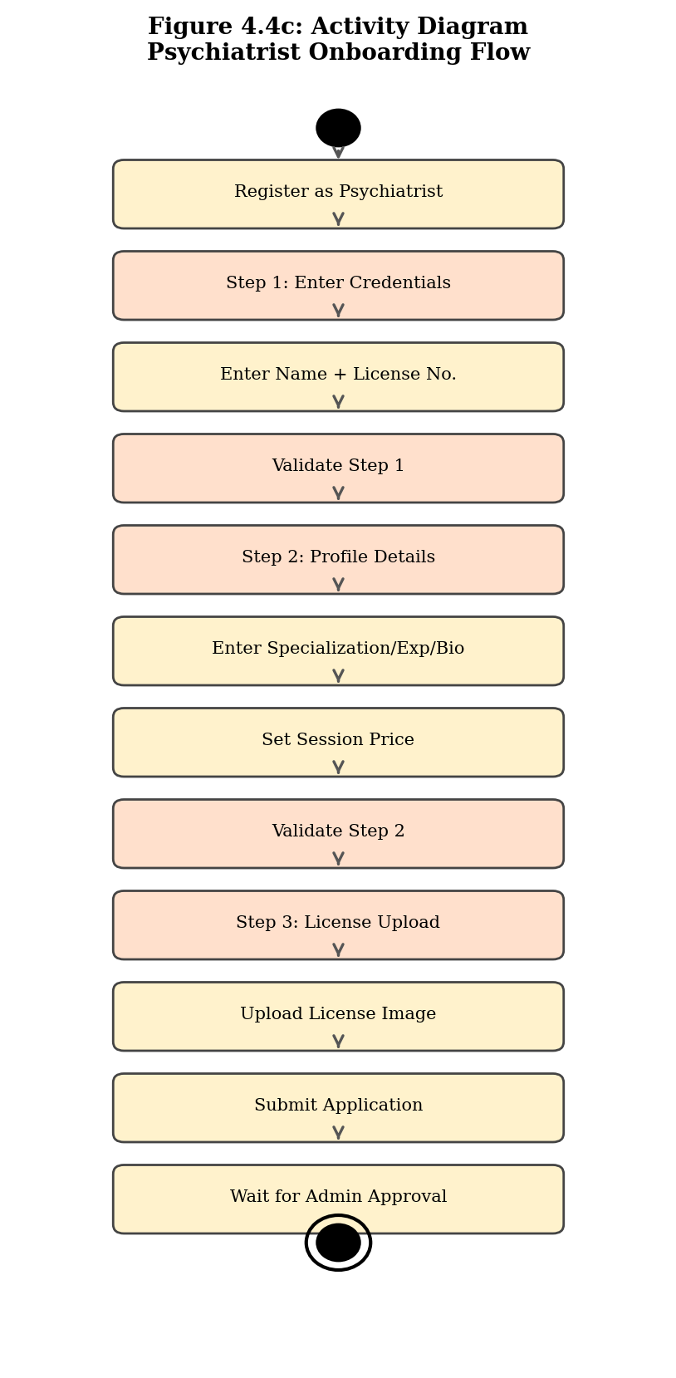
Figure 4.4c: Activity Diagram - Psychiatrist Onboarding

4.5 ER Diagram
The database schema consists of four primary entities stored in Supabase (PostgreSQL). All tables use UUID primary keys and include created_at timestamps.
Entity: Users
- id (PK, UUID)
- firebase_uid (unique, string)
- email (string)
- display_name (string)
- role (enum: client/psychiatrist/admin)
- is_anonymous (boolean)
- alias (string, auto-generated)
- created_at (timestamp)
Entity: Psychiatrists
- id (PK, UUID)
- user_id (FK → Users.id)
- full_name (string)
- license_number (string)
- license_image_url (string, Supabase Storage URL)
- specialization (string)
- experience (integer, years)
- bio (text)
- price (integer, INR)
- is_approved (boolean, default false)
- is_online (boolean, default false)
- rating (float, default 5.0)
- total_sessions (integer, default 0)
- created_at (timestamp)
Entity: Sessions
- id (PK, UUID)
- client_id (FK → Users.id)
- psychiatrist_id (FK → Psychiatrists.id)
- type (string: video/chat)
- status (enum: pending/active/completed/rejected)
- room_url (string, Daily.co room URL)
- created_at (timestamp)
- ended_at (timestamp, nullable)
Entity: Psychiatrist_Ratings
- id (PK, UUID)
- psychiatrist_id (FK → Psychiatrists.id)
- session_id (FK → Sessions.id)
- rating (integer, 1-5)
- ended_at (timestamp)
Relationships:
- Users (1) → (0..1) Psychiatrists: A user with role 'psychiatrist' has one psychiatrist profile.
- Users (1) → (0..N) Sessions: A client can have multiple sessions.
- Psychiatrists (1) → (0..N) Sessions: A psychiatrist can have multiple sessions.
- Sessions (1) → (0..1) Psychiatrist_Ratings: Each session can have one rating.
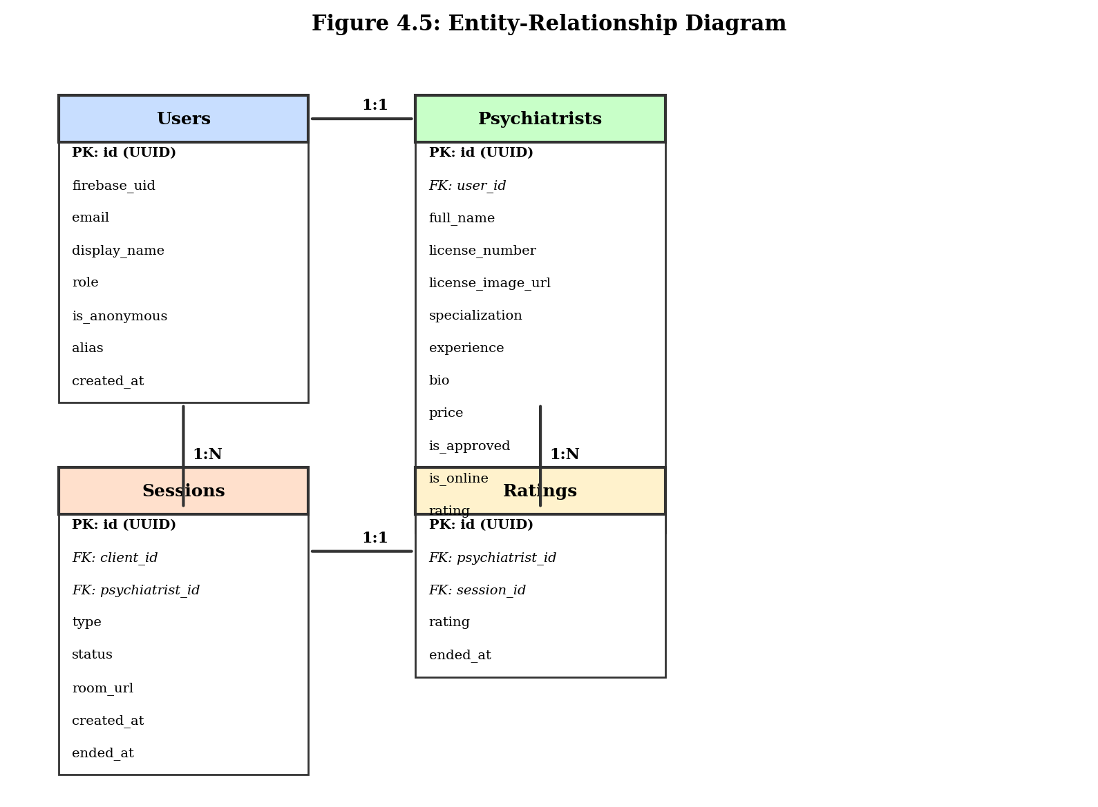
Figure 4.5: Entity-Relationship Diagram

4.6 Project System Screens
The Sahay application consists of 22 distinct screens organized across four navigation stacks. Each screen is designed with consistent styling, proper input validation, loading states, and error handling. Below are placeholders for screenshots of each screen.

4.6.1 WelcomeScreen
The landing screen displaying the Sahay branding, tagline, and three access options: 'Sign In' (email/password), 'Create Account' (registration), and 'Continue as Guest' (anonymous access with auto-generated alias).

4.6.1 WelcomeScreen
[Screenshot: WelcomeScreen]
Figure: WelcomeScreen

4.6.2 LoginScreen
Email/password login with real-time validation (email format via isValidEmail), friendly Firebase error messages, 'Forgot Password' link (sends Firebase reset email), and password visibility toggle.

4.6.2 LoginScreen
[Screenshot: LoginScreen]
Figure: LoginScreen

4.6.3 RegisterScreen
Role-based registration (Client/Psychiatrist toggle) with email format validation, password length check (≥6 characters), confirm password match, and Firebase error code mapping for duplicate emails.

4.6.3 RegisterScreen
[Screenshot: RegisterScreen]
Figure: RegisterScreen

4.6.4 EmailVerificationScreen
Post-registration verification screen with auto-polling (checks Firebase every 5 seconds), 60-second resend cooldown timer, 'Resend Email' button, and 'Skip for now' option.

4.6.4 EmailVerificationScreen
[Screenshot: EmailVerificationScreen]
Figure: EmailVerificationScreen

4.6.5 ClientHomeScreen
Main dashboard with animated greeting, mood selector chips, quick action cards (Find Psychiatrist, AI Chatbot, Self-Care), session statistics, and crisis helpline banner with direct call capability.

4.6.5 ClientHomeScreen
[Screenshot: ClientHomeScreen]
Figure: ClientHomeScreen

4.6.6 FindPsychScreen
Searchable, filterable directory of verified psychiatrists with cards showing name, specialization, experience, rating, price, and online/offline status. Includes pull-to-refresh and skeleton loading.

4.6.6 FindPsychScreen
[Screenshot: FindPsychScreen]
Figure: FindPsychScreen

4.6.7 SessionRequestScreen
Detailed psychiatrist profile view with bio, credentials, rating stars, session count, and 'Book Video Session' action button (disabled for offline doctors).

4.6.7 SessionRequestScreen
[Screenshot: SessionRequestScreen]
Figure: SessionRequestScreen

4.6.8 PaymentScreen
Dual payment method interface (UPI with @ validation, Card with 16-digit number + future expiry date + 3-digit CVV). Real-time validation enables/disables pay button. Success animation with checkmark.

4.6.8 PaymentScreen
[Screenshot: PaymentScreen]
Figure: PaymentScreen

4.6.9 SessionWaitingScreen
Post-payment waiting screen showing psychiatrist details, session status polling every 3 seconds, animated waiting indicator, and auto-navigation to video call on acceptance.

4.6.9 SessionWaitingScreen
[Screenshot: SessionWaitingScreen]
Figure: SessionWaitingScreen

4.6.10 VideoCallScreen (Client)
Full-screen Daily.co WebRTC video call interface with local/remote video feeds, mute/unmute toggle, camera toggle, and end call button.

4.6.10 VideoCallScreen (Client)
[Screenshot: VideoCallScreen (Client)]
Figure: VideoCallScreen (Client)

4.6.11 ChatScreen (AI Chatbot)
Google Gemini-powered conversational AI interface with message bubbles, typing indicator, maintained conversation history, and mental health-focused empathetic responses.

4.6.11 ChatScreen (AI Chatbot)
[Screenshot: ChatScreen (AI Chatbot)]
Figure: ChatScreen (AI Chatbot)

4.6.12 SelfCareScreen
Mood-filtered YouTube video resource screen with five mood chips (😊 Happy, 😢 Sad, 😰 Anxious, 😠 Angry, 😐 Neutral) using flexWrap layout, video cards with thumbnails, and in-app WebView player.

4.6.12 SelfCareScreen
[Screenshot: SelfCareScreen]
Figure: SelfCareScreen

4.6.13 OnboardingScreen
3-step professional setup wizard: Step 1 (credentials: name + license ≥5 chars), Step 2 (profile: specialization selection, experience 0-50, bio ≥20 chars, price ₹99-499), Step 3 (license image upload with camera/gallery picker).

4.6.13 OnboardingScreen
[Screenshot: OnboardingScreen]
Figure: OnboardingScreen

4.6.14 PsychHomeScreen
Doctor dashboard with greeting, online/offline toggle switch, stat cards (rating, sessions done, pending requests), quick action cards (Session Queue, Edit Profile), and recent ratings list with star display.

4.6.14 PsychHomeScreen
[Screenshot: PsychHomeScreen]
Figure: PsychHomeScreen

4.6.15 SessionQueueScreen
List of pending session requests showing client name/alias, session type, request timestamp, with Accept (green) and Reject (red) action buttons per request.

4.6.15 SessionQueueScreen
[Screenshot: SessionQueueScreen]
Figure: SessionQueueScreen

4.6.16 EditProfileScreen
Profile editing form with pre-filled fields for specialization, experience, bio, and session price. Input validation matching onboarding requirements with save confirmation.

4.6.16 EditProfileScreen
[Screenshot: EditProfileScreen]
Figure: EditProfileScreen

4.6.17 ChatScreen (Psychiatrist)
Session-specific chat interface for text communication with clients during or between video sessions.

4.6.17 ChatScreen (Psychiatrist)
[Screenshot: ChatScreen (Psychiatrist)]
Figure: ChatScreen (Psychiatrist)

4.6.18 VideoCallScreen (Psychiatrist)
Doctor-side video consultation interface matching client-side layout with additional session management controls.

4.6.18 VideoCallScreen (Psychiatrist)
[Screenshot: VideoCallScreen (Psychiatrist)]
Figure: VideoCallScreen (Psychiatrist)

4.6.19 AdminDashboard
Real-time analytics dashboard with four stat cards (Pending Applications, Approved Psychiatrists, Registered Clients, Active Sessions), pending applications alert banner, and quick action cards.

4.6.19 AdminDashboard
[Screenshot: AdminDashboard]
Figure: AdminDashboard

4.6.20 PsychApplications
Scrollable list of pending psychiatrist applications showing applicant name, specialization, submission date, with tap-to-review navigation.

4.6.20 PsychApplications
[Screenshot: PsychApplications]
Figure: PsychApplications

4.6.21 ApplicationDetail
Detailed application review screen with psychiatrist credentials, bio, license image viewer, experience and pricing details, and prominent Approve/Reject action buttons.

4.6.21 ApplicationDetail
[Screenshot: ApplicationDetail]
Figure: ApplicationDetail

5. Implementation and Testing

5.1 Algorithms and Major Modules
Algorithm 1: Authentication Flow (AuthContext.tsx)
1. User selects authentication method on WelcomeScreen (Email, Google, or Anonymous).
2. For Email: Call Firebase createUserWithEmailAndPassword(email.trim(), password).
For Google: Trigger Google Sign-In SDK → get idToken → call Firebase signInWithCredential().
For Anonymous: Call Firebase signInAnonymously() → generate alias 'User_' + random(6).
3. Firebase onAuthStateChanged listener triggers automatically.
4. loadOrCreateUser() function executes:
a. Query Supabase 'users' table WHERE firebase_uid = currentUser.uid
b. IF user exists: Set user state from database record
c. IF new user: INSERT into Supabase with {firebase_uid, email, role, is_anonymous, alias}
5. RootNavigator evaluates routing conditions:
a. IF !user → Show AuthNavigator (Welcome/Login/Register)
b. IF user.role === 'client' AND !emailVerified → Show EmailVerificationScreen
c. IF user.role === 'client' → Show ClientNavigator
d. IF user.role === 'psychiatrist' → Show PsychNavigator
e. IF user.role === 'admin' → Show AdminNavigator
Algorithm 2: Email Verification Module (EmailVerificationScreen.tsx)
1. On screen mount, start 5-second interval timer (auto-poll).
2. Each poll iteration:
a. Call Firebase auth.currentUser.reload() to refresh user data
b. Check auth.currentUser.emailVerified boolean
c. IF true: Update AuthContext state → RootNavigator re-routes to ClientNavigator
3. 'Resend Email' button:
a. Check cooldown timer (must be 0)
b. Call Firebase sendEmailVerification(auth.currentUser)
c. Start 60-second countdown timer
d. Show success/error toast
4. 'Skip for now' button:
a. Call checkEmailVerified(true) with skip=true parameter
b. AuthContext sets emailVerified=true in local state (not Firebase)
c. RootNavigator re-evaluates → routes to ClientNavigator
5. On screen unmount, clear interval timer to prevent memory leaks.
Algorithm 3: Session Booking and Payment Flow
1. Client taps 'Book Video Session' on SessionRequestScreen.
2. Navigate to PaymentScreen with psychiatrist data as route params.
3. Client selects payment method:
a. UPI: Validate format (must contain '@' with text before and after)
b. Card: Validate card number (≥16 digits), expiry (valid month 1-12, future date), CVV (3 digits)
4. isPayReady computed property enables/disables Pay button in real-time.
5. On Pay press:
a. Set paying=true, disable button (prevent double-tap)
b. Simulate payment processing (1.5 second delay)
c. Show success animation with checkmark
d. INSERT session record into Supabase:
{client_id, psychiatrist_id, type: 'video', status: 'pending', room_url: null}
e. Send push notification to psychiatrist via Expo Notifications
f. Navigate to SessionWaitingScreen
6. SessionWaitingScreen polls Supabase every 3 seconds for status changes.
7. When psychiatrist accepts → status becomes 'active' → Daily.co room created → navigate to VideoCallScreen.
Algorithm 4: Psychiatrist Onboarding Pipeline
1. Step 1 Validation (validateStep1):
- fullName: required (non-empty)
- licenseNumber: required AND minimum 5 characters
- Uses else-if to prevent overwriting error messages
2. Step 2 Validation (validateStep2):
- specialization: required (selection from 8 predefined options)
- experience: required, must be number, 0 ≤ value ≤ 50
- bio: required, minimum 20 characters
- price: required, must be number, 99 ≤ value ≤ 499
3. Step 3: License Upload:
- Request media library permission via expo-image-picker
- Pick image with editing enabled, quality 0.8
- On submit: Upload to Supabase Storage bucket 'licenses'
- Get public URL for stored image
- INSERT psychiatrist record with is_approved=false
- UPDATE user role to 'psychiatrist'
- Navigate to PsychHomeScreen (shows pending approval banner)

5.2 Testing Approaches
The following testing approaches were employed to ensure application reliability:
- Manual Testing: All 22 screens were manually tested on a physical Samsung Galaxy M36 device (Android 13) and on Android emulators with varying screen sizes (Pixel 4, Pixel 7, Galaxy S21) to verify responsive behavior.
- Integration Testing: End-to-end integration between Firebase Authentication and Supabase database was tested for all three authentication methods. Verified that user creation, login, logout, and session persistence work correctly across app restarts.
- Validation Testing: All form inputs across Registration, Login, Onboarding, and Payment screens were tested with boundary values (empty strings, minimum length, maximum length), invalid formats, special characters, and SQL injection attempts.
- Network Error Testing: Application behavior was tested under airplane mode, poor connectivity (2G simulation), and WiFi disconnection to verify graceful error handling and appropriate user feedback.
- UX Testing: The application was shared with 5 peer testers (BCA classmates) who provided feedback on navigation flow, visual design, color accessibility, and overall intuitiveness of the user journey.

5.3 Test Cases and Test Results
Test ID | Test Case Description | Expected Result | Status
TC-01 | Register with valid email and password (≥6 chars) | Firebase account created, verification email sent, verification screen shown | PASS
TC-02 | Register with already registered email | Error toast: 'This email is already registered' | PASS
TC-03 | Register with password < 6 characters | Validation error: 'Password must be at least 6 characters' | PASS
TC-04 | Register with mismatched confirm password | Validation error: 'Passwords do not match' | PASS
TC-05 | Login with valid credentials | Successful login, navigate to Home screen | PASS
TC-06 | Login with wrong password | Friendly error: 'Incorrect password' | PASS
TC-07 | Login with unregistered email | Friendly error: 'No account found with this email' | PASS
TC-08 | Login with invalid email format | Validation error: 'Please enter a valid email' | PASS
TC-09 | Forgot Password with valid email | Reset email sent, success toast shown | PASS
TC-10 | Google Sign-In with valid account | OAuth flow completes, user created in Supabase | PASS
TC-11 | Anonymous login | Auto-generated alias assigned, navigate to Home | PASS
TC-12 | Email verification auto-poll detects verified | Auto-navigates to Home within 5 seconds of verification | PASS
TC-13 | Email verification skip | User enters app, marked as verified locally | PASS
TC-14 | Email verification resend with cooldown | Email resent, 60s timer starts, button disabled during cooldown | PASS
TC-15 | Search psychiatrist by name | Filtered results shown in real-time | PASS
TC-16 | Book session with offline psychiatrist | Request button disabled with 'Offline' badge | PASS
TC-17 | Payment with valid UPI (name@bank) | Pay button enabled, payment processes successfully | PASS
TC-18 | Payment with invalid UPI (no @) | Pay button remains disabled | PASS
TC-19 | Payment with expired card date | Pay button remains disabled | PASS
TC-20 | Payment with valid card details | Payment succeeds, session created | PASS
TC-21 | Session creation failure after payment | Error toast: 'Session creation failed. Please contact support.' | PASS
TC-22 | Onboarding Step 1 with empty fields | Validation errors for fullName and licenseNumber | PASS
TC-23 | Onboarding Step 1 with license < 5 chars | Error: 'Enter a valid license number' | PASS
TC-24 | Onboarding Step 2 with experience > 50 | Error: 'Experience cannot exceed 50 years' | PASS
TC-25 | Onboarding license upload without image | Error toast: 'Please upload your license image' | PASS
TC-26 | Admin approve psychiatrist | Psychiatrist status updated, online toggle enabled | PASS
TC-27 | Self-care mood filter selection | Videos filtered to match selected mood category | PASS
TC-28 | AI chatbot conversation | Contextual, empathetic response received from Gemini | PASS

6. Results and Discussion
The Sahay application was successfully developed, tested, and deployed as a production-ready Android APK. All core functionalities were implemented and validated through comprehensive manual testing on both physical devices (Samsung Galaxy M36, Android 13) and Android emulators across multiple screen configurations.
Key Results Achieved:
- Multi-Role Authentication: The authentication system successfully handles all three sign-in methods (email/password, Google OAuth, anonymous) with seamless Supabase user record synchronization. Role-based navigation correctly routes users to their respective interfaces (Client, Psychiatrist, Admin) immediately upon authentication.
- Email Verification System: Firebase email verification links are delivered successfully to registered email addresses. The auto-polling mechanism (5-second intervals) detects verification within seconds of the user clicking the link. The 60-second resend cooldown prevents rate limiting, and the skip option provides a fallback for users experiencing email delivery issues.
- Psychiatrist Onboarding Pipeline: The 3-step onboarding wizard validates all inputs at each stage, preventing incomplete submissions. License images are uploaded to Supabase Storage with unique filenames and public URL generation. The admin review workflow correctly transitions psychiatrist status from pending to approved, enabling the online toggle.
- Session Booking and Payment: The simulated payment system validates UPI format and card details (including future expiry date verification) in real-time, providing immediate feed-back on input validity. Session records are correctly created in Supabase with appropriate status tracking through the pending → active → completed lifecycle.
- AI Chatbot: The Google Gemini-powered chatbot provides contextual, empathetic responses to mental health queries. Conversation history is maintained throughout the session, allowing the AI to reference previous messages and maintain coherent, supportive dialogue.
- Self-Care Resources: The mood-based filtering system correctly categorizes and displays YouTube video resources across five emotional categories. The in-app WebView player provides seamless playback without leaving the application.
- Admin Dashboard: Real-time statistics are fetched using Supabase aggregate queries, providing accurate counts of pending applications, approved psychiatrists, registered clients, and active sessions. The application review workflow enables administrators to view license images and make informed approve/reject decisions.
- Production Build: A release APK was successfully generated using Gradle assembleRelease, demonstrating the application's readiness for distribution through the Google Play Store or direct APK installation. The SHA-1 fingerprint was identified for Firebase Console configuration.
Limitations and Observations:
- Google Sign-In Configuration: Google Sign-In requires SHA-1 fingerprint registration in Firebase Console, which differs between debug and release builds. This requires developers to register both fingerprints during development.
- Email Delivery: Firebase verification emails may occasionally land in spam/junk folders, particularly for Gmail accounts with strict filtering. The 'Skip for now' option was implemented as a mitigation strategy, with friendly instructions to check spam folders.
- Payment Simulation: The current payment implementation is simulated (1.5-second delay) and does not integrate with a real payment gateway. Production deployment would require integration with Razorpay, PhonePe, or similar Indian payment processors.
- Offline Support: The application currently requires active internet connectivity for all features. No offline caching or data persistence layer exists for scenarios where connectivity is intermittent.

7. Conclusion and Future Work
7.1 Conclusion
The Sahay mobile application successfully demonstrates that modern technology can meaningfully bridge the gap between mental health professionals and individuals seeking support. Through careful architectural design, robust input validation, and empathetic user experience choices, the application provides a secure, accessible, and privacy-first platform that addresses the four core barriers to psychiatric care in India: stigma (via anonymous access with system-generated aliases), cost (via affordable session pricing between INR 99-499), geographical distance (via smartphone-based video consultations), and availability (via 24/7 AI chatbot support).
The multi-role architecture ensures that each stakeholder — clients seeking help, psychiatrists offering services, and administrators maintaining quality — has a tailored experience with appropriate permissions, workflows, and validation safeguards. The integration of AI support alongside human professionals creates a complementary care model where users can access immediate conversational help via the chatbot and schedule professional video sessions when deeper, clinical support is needed.
The project fulfills all seven stated objectives: multi-method authentication with email verification, video consultation booking with payment processing, AI chatbot integration, mood-based self-care resources, anonymous access capability, admin verification pipeline, and comprehensive input validation across all 22 application screens. The successful generation of a production-ready release APK demonstrates the application's readiness for real-world deployment.
Technically, the project demonstrates proficiency in modern mobile application development using React Native with TypeScript, cloud-native architecture with Firebase and Supabase, third-party API integration (Google Gemini, Daily.co), and the complete software development lifecycle from requirements analysis through testing and deployment.
7.2 Future Work
The following enhancements are identified for future development iterations:
- Real Payment Gateway Integration: Integrate Razorpay or PhonePe SDK for actual UPI and card payment processing with transaction receipts, refund handling, and payment history.
- Group Therapy Sessions: Implement multi-participant video rooms where a psychiatrist can conduct group therapy sessions with multiple clients simultaneously, with moderation controls.
- End-to-End Encryption: Implement client-side encryption for chat messages and session metadata using the Signal Protocol or similar, ensuring even server administrators cannot access conversation content.
- Multi-Language Support: Add Hindi, Marathi, Tamil, and Bengali translations using React Native i18n libraries, making the platform accessible to non-English speaking populations.
- iOS Deployment: Generate iOS builds using Expo EAS Build and publish to the Apple App Store, expanding the platform's reach to iPhone users.
- Mood Tracking Analytics: Implement persistent mood logging with visual analytics (charts, graphs, trend indicators) showing emotional patterns over weeks and months, enabling users and their psychiatrists to track progress.
- Prescription and Medication Management: Allow psychiatrists to issue digital prescriptions through the platform, with medication reminders and refill tracking for clients.
- Referral System: Enable psychiatrists to refer clients to other specialists on the platform based on specific needs, with seamless handoff of relevant session notes (with client consent).
- Progressive Web App (PWA): Deploy a web version of the application for desktop browser access, enabling usage on laptops and desktops without app installation.

References
[1] World Health Organization, "Mental Health Atlas 2020," WHO Publications, Geneva, 2021. Available: https://www.who.int/publications/i/item/9789240036703
[2] National Institute of Mental Health and Neuro Sciences (NIMHANS), "National Mental Health Survey of India, 2015-16," Ministry of Health and Family Welfare, Government of India, 2016.
[3] S. Grover et al., "Mental health of the elderly in India: Prevalence and impact," The Lancet Psychiatry, vol. 7, no. 12, pp. 1020-1021, 2020.
[4] React Native Documentation, Meta Platforms Inc. [Online]. Available: https://reactnative.dev/docs/getting-started
[5] Expo Documentation, Expo Inc. [Online]. Available: https://docs.expo.dev/
[6] Firebase Authentication Documentation, Google LLC. [Online]. Available: https://firebase.google.com/docs/auth
[7] Supabase Documentation, Supabase Inc. [Online]. Available: https://supabase.com/docs
[8] TypeScript Handbook, Microsoft Corporation. [Online]. Available: https://www.typescriptlang.org/docs/handbook/
[9] React Navigation Documentation, Software Mansion. [Online]. Available: https://reactnavigation.org/docs/getting-started/
[10] Daily.co WebRTC Platform Documentation, Daily Inc. [Online]. Available: https://docs.daily.co/
[11] Google Gemini AI Developer Documentation, Google DeepMind. [Online]. Available: https://ai.google.dev/docs
[12] Expo Push Notifications Documentation, Expo Inc. [Online]. Available: https://docs.expo.dev/push-notifications/overview/
[13] Indian Psychiatry Journal, "Prevalence of depression among college students during COVID-19 pandemic," vol. 30, no. 2, pp. 45-52, 2021.
[14] R. Sommerville, Software Engineering, 10th ed., Pearson Education, 2016.
[15] E. Gamma, R. Helm, R. Johnson, and J. Vlissides, Design Patterns: Elements of Reusable Object-Oriented Software, Addison-Wesley, 1994.

