**SOURCE CODE**

<?php

class databse{

protected $servername = "localhost";

protected $username = "root";

protected $password = "";

protected $dbName = "QLDANGKY";

protected $sql1 = "CREATE TABLE SINHVIEN(

MaSV int(11) AUTO_INCREMENT PRIMARY KEY,

Ten varchar(30) NOT NULL,

Lop varchar(30) NOT NULL,

Nganh varchar(30) NOT NULL

)";

protected $sql2 = "CREATE TABLE HOCPHAN(

MaHP int(11) AUTO_INCREMENT PRIMARY KEY,

Sluong int(11) NOT NULL,

MaMH int(11) NOT NULL

)";

protected $sql3 = "CREATE TABLE HOC(

MaSV int(11) NOT NULL,

MaHP int(11) NOT NULL,

DIEMLT int(2) NOT NULL,

DIEMTH int(2) NOT NULL,

PRIMARY KEY(MaSV,MaHP)

)";

protected $sql4 = "CREATE TABLE MONHOC(

MaMH int(11) AUTO_INCREMENT PRIMARY KEY,

TenMH varchar(30) NOT NULL,

Khoa varchar(30) NOT NULL,

TinChi int(11) NOT NULL

)";

protected $sqlSVcontainHOC = "ALTER TABLE HOC ADD CONSTRAINT fk_SV_HOC FOREIGN KEY (MaSV) REFERENCES SINHVIEN(MaSV)";

protected $sqlHPcontainHOC = "ALTER TABLE HOC ADD CONSTRAINT fk_HP_HOC FOREIGN KEY (MaHP) REFERENCES HOCPHAN(MaHP)";

protected $sqlMHcontainHOCPHAn = "ALTER TABLE HOCPHAN ADD CONSTRAINT fk_MONHOC_HOCPHAN FOREIGN KEY (MaMH) REFERENCES MONHOC(MaMH)";

protected $sqlInsert1_1 = "INSERT INTO SINHVIEN(Ten,Lop,Nganh) VALUES('Le Quang Long','20NS','KHMT')";

protected $sqlInsert1_2 = "INSERT INTO SINHVIEN(Ten,Lop,Nganh) VALUES('Le Quang Thanh','20NS','KHMT')";

protected $sqlInsert2_1 = "INSERT INTO HOCPHAN(Sluong,MaMH) VALUES(1,1)";

protected $sqlInsert2_2 = "INSERT INTO HOCPHAN(Sluong,MaMH) VALUES(2,2)";

protected $sqlInsert3_1 = "INSERT INTO HOC(MaSV,MaHP,DIEMLT,DIEMTH) VALUES(1,1,10,10)";

protected $sqlInsert3_2 = "INSERT INTO HOC(MaSV,MaHP,DIEMLT,DIEMTH) VALUES(2,2,8,8)";

protected $sqlInsert4_1 = "INSERT INTO MONHOC(TenMH,Khoa,TinChi) VALUES('lap trinh web','KHMT',3)";

protected $sqlInsert4_2 = "INSERT INTO MONHOC(TenMH,Khoa,TinChi) VALUES('lap trinh java','KTPH',2)";

function __construct(){

// tao database

$this->createDB($this->servername,$this->username,$this->password);

// tao bang SINHVIEN

$this->createTable($this->servername,$this->username,$this->password,$this->dbName,$this->sql1);

// tao bang HOC PHAN

$this->createTable($this->servername,$this->username,$this->password,$this->dbName,$this->sql2);

// tao bang HOC

$this->createTable($this->servername,$this->username,$this->password,$this->dbName,$this->sql3);

// tao bang MON HOC

$this->createTable($this->servername,$this->username,$this->password,$this->dbName,$this->sql4);

// tao moi quan he HP --> HOC

$this->creatRelationShip($this->servername,$this->username,$this->password,$this->dbName,$this->sqlHPcontainHOC);

// tao moi quan he SV --> HOC

$this->creatRelationShip($this->servername,$this->username,$this->password,$this->dbName,$this->sqlSVcontainHOC);

// tao moi quan he MH --> HP

$this->creatRelationShip($this->servername,$this->username,$this->password,$this->dbName,$this->sqlMHcontainHOCPHAn);

// insert sv

$this->insert($this->servername,$this->username,$this->password,$this->dbName,$this->sqlInsert1_1);

$this->insert($this->servername,$this->username,$this->password,$this->dbName,$this->sqlInsert1_2);

// insert mh

$this->insert($this->servername,$this->username,$this->password,$this->dbName,$this->sqlInsert4_1);

$this->insert($this->servername,$this->username,$this->password,$this->dbName,$this->sqlInsert4_2);

//insert hp

$this->insert($this->servername,$this->username,$this->password,$this->dbName,$this->sqlInsert2_1);

$this->insert($this->servername,$this->username,$this->password,$this->dbName,$this->sqlInsert2_2);

// insert hoc

$this->insert($this->servername,$this->username,$this->password,$this->dbName,$this->sqlInsert3_1);

$this->insert($this->servername,$this->username,$this->password,$this->dbName,$this->sqlInsert3_2);

}

function createDB($servername,$username,$password){

try{

$conn = new PDO("mysql:host=$servername",$username,$password);

$conn->setAttribute(PDO::ATTR_ERRMODE,PDO::ERRMODE_EXCEPTION);

$sql = "CREATE DATABASE QLDANGKY";

$conn->exec($sql);

echo "DATABASE CREATE SUCCESSFULLY<br>";

}catch(PDOException $e){

echo "FAULT ==> ".$e->getMessage();

}

}

function createTable($servername,$username,$password,$dbName,$sql){

try{

$conn = new PDO("mysql:host=$servername;dbname=$dbName",$username,$password);

$conn->setAttribute(PDO::ATTR_ERRMODE,PDO::ERRMODE_EXCEPTION);

$conn->exec($sql);

echo "TABLE CREATE SUCCESSFULLY<br>";

}catch(PDOException $e){

echo "FAULT ==> ".$e->getMessage();

}

}

function insert($servername,$username,$password,$dbName,$sql){

try{

$conn = new PDO("mysql:host=$servername;dbname=$dbName",$username,$password);

$conn->setAttribute(PDO::ATTR_ERRMODE,PDO::ERRMODE_EXCEPTION);

$query = $conn->prepare($sql);

$query->execute();

echo "INSERT SUCCESSFULLY<br>";

}catch(PDOException $e){

echo "FAULT ==> ".$e->getMessage();

}

}

function creatRelationShip($servername,$username,$password,$dbName,$sql){

try{

$conn = new PDO("mysql:host=$servername;dbname=$dbName",$username,$password);

$conn->setAttribute(PDO::ATTR_ERRMODE,PDO::ERRMODE_EXCEPTION);

$conn->exec($sql);

echo "CREATE RELATIONSHIP SUCCESSFULLY<br>";

}catch(PDOException $e){

echo "FAULT ==> ".$e->getMessage();

}

}

}

?>

**RUN CODE**

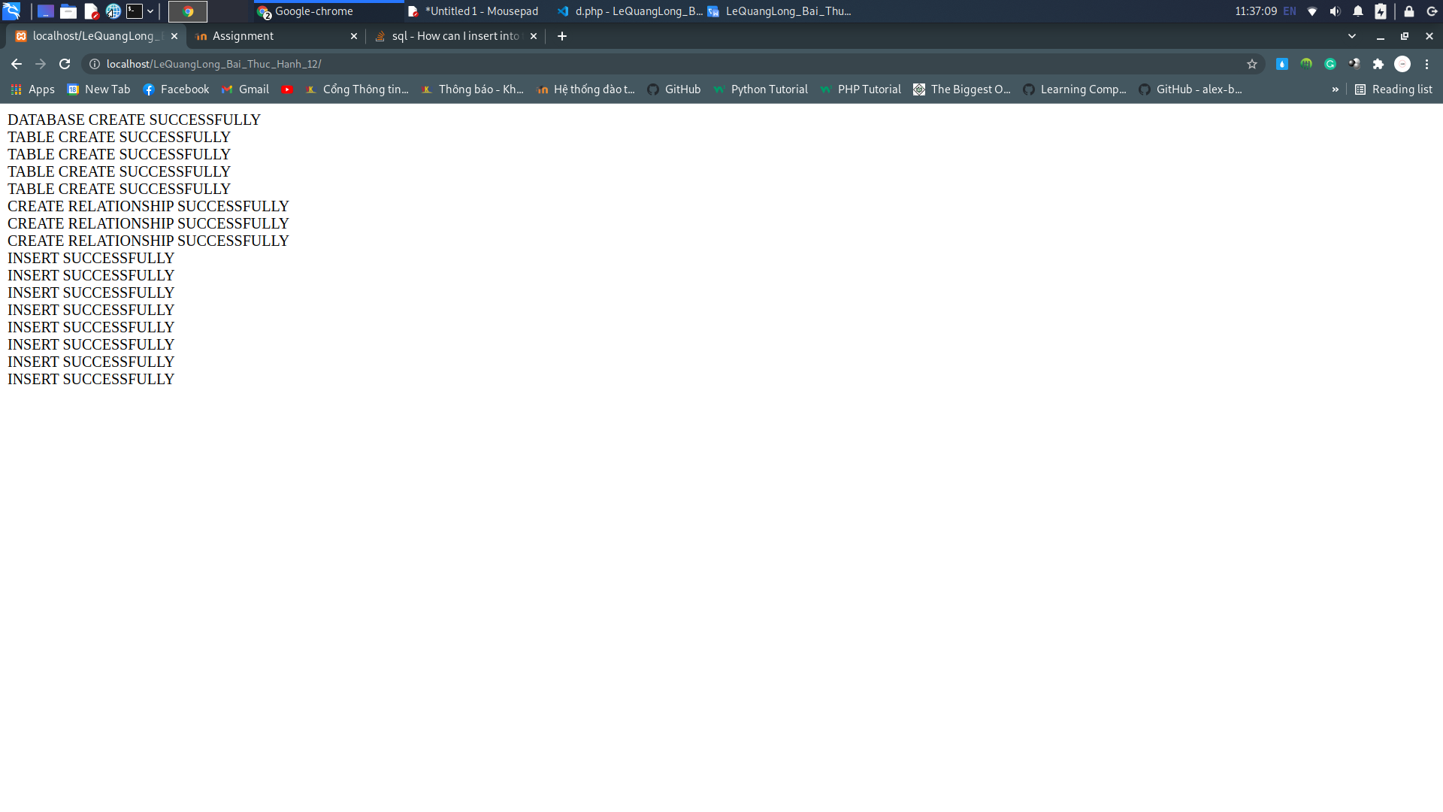

**RESULT** 