SBS 260s/360s Professor Ruben Mendoza

Archaeology of a California Mission

Artifact Tags and Catalog Entry

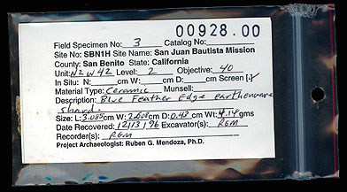
The Field Specimen Card
The 3" x 5" plastic zip-lock bag and Specimen Card shown above provides one example of the way in which specimens are individually documented in the field. The Field Specimen Number, Catalog Number, Unit, Level, Objective, Material Type, Description, Date Recovered, and Excavator are all crucial bits of information for identifying the specimens and their provenience.

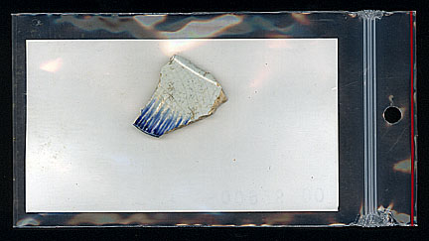

The Artifact or Specimen
When "diagnostic" or important bits of cultural information, such as ceramics and other potentially datable material are encountered, all efforts to properly record the exact (or "In Situ") location of the artifact within the individual unit should be attempted. When not available, basic level information and associations should be carefully recorded. Note: Proper placement of the artifact is as shown with primary design visible to exterior.

Ruben G. Mendoza, Ph.D., CSU Monterey Bay
See http:// http://archaeology.csumb.edu/ArtifactsOnline/dBaseEntry.html

