**Bài 1: Cho Database**

|  |
| --- |
| USE [Trading2021]  GO  /****** Object: Table [dbo].[Department] Script Date: 3/2/2020 4:57:51 PM ******/  SET ANSI_NULLS ON  GO  SET QUOTED_IDENTIFIER ON  GO  CREATE TABLE [dbo].[Department](  [id] [int] NOT NULL,  [name] [varchar](150) NOT NULL,  CONSTRAINT [PK_Department] PRIMARY KEY CLUSTERED  (  [id] ASC  )WITH (PAD_INDEX = OFF, STATISTICS_NORECOMPUTE = OFF, IGNORE_DUP_KEY = OFF, ALLOW_ROW_LOCKS = ON, ALLOW_PAGE_LOCKS = ON) ON [PRIMARY]  ) ON [PRIMARY]  GO  /****** Object: Table [dbo].[Employee] Script Date: 3/2/2020 4:57:51 PM ******/  SET ANSI_NULLS ON  GO  SET QUOTED_IDENTIFIER ON  GO  CREATE TABLE [dbo].[Employee](  [id] [int] NOT NULL,  [name] [varchar](150) NOT NULL,  [dob] [date] NOT NULL,  [gender] [bit] NOT NULL,  [did] [int] NOT NULL,  CONSTRAINT [PK_Employee] PRIMARY KEY CLUSTERED  (  [id] ASC  )WITH (PAD_INDEX = OFF, STATISTICS_NORECOMPUTE = OFF, IGNORE_DUP_KEY = OFF, ALLOW_ROW_LOCKS = ON, ALLOW_PAGE_LOCKS = ON) ON [PRIMARY]  ) ON [PRIMARY]  GO  INSERT [dbo].[Department] ([id], [name]) VALUES (1, N'IS')  INSERT [dbo].[Department] ([id], [name]) VALUES (2, N'IA')  INSERT [dbo].[Employee] ([id], [name], [dob], [gender], [did]) VALUES (1, N'mr A', CAST(N'2000-01-01' AS Date), 1, 2)  INSERT [dbo].[Employee] ([id], [name], [dob], [gender], [did]) VALUES (2, N'mr AA', CAST(N'2000-01-01' AS Date), 1, 1)  INSERT [dbo].[Employee] ([id], [name], [dob], [gender], [did]) VALUES (3, N'mr B', CAST(N'2000-01-01' AS Date), 1, 1)  INSERT [dbo].[Employee] ([id], [name], [dob], [gender], [did]) VALUES (4, N'mr BBB', CAST(N'2000-01-01' AS Date), 1, 2)  ALTER TABLE [dbo].[Employee] WITH CHECK ADD CONSTRAINT [FK_ Employee_Department] FOREIGN KEY([did])  REFERENCES [dbo].[Department] ([id])  GO |

Department

Id

name

Employee

Id

Name

Dob

Gender

did

/search

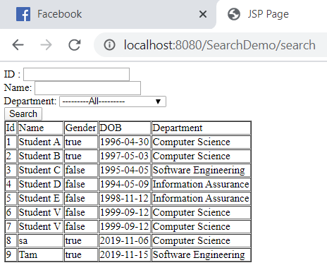

**Bước 1:**

**Department.java (id,name)**

**Employee.java(id,name,dob,gender,depts)**

**Bước 2:**

* **DepartmentDAO.java:**

**List<Department> getAllDepts();**

**select * from department**

* **EmployeeDAO.java**
* select e.id,e.name,e.gender,e.dob,e.did,d.name

from Employee e inner join Department d on (d.id=e.did)

where 1=1

**Bước 3:**

**Tạo /search**

**Viết vào doGet:**

**DepartmentDAO deptDB = new DepartmentDAO();**

**List<Department> depts = deptDB.getAllDepts();**

**request.setAttribute("depts", depts);**

**EmployeeDAO edb=new EmployeeDAO();**

**List<Employee> emps=edb.searchEmps(null,null, 0);**

**request.setAttribute("emps", emps);**

**request.getRequestDispatcher("list.jsp").forward(request, response);**

**Bước 4: list.jsp:**

**Bước 5: viết vào doPost (/search):**

**Bài 2: Cho Database**

