**Bài 1:**

You are asked to build a webpage to add new subject and show list of added items. The user can access your page via url /subjects. Your tasks include:

* (1 point) when user accsess /subjects for the first time. The system displays the form as below figure:

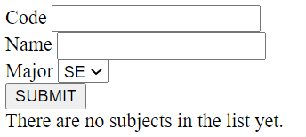

Figure 1: The first time, system displays the form

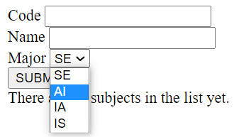

Figure 2: 4 options of dropdownlist

* (2 points) when the user clicks [SUBMIT] button. The system adds new subject into the list that is stored in SESSION SCOPE. At the same time, the list of subjects that you have adds is updated. Figure 3 below is the result of the page after you have added 2 subjects.

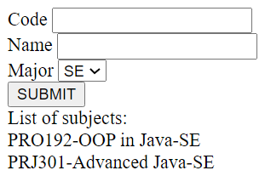

Figure 3: The page after adding 2 subjects

**Bài 2:**

