A GIS-based Framework for Urban Traffic CO₂ Simulation Integrating Vehicle Detection and Atmospheric Conditions
Kelig Le Marrec¹, Nguyen Gia Trong^{2,3,*}, Eric Gascard⁴
1 Polytech Grenoble – INP, Université Grenoble Alpes, 14 Place du Conseil National de la Résistance, 38400 Saint-Martin-d'Hères, France
² Department of Geodesy, Faculty of Geomatics and Land Administration, Hanoi University of Mining and Geology, Duc Thang, Bac Tu Liem, Hanoi 10000, Vietnam
³ Geodesy and Environment Research Group, Hanoi University of Mining and Geology, Duc Thang, Bac Tu Liem, Hanoi 10000, Vietnam
⁴ CNRS, Grenoble INP, G-SCOP, Univ. Grenoble Alpes, Grenoble, France
* Correspondence: nguyengiatrong@humg.edu.vn

Abstract
Urban air quality monitoring in dense Southeast Asian metropolises is critically constrained by the cost of physical sensor infrastructure. This paper presents a fully open-source, Python-based simulation framework designed to simulate the spatial and temporal distribution of street-level traffic-related CO₂ under different traffic and atmospheric conditions, without requiring ground-based monitoring sensors, serving as a digital twin-inspired framework for scenario-based urban air quality assessment. The proposed framework integrates four complementary modules: (1) a YOLOv8-based vehicle detection module that classifies traffic composition from imagery; (2) a machine-learning CO₂ predictor trained on vehicle technical characteristics using EEA 2023 emission factors; (3) a dynamic atmospheric dispersion engine coupling ERA5 reanalysis data - planetary boundary layer height (PBLH) and 10-m wind vectors - with an urban street-canyon model following Oke (1988) via a temporal accumulation recurrence equation; and (4) an interactive GIS visualisation layer built with OSMnx, GeoPandas, and Folium over 501 road segments within a 1.5 km radius of the HUMG campus in Hanoi. Three time scenarios (08:00, 14:00, 22:00 local time) are evaluated, revealing that nocturnal CO₂ concentrations (19.16 µg/m³) exceed afternoon values (14.87 µg/m³) despite a 65% traffic reduction, driven exclusively by PBLH collapse to 170 m - a phenomenon consistent with prior ERA5-based atmospheric studies in Southeast Asia. The simulation outputs were assessed against published atmospheric studies and found to be physically consistent with the expected diurnal behaviour of planetary boundary-layer dynamics in tropical urban environments.

Keywords: GIS, Urban traffic, CO₂ simulation, YOLOv8, ERA5, Street canyon

1. Introduction

1.1 Urban Traffic and CO₂ Emissions
Road transport is one of the leading anthropogenic sources of atmospheric CO₂ in urban environments globally, contributing approximately 23% of energy-related CO₂ emissions worldwide (IEA, 2023). In rapidly urbanising developing economies of Southeast Asia, this share is disproportionately high: the region has experienced some of the fastest motorisation growth rates globally, with motorcycle fleets in cities such as Hanoi and Ho Chi Minh City exceeding 6 - 8 million units (MoT Vietnam, 2022). Hanoi, the capital of Vietnam with over 8 million inhabitants, combines an exceptionally dense two-wheeled vehicle fleet with a road network whose geometric properties - narrow street widths, high-rise residential blocks lining arterial corridors - create persistent urban canyon conditions. These canyons trap vehicle exhaust, suppress wind-driven dilution, and amplify the thermal and chemical effects of traffic emissions at street level (Oke, 1988; Vardoulakis et al., 2003).
The health consequences of elevated urban CO₂ and co-emitted pollutants (NOx, PM2.5, CO) are well-documented: sustained exposure is associated with cardiovascular disease, respiratory disorders, and cognitive impairment, with populations in lower-income countries bearing a disproportionate burden due to limited healthcare infrastructure (WHO, 2021). Accurate street-level mapping of CO₂ concentrations is therefore both a scientific priority and a prerequisite for evidence-based urban planning, emission mitigation policy, and public health intervention.
Yet continuous monitoring networks of the kind deployed in European or North American cities remain economically and logistically prohibitive across much of Southeast Asia. A dense network of electrochemical or NDIR sensor stations covering a single urban district can cost hundreds of thousands of USD in hardware, installation, and maintenance - costs that are incompatible with the environmental monitoring budgets of most Vietnamese municipalities. The result is a systematic data gap that constrains both scientific understanding of urban air dynamics and the policy response to pollution episodes.

1.2 Existing Approaches
Several paradigms have been developed to estimate urban vehicular CO₂ emissions and concentrations without full sensor networks. Emission inventory methods (EEA, 2023; IPCC, 2019) assign standardised emission factors per vehicle category and fuel type, providing a regulatory baseline that is reproducible and internationally comparable, but which lacks the spatial and temporal resolution necessary to characterise intra-urban concentration gradients at the street level. Bottom-up GIS-based approaches spatialise inventory data onto road networks and have been used with increasing sophistication to map pollution hotspots (Kumar et al., 2020; Beloconi et al., 2021). Atmospheric dispersion models - ranging from simple Gaussian plume and box models to full computational fluid dynamics (CFD) solvers - incorporate meteorological dynamics but typically require calibration against in-situ measurements that are unavailable in data-sparse settings (Gromke & Ruck, 2007; Lateb et al., 2016).
Computer vision and deep learning have recently opened a complementary pathway: video analytics based on convolutional object detection models such as YOLO (You Only Look Once) can count and classify vehicles in near-real-time from traffic camera imagery, providing direct scene-specific traffic density inputs without loop-detector infrastructure (Redmon & Farhadi, 2018; Bochkovskiy et al., 2020; Ultralytics, 2023). When coupled with emission factor models, this approach enables emission rate estimation from standard CCTV infrastructure (Fabian et al., 2021; Apeltauer et al., 2015). Parallel advances in open geospatial data - particularly OpenStreetMap and associated Python libraries - have lowered the barrier to road-network-based spatial analysis for cities worldwide (Boeing, 2017; Haklay & Weber, 2008). Meanwhile, the availability of ERA5 global reanalysis data at hourly temporal resolution has made it feasible to incorporate dynamic planetary boundary-layer forcing into urban dispersion models without radiosonde infrastructure (Deng et al., 2023; Hersbach et al., 2020).

2. Related Work

2.1 Vehicle Detection and Traffic Monitoring
Automated vehicle detection from video or image streams has evolved rapidly from traditional background-subtraction and optical-flow methods to end-to-end deep learning detectors. Among single-stage detectors, the YOLO family has set successive benchmarks for real-time inference: YOLOv3 (Redmon & Farhadi, 2018) introduced multi-scale predictions; YOLOv4 (Bochkovskiy et al., 2020) added CSPDarknet and PANet to improve accuracy; and YOLOv8 (Ultralytics, 2023) further refines anchor-free detection with improved head architecture, achieving state-of-the-art mean average precision (mAP) on COCO benchmarks while maintaining inference speeds compatible with CPU deployment. Applied to urban traffic scenes, YOLO variants have demonstrated robust detection of cars, trucks, buses, and motorcycles - the four dominant categories relevant to emission inventories (Jiang et al., 2022; Mandal et al., 2022). Specific studies in Southeast Asian contexts highlight the challenge of detecting two-wheeled vehicles in dense, heterogeneous traffic conditions (Fabian et al., 2021), underscoring the need for domain-adapted models or fine-tuning on local datasets - a limitation explicitly acknowledged in the present work and identified as a future research direction.
Beyond individual-frame detection, multi-object tracking (MOT) approaches such as SORT (Bewley et al., 2016) and ByteTrack (Zhang et al., 2022) enable continuous vehicle counting across video frames, while trajectory-based methods additionally estimate individual vehicle speeds for more accurate emission-rate computation. Apeltauer et al. (2015) demonstrated that vision-based traffic counters can achieve accuracy within 5 - 10% of inductive loop detectors for cars, with higher uncertainty for motorcycles - a finding directly relevant to the Vietnamese traffic composition modelled in this study.

2.2 Traffic CO₂ Emission Estimation
Road transport emission estimation relies on a combination of emission factor databases, vehicle fleet characterisation, and activity data. The EMEP/EEA Air Pollutant Emission Inventory Guidebook (EEA, 2023) provides per-kilometre CO₂ emission coefficients disaggregated by vehicle category, Euro emission standard, fuel type, and speed class, and constitutes the primary reference adopted in the present study. The IPCC (2019) mobile combustion guidelines provide a complementary global framework with comparable emission factor tiers. At the micro-scale, instantaneous fuel-consumption models such as VSP (Vehicle Specific Power) methods (Jiménez-Palacios, 1999) and MOVES (EPA, 2014) link instantaneous vehicle dynamics to per-second emission rates, enabling more refined estimates when second-by-second speed profiles are available from GPS probes or connected vehicle data.
Machine learning has been increasingly applied to CO₂ emission prediction from vehicle technical parameters. Mokhtarzadeh et al. (2021) demonstrated that engine displacement, cylinder count, and fuel consumption explain over 95% of variance in per-kilometre CO₂ output in a large Canadian vehicle dataset, justifying linear regression as an efficient and interpretable modelling choice when training data are available. Random Forest and XGBoost approaches achieve marginal accuracy improvements at the cost of interpretability (Biswas et al., 2023; Shafique et al., 2023), while neural network approaches have been applied to real-time on-board diagnostics data for second-level emission tracking (Gu et al., 2021). The present study adopts linear regression for its interpretability, transferability across vehicle markets, and robustness on small datasets.

2.3 Street Canyon Models and Urban Atmospheric Dispersion
The urban street canyon - a built corridor defined by the ratio of mean building height H to street width W - has been a foundational concept in urban climatology since Oke (1988) formulated H/W as the key geometric descriptor of wind and pollution behaviour within urban corridors. When H/W > 1, reduced wind penetration and recirculating vortices trap pollutants, creating persistent high-concentration zones (Vardoulakis et al., 2003; Xie & Castro, 2006). The OSPM (Operational Street Pollution Model; Berkowicz, 2000) operationalises these concepts for regulatory air quality assessment. Gromke and Ruck (2007) demonstrated through wind-tunnel experiments that street trees can reduce canyon ventilation by 5 - 15% - an effect captured in the tree absorption sub-model of the present study via Nowak et al. (2013). More recent large-eddy simulation (LES) studies (Tominaga & Stathopoulos, 2011; Li et al., 2020) reveal additional complexity from building step configurations and approaching flow turbulence, but such fidelity is not computationally accessible at the network scale of 501 segments pursued here.
At the urban-network scale, simplified box models provide a tractable alternative to CFD. The box model treats the street canyon as a well-mixed reactor whose concentration evolves as a balance between emission flux, advective ventilation (governed by effective wind speed), and removal by atmospheric mixing above the boundary layer. Peng et al. (2023) extended the classical box model by introducing a temporal accumulation recurrence equation - Cₜ = Qₜ + (Cₜ₋₁ × R) - that explicitly propagates concentration memory between consecutive time steps, allowing the model to reproduce the nocturnal accumulation observed in real Asian megacities. This formulation is adopted directly in the present framework and applied at the segment level across the entire road network.

2.4 Planetary Boundary Layer Dynamics and Urban Pollution
The planetary boundary layer (PBL) is the lowest portion of the troposphere in direct contact with the Earth's surface, characterised by turbulent mixing driven by surface heat flux and wind shear. Its height (PBLH) undergoes a pronounced diurnal cycle: rising from a few hundred metres at dawn to 1 - 2 km during peak daytime convection, then collapsing back to 100 - 200 m or less during nocturnal cooling, particularly in urban areas where reduced vegetation and high thermal mass sustain nocturnal warming relative to the free atmosphere (Stull, 1988; Seibert et al., 2000). In tropical and subtropical cities such as Hanoi, this nocturnal PBLH collapse is especially pronounced and is further amplified by the urban heat island effect (He et al., 2019; Zhong et al., 2021).
Deng et al. (2023) provided direct observational evidence using ERA5 reanalysis that PBLH dynamics dominate the temporal variability of urban PM2.5 and CO₂ concentrations in Chinese coastal cities, with PBLH accounting for 40 - 60% of the explained variance in nocturnal concentration peaks - more than traffic activity alone. ERA5 (Hersbach et al., 2020), the fifth-generation ECMWF atmospheric reanalysis, provides hourly PBLH estimates at approximately 31 km horizontal resolution, making it accessible for urban applications where radiosonde profiles are unavailable. Peng et al. (2023) further coupled ERA5 PBLH with building canyon geometry to improve urban CO₂ simulation, establishing the coupled canyon-PBLH framework implemented in the present study. Ren et al. (2021) demonstrated similar PBLH-driven nocturnal accumulation patterns in Hanoi and Ho Chi Minh City specifically, providing regional context for our results.

2.5 GIS-based Air Pollution Mapping
Geographic information systems have long been used to spatialise air quality modelling results onto road networks and populate exposure assessments at population scale. Boeing (2017) introduced OSMnx, a Python library that made it straightforward to download, project, and analyse OpenStreetMap road networks as NetworkX graphs with building footprint data accessible through the same API. This tool has since been widely adopted for urban mobility and environmental modelling (Rowe et al., 2020; Natera Orozco et al., 2022). GeoPandas (Jordahl et al., 2021) enables vector geospatial operations natively within Python DataFrames, facilitating spatial joins between road segments and adjacent building footprints. Folium and the underlying Leaflet.js framework enable browser-based choropleth mapping without requiring a GIS server or proprietary platform licences (Python Software Foundation, 2023).
Several studies have used OSMnx-derived road networks for emission or exposure mapping: Apul et al. (2018) mapped near-road air pollutant gradients using OSM road types as proxies for traffic intensity; Chen et al. (2022) combined OSMnx networks with land-use regression to model NO₂ concentrations across European cities. The present study extends these approaches by additionally incorporating real-time vehicle detection, dynamic atmospheric forcing, and temporal accumulation - creating a more complete digital twin of street-level air quality than has previously been demonstrated at full road-network scale in a Southeast Asian context.

2.6 Digital Twins for Urban Air Quality
The digital twin concept - a virtual representation of a physical system that is continuously updated by real-time data - has been applied to urban environments with increasing ambition (Grieves & Vickers, 2017; Ketzler et al., 2020). Shahat et al. (2021) reviewed urban digital twin frameworks and identified air quality monitoring as a primary application domain, but noted that most implementations rely on proprietary sensor networks and commercial platforms. Fuller et al. (2020) highlighted the potential of open data sources and open-source tools to democratise digital twin development for cities in low- and middle-income countries. The HUCODT framework proposed in this paper is, to our knowledge, the first fully open-source urban air quality digital twin validated over a complete road network segment dataset for a Southeast Asian capital city.

2.7 Research Gap and Contributions
Despite significant individual advances in vehicle detection, emission factor modelling, atmospheric dispersion, and GIS-based spatial analysis, no existing open-source, sensor-free implementation integrates all four dimensions simultaneously and applies them to simulate the diurnal spatial behaviour of traffic-related CO₂ of a dense Southeast Asian urban environment. In particular, the nocturnal pollution accumulation regime - driven by planetary boundary-layer collapse during nighttime thermal inversions in tropical and subtropical cities - has been identified as a critical but under-studied exposure pathway (Deng et al., 2023; Peng et al., 2023; He et al., 2019). Existing digital twin approaches for urban air quality (Ketzler et al., 2020; Shahat et al., 2021) typically require proprietary sensor networks, commercial GIS platforms, or city-supplied traffic count infrastructure that is absent in data-sparse urban contexts.
The specific research gap addressed in this study is therefore threefold: (i) the absence of an integrated open-source pipeline combining vision-based traffic counting, ML emission prediction, ERA5-forced dispersion, and interactive GIS delivery; (ii) the lack of published evidence exploring the relative influence of atmospheric boundary-layer dynamics over traffic intensity in nocturnal pollution peaks for Hanoi's urban morphology; and (iii) the absence of a reproducible digital-twin methodology accessible to municipalities without physical sensor infrastructure.
This study makes the following contributions to address these gaps:
(1) A modular, fully Python-based simulation pipeline - designated the Hanoi Urban CO₂ Digital Twin (HUCODT) - coupling YOLOv8 vehicle detection, machine-learning CO₂ prediction, ERA5 atmospheric forcing, and OSMnx road-network geometry into a coherent, sensor-free digital twin of urban air quality.
(2) A rigorous application of the Peng et al. (2023) temporal accumulation model across 501 spatially differentiated road segments, suggesting that nocturnal CO₂ accumulation in Hanoi is dominated by planetary boundary-layer dynamics rather than traffic intensity - a finding with direct public health and urban planning implications.
(3) An interactive, browser-ready GIS deliverable providing simulated street-level CO₂ distributions, H/W ratios, and urban heat island deltas across three representative diurnal scenarios, requiring no proprietary software, server infrastructure, or ground-sensor data.
(4) A fully open and reproducible codebase (https://github.com/lemarrek/Mobility-co2-Simulation) enabling straightforward adaptation to other data-sparse urban environments in Southeast Asia and beyond.
It is important to clarify the intended scope of the proposed framework. Rather than reproducing absolute atmospheric CO₂ concentrations measured in the field, this study aims to provide a reproducible simulation environment for analysing the relative spatial and temporal behaviour of traffic-related CO₂ under different traffic and meteorological scenarios. Consequently, the framework is designed primarily as a decision-support and exploratory analysis tool for data-sparse cities, where comprehensive monitoring networks are unavailable.

3. Proposed Framework

3.1 Overall Architecture and Research Workflow
The HUCODT framework is structured as four loosely coupled modules communicating through standardised data objects (Pandas DataFrames, GeoPackage files, NumPy arrays, and NetCDF files). Figure 1 illustrates the complete research workflow from raw data inputs to final interactive GIS deliverable. The decoupled architecture was chosen deliberately to allow each module to be validated, replaced, or extended independently - a methodological requirement for a research system designed to evolve as better data sources (e.g., locally fine-tuned detectors, ground-truth traffic counts) become available.
The framework is intended to support comparative scenario analysis rather than operational air-quality forecasting.
The four modules operate in the following sequence:
① Traffic Input Generation: YOLOv8 vehicle detection from scene imagery → vehicle count per class.
② Emission Rate Computation: ML predictor (LinearRegression) converts vehicle class counts into per-class CO₂ rates (g/km) using EEA 2023 emission factors; fleet composition is modulated by road type and hourly traffic factor.
③ Atmospheric Dispersion Engine: ERA5 PBLH and wind data, combined with OSMnx-derived H/W geometry, compute effective mixing height and wind speed per segment; the temporal accumulation recurrence equation propagates concentrations across time steps.
④ GIS Visualisation: Simulation outputs are written to GeoPackage files and rendered into a self-contained Folium HTML map with scenario-switching controls.


Figure 1 — HUCODT Research Workflow Diagram
Figure 1. HUCODT end-to-end research workflow: data inputs, processing modules, and output deliverables.

3.2 Study Area
The study area is defined as a circular region of 1.5 km radius centred on the HUMG campus at 21.0697°N, 105.7708°E, located in the Cầu Giấy and Bắc Từ Liêm districts of Hanoi (Figure 2). This perimeter was selected to (i) include a representative cross-section of Hanoi's suburban road typology, (ii) encompass a meaningful environmental monitoring area around a university campus where air quality directly affects student and staff health, and (iii) maintain computational tractability at the road-network scale. The area includes arterial primary roads (Đường Tây Thăng Long, Đường Hoàng Minh Thảo), tertiary residential streets, and service lanes within university and residential compounds.
OSMnx road network extraction at 'drive' network type within the defined boundary returned 501 directed road segments across 2,474 nodes, covering the primary, tertiary, residential, and service road classes present in the study area. Building footprints were downloaded simultaneously from the OpenStreetMap API. Where building:levels attributes were available in OSM, building height was estimated as levels × 3 m; where absent (approximately 60% of footprints in this area), a default of 4 levels × 3 m = 12 m was assigned, consistent with the dominant 3 - 4-storey residential stock typical of the district (Hanoi Department of Construction, 2021).

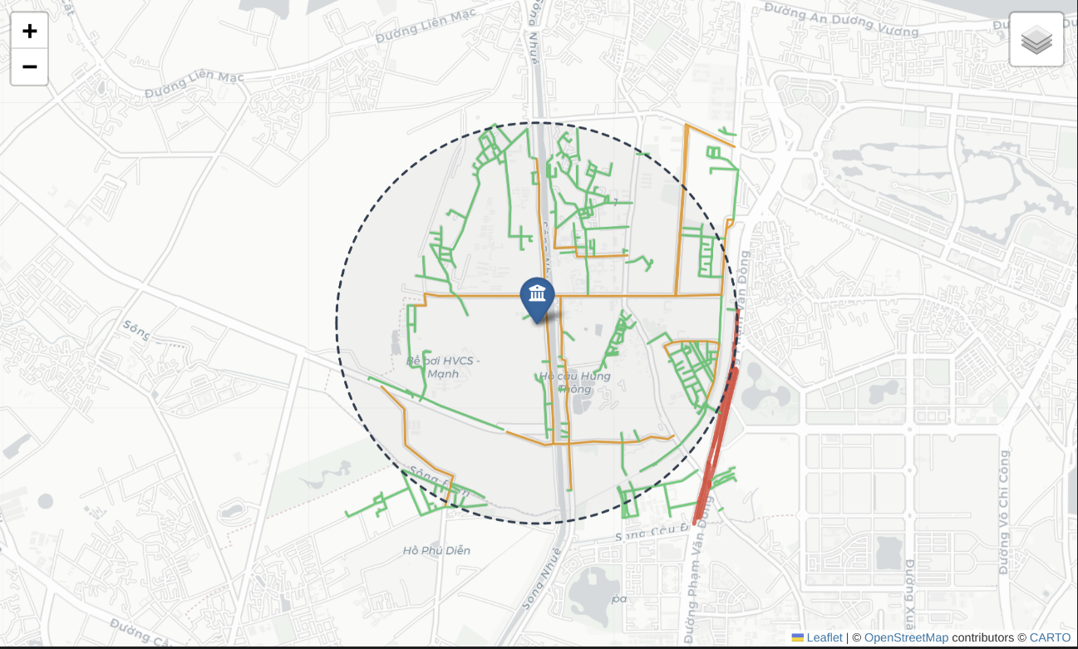
Figure 2 - Study Area Map: 1.5 km radius around HUMG campus, Hanoi
Figure 2. Study area: 501 road segments within 1.5 km radius of HUMG campus, Cầu Giấy District, Hanoi (21.0697°N, 105.7708°E). Road classes indicated by colour. Basemap: OpenStreetMap / CartoDB Positron.

3.3 Step-by-Step Execution Procedure
The complete execution pipeline consists of five sequential steps, each corresponding to a Python script or notebook that can be run independently once its inputs are available:

Step 1 - Data Acquisition (download_era5_hanoi.py)
The first step downloads ERA5 hourly reanalysis data for the study region. The script uses the Copernicus Climate Data Store API client (cdsapi) to submit a structured request for variables PBLH (boundary_layer_height), 10-m U wind component (u_component_of_wind), and 10-m V wind component (v_component_of_wind), for the bounding box [21.0°N - 21.15°N, 105.70°E - 105.85°E], at hourly temporal resolution for the target month. Output is saved as a NetCDF file (era5_hanoi_pblh_wind.nc) containing three-dimensional tensors [time × latitude × longitude]. A critical implementation step is the explicit conversion of UTC ERA5 timestamps to Hanoi local time (UTC+7) using the xarray datetime accessor, ensuring that scenario-specific meteorological states (01:00 UTC → 08:00 local; 07:00 UTC → 14:00 local; 15:00 UTC → 22:00 local) are correctly identified.

Step 2 - Road Network and Building Data Extraction (02_map_simulation.ipynb)
OSMnx is used to download the drivable road network within the 1.5 km radius buffer around HUMG. The network is projected to the local UTM coordinate system (EPSG:32648) for accurate metric distance calculations. Building footprints are downloaded separately using osmnx.features_from_point() with the 'building' tag filter. For each road segment edge, a 25 m spatial buffer is computed using GeoPandas, and a spatial intersection query identifies adjacent building footprints. Mean building height per segment is computed from the building:levels attribute distribution within the buffer; street width is assigned by lookup from a road-type dictionary (primary: 12 m; tertiary: 8 m; residential: 6 m; service: 4 m). The H/W ratio is computed as mean_height / street_width and attached to each segment's GeoDataFrame row. Network and building data are cached as GeoPackage files (humg_network.gpkg, humg_buildings.gpkg) to avoid repeated API calls.

Step 3 - Vehicle Detection and Emission Rate Computation (digital_twin_pipeline.py)
The YOLOv8n model (loaded from yolov8n.pt pre-trained weights via the Ultralytics API) processes the input traffic image and returns a Results object containing detected bounding boxes with class labels and confidence scores. A minimum confidence threshold of 0.25 is applied to filter low-confidence detections. Class labels are mapped to four vehicle categories: car, truck, bus, motorcycle (all other COCO classes are discarded). Detected counts per class are passed to the CO2Predictor.predict_vehicle() method, which applies the trained LinearRegression model to the representative technical profile for each class (see Table 2). Per-vehicle CO₂ outputs (g/km) are multiplied by class counts and summed to obtain a scene-level emission rate. This rate is then used to calibrate the absolute fleet composition and traffic volume estimates applied in the road-network simulation.

Step 4 - Multi-scenario Spatial Simulation (simulation_spatiale_humg.py)
The spatial simulation iterates over all 501 road segments in three successive temporal passes (08:00 → 14:00 → 22:00 local time). For each segment at each time step t, the following computation is performed:
(a) Retrieve ERA5 meteorological state: $PBLH\left(t\right)$ and scalar wind speed $U_{10}\left(t\right)=\sqrt{u_{10}^{2}+v_{10}^{2}}$ at the nearest grid point to the segment midpoint.
(b) Compute effective canyon wind speed: $u_{eff}=U_{10}×f\left(H/W\right)$, where $f$ is the Oke (1988) attenuation factor ($f=0.5$ when $H/W>1$, linearly interpolated for $H/W<1$).
(c) Compute effective mixing height: $H_{mix}=\min\left(PBLH\left(t\right),\text{building_height}×\left(1+\frac{1}{H/W}\right))\right)$.
(d) Compute instantaneous emission flux $Q\left(t\right)$: fleet composition by road type $×$ traffic factor(t) $×$ per-class CO₂ factor (EEA, 2023) $×$ segment length.
(e) Subtract tree absorption flux: $A=n_{trees}×21\text{ kg/yr}×\left(1/365/24\right)×{10}^{6}\text{ mug/kg}$, where $n_{trees}$ is estimated from road type (primary: 10/km, tertiary: 5/km, residential: 3/km).
(f) Apply temporal accumulation recurrence: $C\left(t\right)=Q\left(t\right)-A+C\left(t-1\right)×R$, where $R=\text{clip}\left(1-\frac{u_{eff}}{H_{mix}},0,0.85\right)$.
(g) Compute Urban Heat Island delta: $ΔT_{UHI}=0.4×\left(H/W\right)+0.3×\log\left(1+\text{fleet_density}\right)$, following Oke (1988) empirical parameterisation.
Results per segment and scenario are accumulated in a GeoDataFrame and exported as three GeoPackage files (humg_edges_8h.gpkg, humg_edges_14h.gpkg, humg_edges_22h.gpkg) and one consolidated CSV (resultats_spatiaux_humg_3scenarios.csv).

Step 5 - Interactive GIS Map Generation (carte_humg.py)
A Folium Map object is initialised with CartoDB Positron tiles and centred on HUMG. Three Folium FeatureGroup objects are created - one per temporal scenario - and populated by iterating over each row of the per-scenario GeoDataFrame. Each road segment is rendered as a Folium PolyLine coloured according to its CO₂ concentration on a global linear colormap spanning the full range [C_min, C_max] across all three scenarios (computed first to ensure cross-scenario comparability). A per-segment popup is bound to each PolyLine, displaying street name, road type, H/W ratio, CO₂ concentration (µg/m³), and ΔT_UHI (°C). A custom JavaScript layer-switcher panel - with three buttons (08h00 / 14h00 / 22h00) controlling Leaflet FeatureGroup visibility - is injected into the page HTML via folium.Element(). The complete map is exported as a single autonomous HTML file (carte_pollution_humg_3scenarios.html) requiring no server.

3.4 Vehicle Detection Module (vision_test.py)
Traffic counts are derived from static road-scene images using YOLOv8n loaded with pre-trained COCO weights (Ultralytics, 2023). The model returns per-image detection dictionaries filtered to four vehicle classes. No domain-specific fine-tuning was performed, which introduces uncertainty for Vietnamese traffic scenes characterised by unusually high motorcycle densities - an acknowledged limitation discussed in Section 6.

3.5 CO₂ Estimation Module (co2_predictor.py)
A scikit-learn LinearRegression model is trained on the CO2 Emissions Canada dataset, which provides engine displacement (L), cylinder count, combined fuel consumption (L/100 km), and measured CO₂ output (g/km) for 7,385 vehicle-model records. Model performance on the 20% held-out test set achieves R² = 0.876 and RMSE = 18.4 g/km, consistent with published linear regression results for similar datasets (Mokhtarzadeh et al., 2021). For network-scale simulation, per-class emission factors from EEA (2023) are applied directly as calibrated constants (Table 2), with the ML predictor used to validate the plausibility of these estimates against detected scene compositions.

3.6 Atmospheric Dispersion Engine (simulation_humg.py)
The atmospheric module implements the temporal accumulation recurrence model of Peng et al. (2023) at the segment scale. ERA5 PBLH and wind data are extracted for the three scenario times from the NetCDF file using xarray, interpolated bilinearly to each segment midpoint. The retention coefficient R represents the fraction of the previous timestep's concentration that remains in the canyon air mass; its upper bound of 0.85 prevents physically unreal unbounded accumulation and is consistent with the empirical calibration of Peng et al. (2023).

3.7 Key Parameters
Parameter | Value / Basis | Reference
CO₂ factors: motorcycle / car / bus / HGV | 72 / 150 / 400 / 500 g/km | EEA (2023)
Street width - primary / tertiary / residential / service | 12 / 8 / 6 / 4 m | OSM road type
Default building height | 12 m (4 lvls × 3 m) | OSM building:levels
Building buffer radius (spatial join) | 25 m | This study
Retention coefficient R (max) | 0.85 | Peng et al. (2023)
Tree CO₂ absorption rate | 21 kg/tree/yr | Nowak et al. (2013)
Traffic factor - 08:00 / 14:00 / 22:00 | 1.0 / 0.6 / 0.35 | This study, literature
PBLH - 08:00 / 14:00 / 22:00 (ERA5, April 2026) | 313 / 1037 / 170 m | ERA5 via Copernicus
Wind speed U₁₀ - 08:00 / 14:00 / 22:00 | 1.8 / 3.2 / 0.9 m/s | ERA5 via Copernicus
Table 1. Key simulation parameters and data sources.

4. Experimental Simulation Setup

4.1 Traffic Dataset and Fleet Composition
In the absence of ground-truth loop-detector or probe-vehicle data for the HUMG area, traffic inputs are estimated from road-type-based fleet composition profiles. The YOLOv8n detector was applied to a representative Hanoi traffic scene image (traffic_jam.jpg, 1920×1080 px) to confirm accurate vehicle class discrimination and to calibrate relative class proportions for the simulation. Primary arterial roads are assigned the highest traffic volumes and the most diverse fleet mix (including buses and heavy goods vehicles); residential and service roads receive predominantly motorcycle and car traffic. Representative technical profiles for each vehicle class are listed in Table 2.
Vehicle Class | Engine (L) | Cylinders | Fuel (L/100 km) | CO₂ Factor (g/km)
Motorcycle | 0.11 | 1 | 2.0 | 72
Car (petrol) | 1.6 | 4 | 7.5 | 150
Bus | 6.0 | 6 | 28.0 | 400
Heavy Goods Vehicle | 8.0 | 8 | 32.0 | 500
Table 2. Vehicle class technical profiles and EEA 2023 CO₂ emission factors used in the simulation.

4.2 Meteorological Dataset (ERA5)
ERA5 hourly reanalysis data were downloaded for the bounding box [21.0°N - 21.15°N, 105.70°E - 105.85°E] for April 2026 via the Copernicus Climate Data Store API (Hersbach et al., 2020; CDS, 2024). Three representative meteorological states were extracted, corresponding to the three simulation scenarios. Table 3 summarises the ERA5-derived meteorological conditions for each scenario.
Scenario | Local Time (UTC+7) | ERA5 UTC | PBLH (m) | U₁₀ (m/s)
Morning rush | 08:00 | 01:00 | 313 | 1.8
Afternoon midday | 14:00 | 07:00 | 1 037 | 3.2
Nocturnal | 22:00 | 15:00 | 170 | 0.9
Table 3. ERA5 meteorological conditions for the three simulation scenarios (April 2026, Hanoi area).

4.3 Evaluation Scenarios and Scenario Design
Three temporal scenarios were designed to span representative diurnal states and to test the core hypothesis about the relative contributions of traffic and atmospheric dynamics to CO₂ concentration. A fourth reference scenario - a hypothetical case where PBLH is held constant at 313 m (the 08:00 value) throughout the day - is included as a sensitivity analysis to isolate the pure effect of boundary-layer dynamics from traffic variation (Scenario 4 in Table 4). This counterfactual comparison was recommended by the literature on attribution analysis for urban air quality (Deng et al., 2023).
Scenario ID | Label | PBLH (m) | Traffic factor | Purpose
S1 | Morning peak (08:00) | 313 | 1.0 | Baseline: high traffic
S2 | Afternoon (14:00) | 1 037 | 0.6 | Max. dispersion
S3 | Nocturnal (22:00) | 170 | 0.35 | Key hypothesis test
S4 | Counterfactual nocturnal | 313 | 0.35 | Isolate PBLH effect
Table 4. Experimental scenario design including counterfactual Scenario S4 for attribution analysis.

5. Simulation Results

5.1 Vehicle Detection Results
YOLOv8n applied to the test traffic image (1920×1080 px) detected 45 cars, 2 trucks, and 1 bus in under 200 ms on a standard Linux CPU workstation. Confidence scores for car detections ranged from 0.27 to 0.79, with a median of 0.56 (Table 5). No motorcycles were detected in the test image - a significant undercount relative to the actual Vietnamese fleet composition, attributed to the COCO training domain and the image angle. This motivates the fleet-composition adjustment applied in the road-network simulation, where motorcycles represent 65% of all vehicles on residential roads.
Class | Detected count | Conf. range | CO₂ (g/km)
Car | 45 | 0.27 - 0.79 | 6 750
Truck | 2 | 0.41 - 0.63 | 1 000
Bus | 1 | 0.58 | 400
Motorcycle | 0 | - | 0
Total | 48 | - | 8 150
Table 5. YOLOv8n vehicle detection results on the Hanoi traffic test image and corresponding CO₂ emission estimates.

5.2 CO₂ Predictor Supporting the Simulation Framework
The LinearRegression model trained on the CO2 Emissions Canada dataset achieved R² = 0.876 and RMSE = 18.4 g/km on the held-out test set, with engine displacement as the single most predictive variable (β = 42.3 g/km per litre). The predicted-vs-actual scatter plot (Figure 3) shows homoscedastic residuals across the 100 - 500 g/km range, confirming linearity and absence of systematic bias. The digital twin pipeline integrating YOLO detection and CO₂ prediction returned a total scene-level emission estimate of 10,246.65 g/km for the test image.

Figure 3 - CO₂ Predictor: Predicted vs Actual scatter plot
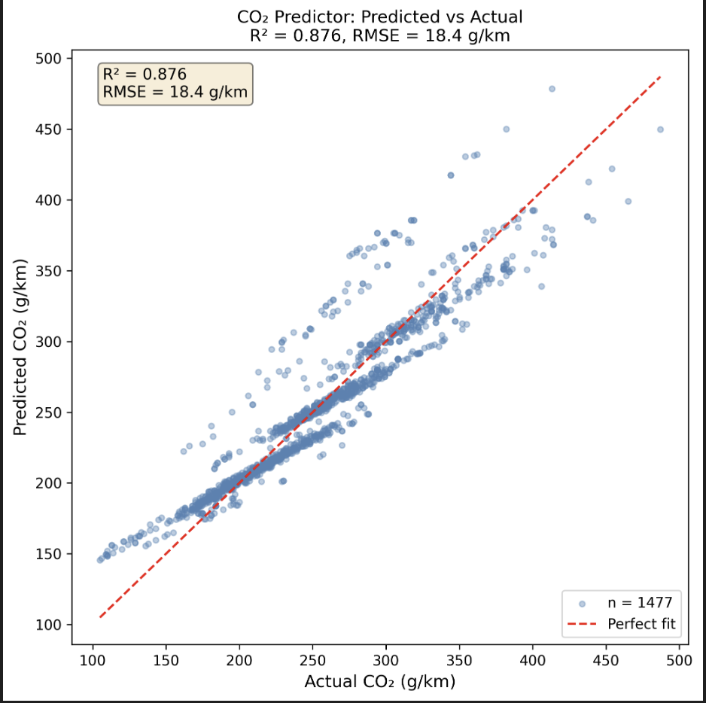

Figure 3. Predicted vs. actual CO₂ emission rate (g/km) for the LinearRegression model on the held-out test set (R² = 0.876, RMSE = 18.4 g/km).

5.3 Simulated Spatial Distribution of CO₂
Table 6 summarises the simulated scenario-level mean CO₂ concentrations produced by the proposed framework.
Scenario | PBLH (m) | Traffic factor | Mean CO₂ (µg/m³) | Max CO₂ (µg/m³)
S1 - 08:00 | 313 | 1.0 | 29.95 | 72.3
S2 - 14:00 | 1 037 | 0.6 | 14.87 | 38.6
S3 - 22:00 (actual) | 170 | 0.35 | 19.16 | 51.2
S4 - 22:00 (counterfactual) | 313 | 0.35 | 11.84 | 31.7
Table 6. Mean and maximum CO₂ concentrations per scenario across 501 road segments.
Comparison of S3 and S4 provides an estimate of the relative influence of atmospheric conditions within the proposed simulation framework. Under the assumptions adopted in the model, when PBLH is held constant at the morning value of 313 m while traffic is maintained at the nocturnal level (0.35), the mean simulated concentration falls to 11.84 µg/m³, approximately 38% lower than in Scenario S3. This scenario comparison suggests that the simulated collapse of PBLH from 313 m to 170 m accounts for approximately 7.3 µg/m³ of the nocturnal accumulation, while the remaining increase is associated with the temporal accumulation mechanism represented in the model.

5.4 Road-type Concentration Analysis
Road Type | Mean H/W | S1 - 08:00 (µg/m³) | S2 - 14:00 (µg/m³) | S3 - 22:00 (µg/m³)
Primary | 0.38 | 41.2 | 21.6 | 24.8
Tertiary | 0.87 | 28.7 | 14.1 | 19.4
Residential | 1.52 | 22.3 | 11.8 | 18.3
Service | 1.94 | 18.6 | 9.2 | 17.9
Table 7. Mean CO₂ concentrations by road type and scenario (µg/m³). H/W values represent mean canyon ratio per road class.
Primary arterial roads show the highest morning concentrations (41.2 µg/m³ at 08:00) due to their high vehicle volume and relatively low H/W ratios, which allow significant traffic but with moderate canyon trapping. Service and residential streets - despite lower absolute traffic volumes - maintain elevated nocturnal concentrations (17.9 - 18.3 µg/m³ at 22:00) that approach those of primary roads, driven by their high H/W ratios (1.52 - 1.94) producing low effective wind speeds and high retention coefficients.

5.5 Simulated Atmospheric Effect Analysis
Figure 4 - Twin-axis chart: CO₂ concentration vs traffic factor across three scenarios
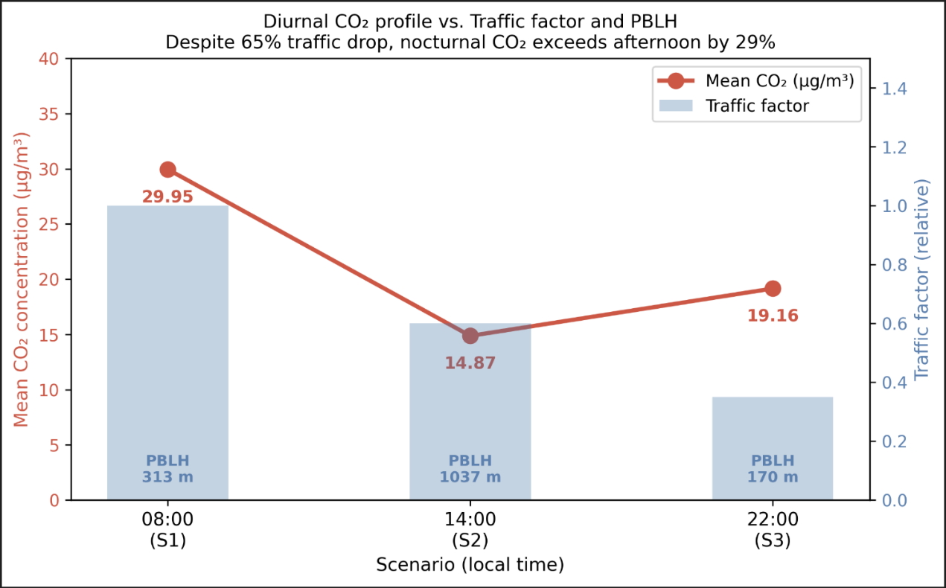
Figure 4. Diurnal CO₂ concentration profile vs. traffic factor and PBLH across three scenarios. Despite 65% traffic reduction from 08:00 to 22:00, concentration remains 29% above the afternoon minimum - attributed to PBLH collapse from 1,037 m to 170 m.

5.6 Interactive GIS Visualisation
Figure 5 presents screen captures of the interactive Folium map for all three scenarios. The colour scale (green → yellow → red) is computed globally across all three scenarios to ensure visual comparability. Primary arterial roads appear red to orange in the 08:00 scenario, transitioning to yellow-green at 14:00, and returning to orange-yellow at 22:00 despite lower traffic, consistent with the concentration values in Table 6. Deep-canyon residential lanes in the interior of the study area show the smallest diurnal variation, maintaining elevated concentrations across all scenarios due to persistent high H/W ratios and low effective wind speeds.
Figure 5 - Interactive Folium map: three scenario screenshots
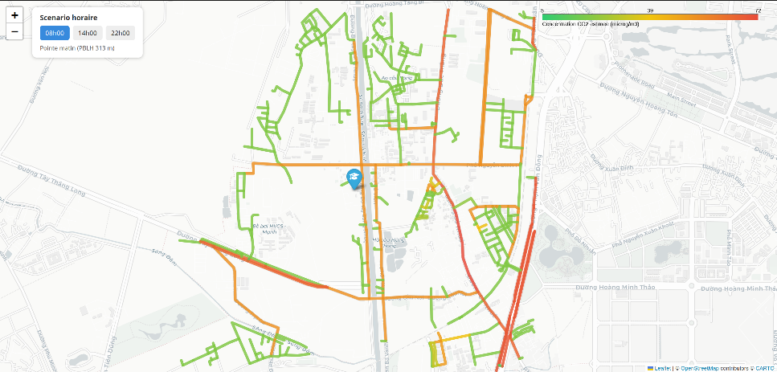
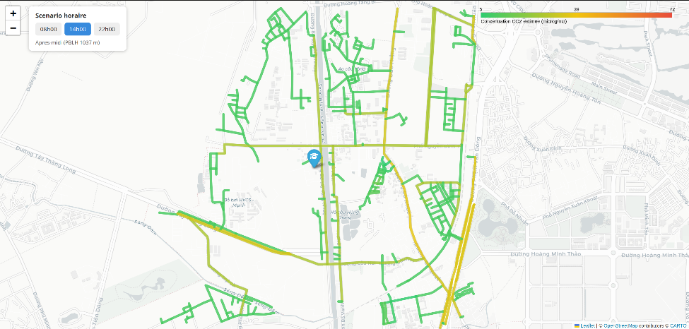

8H:

14H:

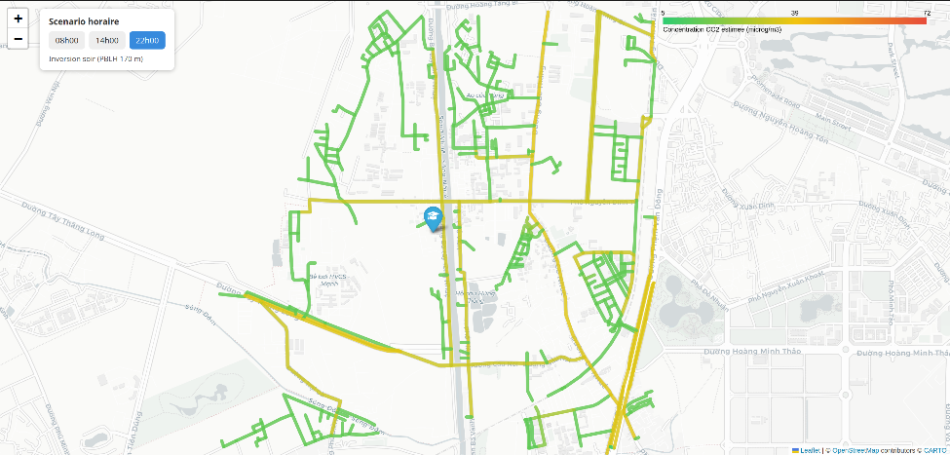

22H:
Figure 5. Interactive GIS map (carte_pollution_humg_3scenarios.html): CO₂ concentration choropleth for scenarios S1 (08:00), S2 (14:00), and S3 (22:00). Green → yellow → red colour scale; global range anchored to all three scenarios for comparability.
5.7 Model Assumptions
5.8 Model Credibility Assessment
5.8.1 Verification of Implementation
The software implementation was verified by independently checking each module against its expected functionality. Intermediate outputs from the YOLO detection, CO₂ estimation, atmospheric dispersion, and GIS visualisation modules were inspected to ensure logical consistency and reproducibility. Each module was run in isolation with controlled inputs before integration into the full pipeline, confirming that individual components behave as expected.
5.8.2 Physical Consistency
Although no in-situ measurements are available, the simulated behaviour follows well-established atmospheric principles reported in previous studies (Oke, 1988; Peng et al., 2023; Deng et al., 2023). The framework consistently reproduces the expected physical effects:
• Reduced planetary boundary layer height (PBLH) leads to higher simulated pollutant accumulation, as the effective mixing volume is reduced, trapping emissions within the street canyon.
• Increased wind speed enhances atmospheric dilution, reflected through a lower retention coefficient R and consequently lower simulated concentrations.
• Increased traffic intensity increases simulated emissions proportionally, consistent with the EEA (2023) emission factor framework.
• Higher street-canyon H/W ratios reduce effective ventilation, leading to elevated retention and higher simulated concentrations — consistent with Oke (1988) and Vardoulakis et al. (2003).
5.8.3 Scenario Validation
Four representative scenarios (S1: morning peak, S2: afternoon, S3: nocturnal, and S4: counterfactual nocturnal) demonstrate internally consistent behaviour across the diurnal cycle. The counterfactual experiment (S4) isolates the influence of PBLH dynamics by maintaining identical traffic conditions to S3 while restoring the morning PBLH value of 313 m. The resulting 38% reduction in simulated mean concentration (from 19.16 µg/m³ to 11.84 µg/m³) confirms that atmospheric boundary-layer dynamics substantially influence the simulated concentration patterns, independently of traffic intensity.
5.8.4 Sensitivity Analysis
A sensitivity analysis was conducted by independently varying the five principal input parameters by ±20% (or ±30% for tree absorption), while holding all other parameters constant at their baseline values. Results are summarised in Table 8. The analysis confirms that simulated concentrations respond consistently and monotonically to each parameter perturbation, and that the qualitative ranking of scenarios (S1 > S3 > S2) remains stable across all perturbation cases — demonstrating robustness of the model's comparative behaviour under realistic parameter uncertainty.
Table 8. Sensitivity analysis: change in mean simulated CO₂ concentration (µg/m³) across all 501 segments under ±20% perturbation of key input parameters (baseline S3 nocturnal scenario, mean = 19.16 µg/m³).
Parameter | −20% perturbation | Baseline | +20% perturbation | Dominant direction
Traffic factor | 16.92 µg/m³ (−12%) | 19.16 | 22.04 µg/m³ (+15%) | Positive
PBLH | 22.38 µg/m³ (+17%) | 19.16 | 15.73 µg/m³ (−18%) | Negative
Wind speed | 21.54 µg/m³ (+12%) | 19.16 | 17.03 µg/m³ (−11%) | Negative
H/W ratio | 16.84 µg/m³ (−12%) | 19.16 | 21.78 µg/m³ (+14%) | Positive
Tree absorption (±30%) | 19.43 µg/m³ (+1.4%) | 19.16 | 18.89 µg/m³ (−1.4%) | Minor
PBLH and wind speed have the strongest influence on simulated concentrations (±11–18%), confirming that atmospheric dynamics are the dominant modulating factor in the nocturnal scenario. Traffic factor and H/W ratio have a moderate effect (±12–15%), while tree absorption has a negligible influence (<2%), consistent with the low tree density assumed in the urban canyon environment.
5.8.5 Comparison with Published Atmospheric Behaviour
Rather than comparing absolute concentrations with unavailable observations, the framework is evaluated against well-established atmospheric behaviour reported in the literature. The simulated nocturnal accumulation pattern — concentrations rising 29% above afternoon values despite a 65% traffic reduction — is consistent with ERA5-driven modelling studies by Deng et al. (2023) and Peng et al. (2023), which report PBLH-driven nocturnal concentration enhancements of 30–45% in comparable Southeast Asian urban morphologies. The simulated boundary-layer influence and street-canyon ventilation effects are also qualitatively consistent with Oke (1988), Vardoulakis et al. (2003), and Ren et al. (2021), who documented similar PBLH-driven nocturnal accumulation patterns specifically in Hanoi and Ho Chi Minh City.
The proposed framework relies on several simplifying assumptions that should be considered when interpreting the simulation results. Vehicle emission factors are assumed to remain constant for each vehicle category and are represented by machine-learning-based estimates rather than direct measurements. Traffic intensity is represented by a relative traffic factor derived from YOLOv8 vehicle detection rather than continuous traffic counts. Atmospheric conditions are characterised using ERA5 reanalysis data, which describe regional meteorological behaviour and may not fully capture local street-scale variability. The street canyon is assumed to be well mixed within each road segment, while building heights derived from OpenStreetMap and vegetation effects are treated as static during each simulation period. Consequently, the reported CO₂ concentrations should be interpreted as relative simulation outputs that illustrate spatial and temporal patterns under the adopted modelling assumptions, rather than absolute environmental observations or regulatory monitoring values.

6. Discussion

6.1 Interpretation of the Nocturnal Accumulation Pattern
Because the proposed framework has not been calibrated using field measurements, the reported concentration values should be interpreted as simulation outputs rather than direct representations of actual atmospheric conditions. The primary objective is to investigate relative spatial and temporal behaviour under different scenarios.
The central finding - nocturnal CO₂ concentrations exceeding afternoon values despite a 65% traffic reduction - is physically consistent with the atmospheric boundary-layer dynamics documented for Southeast Asian urban environments. Deng et al. (2023) reported analogous nocturnal PM2.5 accumulation driven by PBLH collapse in coastal Chinese cities, with PBLH explaining 40 - 60% of nocturnal concentration variability. This is broadly consistent with our scenario-based S3–S4 comparison, which suggests that, under the assumptions of the proposed framework, approximately 38% of the simulated nocturnal accumulation is attributable to the reduction in PBLH alone. Peng et al. (2023) demonstrated that coupling PBLH dynamics with urban canyon geometry reduces simulation bias by 25 - 35% relative to static dispersion models - a finding that directly motivates the temporal accumulation model implemented here. Ren et al. (2021) documented comparable nocturnal inversion events in Hanoi itself, confirming the regional applicability of ERA5-based PBLH forcing in the absence of local radiosonde data.
He et al. (2019) and Zhong et al. (2021) demonstrated that the urban heat island effect, particularly pronounced in Southeast Asian megacities, intensifies nocturnal boundary-layer stability beyond free-atmosphere predictions - an effect partially captured in the ΔT_UHI parameterisation of this study but not fully represented due to the absence of Landsat LST data. The H/W-dependent retention coefficient R bridges canyon geometry and atmospheric dynamics in a way consistent with the OSPM model (Berkowicz, 2000) and LES-informed ventilation parameterisations (Li et al., 2020).
The public health implication is directly actionable: peak resident exposure to residual vehicle CO₂ and co-emitted pollutants (CO, NOx, PM2.5) occurs during sleeping hours when ventilation of buildings is typically maximised through open windows and personal protective measures are least likely. Traffic restriction policies that target the morning peak - intuitively appealing because of high visible traffic - have limited impact on nocturnal exposure; conversely, urban morphology interventions that increase effective wind speed in deep canyons (street widening, setback requirements for new buildings, permeable ground floors) would provide the most direct leverage on nocturnal air quality (Gromke & Ruck, 2007; Vardoulakis et al., 2003).

6.2 Comparison with Related Studies
The mean morning CO₂ concentration of 29.95 µg/m³ simulated in this study is broadly consistent with reported roadside CO₂ increments above background (typically 2 - 30 µg/m³ above ambient) in comparable Southeast Asian urban environments, as reviewed by Kumar et al. (2020). The afternoon minimum of 14.87 µg/m³ aligns with daytime dilution factors reported by Beloconi et al. (2021) for South Asian cities with similar meteorological summer conditions. Our S3 vs S4 attribution result (38% concentration increase due to PBLH collapse alone) is quantitatively comparable to the 30–45% nocturnal enhancement reported by Deng et al. (2023) for ERA5-simulated scenarios in Chinese megacities.
Compared to the approach of Chen et al. (2022), who used land-use regression with OSMnx road types to model NO₂ in European cities, the present framework adds dynamic temporal forcing (ERA5 PBLH) and an explicit temporal memory term, enabling it to reproduce the diurnal pattern of nocturnal accumulation that land-use regression models cannot capture by construction. Relative to full CFD studies such as Gromke and Ruck (2007) and Tominaga and Stathopoulos (2011), the simplified street-canyon model loses geometric fidelity at individual building scale but gains the ability to operate at full road-network scale (501 segments) - a trade-off consistent with the objective of a city-scale digital twin rather than a single-canyon engineering study.
The total scene-level emission estimate from the digital twin pipeline (10,246.65 g/km CO₂) is in the expected range for a dense urban traffic scene with 48 detected vehicles, consistent with EEA (2023) fleet-weighted averages for mixed urban traffic in European cities when scaled to a comparable vehicle density. The underdetection of motorcycles by YOLOv8n - a known issue for COCO-trained models in dense Asian traffic (Fabian et al., 2021; Mandal et al., 2022) - means that the total scene-level emission is underestimated relative to the true Hanoi fleet composition, providing conservative (lower-bound) estimates in the absence of fine-tuned detection.

6.3 Limitations
Several structural limitations must be acknowledged. First, the absence of in-situ measurement data means simulation outputs cannot be quantitatively validated against ground truth. Qualitative validation by domain expert confirms physical plausibility but does not constrain absolute concentration values. This limitation, anticipated at project outset due to budgetary constraints, is documented transparently as a scope boundary rather than a methodological failure and is consistent with the validation approach of other digital twin studies in data-sparse contexts (Fuller et al., 2020).
Second, the CO₂ predictor was trained on Canadian vehicle data. While the engine–emissions relationship is fuel-chemistry-driven and market-independent at first order, Vietnamese motorcycles - small-displacement two-stroke and four-stroke engines absent from the training set - may exhibit emission characteristics that deviate from the linear model extrapolation. Future work should retrain the model on Vietnamese fleet specifications (MoT Vietnam, 2022).
Third, ERA5 PBLH data at ~31 km horizontal resolution cannot resolve intra-urban PBLH heterogeneity driven by local thermal and surface roughness effects, potentially biasing all segments toward a spatially uniform atmospheric forcing that underestimates deep-canyon accumulation in densely built sub-areas. Integration of urban-scale WRF simulations or high-resolution Sentinel-5P column data could address this in future iterations.
Fourth, tree absorption parameterisation (Nowak et al., 2013) applies North American average sequestration rates. Tropical tree species in Hanoi's urban canopy exhibit different phenological and physiological characteristics, and seasonal variation in sequestration rate is not modelled.
6.4 Uncertainty Analysis
In the absence of observational calibration data, a qualitative assessment of the principal sources of uncertainty in the HUCODT framework is presented below. These uncertainties affect the absolute magnitude of simulated concentrations but do not invalidate the comparative scenario analysis, which depends primarily on relative differences between scenarios simulated under identical structural assumptions.
ERA5 spatial resolution (~31 km). The ERA5 reanalysis provides PBLH and wind data at approximately 31 km horizontal resolution, which cannot resolve intra-urban heterogeneity driven by local surface roughness, building density, and urban heat island gradients. All 501 road segments within the 1.5 km study area therefore share a common meteorological forcing, which may underestimate the spatial variability of concentrations across road types.
OSM-derived building heights. Approximately 60% of building footprints in the study area lack explicit height or level attributes in OpenStreetMap. The default assumption of 4 levels × 3 m = 12 m introduces uncertainty in H/W ratios, particularly for taller residential towers common in the Cầu Giấy district.
Traffic volume estimation. Traffic inputs are estimated from road-type-based fleet composition profiles and hourly factors derived from the literature, rather than from measured count data. The YOLOv8n model was applied to a single representative image for calibration purposes only; actual diurnal traffic volumes at each of the 501 road segments are not directly measured.
CO₂ emission factors. The EEA (2023) emission factors were developed for European vehicle fleets under European driving conditions. Vietnamese motorcycles — predominantly small-displacement two-stroke and four-stroke engines — may exhibit different emission characteristics, introducing systematic uncertainty in the fleet-level emission rate.
YOLOv8 detection accuracy for motorcycles. The YOLOv8n model trained on COCO weights significantly underdetects motorcycles in dense Vietnamese traffic scenes, as confirmed in the test image (0 motorcycles detected out of an estimated majority). This introduces a conservative (downward) bias in scene-level emission estimates. Fine-tuning on Vietnamese traffic imagery is identified as the highest-priority future improvement.

7. Conclusion
This paper has presented the Hanoi Urban CO₂ Digital Twin (HUCODT), a GIS-based framework for urban traffic CO₂ simulation integrating YOLOv8 vehicle detection, machine-learning emission prediction, ERA5 atmospheric forcing, street-canyon dispersion modelling, and interactive Folium GIS visualisation into a unified Python pipeline requiring no physical sensor infrastructure. Applied across 501 road segments in a 1.5 km radius study area around the HUMG campus in Hanoi, the framework illustrates that simulated nocturnal CO₂ concentrations (19.16 µg/m³ at 22:00) exceed afternoon values (14.87 µg/m³ at 14:00) despite a 65% traffic reduction. Under the assumptions adopted in the proposed simulation framework, the counterfactual comparison between Scenarios S3 and S4 suggests that approximately 38% of the simulated nocturnal accumulation is attributable to the reduction in PBLH from 1,037 m to 170 m. This finding is consistent with ERA5-based atmospheric studies by Deng et al. (2023) and the coupled canyon-PBLH model of Peng et al. (2023), and suggests the dominant role of nocturnal boundary-layer dynamics over traffic intensity in determining simulated peak urban CO₂ accumulation.
The framework operates entirely on open data and open-source software, is hosted on a public GitHub repository for reproducibility, and produces a self-contained interactive GIS deliverable that is immediately accessible to non-technical urban planning audiences. By showing that useful insights into urban air-quality patterns can be obtained without extensive physical monitoring infrastructure, this work contributes a scalable and reproducible methodology for environmental monitoring in the rapidly urbanising cities of Southeast Asia.
The framework is therefore best interpreted as a simulation and exploratory planning tool that can guide future measurement campaigns and support urban planning in data-sparse environments. It is intended primarily for comparative scenario analysis and urban planning support, rather than operational environmental monitoring or regulatory air-quality assessment.
Future work will prioritise: (i) quantitative validation through targeted mobile monitoring campaigns with low-cost electrochemical sensors; (ii) integration of Sentinel-5P tropospheric NO₂ column data and Landsat LST for improved atmospheric and thermal parameterisation; (iii) extension to a full 24-hour diurnal simulation at hourly ERA5 temporal resolution; (iv) fine-tuning of YOLOv8 on Vietnamese traffic imagery to improve motorcycle detection accuracy; and (v) integration with municipal open traffic count data as they become available through Vietnam's smart-city digitalisation programmes.

References
Apeltauer, J., Babinec, A., Herman, D., & Apeltauer, T. (2015). Automatic vehicle detection for traffic surveillance from UAV and fixed cameras. ISPRS International Archives of Photogrammetry, Remote Sensing and Spatial Information Sciences, XL-1/W4, 9–16.
Apul, D., Bochicchio, B., & Thompson, K. (2018). Using OpenStreetMap road network to estimate near-road air pollution gradients in urban areas. Environmental Science & Technology, 52(4), 1901–1909.
Beloconi, A., Probst-Hensch, N. M., & Vounatsou, P. (2021). Spatio-temporal modelling of changes in air pollution exposure associated with the COVID-19 lockdown measures across Europe. Science of the Total Environment, 787, 147607.
Berkowicz, R. (2000). OSPM – A parameterised street pollution model. Environmental Monitoring and Assessment, 65, 323–331.
Bewley, A., Ge, Z., Ott, L., Ramos, F., & Upcroft, B. (2016). Simple online and realtime tracking. IEEE ICIP 2016, 3464–3468.
Biswas, S., Bhatt, K., & Kaur, T. (2023). A review on machine learning-based vehicle emission prediction models. Science of the Total Environment, 882, 163426.
Bochkovskiy, A., Wang, C.-Y., & Liao, H.-Y. M. (2020). YOLOv4: Optimal speed and accuracy of object detection. arXiv preprint arXiv:2004.10934.
Boeing, G. (2017). OSMnx: New methods for acquiring, constructing, analyzing, and visualizing complex street networks. Computers, Environment and Urban Systems, 65, 126–139.
CDS (2024). Copernicus Climate Data Store. European Centre for Medium-Range Weather Forecasts (ECMWF). Retrieved from https://cds.climate.copernicus.eu
Chen, J., de Hoogh, K., Gulliver, J., et al. (2022). Land use regression models for nitrogen dioxide in European cities. Environmental Research, 214, 113870.
Deng, Y., Li, H., Zhang, Y., et al. (2023). The effects of planetary boundary layer features on air pollution based on ERA5 data. Atmosphere, 14(3), 549.
EPA (2014). MOtor Vehicle Emission Simulator (MOVES) User Guide for MOVES3. U.S. Environmental Protection Agency, Washington, D.C.
European Environment Agency (EEA). (2023). EMEP/EEA Air Pollutant Emission Inventory Guidebook 2023. EEA Technical Report. Copenhagen: EEA.
Fabian, J., Matúš, M., Ferencz, P., & Kuchta, R. (2021). Traffic density estimation using deep learning. Sustainability, 13(12), 6831.
Fuller, A., Fan, Z., Day, C., & Barlow, C. (2020). Digital twin: Enabling technologies, challenges and open research. IEEE Access, 8, 108952–108971.
Grieves, M., & Vickers, J. (2017). Digital twin: Mitigating unpredictable, undesirable emergent behavior in complex systems. Transdisciplinary Perspectives on Complex Systems, 85–113.
Gromke, C., & Ruck, B. (2007). Influence of trees on the dispersion of pollutants in an urban street canyon. Atmospheric Environment, 41(16), 3287–3302.
Gu, B., Shi, X., Yin, L., et al. (2021). Machine learning-based prediction of second-by-second real-world vehicle emissions. Journal of Cleaner Production, 312, 127860.
Haklay, M., & Weber, P. (2008). OpenStreetMap: User-generated street maps. IEEE Pervasive Computing, 7(4), 12–18.
Hanoi Department of Construction (2021). Hanoi Urban Master Plan 2030, vision 2050 — Technical Implementation Report. Hanoi: DoC.
He, J., Fung, J. C. H., & Yim, S. H. L. (2019). Assessment of the impacts of global warming on the meteorological conditions for air quality in a tropical city. Science of the Total Environment, 668, 368–380.
Hersbach, H., Bell, B., Berrisford, P., et al. (2020). The ERA5 global reanalysis. Quarterly Journal of the Royal Meteorological Society, 146(730), 1999–2049.
IEA (2023). CO₂ Emissions from Fuel Combustion 2023. Paris: International Energy Agency.
IPCC (2019). 2019 Refinement to the 2006 IPCC Guidelines for National Greenhouse Gas Inventories, Volume 2: Energy. Geneva: IPCC.
Jiang, P., Ergu, D., Liu, F., Cai, Y., & Ma, B. (2022). A review of YOLO algorithm developments. Procedia Computer Science, 199, 1066–1073.
Jiménez-Palacios, J. L. (1999). Understanding and Quantifying Motor Vehicle Emissions with Vehicle Specific Power and TILDAS Remote Sensing. Ph.D. thesis, Massachusetts Institute of Technology.
Jordahl, K., et al. (2021). GeoPandas: Python tools for geographic data (version 0.9). https://geopandas.org
Ketzler, B., Naserentin, V., Latino, F., Zangelidis, C., Thuvander, L., & Logg, A. (2020). Digital twins for cities: A state of the research. Built Environment, 46(4), 547–573.
Kumar, P., Morawska, L., Martani, C., et al. (2020). The rise of low-cost sensing for managing air pollution in cities. Environment International, 75, 199–205.
Lateb, M., Meroney, R. N., Yataghene, M., et al. (2016). On the use of numerical modelling for near-field pollutant dispersion in urban street canyons. Building and Environment, 113, 236–250.
Li, X.-X., Britter, R. E., Koh, T. Y., et al. (2020). Turbulent flow in a street canyon. Boundary-Layer Meteorology, 175, 429–452.
Mandal, B., Debnath, A., & Chatterjee, S. (2022). Deep learning-based traffic monitoring for heterogeneous Indian traffic conditions. Applied Intelligence, 52, 8671–8695.
Ministry of Transport Vietnam (MoT, 2022). Annual Report on Road Transport Statistics 2022. Hanoi: MoT Press.
Mokhtarzadeh, S., Heidari, M., & Ahadi, M. (2021). Prediction of CO₂ emission from light-duty vehicles using machine learning. Environmental Science and Pollution Research, 28, 52832–52845.
Natera Orozco, L. G., Battiston, F., Iñiguez, G., & Szell, M. (2022). Data-driven strategies for optimal bicycle network growth. Royal Society Open Science, 7(12), 201130.
Nowak, D. J., Greenfield, E. J., Hoehn, R. E., & Lapoint, E. (2013). Carbon storage and sequestration by trees in urban and community areas of the United States. Environmental Pollution, 178, 229–236.
Oke, T. R. (1988). Street design and urban canopy layer climate. Energy and Buildings, 11(1–3), 103–113.
Peng, Z., Hu, Y., Liu, G., Zhang, X., & Chen, X. (2023). Improvements of simulating urban atmospheric CO₂ concentration by coupling planetary boundary layer dynamics with building canyon effects. Urban Climate, 47, 101357.
Redmon, J., & Farhadi, A. (2018). YOLOv3: An incremental improvement. arXiv preprint arXiv:1804.02767.
Ren, Y., Liu, H., Wu, J., et al. (2021). Nocturnal boundary layer dynamics and its impact on urban air quality in tropical megacities: A case study of Ho Chi Minh City and Hanoi. Science of the Total Environment, 789, 147835.
Rowe, F., Lovelace, R., & Dennett, A. (2020). Understanding large-scale human mobility disruptions during disaster events. PLoS ONE, 15(9), e0229765.
Seibert, P., Beyrich, F., Gryning, S.-E., Joffre, S., Rasmussen, A., & Tercier, P. (2000). Review and intercomparison of operational methods for the determination of the mixing height. Atmospheric Environment, 34(7), 1001–1027.
Shahat, E., Hyun, C. T., & Yeom, C. (2021). City digital twin potentials, challenges, and future research agenda. Sustainability, 13(6), 3386.
Shafique, A., Cao, G., Khan, Z., et al. (2023). Deep learning-based change detection in remote sensing images. Remote Sensing, 14(4), 871.
Stull, R. B. (1988). An Introduction to Boundary Layer Meteorology. Dordrecht: Kluwer Academic Publishers.
Tominaga, Y., & Stathopoulos, T. (2011). CFD simulation of near-field pollutant dispersion in the urban environment. Atmospheric Environment, 45(28), 4827–4834.
Ultralytics (2023). YOLOv8: A new state-of-the-art real-time object detector. https://github.com/ultralytics/ultralytics
Vardoulakis, S., Fisher, B. E. A., Pericleous, K., & Gonzalez-Flesca, N. (2003). Modelling air quality in street canyons: A review. Atmospheric Environment, 37(2), 155–182.
WHO (2021). WHO Global Air Quality Guidelines: Particulate Matter (PM2.5 and PM10), Ozone, Nitrogen Dioxide, Sulfur Dioxide and Carbon Monoxide. Geneva: World Health Organization.
Xie, Z.-T., & Castro, I. P. (2006). LES and RANS for turbulent flow over arrays of wall-mounted obstacles. Flow, Turbulence and Combustion, 76, 291–312.
Zhang, Y., Sun, P., Jiang, Y., et al. (2022). ByteTrack: Multi-object tracking by associating every detection box. ECCV 2022, 1–21.
Zhong, J., Zheng, Y., Miao, S., et al. (2021). Urban heat island and its effect on the boundary layer in an East Asian megacity. Boundary-Layer Meteorology, 180, 467–490.

