Macroevolutionary and Ecological Consequences of Arboreality in Salamanders

Erica Baken^{1,2} and Dean C. Adams¹

¹Department of Ecology, Evolution, and Organismal Biology; Iowa State University; Ames, Iowa, U.S.A. 50011
²Corresponding author: ebaken@iastate.edu

Running Title: Salamander macroevolution and arboreality

Author Contributions: EB and DCA conceived of the study, EB collected the data and conducted all analyses, EB and DCA contributed equally to the writing of the manuscript

Acknowledgments: We thank L. Mellenthin with assistance in data collection, and XYZPDQ for comments on versions of the manuscript. This work was sponsored in part by the U.S. National Science Foundation grant DEB-1556379 to DCA.

Data Accessibility: All data in this manuscript are available on DRYAD (xxx)

Abstract: Evolutionary theory predicts that selection in distinct microhabitats generates correlations between morphological and ecological traits, and may increase both phenotypic and taxonomic diversity. However, some microhabitats exert unique selective pressures that act as a restraining force on macroevolutionary patterns of diversification. In this study, we use phylogenetic comparative approaches to investigate the evolutionary outcomes of inhabiting the arboreal microhabitat in salamanders. We find that arboreality has independently evolved at least five times in the clade, and has arisen primarily from terrestrial ancestors. However, the evolutionary rate from arboreality to terrestriality is 24 times higher than the converse. This suggests that macroevolutionary trends in microhabitat use tend towards terrestriality over arboreality, which influences the extent to which use of the arboreal microhabitat proliferates. Morphologically, we find no evidence for an arboreal phenotype, as variation in overall body proportions overlaps broadly with species that utilize different microhabitats. However, reduced rates of phenotypic evolution in arboreal taxa and evidence of morphological convergence among arboreal lineages are observed. Taken together, these patterns suggest that the evolution to an arboreal lifestyle in salamanders acts as a constraint on subsequent evolution, and may alter macroevolutionary trends of taxonomic and phenotypic diversification in the group.

Key words: Macroevolution, phylogenetic comparative methods, microhabitat

Introduction
Understanding how taxa respond evolutionarily to the microhabitats they utilize is of major interest in evolutionary biology. That differing microhabitats exert unique ecological selection pressures is axiomatic in biology, and species inhabiting distinct microhabitats often display phenotypic or functional differences resulting from adaptive diversification to those niches (e.g., Irschick et al. 2008; Kaliontzopoulou et al. 2015; Price et al. 2015; Marques and Nomura 2015). Indeed, the observed phenotypic differences among taxa utilizing distinct microhabitats provides support for the power of ecological selection, and is often treated as primae facae evidence of the ecomorphological paradigm (sensu Winemiller 1991; Wainwright and Reilly 1994). In vertebrates, well-studied examples of ecomorphological trends include the phenotypic differences displayed by Anolis lizards (Losos 1992; Losos et al. 1998; Mahler et al. 2013), the distinct body forms of freshwater fishes utilizing benthic and limnetic habitats (Schluter and McPhail 1992; Robinson et al. 1993; Jastrebski and Robinson 2004; Berner et al. 2008), and the recurring phenotypes of African lake cichlids in distinct ecological zones (Fryer and Iles, 1972; Albertson and Kocher, 2001; Rüber and Adams 2001), among others. Finally, when viewed at broader evolutionary scales, differential microhabitat use is also expected to play a pervasive role in the ecology of adaptive radiations and the generation of biodiversity (Schluter 2000; Mahler et al. 2013; also Wainwright 2007).
Among vertebrates, amphibians are generally considered to be ecologically restricted due to their affinities to water, yet some lineages have diversified into a variety of microhabitats, including the arboreal niche (Wake 1987; Duellman 2005; Moen et al. 2013). Arboreal habitats present particular challenges for their inhabitants, as they confer unique selective pressures on many aspects of their natural history, including on foraging strategies, predator avoidance, locomotion, and osmoregulation (see Cartmill 1985; Hood and Tschinkel 1990; Losos 1990; Astley and Jayne 2009). As a consequence, it is often hypothesized that use of an arboreal habitat may restrain phenotypic or taxonomic diversification of the lineages that inhabit them (Alencar et al. 2017). Despite this prediction, some arboreal anuran lineages display increased diversification rates as compared to less arboreal groups (Moen and Wiens 2017), suggesting that in some circumstances, the transition to an arboreal lifestyle can facilitate rather than restrict the generation of biodiversity.
In salamanders, species of the family Plethodontidae display an impressive diversity of microhabitat use, including species that are fully aquatic, terrestrial, fossorial, cave dwelling, saxicolous, and even arboreal (Wake 1987; Petranka 1998; Blankers et al. 2012; McEntire 2016). Some arboreal salamanders display webbing on their hands and feet, or have prehensile tails, both of which are thought to be adaptations that facilitate climbing (see Wake and Lynch 1976; Alberch 1981; Darda and Wake 2015). However, the extent to which arboreal species exhibit a distinct phenotype as compared to non-arboreal species generally remains unknown (but see Blankers et al. 2012 for a general phenotypic survey). Recently, McEntire (2016) characterized the microhabitat preferences of plethodontid salamanders, revealing that nearly 100 species (over 20% of the family) utilize arboreal habitats, with over 60 using arboreal niches as their primary microhabitat type. Further, these species were found in over 20 genera across the lineage, prompting McEntire (2016) to hypothesize that arboreality is either a conserved trait in plethodontids (i.e., ancestral), or has evolved multiple times across the phylogeny. However, to date these alternative hypotheses have not been tested in a phylogenetic framework.
Given the frequency with which plethodontids exploit arboreal microhabitats, it is surprising that the macroevolutionary consequences of arboreality have been understudied in this group. To fill this void, we investigated the history of microhabitat use across salamanders to better understand the evolution of arboreality, and to evaluate the extent to which use of the arboreal microhabitat influences patterns of morphological diversification. To accomplish this, we used a time-calibrated molecular phylogeny for salamanders (Bonett and Blair 2017), and estimated rates of microhabitat transitions across the evolutionary history of salamanders using data obtained from the literature. We then evaluated whether use of an arboreal microhabitat represents a single evolutionary event in plethodontids, or whether multiple transitions to this unique microhabitat have occurred. Additionally, we characterized morphology using linear measurements and tested whether arboreal species display distinct patterns in their body proportions, which would provide evidence of an arboreal phenotype. We also tested for the presence of phenotypic convergence across arboreal lineages, and evaluated whether rates of phenotypic diversification were affected by microhabitat use. Finally, we estimated the ancestral microhabitat type at the root of Plethodontidae to shed light on the deeper evolutionary history of microhabitat use in the group. Historically, it has been assumed that plethodontids arose in an aquatic habitat (Dunn 1926; Beachy and Bruce 1992); however, recent life history data on salamander life cycles (Bonett and Blair 2017) revealed that ancestral plethodontids displayed direct development. This observation has led to the intriguing hypothesis that the ancestral plethodontid may have been of terrestrial origin. We evaluate that possibility here.

Materials and Methods

Phylogeny
We used a multi-gene time-calibrated molecular phylogeny for Caudata from Bonett and Blair (2017) to evaluate our macroevolutionary hypotheses. This phylogeny included 516 taxa and was estimated from three mitochondrial genes and four nuclear genes using Bayesian approaches with a pure-birth speciation prior, an uncorrelated lognormal molecular clock, and node calibrations from Shen et al. (2016: for additional details see Bonett and Blair 2017). Our primary analyses were based on the maximum clade credibility tree derived from a set of 1000 posterior chronograms (Bonett and Blair 2017). Specifically, we matched the consensus phylogeny of Bonett and Blair (2017) with the species for which microhabitat data was available, resulting in a 495 species phylogeny (Fig. 1). This included 327 species from the family Plethodontidae; approximately 71% of the recognized diversify for this clade. Likewise, we pruned each of the 1000 posterior chronograms to match our species level data in order to perform sensitivity analyses with respect to phylogenetic uncertainty (see below).

Microhabitat Classification
We characterized microhabitat use for 495 salamander species present on the phylogeny of Bonett and Blair (2017; Fig. 1) using published literature and accounts from field observations. Most of the microhabitat data was obtained from Wake and Lynch (1976), Wake (1987), Petranka (1998), IUCN (2010), Blankers et al. (2012), AmphibiaWeb (2016), and McEntire (2016), and was corroborated by additional primary sources. For species not included in these broader surveys, microhabitat data was obtained from species accounts, species descriptions, and other natural history sources. Our classification procedures roughly followed that of previous authors (e.g., Wake and Lynch 1976; Blankers et al. 2012; McEntire 2016) and included the following microhabitat categories: arboreal (A), cave (C), fossorial (F), saxicolous (S), terrestrial (T), and aquatic (W). We included bromeliad dwellers in the arboreal category and moss mat dwellers in the terrestrial category, unless the moss mat was specified as arboreal.
Species that utilized more than one microhabitat during their lifetime (approximately 1/3 of the species in this study) were assigned both a primary and secondary microhabitat category. Microhabitat use for these species could theoretically be measured as a proportion of the species’ life spent in each microhabitat, but these data were not available for this study for two reasons: there was considerable intra-species variation in microhabitat use, and reliable proportion data of this sort was not available on a macroevolutionary scale. These considerations led us to employ various microhabitat classification schemes that were used to evaluate the robustness of our macroevolutionary inferences with respect to the limitations of this dataset. The classification schemes are described below and are summarized in Table 1.
First, species were assigned to one of the six microhabitats above (A, C, F, S, T, or W), based on the microhabitat in which they spend the majority of their time (6-M; majority-rule criterion). The second classification scheme was more lenient in assigning species to non-terrestrial habitats (terrestrial being the dominant category), such that species occurring in both the terrestrial microhabitat and another microhabitat were assigned to the latter category (e.g., fossorial; 6-L). Next, to account for the possibility that semi-aquatic species might confer a unique ecological category distinct from both fully aquatic and fully non-aquatic species, we created a seventh category (semi-aquatic: SA), and assigned species to microhabitats using both a seven category majority-rule scheme (7-M), and the more lenient scheme (7-L), as in 6-M and 6-L respectively. Finally, we evaluated variation in arboreal microhabitat designation by incorporating McEntire’s (2016) arboreal classification scheme into the broader 6-M and 6-L classification schemes above. Specifically, we used McEntire’s ‘obligate’ arboreal classification to represent arboreal species in the 6-M scheme above (6-McM), and for a more lenient view of arboreality, we treated all of McEntire’s arboreal designations (‘obligate’ and ‘facultative’) as arboreal taxa in the 6-L classification scheme (6-McL). In all cases, microhabitat was treated as an unordered, multistate character. Microhabitat classifications for all species across all classification schemes are found in the Supplemental Material.

Morphology
To characterize general body proportions, we measured 3,116 adult specimens across 310 species of plethodontid salamanders included on the Bonett and Blair (2017) phylogeny. Sample size varied between 1 and 26 specimens per species (mean = 9.56), and were based on specimens available in museum collections. Within species sexual size dimorphism in plethodontids is small as compared to size differences between species (Petranka 1998). Therefore, we did not perform separate analyses on each sex, but rather combined all animals for our analyses, as in previous macroevolutionary studies (e.g., Blankers et al. 2012). A list of species and specimens used in this study, and their respective museum collections is provided in the Supplemental Material.

From each specimen we collected the following seven linear measurements: snout-vent length (SVL), tail length (TL), head length (HL), body width (BW), snout-eye distance (SE), forelimb length (FLL), and hind limb length (HLL) (see Blankers et al 2012 for measurement details). For the few specimens with damaged anatomical components, measurements were only taken from those regions that were intact. In such cases, statistical imputation via multivariate multiple regression was used to estimate the missing values. Only 43 of the 21,812 total measurements (0.2%) required imputation. For each species, mean values for all linear measurements were obtained. These means were then standardized for body size (SVL), resulting in a set of shape ratios (sensu Mosimann 1970) which were then log-transformed, and matched to the phylogeny of Bonett and Blair (2017) for subsequent phylogenetic comparative analyses.

Phylogenetic Comparative Analyses

We used both maximum-likelihood (ML) methods and Bayesian stochastic mapping to characterize the evolutionary history of microhabitat use across the phylogeny. First, we compared the empirical fit of the microhabitat data to the phylogeny under three evolutionary models (equal rates: ER, symmetric: Sym, and all rates different: ARD), and identified the optimal model of discrete character evolution using AIC. We then used the matrix of transition-rates (Q-matrix: sensu Pagel 1999) obtained under the optimal model (ARD, see Results) to estimate ancestral microhabitat use under a maximum likelihood (ML) framework. Additionally, we conducted Bayesian stochastic character mapping (Huelsenbeck et al. 2003; Bollback 2006) to estimate shifts in microhabitat use across the phylogeny, and to evaluate transition rates among microhabitat categories. Here we generated 1000 stochastic maps across the maximum clade credibility tree, using an empirically calculated Q-matrix under the optimal ARD model (see Results). These stochastic maps were then summarized to obtain estimates of microhabitat use at each node of the phylogeny, including at the root of Plethodontidae, and to provide estimates of the number of evolutionary transitions between microhabitat categories.

To evaluate morphological trends, we first performed a multivariate phylogenetic analysis of variance (phylogenetic ANOVA: sensu Garland et al 1993; Adams 2014a; Adams and Collyer 2018), to determine whether species utilizing distinct microhabitat types differ in their overall body proportions. Residual randomization permutation procedures (RRPP: Collyer et al. 2015) were used to evaluate model significance. Pairwise comparisons were then performed using Euclidean distances between phenotypic means for each microhabitat, which were statistically evaluated using the same permutation procedure. Next, patterns of phenotypic variation were visualized in a phylomorphospace (sensu Rohlf 2002; Sidlauskas 2008), where the phenotypic data were rotated to their principal axes and the phylogeny was superimposed. To evaluate the extent to which arboreal species have converged phenotypically, we quantified two convergence measures recently proposed by Stayton (2015). The first (C₁) characterizes the magnitude of morphological convergence in focal extant taxa relative to the maximal divergence in their ancestral values, with larger values representing a greater degree of phenotypic convergence. The second (C₅) measures the frequency of convergence to a particular region of morphospace, estimated by the number of focal lineages whose evolution transects the boundary region transcribed by the focal taxa. Both measures were evaluated via phylogenetic simulation under Brownian motion (see Stayton 2015). In addition, we quantified the rate of multivariate phenotypic evolution across species within each microhabitat category (sensu Adams 2014b), and compared these evolutionary rates statistically using Brownian motion simulations.

Finally, to account for uncertainty in microhabitat designations, each analysis was repeated using all the relevant microhabitat classification schemes as described above (Table 1). Likewise, to account for phylogenetic uncertainty, all analyses were repeated on each of the 1000 chronograms from the posterior distribution of Bonett and Blair (2017), which were used to estimate confidence intervals on values obtained from the maximum clade credibility tree. All analyses were performed in R 3.5.0 (R Core Team 2017), using the packages corHMM (Beaulieu et al. 2017), phytools (Revell 2018), convevol (Stayton 2017), and geomorph (Adams and Otarola-Castillo 2013; Adams et al. 2018).

Results
The All Rates Differ (ARD) evolutionary model displayed the best fit of the microhabitat data to the phylogeny (Table S1; ∆AIC > 15.14). Examination of the resulting Q-matrix (Fig. S1) revealed that transition rates to and from arboreality differed, and that the evolution to arboreality occurred primarily from a terrestrial ancestor (Fig. 2). Further, transition rates to arboreality from terrestriality were nearly twenty-five times lower than the converse (q_{ta} = 0.0011; q_{at} = 0.0305: Fig. S1), and transition rates to and from arboreality with other microhabitat categories (e.g., cave, fossorial, and aquatic) were zero (Fig. S1). Results from stochastic mapping were consistent with these observations, and provided support for multiple origins of arboreality in plethodontids. Though estimates varied slightly depending on which microhabitat classification scheme was evaluated (Table S2), at least five independent transitions to arboreality were inferred by the data, thereby rejecting the hypothesis that arboreality is a conserved trait in the group (Fig. 1; see also Supplemental Material). Further, we estimated over 60 transitions away from arboreality (Fig. 2, Table S2) primarily to the terrestrial microhabitat, which is consistent with the observed high transition rate from arboreal to terrestrial microhabitats. Notably, some transitions to arboreality were deeply nested within the plethodontid phylogeny near the root of neotropical Bolitoglossini salamanders (Fig. 1). This was not surprising, as most arboreal species are members of this lineage. Additionally, many transitions from arboreality to terrestriality were observed within the neotropical Bolitoglossini (Fig. 1). The remaining transitions to arboreality were more recent, and were scattered throughout the plethodontid phylogeny. Finally, both maximum likelihood and Bayesian ancestral state reconstruction supported a terrestrial ancestor for the root of Plethodontidae, and did so with high support (6-M ML: 97.7%; 6-M Bayesian: 95%: Fig. 1). All results were consistent when evaluated across the different microhabitat classification schemes, and across the set of 1000 posterior chronograms, indicating that these macroevolutionary inferences were robust to variation in microhabitat designation as well as to phylogenetic uncertainty (Table S3).
When evaluating morphological trends, phylogenetic ANOVA revealed no differences in overall body proportions among microhabitat groups (R² = 0.0214, F_{5,304} = 1.329, Z = 0.839, P = 0.188 NS), and pairwise comparisons similarly revealed that arboreal species did not differ phenotypically from species utilizing other microhabitat categories (results not shown). These results were consistent with previous findings based on a reduced set of taxa (Blankers et al. 2012), and suggest that arboreal salamanders do not exhibit a unique arboreal phenotype in terms of their general body proportions. Patterns in phylomorphospace re-affirmed these statistical findings, displaying broad overlap among microhabitat groups, and revealing that arboreal taxa were not found in a distinct region of morphospace (Fig. 3). However, when levels of morphological convergence were evaluated, arboreal species did display some degree phenotypic consistency (C₁ = 0.208; P = 0.01; C₅ = 11; P = 0.01; Fig. S4). In particular, C₁ revealed that, on average, arboreal species displayed a 21% reduction in their morphological differences as compared to the maximal spread of their ancestors. Similarly, C₅ showed that these species were found in the same general region of morphospace more often than is expected by chance under Brownian motion, though this region was not uniquely occupied by arboreal taxa. Therefore, while the typical body form of arboreal species was not distinct from that of species utilizing other microhabitat types, arboreal species exhibited greater morphological constancy than expected. Finally, rates of phenotypic evolution differed significantly among microhabitat groups, with arboreal species displaying a rate of phenotypic evolution that was 2.23 times slower than that observed among terrestrial species ($σ_{arb}^{2}=4.70×{10}^{-4}$ vs. $σ_{terr}^{2}=1.05×{10}^{-3}$; P = 0.001; Table S4), and nearly five times slower than that found among aquatic species ($σ_{arb}^{2}=4.70×{10}^{-4}$ vs. $σ_{aquat}^{2}=2.23×{10}^{-3}$; P = 0.001; Table S4). All results were consistent when evaluated across differing microhabitat classification schemes, and across the set of 1000 posterior chronograms, indicating that the macroevolutionary inferences were robust to variation in microhabitat designation as well as to phylogenetic uncertainty (Supplemental Material).

Discussion
How organisms respond to selection pressures across differing microhabitats is a major topic in evolutionary biology. In this study, we characterized the evolutionary history of microhabitat use among salamanders to elucidate how exploiting the arboreal niche has influenced the diversification of the group. Using both maximum likelihood and Bayesian ancestral state reconstruction methods, we observed that arboreality has evolved independently at least five times in plethodontid salamanders. We also demonstrated that across these transitions, arboreality evolved primarily from terrestrial ancestors, and transition rates from arboreality to terrestriality were considerably higher than the converse. Further, our analyses strongly supported a terrestrial ancestor at the root of Plethodontidae. Morphologically, arboreal salamanders were not different from their terrestrial counterparts, providing little evidence for the existence of a distinct arboreal phenotype. However, there was evidence of morphological convergence among arboreal salamanders, and arboreal taxa displayed reduced rates of phenotypic evolution as compared to both terrestrial and aquatic salamander species. Overall, our findings provide several key insights into the evolution of arboreality in salamanders, and the effects of microhabitat use on patterns of diversification in the group.
First, our results suggest that, in contrast to anurans (Moen and Wiens 2017), use of an arboreal habitat may act as a restraining force on evolution and diversification in salamanders. Several lines of evidence are consistent with this hypothesis. For instance, there are many more reversals to terrestriality than successful colonizations of the arboreal niche from a terrestrial ancestor (Figs. 1 and 2), resulting in far more terrestrial species than arboreal species. Thus, despite the observation that many plethodontid species are in fact arboreal, macroevolutionary trends in microhabitat use favor terrestriality over arboreality, as seen in the large differences in evolutionary transition rates between these microhabitat categories. Additionally, arboreal taxa are not distinct phenotypically from their terrestrial counterparts. This suggests that there is not a unique arboreal phenotype (at least in terms of general body proportions), and that use of the arboreal microhabitat has not resulted in an expansion of phenotypic diversity in the clade (Fig. 3). Similarly, arboreal species display lower rates of phenotypic evolution as compared to terrestrial and aquatic taxa, revealing that arboreal lineages contribute less to phenotypic diversification over time as compared to species that utilize terrestrial or aquatic microhabitats. Taken together, these observations are consistent with the hypothesis that the ecological selection pressures of arboreality may act as a restraining force in salamanders, as has been found in some other arboreal vertebrates (e.g., Alencar et al. 2017).
Second, apart from neotropical salamanders, our microhabitat data confirmed that primary use of the arboreal microhabitat in other species is relatively rare. As noted by McEntire (2016), arboreality is observed in the genus Aneides, which includes several species that regularly climb trees (Petranka 1998; McEntire 2016). Further, A. vagrans frequently occupies arboreal habitats (Welsh and Wilson 1995), and has been found in the canopy over 70m above the forest floor (Spickler et al. 2006). Yet, current evidence suggests that Aneides is the only temperate lineage that regularly exploits arboreal habitats. In contrast to temperate plethodontids, arboreal species are found in at least 19 distinct genera of neotropical salamanders, many of whom utilize bromeliads and other aspects of the arboreal microhabitat (see Wake and Lynch 1976; Wake 1987). Our analyses place these natural history observations in a phylogenetic context, and reveal that arboreality evolved early in the history of neotropical plethodontids (Fig. 1). Further, while many neotropical species have since re-acquired use of terrestrial microhabitats or utilize other ecological zones, arboreality remains pervasive within the group. Thus, the observation that arboreality evolved near the basal nodes of neotropical plethodontids suggests the hypothesis that use of this microhabitat may have played an important role in the diversification of plethodontid salamanders in the neotropics, contributing to the high levels of species diversity observed in these regions (see also Wake 1987).
One possible limitation of our study is that arboreal salamanders may have distinct phenotypic attributes that are not characterized by the general body proportions quantified here. Indeed, previous research has demonstrated that some arboreal species have unique anatomical features not observed in other salamanders, such as webbing on their hands and feet (e.g., Wake and Lynch 1976; Alberch 1981; Wake 1987), tarsal rearrangements that increase the surface area of the foot (Wake 1991), and prehensile tails that are used to aid locomotion in arboreal microhabitats (Darda and Wake 2015). All of these features demonstrate that phenotypic adaptations for climbing exist in some arboreal salamanders, and if such features are widespread, raises the possibility that taxa routinely utilizing climbing locomotion may display unique phenotypic adaptations (for another example of climbing adaptations in cave salamanders see e.g., Adams and Nistri 2010; Adams et al. 2017). Future research will investigate this possibility and determine whether there is a consistent climbing phenotype in such anatomical features across those salamanders that display climbing locomotion.
Lastly, our findings reveal strong support for a terrestrial ancestor at the basal node of plethodontid salamanders (Fig. 1). Our study is the first to utilize a phylogenetic framework to elucidate evolutionary trends of microhabitat use in plethodontids, and suggests that the transition from an aquatic to a terrestrial lifestyle occurred at the earliest stages of this incipient salamander radiation. However, the observation that early plethodontids were likely terrestrial stands in direct contrast with the dominant, and long-standing, hypothesis that plethodontids originated from an aquatic (and biphasic) ancestor that inhabited fast flowing mountain streams in southeastern North America (Wilder and Dunn 1920; Beachy and Bruce 1992). In addition, this Wilder-Dunn (1920) hypothesis also posited that the evolution of lunglessness, a trait shared by all plethodontid species, but which is otherwise exceedingly rare in vertebrates, occurred as a rheotropic adaptation to larval life (Beachy and Bruce 1992). While the evolution of lunglessness remains a major macroevolutionary paradox, several lines of evidence render the Wilder-Dunn (1920) hypothesis incompatible with current observations. For instance, recent phylogenetic analyses of life cycle evolution have convincingly demonstrated that the ancestor of Plethodontidae exhibited direct development, rather than a biphasic lifestyle that included an aquatic larval stage (Bonett and Blair 2017; also Chippendale et al. 2004). Further, because all extant direct developing plethodontids utilize terrestrial microhabitats, having a direct developing ancestor implies that terrestriality was basal for the clade as well. Our macroevolutionary analyses confirm this prediction, and provide strong support for a terrestrial origin of plethodontid salamanders (Fig. 1). Thus, our results, in combination with those of Bonett and Blair (2017), provide convincing evidence rejecting the two primary assumptions of the Wilder-Dunn hypothesis. Finally, while other hypotheses for the evolution of lunglessness have been proposed (e.g., Reagan and Verrell 1991), none have been tested empirically. Therefore, at present, phylogenetic patterns in both life history and microhabitat evolution suggest that the evolution of lunglessness in plethodontid salamanders is likely not a rheotropic adaptation to an aquatic lifestyle, but instead requires an alternative explanation that to date, has not been fully examined empirically.
Literature Cited
Adams, D. C. 2014a. A method for assessing phylogenetic least squares models for shape and other high-dimensional multivariate data. Evolution 68:2675-2688.

Adams, D. C. 2014b. Quantifying and comparing phylogenetic evolutionary rates for shape and other high-dimensional phenotypic data. Syst. Biol. 63(2):166-177.

Adams, D. C., and M. L. Collyer. 2018. Phylogenetic ANOVA: Group-clade aggregation, biological challenges, and a refined permutation procedure. Evolution 72: 1204-1215.

Adams D. C., M. L. Collyer, and A. Kaliontzopoulou. 2018. Geomorph: Software for geometric morphometric analyses. R package version 3.0.7. https://cran.r-project.org/package=geomorph.

Adams, D. C., D. Korneisel, M. Young, and A. Nistri. 2017. Natural history constrains the macroevolution of foot morphology in European plethodontid salamanders. Am. Nat. 190:292-297.

Adams, D. C., and A. Nistri. 2010. Ontogenetic convergence and evolution of foot morphology in European cave salamanders (Family:Plethodontidae). BMC Evol. Biol. 10(1):216.

Adams, D. C., and E. Otarola-Castillo. 2013. geomorph: an R package for the collection and analysis of geometric morphometric shape data. Methods Ecol. Evol. 4:393-399.

Alberch, P. 1981. Convergence and parallelism in foot morphology in the neotropical salamander genus Bolitoglossa. Evolution 35(1):84-100.
Albertson, R. C., and T. D. Kocher. 2001. Assessing morphological differences in an adaptive trait: a landmark-based morphometric approach. J. Exp. Zool. 289(6):385-403.
Alencar, L.R.V., M. Martins, G. Burin, and T.B. Quental. 2017. Arboreality constrains morphological evolution but not species diversification in vipers. Proc. Roy. Soc. B. 284: 20171775.
AmphibiaWeb. 2016. Amphibian species lists. Accessed July, 2016.

Astley, H. C., and B. C. Jayne. 2009. Arboreal habitat structure affects the performance and modes of locomotion of corn snakes (Elaphe guttata). J. Exp. Zool. 311:207-216.
Beachy, C. K., and R. C. Bruce. 1992. Lunglessness in plethodontid salamanders is consistent with the hypothesis of a mountain stream origin: a response to Ruben and Boucot. Am. Nat. 139:839–847.
Beaulieu, J. M., J. C. Oliver, and B. O’Meara. 2017. corHMM: Analysis of binary character evolution. R package Version 1.22. https://cran.r-project.org/package=corHMM.
Berner, D., D. C. Adams, A. C. Grandchamp, and A. P. Hendry. 2008. Natural selection drives patterns of lake-stream divergence in stickleback foraging morphology. J. Evol. Biol. 21(6):1653-1665.
Blankers, T., D. C. Adams, and J. J. Wiens. 2012. Ecological radiation with limited morphological diversification in salamanders. J. Evol. Biol. 25:634–646.

Bollback, J. P. 2006. SIMMAP: Stochastic character mapping of discrete traits on phylogenies. BMC Bioinformatics 7(1):88.

Bonett, R. M., and A. L. Blair. 2017. Evidence for complex life cycle constraints on salamander body form diversification. Proc. Natl. Acad. Sci. 114(37):9936-9941.
Cartmill, M. 1985. Climbing. Functional Vertebrate Morphology. Harvard Univ Pres, Cambridge, MA.
Chippendale, P. T., Bonett, R. M., A. S. Baldwin, and J. J. Wiens. 2004. Phylogenetic evidence for a major reversal of life-history evolution in plethodontid salamanders. Evolution 58(12):2809-2822.

Collyer, M. L., D. J. Sekora, and D. C. Adams. 2015. A method for analysis of phenotypic change for phenotypes described by high-dimensional data. Heredity 115(4): 357-365.

Darda, D. M., and D. B. Wake, 2015. Osteological variation among extreme morphological forms in the Mexican salamander genus Chiropterotriton (Amphibia: Plethodontidae): Morphological evolution and homoplasy. PloS one 10(6):e0127248.

Duellman, W. E. 2005. Cusco Amazónico: the lives of amphibians and reptiles in an Amazonian rainforest. Comstock Publishing Associates, Cornell Univ Pres, Ithica, NY.

Dunn, E. R. 1926. The salamanders of the family Plethodontidae. Smith College, Northampton, MA.
Fryer, G., and T. D. Iles. 1972. The cichlid fishes of the Great Lakes of Africa: their biology and evolution. Edinburgh: Oliver and Boyd.
Garland, T. Jr., A. W. Dickerman, C. M. Janis, and J. A. Jones. 1993. Phylogenetic analysis of covariance by computer simulation. Syst. Biol. 42:265-292.
Hood, G., and W. R. Tschinkel. 1990. Desiccation resistance in arboreal ants. Phys. Ent. 15:23-35.
Huelsenbeck J. P., R. Nielsen, and J. P. Bollback. 2003. Stochastic mapping of morphological characters. Syst. Biol. 52(2):131–158.
Irschick, D. J., J. J. Meyers, J. F. Husak, and J. F. Le Galliard. 2008. How does selection operate on whole-organism functional performance capacities? A review and synthesis. Evol. Ecol. Res. 10(2):177–196.
IUCN. 2010. IUCN Red List of Threatened Species Version 2010. [Database]. URL: www.iucnredlist.org.
Jastrebski, C. J., and B. W. Robinson. 2004. Natural selection and the evolution of replicated trophic polymorphisms in pumpkinseed sunfish (Lepomis gibbosus). Evol. Ecol. Res. 6(2):285-305.
Kaliontzopoulou, A., M. A. Carretero, and D. C. Adams. 2015. Ecomorphological variation in male and female wall lizards and the macroevolution of sexual dimorphism in relation to habitat use. J. Evol. Biol. 28(1):80-94.
Losos, J. B. 1990. Ecomorphology, performance capability and scaling of West Indian Anolis lizards: an evolutionary analysis. Ecol. Monogr. 60(3): 369-388.
Losos, J. B. 1992. The evolution of convergent structure in Caribbean Anolis communities. Syst. Biol. 41(4):403-420.
Losos, J. B., T. R. Jackman, A. Larson, K. de Queiroz, and L. Rodrígues-Schettino. 1998. Contingency and determinism in replicated adaptive radiations of island lizards. Science 279(5359):2115-2118.
Mahler, D. L., T. Ingram, L. J. Revell, and J. B. Losos. 2013. Exceptional convergence on the macroevolutionary landscape in island lizard radiations. Science 341(6143):292-295.
Marques, N. S., and F. Nomura. 2015. Where to live? How morphology and evolutionary history predict microhabitat choice by tropical tadpoles. Biotropica 47(2):227-235.

McEntire, K. D. 2016. Arboreal Ecology of Plethodontidae: A Review. Copeia 104:124–131.
Moen, D. S., D. J. Irschick, and J. J. Wiens. 2013. Evolutionary conservatism and convergence both lead to striking similarity in ecology, morphology and performance across continents in frogs. Proc. R. Soc. B. 280:20132156.

Moen, D. S., and J. J. Wiens. 2017. Microhabitat and climatic niche change explain patterns of diversification among frog families. Am. Nat. 190(1):29-44.

Mosimann, J. E. 1970. Size allometry: size and shape variables with characterizations of the lognormal and generalized gamma distributions. J. Am. Stat. Assoc. 65: 930–945.

Pagel, M. 1999. The maximum likelihood approach to reconstructing ancestral character states of discrete characters on phylogenies. Syst. Biol. 48: 612–622.

Petranka, J. W. 1998. Salamanders of the United States and Canada. Smithsonian Institution Pres, Washington DC.
Price, S. A., S. T. Friedman, and P. C. Wainwright. 2015. How predation shaped fish: the impact of fin spines on body form evolution across teleosts. Proc. R. Soc. B. 282: 20151428.
R Core Team. 2018. R: a language and environment for statistical computing. Version 3.5.0. R Foundation for Statistical Computing, Vienna. Available at http://cran.R-project.org.
Reagan, N. L., and P. A. Verrell. 1991. The Evolution of Plethodontid Salamanders: Did Terrestrial Mating Facilitate Lunglessness? Am. Nat. 138:1307-1313.
Revell, L.J. 2018. phytools: Phylogenetic tools for comparative biology (and other things). R package Version 0.6-60. https://cran.r-project.org/package=phytools.
Robinson, B. W., D. S. Wilson, A. S. Margosian, and P. T. Lotito. 1993. Ecological and morphological differentiation of pumpkinseed sunfish in lakes without bluegill sunfish. Evol. Ecol. 7:451-464.
Rohlf, F. J. 2002. Geometric morphometrics and phylogeny. Systematics Association Special Volume, 64: 175-193.
Rüber, L., and D. C. Adams. 2001. Evolutionary convergence of body shape and trophic morphology in cichlids from Lake Tanganyika. J. Evol. Biol. 14(2):325-332.

Schluter, D. 2000. The ecology of adaptive radiation. OUP, Oxford, England, UK.

Schluter, D., and J. D. McPhail. 1992. Ecological character displacement and speciation in sticklebacks. Am. Nat. 140:85-108.
Shen, X. X., D. Liang, M. Y. Chen, R. L. Mao, D. B. Wake, and P. Zhang. 2016. Enlarged multilocus data set provides surprisingly younger time of origin for the Plethodontidae, the largest family of salamanders. Syst. Biol. 65(1): 66-81.
Sidlauskas, B. 2008. Continuous and arrested morphological diversification in sister clades of characiform fishes: a phylomorphospace approach. Evolution 62(12):3135–3156.
Spickler, J. C., S. C. Sillett, S. B. Marks, and H. H. Welsh, Jr. 2006. Evidence of a new niche for a North American salamander: Aneides vagrans residing in the canopy of oldgrowth redwood forest. Herpetol. Conserv. Biol. 1:16–26.

Stayton, C. T. 2015. The definition, recognition, and interpretation of convergent evolution, and two new measures for quantifying and assessing the significance of convergence. Evolution 69(8): 2140–2153.

Stayton, C. T. 2017. Convevol: Analysis of convergent evolution. R package 1.1. https://cran.r-project.org/web/packages/convevol/.

Wainwright, P. C., and S. M. Reilly. 1994. Ecological morphology: integrative organismal biology. Univ. of Chicago Pres, Chicago, IL.

Wainwright, P. C. 2007. Functional versus morphological diversity in macroevolution. Annu. Rev. Ecol. Evol. Syst. 38:381–401.
Wake, D. B. 1987. Adaptive radiation of salamanders in middle American cloud forests. Ann. Mo. Bot. Gard., 242-264.
Wake, D. B. 1991. Homoplasy: the result of natural selection or evidence of design limitations. Am. Nat. 138:543–67.
Wake, D. B., and J. F. Lynch. 1976. The distribution, ecology, and evolutionary history of plethodontid salamanders in tropical America. Nat. Hist. 25:1-65.
Welsh, H. H., and R. A. Wilson. 1995. Aneides ferreus (clouded salamander) reproduction. Herpetol. Rev. 26:196-197.
Wilder, I. W., and E. R. Dunn. 1920. The correlation of lunglessness in salamanders with a mountain brook habitat. Copeia 84:63-68.

Winemiller, K. O. 1991. Ecomorphological diversification in lowland freshwater fish assemblages from five biotic regions. Ecol. Monogr. 61(4):343–365.

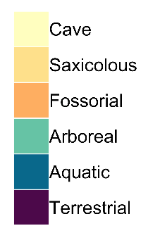
Figure 1: Time-dated phylogeny for salamanders from Bonett and Blair (2017), pruned to the 495 species for which microhabitat data was available in this study. Tips are labeled using the 6-M microhabitat classification scheme (see text), and branches are colored based on stochastic mapping node estimates. Red circles indicate likely transitions from terrestrial to arboreal microhabitats, and the root of Plethodontidae is marked with an asterisk.

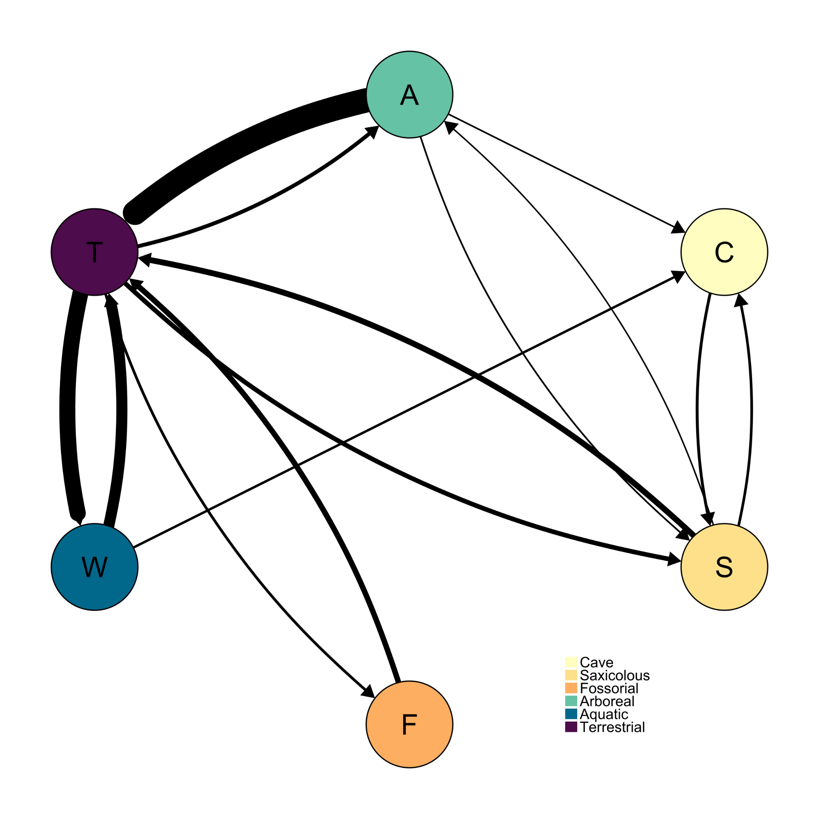Figure 2: Number of transitions between microhabitat categories using the 6-M microhabitat classification and Bayesian stochastic character mapping. Thickness of arrows are proportional to the number of transitions with a high of 63.2 (A to T) and a low of 0.763 (S to A). For exact numbers of transitions, see Table S2.

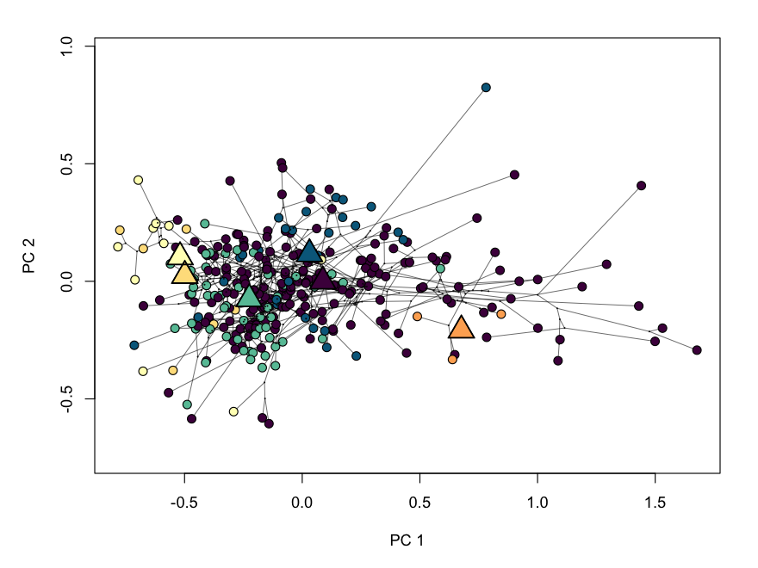Figure 3. Phylomorphospace representing dispersion among species in their general body proportions. The first two axes of phylomorphospace describe 61.8% percent of the total variation (PCA = 42.2%; PC2 = 19.6%). Circles indicate species means while the larger triangles represent mean phenotype of each microhabitat group.

Table 1. Microhabitats used in each classification scheme. Microhabitat abbreviations are: arboreal (A), cave (C), fossorial (F), saxicolous (S), semi-aquatic (SA), terrestrial (T), and aquatic (W). A brief description of each scheme is provided.

Scheme | Microhabitats | Description
6-M | T, W, A, C, F, S | Six microhabitats: majority-rule designation
6-L | T, W, A, C, F, S | Six microhabitats; lenient designation (some time not T)
7-M | T, W, A, C, F, S, SA | Seven microhabitats (semi-aquatic added): majority-rule
7-L | T, W, A, C, F, S, SA | Seven microhabitats (semi-aquatic added): lenient
6-McM | T, W, A, C, F, S | Six microhabitats; majority-rule; McEntire (2016) obligate arboreal
6-McL | T, W, A, C, F, S | Six microhabitats; lenient; McEntire (2016) obligate + facultative arboreal

