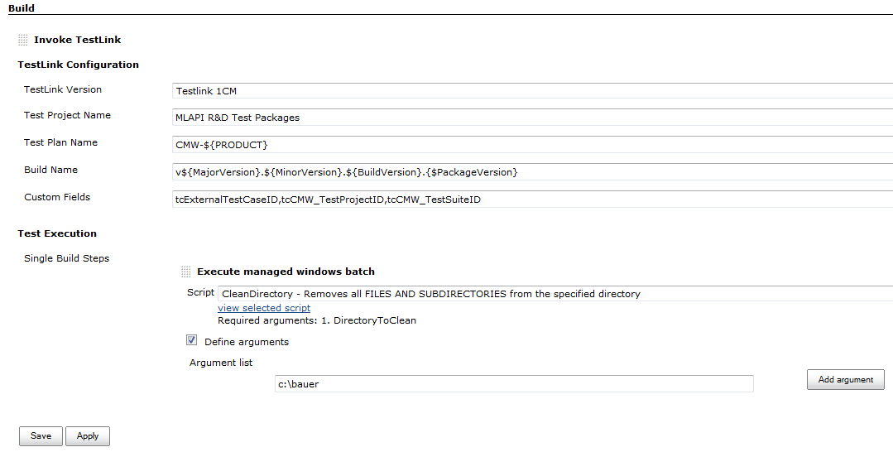

Pressing Save and coming back with "Configure", the same is shown as:
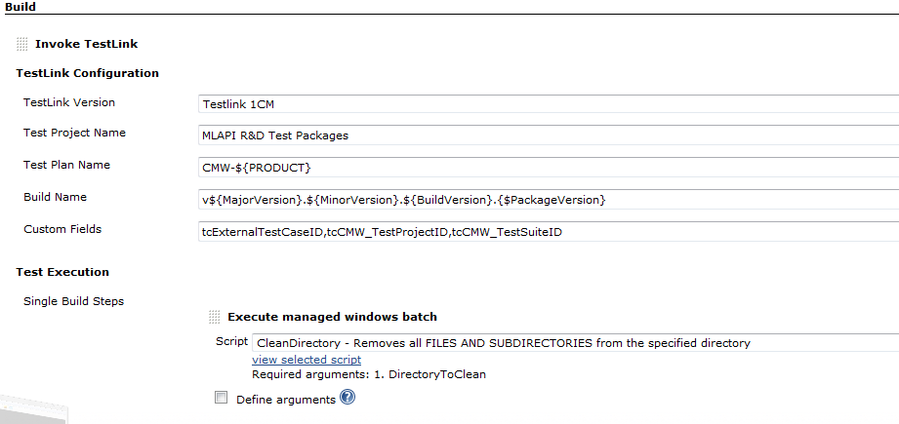
I.e. the given argument is lost.
Now for comparison, doing the same outside of Testlink:
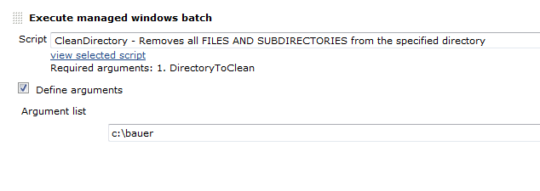Pressing Save and coming back with "Configure", shows the same picture, i.e. the given argument is yet there.

