Here are two ways in .Net (C#) to call web services and obtain xml or json.
var webClient = new WebClient();
content = webClient.DownloadString(requestUrl);
// or
var request = WebRequest.Create(requestUrl) as HttpWebRequest;
var response = request.GetResponse() as HttpWebResponse;

Either method above, when the requestURL = the following, I get xml back as expected.
http://111.206.111.154:8080/api/xml (or json)
http://111.206.111.154:8080/computer/api/xml (or json)
http://111.206.111.154:8080/user/123ABC/api/xml (or json)

However, if the url addresses any job, I always get a:
{"The remote server returned an error: (404) Not Found."}
For instance:
http://111.206.111.154:8080/job/SubCode/api/xml
http://111.206.111.154:8080/job/ SubCode /lastBuild/api/xml
http://111.206.111.154:8080/job/ SubCode /123/api/xml
http://111.206.111.154:8080/job/UCRA/api/xml
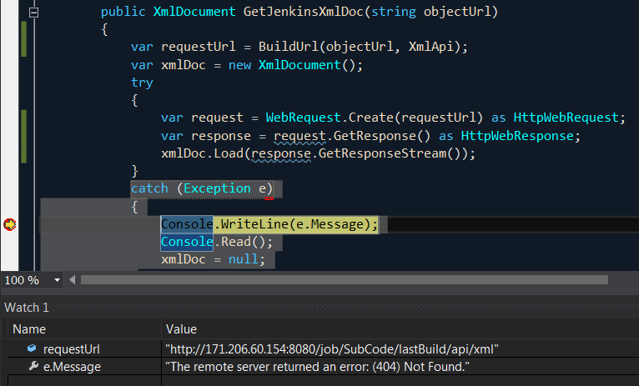
When I copy the requestUrl and paste it in a browser, I get expected data:
