I used this PowerShell Script because it is easier to test because I don’t need to edit, compile and deploy. Notice however that PowerShell is using the exact same assembly (System.Net.WebClient) that my C# class used.
I copied this script to the server so that there would be no network call. Notice that the URL is “localhost”.
The first call works both remotely and locally. I am getting data.
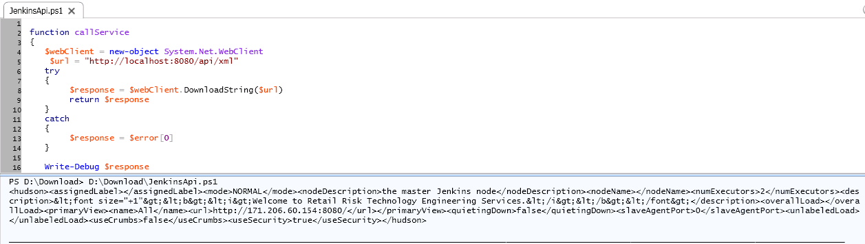
This call also works both remotely and locally. I am getting data.
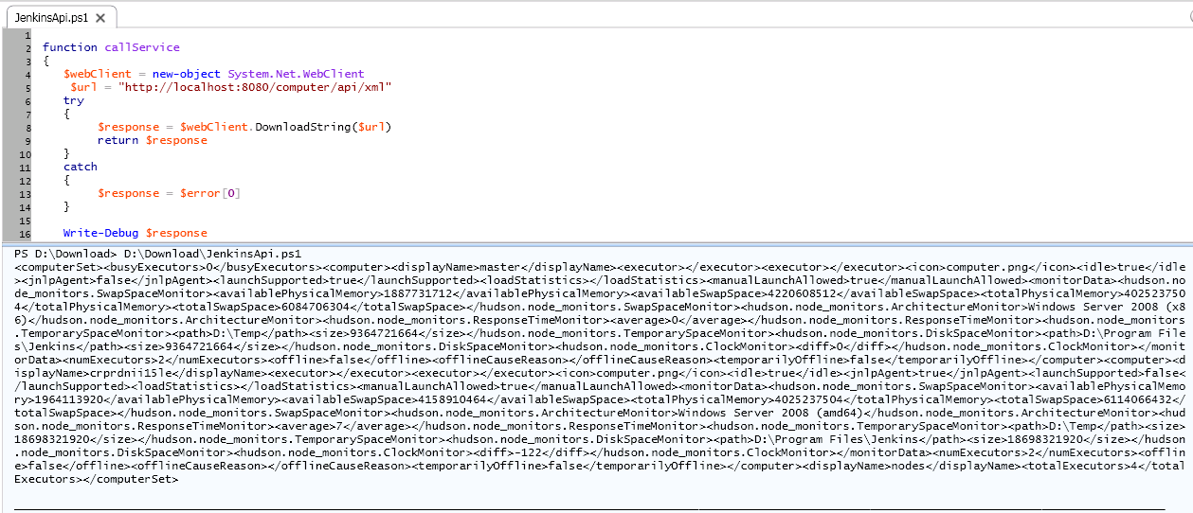
This call also works both remotely and locally. I am getting data.
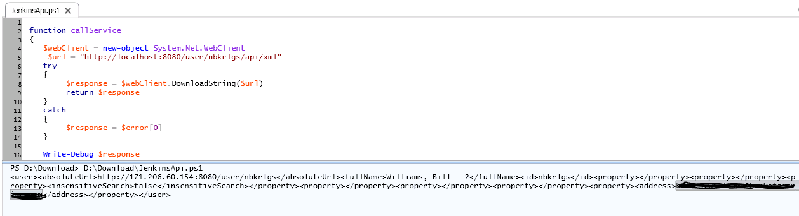
However, any URL that starts with “job” always returns 404 error, both remotely or locally. I can copy and paste the URL into a browser (remotely or locally) and I get data for the following calls but only in the browser.
