I created a global view as admin user
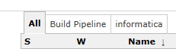
In this view I configured a job for which non-admin user has no permissions.
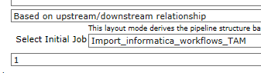
After this I logon as a non-admin user who only has permissions to read or run jobs. In example, user is not allowed to read and/or run job Import_informatica_workflows_TAM
I found out that stack trace appears when user doesn’t have any permissions for a job, when I give permissions then there is no stack trace.

With build pipeline 1.3.5, the views appear but after clicking on one and user has no permissions for job you will see following
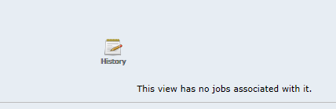

With build pipeline 1.4, 1.4.1 and 1.4.2 the following stack trace appears with the same configuration

