Screenshot of job configuration page.
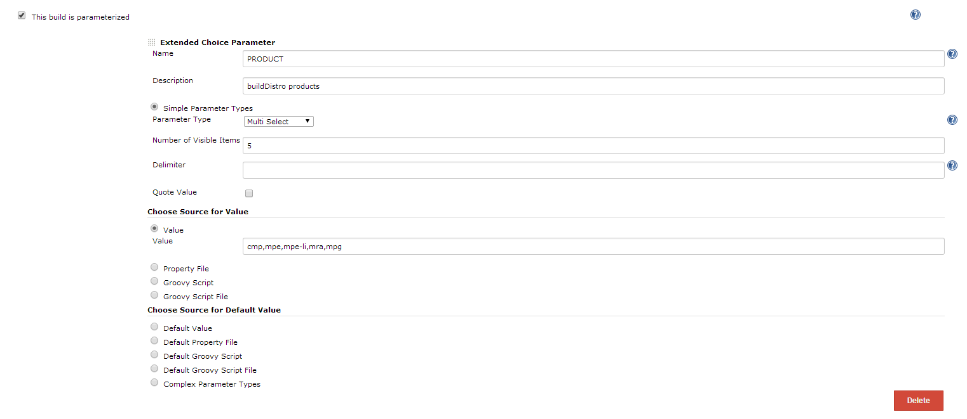

Screenshot of parameters in Jenkins jobs showing the comma being removed.
Plugin 0.28
Notice the comma between cmp and mpe.
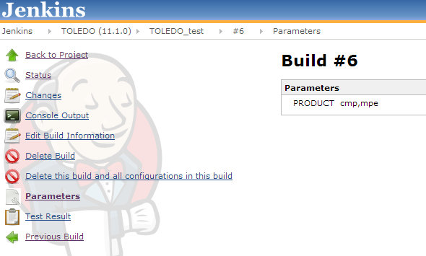
Plugin 0.34
No longer is there a comma.
