What works:
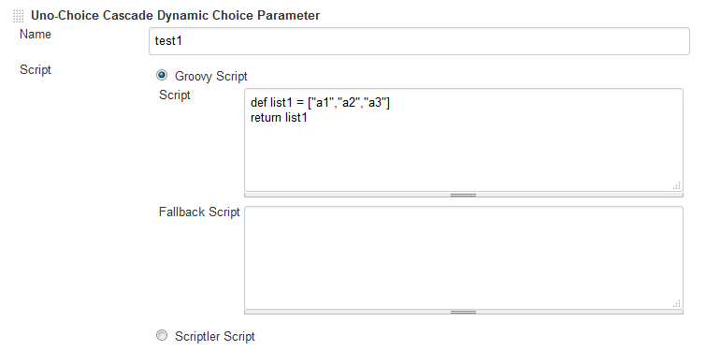
Out put:
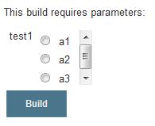
What doesn’t work
File based choice list:
At unix:
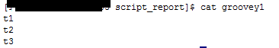
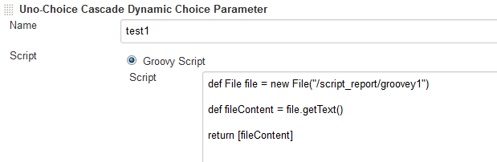
Output:
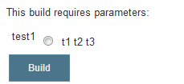

I tried to use “a1”, “a2”, “a3” format in the unix file still it doesn’t work
-------vi groovey1
"t1",
"t2",
"t3",
Output:
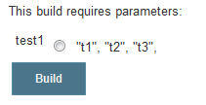
------------------------------------------
Expected output :
O t1
O t2
O t3

