Lemuel Gonzales Activity 1

**FUNDAMENTALS OF DATABASES – WEEK 3 – ACTIVITY 1**

Supply/perform what is asking in the following statements. Attach or put a screenshot for each number to support your answers.

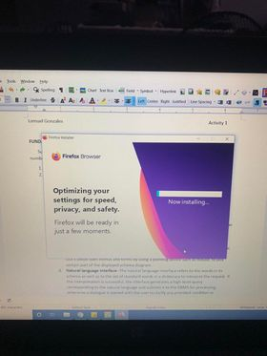

1. Capture or make a screenshot for each types of interface given below and briefly explain its importance or benefits to the users.
   1. **Menu-Based Interface** -These interfaces present the user with lists of options (called menus) that lead the user through the formation of a request. The basic advantage of using menus is that it removes the tension of remembering specific commands and syntax of any query language, rather than query is basically composed step by step by collecting or picking options from a menu that is basically shown by the system.
   2. **Forms-Based Interface-** A forms-based interface displays a form to each user. Users can fill out all of the form entries to insert a new data, or they can fill out only certain entries, in which case the DBMS will redeem same type of data for other remaining entries.
   3. **Graphical User Interface**- A GUI typically displays a schema to the user in diagrammatic form. The user then can specify a query by manipulating the diagram. In many cases, GUI’s utilize both menus and forms by using a pointing device such as mouse, to pick certain part of the displayed schema diagram.
   4. **Natural language Interface -**The natural language interface refers to the words in its schema as well as to the set of standard words in a dictionary to interpret the request. If the interpretation is successful, the interface generates a high-level query corresponding to the natural language and submits it to the DBMS for processing, otherwise a dialogue is started with the user to clarify any provided condition or request.
   5. **Speech Input and Output-** The interface is using s speech input that is detected using a predefined words and used to set up the parameters that are supplied to the queries. It is becoming commonplace applications with limited vocabularies such as inquiries for telephone directory, flight arrival/departure, and bank account information are allowed speech for input and output to enable ordinary folks to access this information.
   6. **Interfaces for DBA-** Most database system contains privileged commands that can be used only by the DBA’s staff. These include commands for creating accounts, setting system parameters, granting account authorization, changing a schema, reorganizing the storage structures of a databases.