FASHION STORE RESEARCH & PROJECT REPORT
Analysis of the Sales Systems of ZARA, H&M, and UNIQLO & Strategic Direction for E-commerce Website Development
2. RESEARCH ON COMPARABLE RETAIL WEBSITES
The team has selected three well-known fashion retail websites for study and reference:
1. ZARA: An international fashion brand characterized by a modern, minimalist style.
2. H&M: A fashion brand offering a diverse range of apparel and accessories.
3. UNIQLO: A brand renowned for its simple, functional designs with a strong focus on quality.
Studying these websites helps the team gain a clear understanding of interface design, product categorization, the purchasing process, and the essential features required for an e-commerce website.
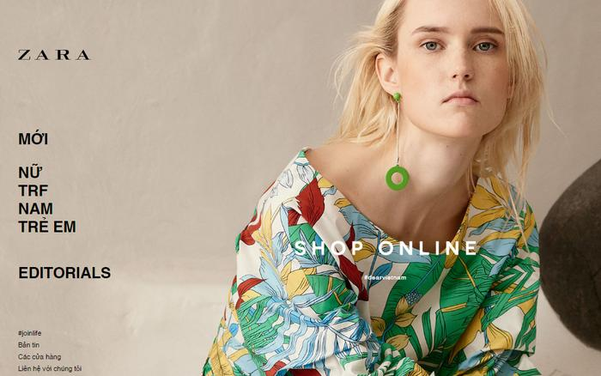
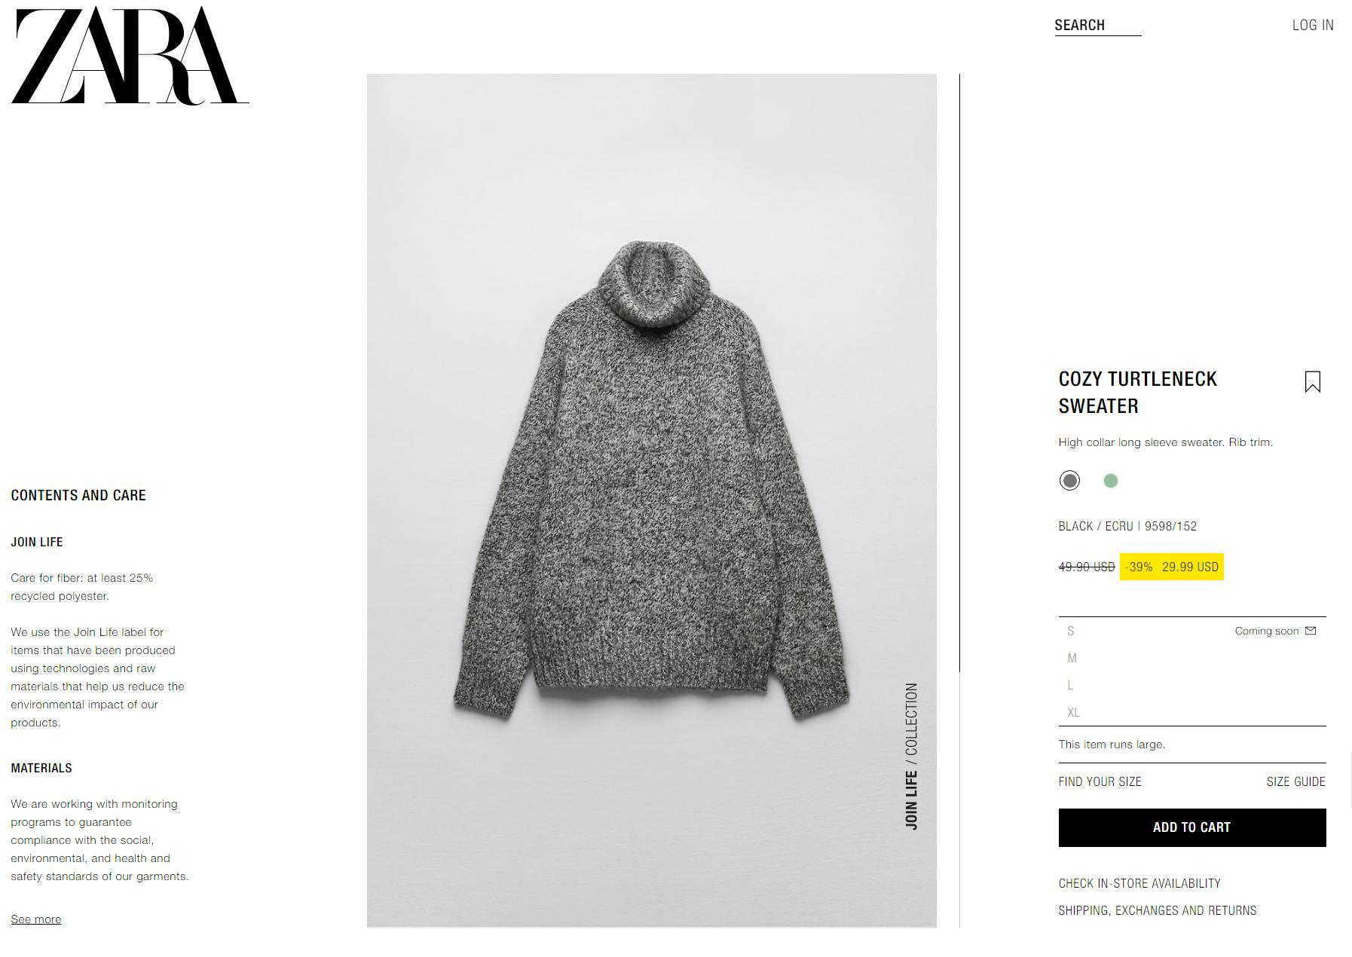
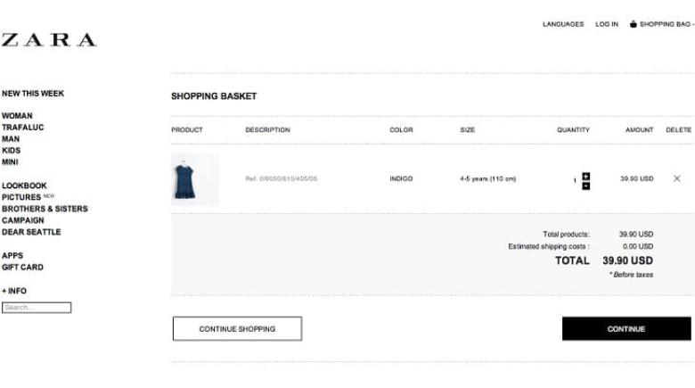
2.1. Website ZARA
Website: https://www.zara.com/vn/vi/
ZARA is an international fashion brand renowned for its modern, minimalist design aesthetic and frequent collection updates.
• Key features:
1. Homepage: Showcases new collections and featured products, includes a navigation menu, and utilizes large-scale imagery to create a visual impact.
2. Categories and Search: Organizes products by gender (men, women, children) and offers browsing, search, and filtering tools.
3. Product Details: Displays high-quality images, product names, prices, descriptions, and options for size and color selection.
4. Shopping Cart and Checkout: Allows users to add items to their cart, review order details, adjust quantities or remove items, and complete the checkout process.
5. Customer Account: Provides login/registration, personal information management, and order tracking.
✔ Strengths:
• A sleek, modern, and professional interface, high-quality product imagery, and a convenient shopping experience.
✖ Weaknesses and considerations:
• The use of many large images requires optimization for faster loading speeds. The minimalist style may also require a learning curve for new users.
💡 Lessons for a Fashion Store:
The team can draw inspiration from ZARA’s approach to product image layout, homepage interface, and product detail page design.
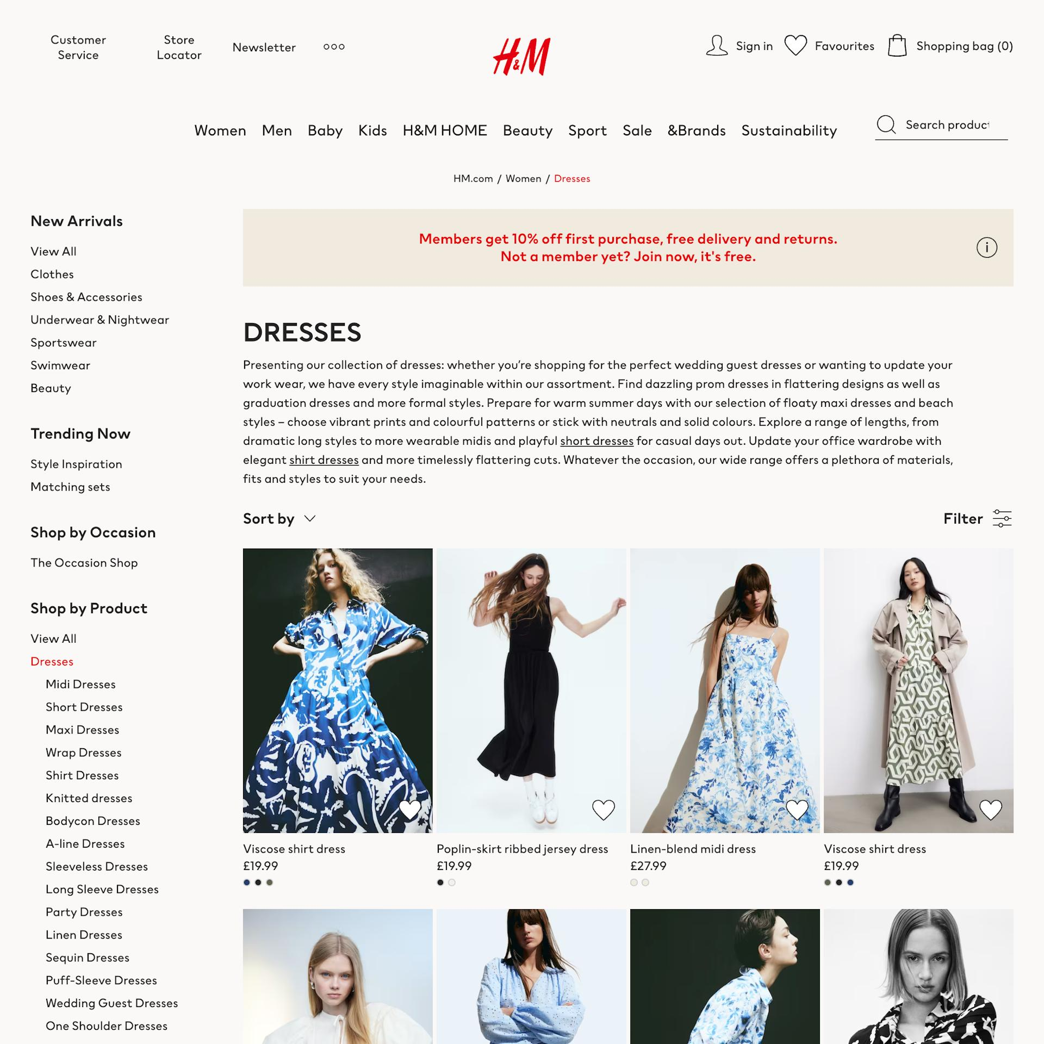
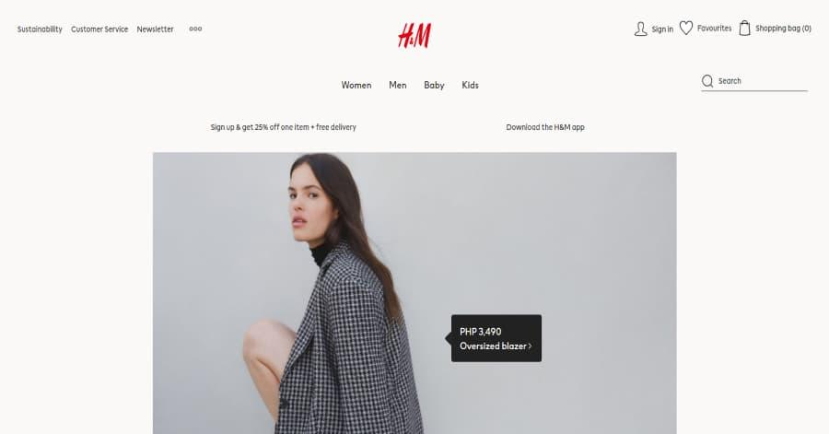
2.2. Website H&M
Website: https://www2.hm.com/vi_vn/
H&M is an international fashion brand offering a wide range of clothing and accessories in diverse styles.
• Key features:
1. Homepage: Displays promotions, new collections, and category links.
2. Product Categories: Organized by men, women, and children; features a broad selection of products with multi-criteria filtering.
3. Product Details: Shows images, product names, prices, material descriptions, and options for selecting sizes and colors.
4. Shopping Cart and Checkout: Allows users to add items, update quantities, and complete orders.
5. Customer Account: Registration/login, personal information management, and order history.
✔ Strengths:
• Diverse product range, user-friendly interface, clear categorization, and frequent promotional offers.
✖ Weaknesses and considerations:
• The large volume of products requires an intuitive filtering system. Promotional content should be strategically placed to avoid visual clutter.
💡 Lessons for the Fashion Store:
The team can draw inspiration from the product filtering, category organization, promotional display, and shopping cart management features.
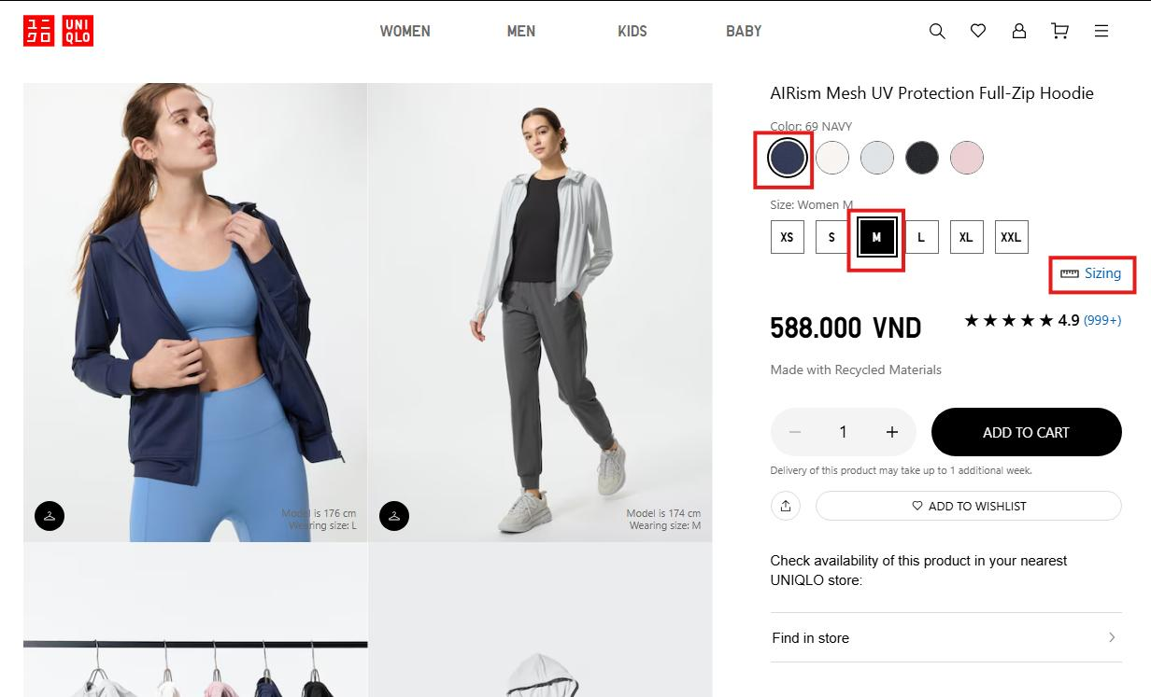
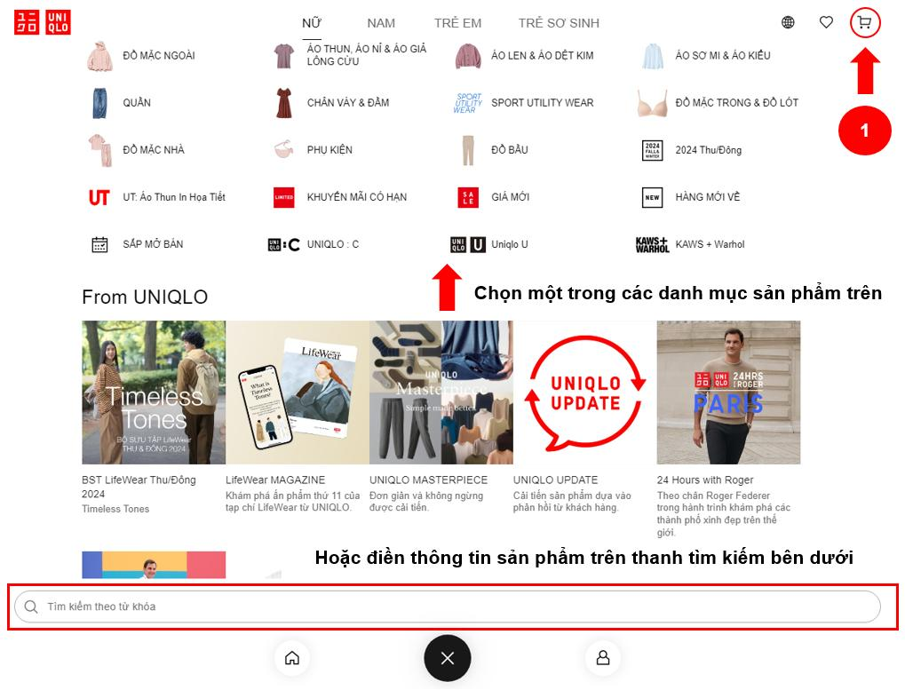
2.3. Website UNIQLO
Website: https://www.uniqlo.com/vn/vi/
UNIQLO is a well-known fashion brand recognized for its simple, functional designs and a strong focus on quality.
• Key features:
1. Homepage: Showcases featured products, new collections, and promotional offers.
2. Product Categories: Organized by gender (men, women, children) and product type (tops, bottoms, outerwear, accessories).
3. Product Details: Includes clear imagery, detailed descriptions of materials, size specifications, and available colors.
4. Shopping Cart & Checkout: Offers a user-friendly shopping cart and a streamlined checkout process.
5. Customer Account: Allows for account management, purchase history tracking, and order monitoring.
✔ Strengths:
• Features a simple, intuitive interface with clear, detailed product information; optimized for various devices.
✖ Weaknesses and considerations:
• Information must be organized effectively to prevent product pages from becoming excessively long.
💡 Lessons for a Fashion Store:
The team can draw inspiration from how UNIQLO presents detailed product information, handles size and color selection, and utilizes a minimalist interface.
3. COMPARISON OF THE WEBSITES STUDIED
3.1. Feature comparison table
Function | ZARA | H&M | UNIQLO
Home | Yes | Yes | Yes
Product Categories | Yes | Yes | Yes
Search for products | Yes | Yes | Yes
Filter products | Yes | Yes | Yes
Product details | Yes | Yes | Yes
Select Size / Color | Yes | Yes | Yes
Shopping cart | Yes | Yes | Yes
Order online | Yes | Yes | Yes
Customer account | Yes | Yes | Yes
Track your order | Yes | Yes | Yes
Inventory Variant Management | Yes | Yes | Yes
3.2. Comparing user interface and user experience
Criteria | ZARA | H&M | UNIQLO
Interface style | Minimalist, modern | Youthful, diverse | Simple and convenient
Product images | Striking, large-scale art | Multiple product images | Presented clearly and in detail
Product categorization | Clear | Diversity | Clearly, visually
Shopping experience | Modern, fashionable | Friendly, with plenty of offers | Easy to use, practical
Highlights | Design & imagery | Categories & Offers | Product information & functionality
3.3. General Observations & Direction for Fashion Store
Through our research, we identified that each of the three websites possesses its own distinct, superior advantages. We have decided to integrate these strengths to develop the Fashion Store website:
• A modern, minimalist interface, inspired by the ZARA style.
• Convenient product categories and filtering options, modeled after H&M.
• Clear, detailed, and user-friendly product information, following the approach of UNIQLO.
4. TECHNOLOGY USED
Technology / Tools | Role within the system
HTML5 / CSS3 | Developing website structure and interface design
JavaScript (ES6+) / AJAX | Handling client-side interactions (Adding to cart without reloading)
PHP (Native / MVC) | Server-side logic execution
MySQL | A database management system stores information.
Bootstrap 5 / Tailwind | Framework supporting mobile-responsive interfaces
Visual Studio Code | Integrated Development Environment (IDE)
XAMPP | Test server environment (Apache and MySQL)
GitHub | Source code management (Git) and teamwork
5. REFERENCES
- Website chính thức ZARA Vietnam – https://www.zara.com/vn/vi/
- Website chính thức H&M Vietnam – https://www2.hm.com/vi_vn/
- Website chính thức UNIQLO Vietnam – https://www.uniqlo.com/vn/vi/
- Tài liệu lập trình W3Schools – https://www3schools.com/
- Tài liệu chính thức PHP Documentation – https://www.php.net/docs.php
- Tài liệu chính thức MySQL Documentation – https://dev.mysql.com/doc/

