Channel computations : comparing current scheme to RMS
THEM1999-03
October 17th, 1999
Daniel Lemire, Ph.D.

Problem

The channels seem to show very little coherence sometimes. It was identified as a baseline problem however, the baseline algorithm seems to do its job fairly well in most cases. While it could be improved, it is not clear at this point that the reported problems depend mostly on the baseline algorithm. This report investigate the use of RMS for channel computations as a way to improve overall results.

RMS

Currently, channels are computed using a simple average :

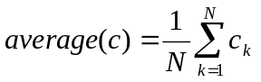 (1)

but I propose to compute them using the RMS (root mean square) :

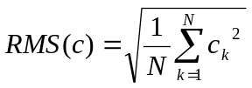 (2)

RMS is a better tool when doing signal processing because it is related to the energy of the signal and the energy is a more stable parameter. Moreover, the current baseline algorithm is optimised for energy computations.

Channel computations

I recommend computing channel values using first the last 48 points (or whatever input is given to the baseline algorithm) as a reference so that channel values are given by

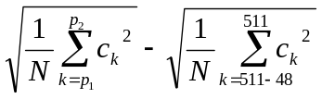

A similar approach is probably recommended for the average value.

Preliminary results

How do we compare the two schemes ? What is most important is inter-channel coherence or correlation. Overall, according to preliminary tests using RMS, the correlation coefficient between channels is improved by about 50 %.

However, so that the reader can judge for itself, figures are given. Please note that :
- when major anomalies are present, they tend to be present in more channels using RMS than simple averaging and while this fact might now be obvious at first it can be shown mathematically using statistical analysis.
- With RMS, it becomes easier to differentiate the various anomalies using their amplitude.
These results are very encouraging.

The signal used in Fig. 1 and 2 is the signal which was identified as a signal giving trouble to the baseline algorithm.

Fig. 1 : channels for current scheme on "bas" data

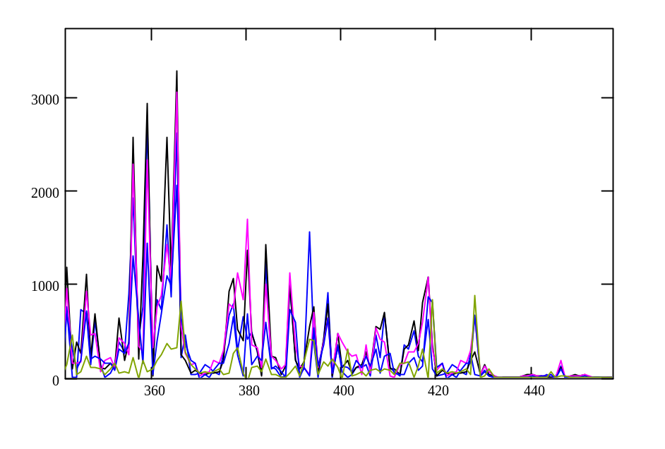

Fig. 2 : new RMS scheme on "bas"
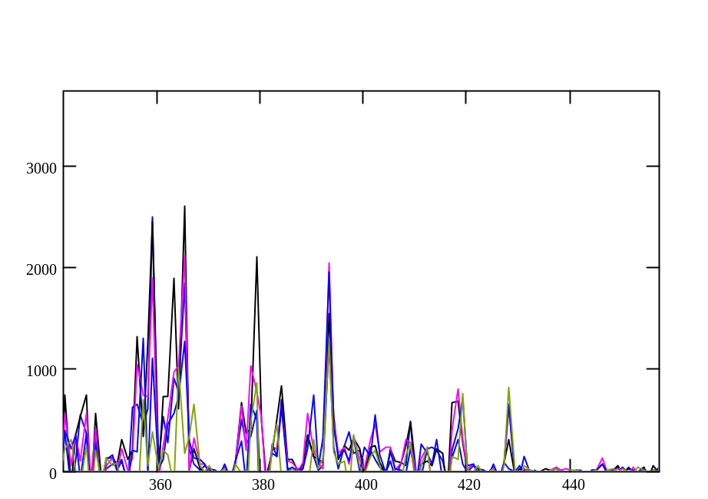

Conclusion

Because of these good results, I recommend immediate testing of this new channel computation scheme. Modifying the current code is a trivial task. In order to compare the new scheme with the old one, I recommend computing inter-channel correlation coefficients. We simply need to modify RMS so that negative anomalies can me measured as well (taking into account signs).

This new scheme can be integrated with the new THEM software as soon as I get the source code and programming environment.

Daniel Lemire, Ph.D.
Daniel.Lemire@Videotron.ca
(514) 524-3517

