Predicting Loan Default In Peer-To-Peer Lending
François Lemoine February 8th, 2017

I. Definition

Project Overview
Loan default prediction is a common problem for various financial companies. This is the type of problem banks (e.g Goldman Sachs), credit card companies (e.g. Visa), micro-credit banks (e.g. Grameen Bank) or FinTech companies (e.g Lending Club) face whenever customers ask for a loan. The data from Lending Club about lenders is available on their website and we will be using it to make predictions about loan default and whether or not we should lend to a customer. We will be using the data from 2007-2011. Lending Club is the platform or rather the marketplace where investors and borrowers meet virtually. On the side of the investor there is still due diligence to be performed in order to insure the creditworthiness of the borrower and the level of risk involved in any given case. Applying machine learning to loan default predictions showcase a useful application of this branch of artificial intelligence to solve real-world and business problems. We will try to build this model with the most transparency possible as to mirror the conditions in which financial institution must disclose this process as to avoid discrimination. Even though we are building this model with a conservative investor in mind, the model could be later tweaked as to use it in a financial institution.
If a model is able to identify credit-worthy customers that were not recognized by the traditional FICO credit score while minimizing their risk of default on the loans, this can become a lucrative niche market or micro-market. Thus pushing higher the profit margin of the financial institution. Although, the prospect of more customers seems positive, we need to be careful as to not lend to people that will default on the loan, this would cause a drop in the earlier stated objective. Thus a somewhat conservative approach and rigorous evaluation metric will be kept in mind throughout the project. The loan default prediction is a problem of binary classification (do we lend or not) and we will be using logistic regression and random forests to build a model.

Metrics
To measure the success rate of our model, the clearest metric is the accurate prediction loan default. The decision that the model takes has consequence as to the profitability of the investment or the financial institution putting money on the line. This is why work will have to be done with the error types (false positive, false negative, true positive and true negative) which we will explain later as this will help guide us to a conservative evaluation of the loan default rate. The best metric to evaluate the model is the accuracy of our algorithm to predict whether or not a customer is likely to repay the loan. We achieve this by training our model on the training dataset and than trying to predict – based on the columns value – the good customers of the testing set. We can measure the accuracy, practicality and realism of the model.

II. Analysis
Data Exploration
The dataset has 42538 rows and 111 columns. The columns represent different information gathered as part of the first inquiry by Lending Club. The data dictionary file provided with the dataset, indicates that columns are information about the borrower and the outcome of their loan repayment. Part of why we picked the data from 2007-2011 is because we are almost certain that the loans have been repaid or defaulted on by this time. This means that we are trying to model future outcomes based on past data.
At first, we wanted to know if the columns were filled with informations or were they mostly empty. Our data exploration has uncovered many empty or almost empty columns and we have removed these columns from the data because it would prove a difficult task to go back and try to answer for each data point that did not seem necessary at the time of the loan application.
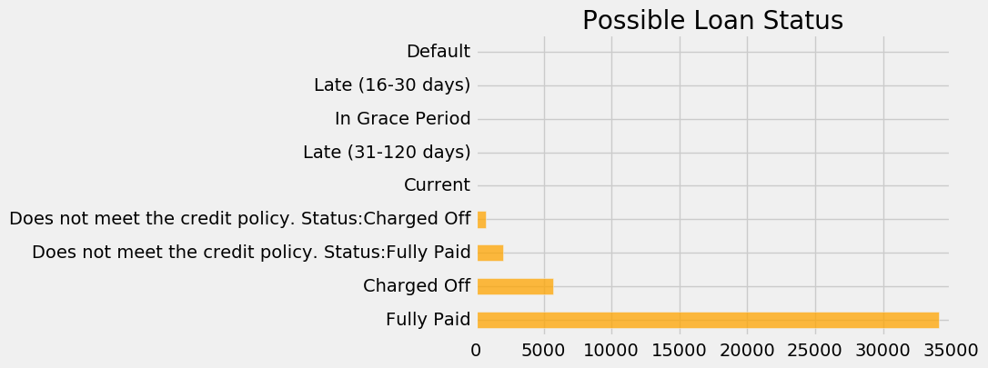
Although, we can never be sure about what information might or might not be helpful in the future, we must accept that practicality must overcome such possible future use of data. Moving forward with what we have at hand, we noticed a candidate for the target of our algorithm (what we want to predict) which is the loan_status column.

Exploratory Visualization
As mentioned in the data exploration section, an important part of of the dataset and binary classification in general is the class imbalance. As a matter of fact, only one seventh of the data is about defaulters, which mean that the model has a good chance of getting it right by predicting all good outcomes (about 85% of the time). Here is the cleaned up version of the previous graph.
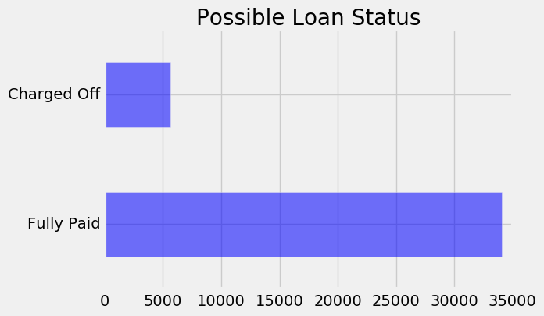

Fig. 1.2, Class Imbalance. In the visualization on the left, we can approximate the 1 to 7 difference between the two possible loan status. This horizontal bar chart is the cleaned up version, as compared to the previous visualization.

Algorithms and Techniques
The model we built uses logistic regression as the main classifier and we ventured a little bit with random forest to try to improve our predictions. But before we dive in the results of these applications on the dataset, we had to explore, clean, rework the dataset. The reason why we had to do this was simply because the data was using a lot of memory and that empty columns slow the training process of our model. (Why do we use logistic regression and random forest)

Benchmark
In the solution statement we talked about the need of a conservative evaluation of the default rate. We must also keep in mind that there is a strong imbalance with the target category of loan repayment in the dataset, because about 6 out of 7 loans are repaid. Meaning that we could lend money all the time (always predicting that the borrower would repay) and be right about 85.71% of the time that the loan would be repaid, but that would mean that the model would not be profitable. Say we lend $1000 at 10% interest, we would expect a return of $100 on each loan. But if we run the experiment 7 times, we would earn $600 (6 x $100) and lose $1000 (the defaulter), we are left with a $400 loss. Hardly a profitable enterprise. The benchmark needs to encompass the weight of the defaulter and the optimization between the true positive rate (good borrowers) and the false positive rate (bad borrowers). This implies that we need to ensure a viable machine learning model and predict a higher percentage of potential defaulters in order to avoid lending to them. The benchmark must beat the 85.71% average loan repayment. Although “money is left on the table”, a conservative investor would rather prefer a steady return on her investment than suffer the 1 in 7 chance of losing her principal.

III. Methodology
Data Preprocessing
We removed columns where more than 50% of the values where empty because these values cannot be filled in any meaningful ways. We analyzed the 52 remaining columns with the data dictionary provided by Lending Club. From this, we worked in 4 steps, by analyzing 13 features at each step and trying to figure out whether they were valuable information about the customer. We also had to deal with “leakage from the future” by making sure that we did not use information that could not be known in advance while taking the decision to lend or not to a customer. This type of information about the future can lead to over fitting and would decrease the ability of our model to make accurate predictions.
A noticeable quality of our dataset is the imbalance between the ‘Fully Paid’ and ‘Charged Off’, this implies that the model might predict a loan outcome based on what is more prevalent in the set, this would lead to an over fitting model and we will need to work around this in the processing phase of our project.
Another part of the preprocessing is the removal of rows with missing values, we had to remove a little more than 700 rows because the informations of the application were incomplete. As we explored the dataset, we saw different data types, and we had to convert – for example – the ‘object’ data type because it cannot be processed by the machine learning algorithms of scikit-learn.

Implementation
In this section, the process for which metrics, algorithms, and techniques that you implemented for the given data will need to be clearly documented. It should be abundantly clear how the implementation was carried out, and discussion should be made regarding any complications that occurred during this process. Questions to ask yourself when writing this section:
- Is it made clear how the algorithms and techniques were implemented with the given datasets or input data?
- Were there any complications with the original metrics or techniques that required changing prior to acquiring a solution?
- Was there any part of the coding process (e.g., writing complicated functions) that should be documented?
We use a logistic regression algorithm from the library scikit-learn as the first algorithm that we fit on the filtered data. We do not put in place a weight on errors, this way, we will try the model with the class imbalance that we noticed previously. By implementing this algorithm on the dataset, we were able to validate our hypothesis about the imbalance and the over fitting that would ensue. If we want to increase the performance of our result, by getting the lowest level possible acceptable to take a decision about lending, we need to add a weight to errors that we want to minimize.
(talk about the implementation of logistic regression and keeping an eye on the true positive, etc rate)

Refinement
In this section, you will need to discuss the process of improvement you made upon the algorithms and techniques you used in your implementation. For example, adjusting parameters for certain models to acquire improved solutions would fall under the refinement category. Your initial and final solutions should be reported, as well as any significant intermediate results as necessary. Questions to ask yourself when writing this section:
- Has an initial solution been found and clearly reported?
- Is the process of improvement clearly documented, such as what techniques were used?
- Are intermediate and final solutions clearly reported as the process is improved?
We add a weight to the error (false positive) to increase the rate we want. The weight of 10 to 1, was found after a couple of trial and error. The balanced weight of scikit-learn is generally 1 to the number of other occurrences. In this case this would have been about 7, but the result that we got after this “normal” re-balancing was not satisfactory to a production level model.

IV. Results
(approx. 2-3 pages)

Model Evaluation and Validation
In this section, the final model and any supporting qualities should be evaluated in detail. It should be clear how the final model was derived and why this model was chosen. In addition, some type of analysis should be used to validate the robustness of this model and its solution, such as manipulating the input data or environment to see how the model’s solution is affected (this is called sensitivity analysis). Questions to ask yourself when writing this section:
- Is the final model reasonable and aligning with solution expectations? Are the final parameters of the model appropriate?
- Has the final model been tested with various inputs to evaluate whether the model generalizes well to unseen data?
- Is the model robust enough for the problem? Do small perturbations (changes) in training data or the input space greatly affect the results?
- Can results found from the model be trusted?

Justification
In this section, your model’s final solution and its results should be compared to the benchmark you established earlier in the project using some type of statistical analysis. You should also justify whether these results and the solution are significant enough to have solved the problem posed in the project. Questions to ask yourself when writing this section:
- Are the final results found stronger than the benchmark result reported earlier?
- Have you thoroughly analyzed and discussed the final solution?
- Is the final solution significant enough to have solved the problem?

V. Conclusion
(approx. 1-2 pages)

Free-Form Visualization
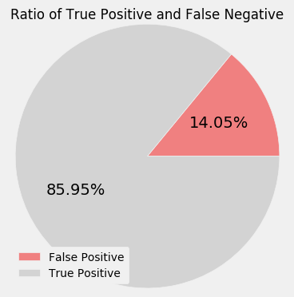
In this section, you will need to provide some form of visualization that emphasizes an important quality about the project. It is much more free-form, but should reasonably support a significant result or characteristic about the problem that you want to discuss. Questions to ask yourself when writing this section:
- Have you visualized a relevant or important quality about the problem, dataset, input data, or results?
- Is the visualization thoroughly analyzed and discussed?
- If a plot is provided, are the axes, title, and datum clearly defined?
Reflection
- Does the final model and solution fit your expectations for the problem, and should it be used in a general setting to solve these types of problems?
The end-to-end process of building a machine learning model is a rigorous process of data analysis, data cleaning, data processing and machine learning algorithms fitting. One interesting aspect of the project was that even with a multitude of columns and data, the information is not always relevant to the problem that we are trying to solve. It obviously showcase the limit of data gathering. Big data does not necessary mean good insights into a problem and a lot of data engineering and processing is needed in order to extract what is relevant. Also, the fine line between information that can be asked of the potential borrower and information that could be discriminatory is not trivial. It is certainly a major issue about how much and how far can data gathering go in the name of a better model or a better product. The part that was the most enjoyable was the machine learning fitting, because it shows how far we have come from a messy .csv file.
Improvement
In this section, you will need to provide discussion as to how one aspect of the implementation you designed could be improved. As an example, consider ways your implementation can be made more general, and what would need to be modified. You do not need to make this improvement, but the potential solutions resulting from these changes are considered and compared/contrasted to your current solution. Questions to ask yourself when writing this section:
- Are there further improvements that could be made on the algorithms or techniques you used in this project?
- Were there algorithms or techniques you researched that you did not know how to implement, but would consider using if you knew how?
- If you used your final solution as the new benchmark, do you think an even better solution exists?
Different classification algorithms such as XGBoost, or even different machine learning architecture such as neural networks could provide better results. Although, it has be used by companies such as Underwrite.ai, deep learning could be another way to discover and push the boundaries of what is possible in predicting the outcome of loans.
On a side note, relaxing the strict requirements could help capturing the false negative market and that could lead to better profitability to the bank that finds a way. This is on the business side and not on the machine learning side, but nonetheless, business problems are a driver in the implementation and deployment of machine learning models. Being able to serve this under-served niche would open opportunities to those customers and potentially increase the profit margin as it had been shown by the Grameen Bank throughout the world, but most notably in India.
References
Lending Club
Wikipedia
Dataquest
Python Machine Learning Raschka

