Nmap Open Service Port Analysis
Cybersecurity Portfolio Project
Kali Linux | Nmap | Network Reconnaissance | Attack Surface Analysis
Project Summary. This project documents a hands-on cybersecurity lab focused on identifying open ports, enumerating services, detecting operating systems, and evaluating network attack surfaces using Kali Linux and Nmap. The work was completed in an authorized CompTIA Security+ training environment across external, guest, client, and server network segments.
Authorized Lab Only: All scanning and testing documented here were performed in a controlled training environment.
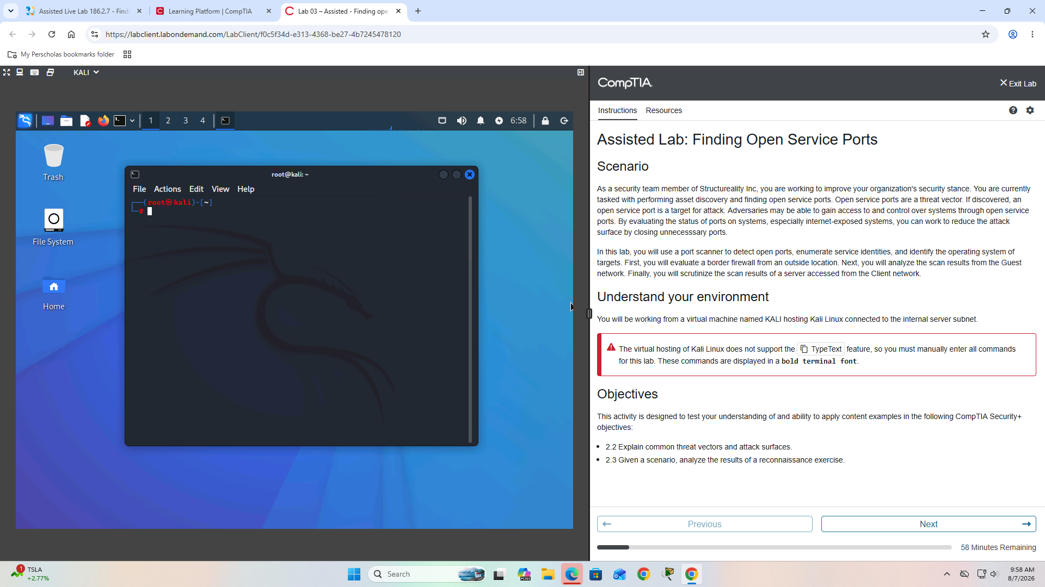
Figure 1. CompTIA Security+ Assisted Lab - Finding Open Service Ports

Objectives
- Identify open TCP ports
- Enumerate running services and versions
- Detect target operating systems
- Compare external, guest, and internal attack surfaces
- Identify network-segmentation weaknesses
- Evaluate exposed management services
- Recommend security controls

Tools and Skills
Tools / Platforms | Skills Demonstrated
Kali Linux  Nmap  Grep  TCP/IP  OPNsense  FreeBSD  Windows Server | Network reconnaissance  Port scanning  Service enumeration  OS fingerprinting  Attack-surface analysis  Threat-vector analysis  Network segmentation  Security hardening

1. External Network Scan
Target: 203.0.113.1
nmap 203.0.113.1 -F -sS -sV -O -Pn -oN border-scan.nmap
This scan used the top 100 common ports, a TCP SYN scan, service/version detection, OS detection, no host discovery, and normal-format output logging.
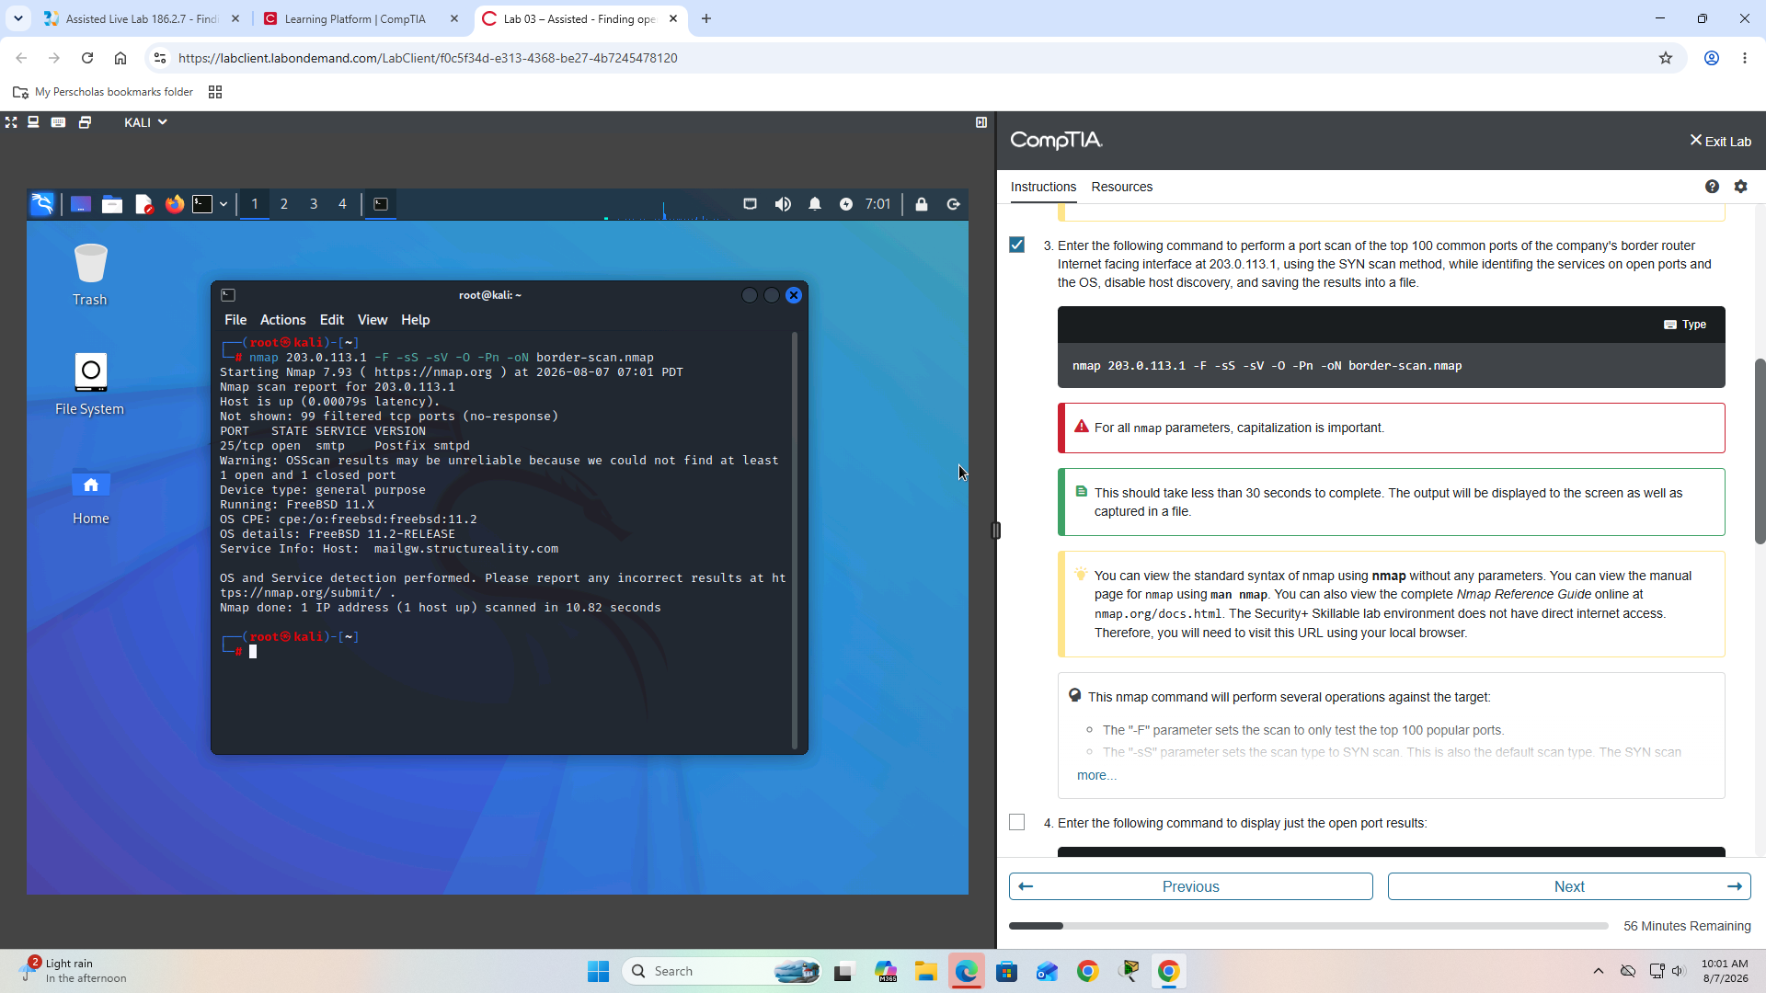
Figure 2. External Nmap scan and service/OS detection output
Finding: 25/tcp open smtp Postfix smtpd
The target exposed SMTP on TCP port 25. Nmap also identified the target as FreeBSD 11.2. Internet-accessible services increase the external attack surface and should only be exposed when required.
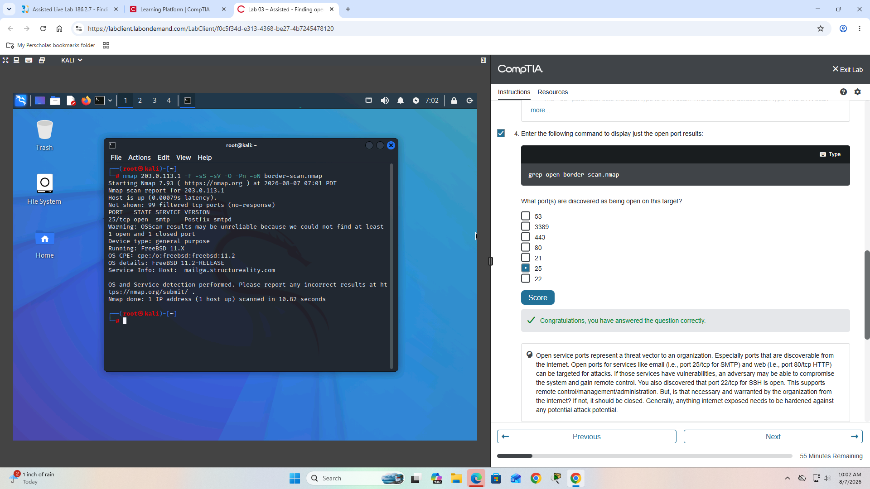
Figure 3. External open-port validation
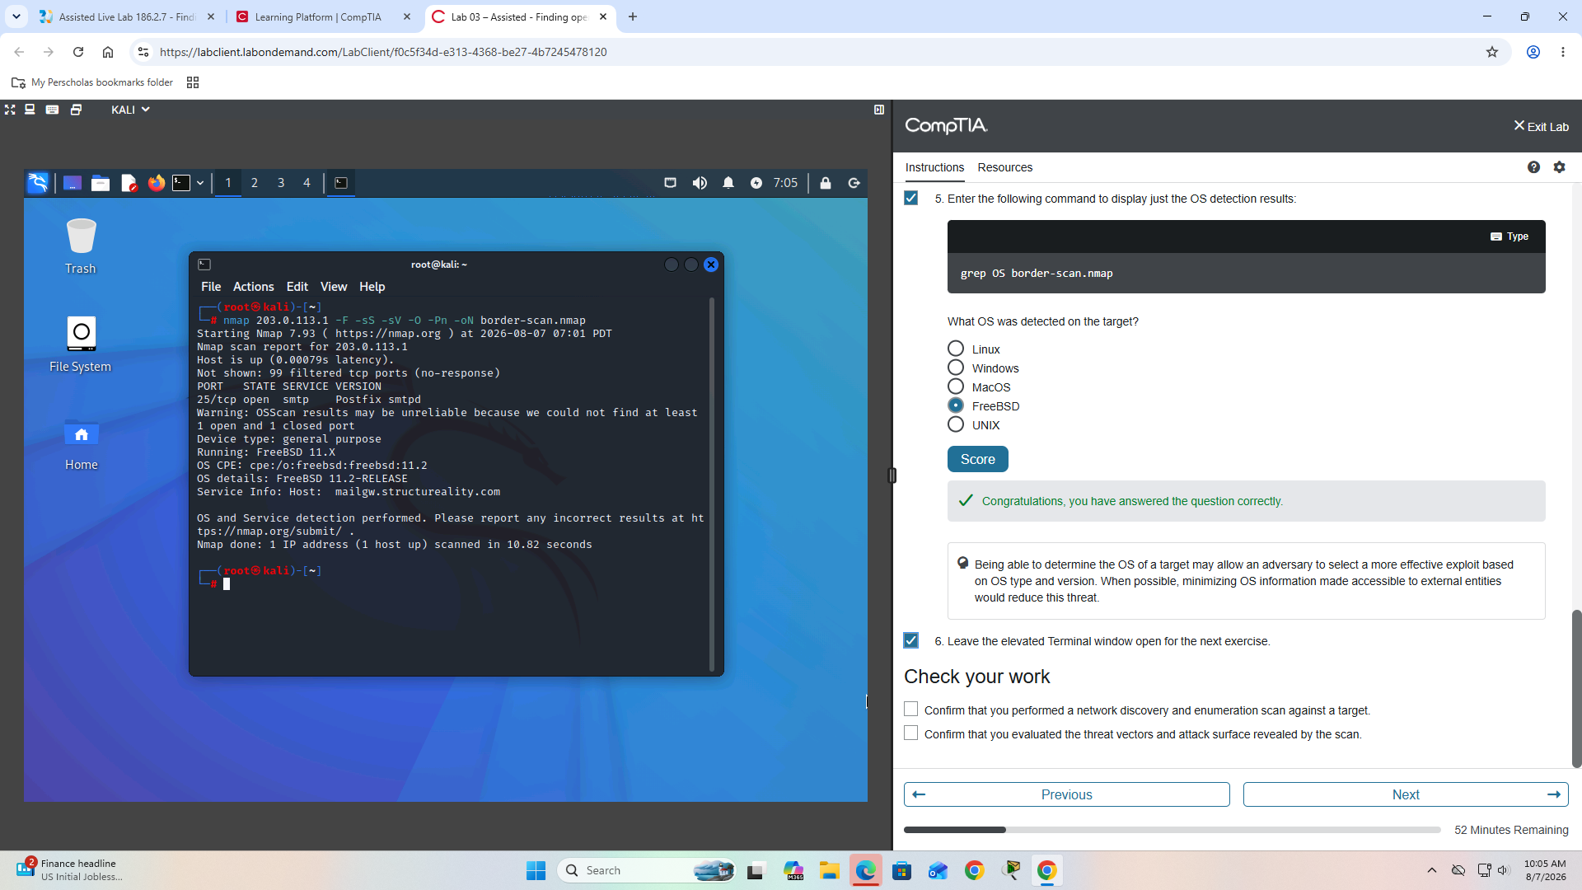
Figure 4. External operating-system detection

2. Guest Network Assessment
The Kali workstation was moved to the guest network. DHCP was refreshed and the interface configuration was verified.
dhclient -r && dhclient
ip a s eth0
The workstation received an address in the 192.168.16.0/24 network.
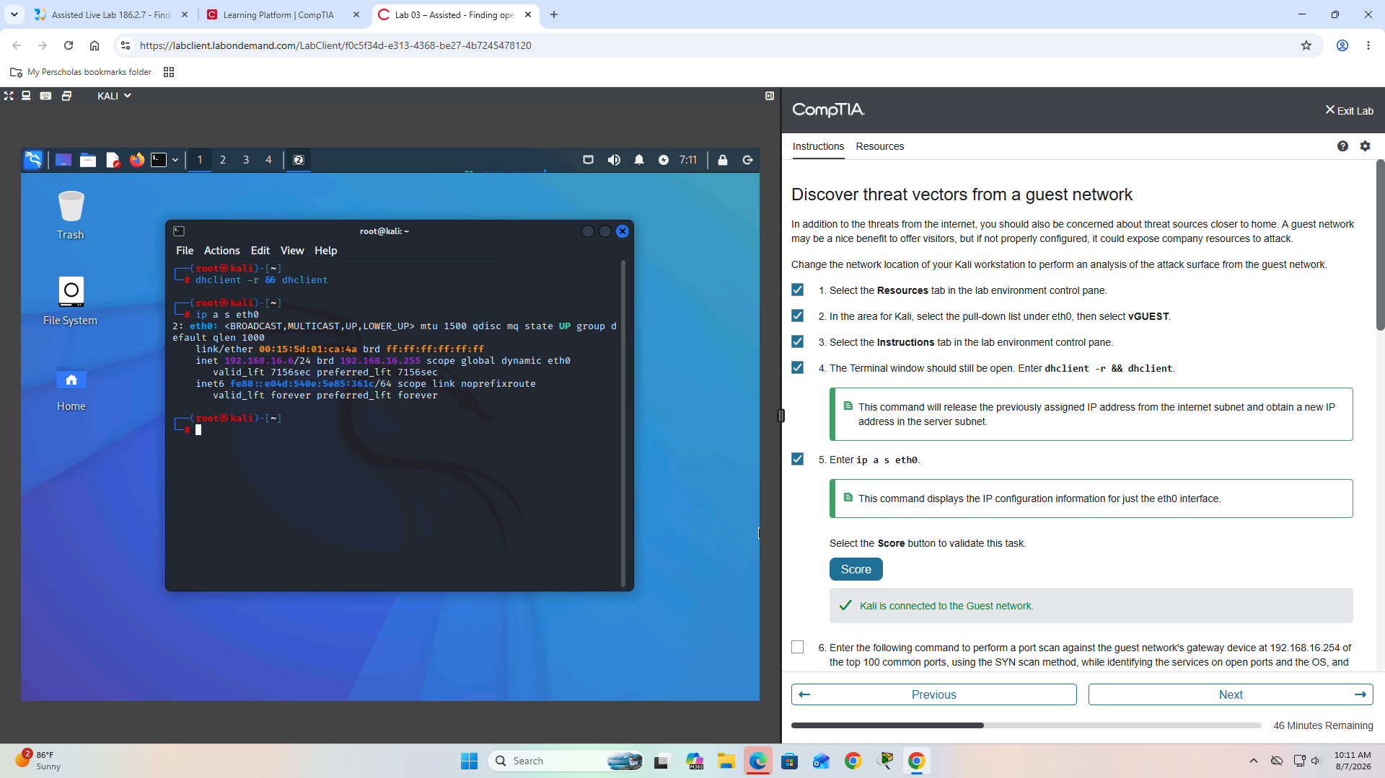
Figure 5. Kali connected to the Guest network
Guest gateway: 192.168.16.254
Service enumeration identified SMTP, DNS, HTTP, HTTPS, and HTTP-alt. OPNsense was detected on ports 80, 443, and 8000.
Port | Service | Detected Technology
25 | SMTP | Postfix smtpd
53 | DNS | Unbound
80 | HTTP | OPNsense
443 | HTTPS | OPNsense
8000 | HTTP-alt | OPNsense
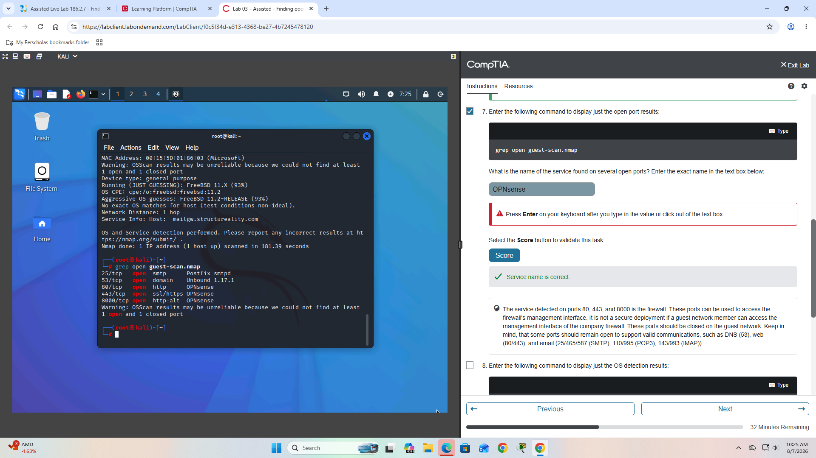
Figure 6. Guest-network service enumeration showing OPNsense
Security finding: Firewall management services were reachable from the guest network. Guest devices should generally not be able to reach administrative interfaces.
Recommended remediation: Restrict management access to a dedicated management VLAN, block guest access with firewall ACLs, limit administration to authorized systems, and require encrypted administrative connections.
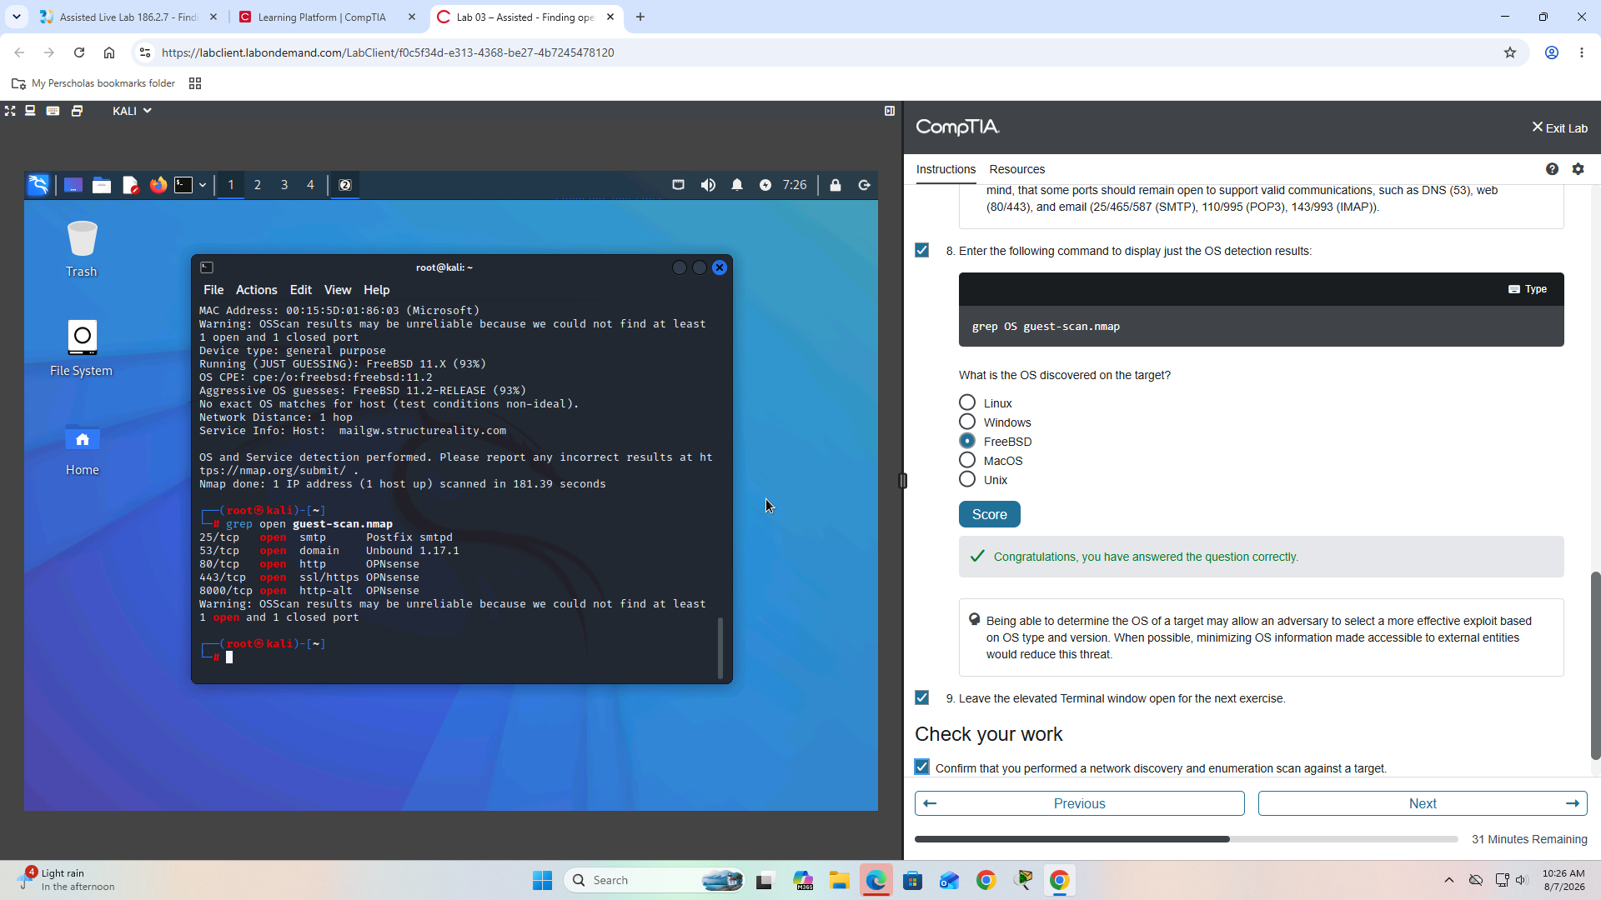
Figure 7. Guest gateway OS detection - FreeBSD 11.x

3. Internal Network Assessment
The Kali workstation was moved to the client network and an internal server in the Server network was assessed.
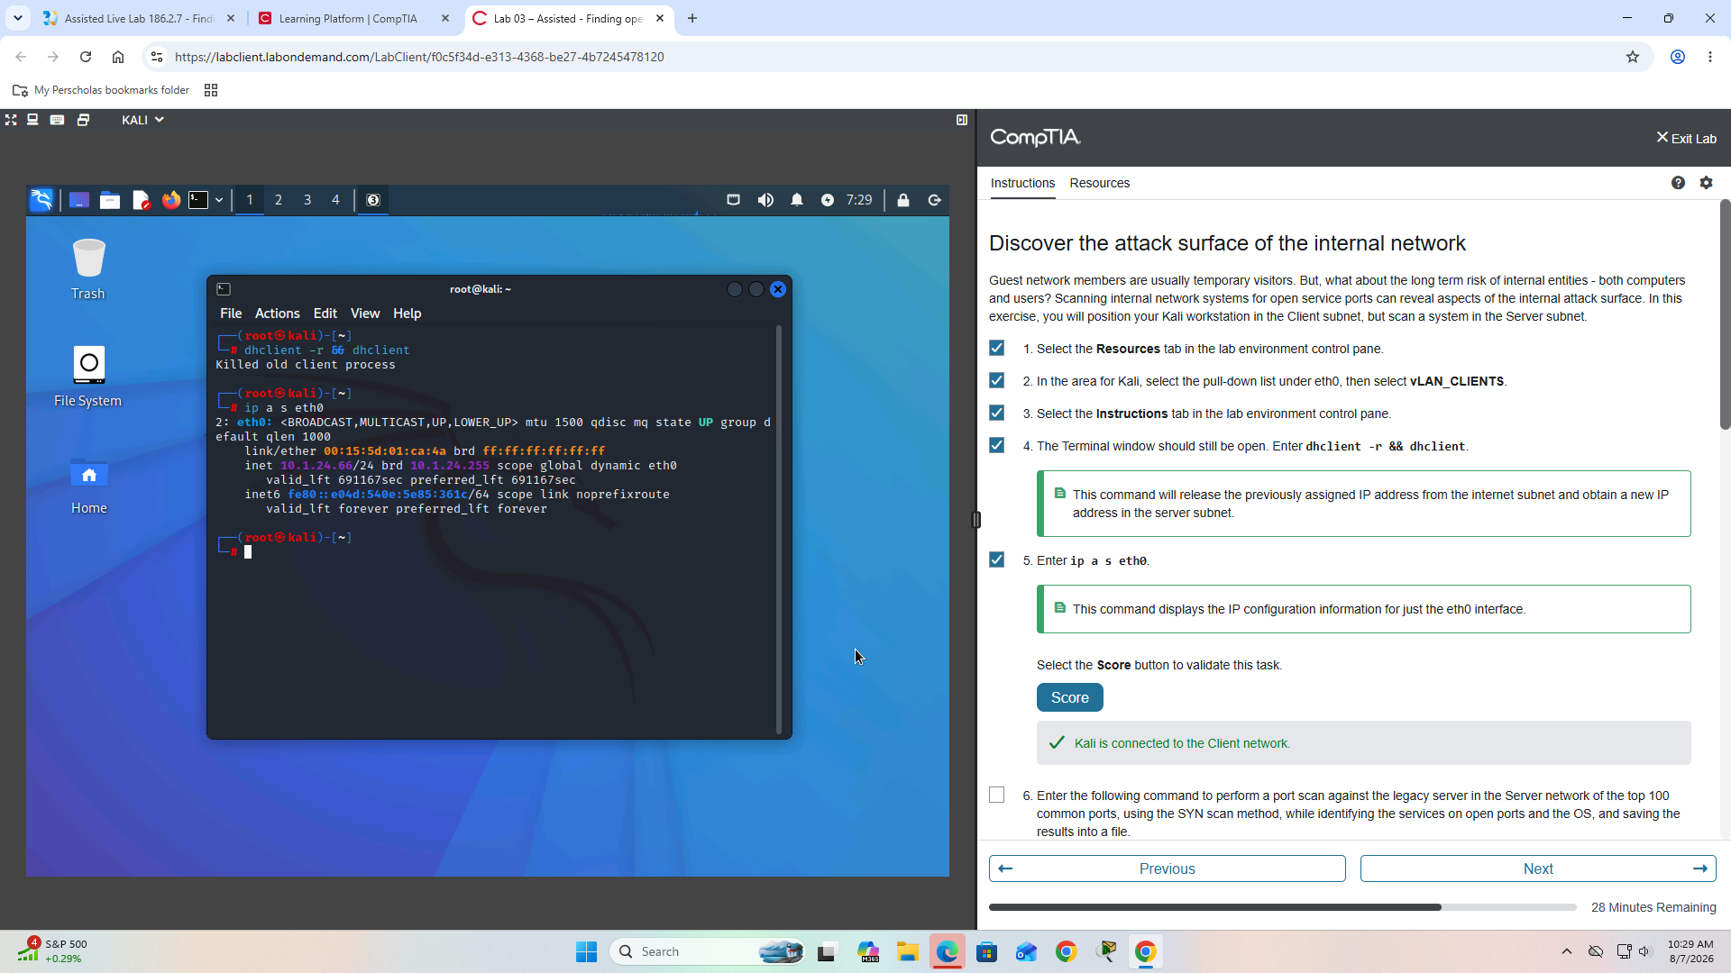
Figure 8. Kali connected to the Client network
Target: 10.1.16.2
nmap 10.1.16.2 -F -sS -sV -O -oN server-scan.nmap
Port | Service
25 | SMTP
80 | HTTP
111 | RPCBind
135 | MSRPC
139 | NetBIOS-SSN
143 | IMAP
443 | HTTPS
445 | Microsoft-DS / SMB
587 | SMTP
2049 | Mount/NFS
3306 | MySQL
5357 | HTTP
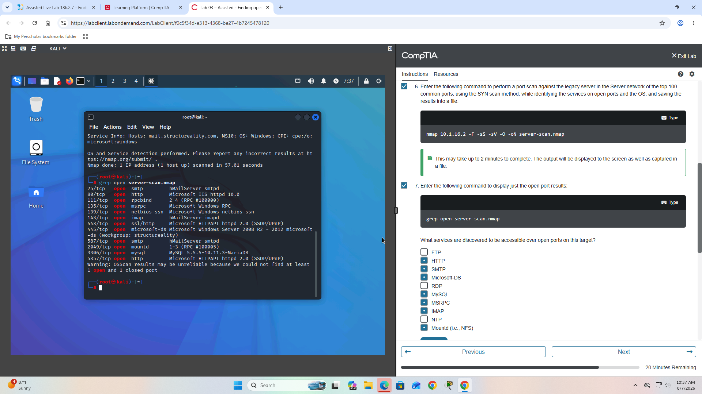
Figure 9. Internal server Nmap scan and service enumeration
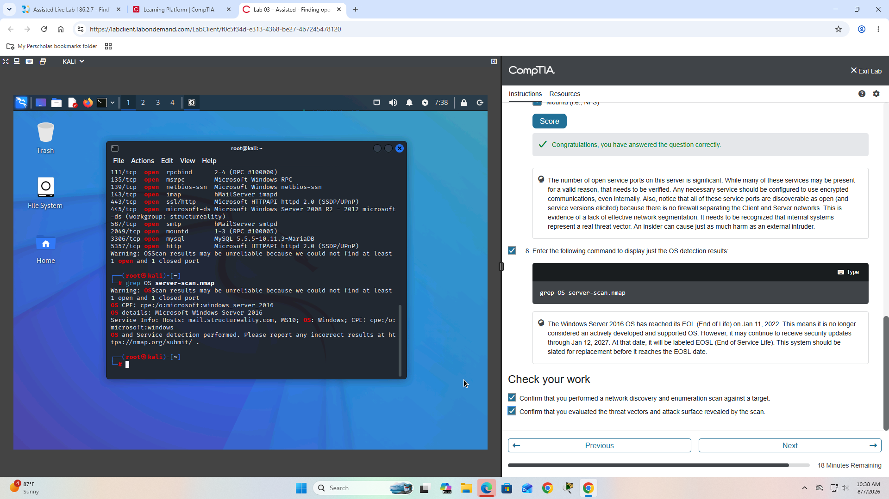
Figure 10. Internal server findings and OS detection
OS detected: Microsoft Windows Server 2016

Key Security Findings
Excessive open ports: The internal server exposed numerous services. Every unnecessary service creates another possible attack path.
Weak network segmentation: The client network could discover many services on the Server network, indicating that stronger segmentation and firewall filtering may be appropriate.
SMB exposure: TCP port 445 exposed Microsoft-DS/SMB, a service frequently targeted during lateral movement and ransomware activity.
Database exposure: TCP port 3306 exposed MySQL. Database connectivity should be restricted to authorized application servers and administrative systems.
OS and service disclosure: Nmap identified operating-system and service information that could help an attacker select platform-specific exploits.

Recommended Security Controls
- Close unnecessary ports and disable unused services
- Implement VLAN segmentation
- Configure firewall ACLs between security zones
- Restrict firewall management interfaces
- Limit SMB and RPC access
- Restrict database access
- Use encrypted protocols
- Patch operating systems and applications
- Replace unsupported systems
- Perform regular vulnerability scanning
- Monitor suspicious activity with IDS/IPS and SIEM
- Apply least-privilege network access

Commands Used
nmap 203.0.113.1 -F -sS -sV -O -Pn -oN border-scan.nmap
grep open border-scan.nmap
grep OS border-scan.nmap
dhclient -r && dhclient
ip a s eth0
grep open guest-scan.nmap
grep OS guest-scan.nmap
nmap 10.1.16.2 -F -sS -sV -O -oN server-scan.nmap
grep open server-scan.nmap
grep OS server-scan.nmap

What I Learned
This lab strengthened practical understanding of Nmap reconnaissance, TCP SYN scanning, service enumeration, OS fingerprinting, firewall exposure, network segmentation, threat vectors, attack-surface reduction, security risk assessment, and remediation planning. The exercise demonstrated that open ports should be evaluated based on business need and that effective security requires both perimeter protection and proper internal segmentation.

Lab Result
CompTIA Security+ Assisted Lab: Finding Open Service Ports
Score: 12/12 - Successfully Completed
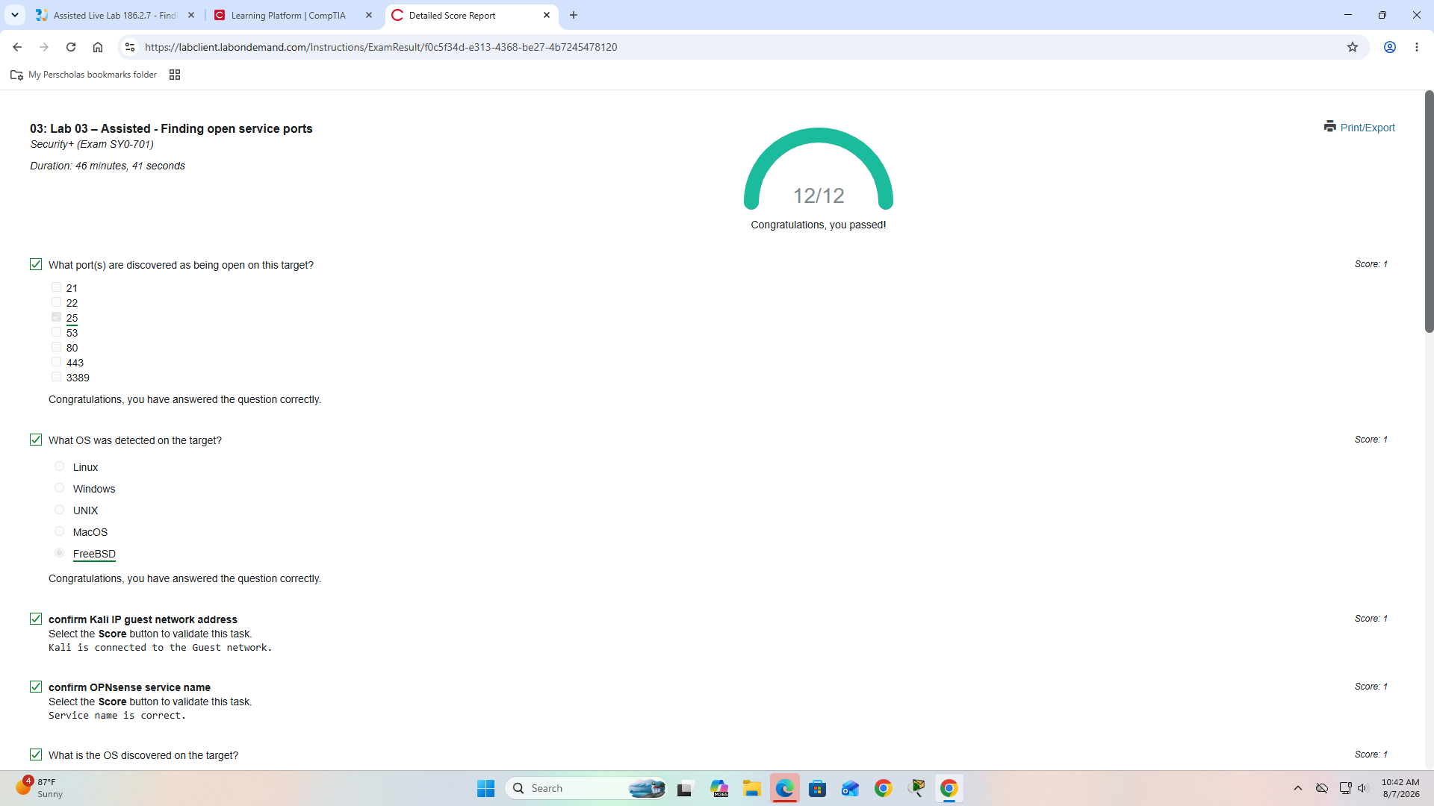
Figure 11. Detailed score report showing 12/12 completion

Disclaimer
This project was completed for educational purposes in an authorized CompTIA cybersecurity training environment. No unauthorized systems were scanned or tested.

