SET Social Engineering Simulation & Defensive Analysis
Authorized CompTIA Security+ Hands-On Lab Portfolio Project
Lab Result: 100%

Project Overview
This report documents an authorized CompTIA Security+ lab focused on social-engineering simulation and defensive analysis using Kali Linux, the Social-Engineer Toolkit (SET), Metasploit, Meterpreter, Sendmail, Thunderbird, and a Windows Server 2016 target VM.
The project emphasizes attack-chain understanding, security-awareness lessons, detection opportunities, and defensive controls rather than real-world exploitation.

Objectives
- Explore SET and identify supported social-engineering attack vectors.
- Analyze spear-phishing and mass-mailer workflows.
- Observe controlled listener/session behavior using Metasploit and Meterpreter.
- Review the phishing message from both attacker and victim perspectives.
- Identify client-side protections and security-awareness controls that can interrupt the attack chain.

Tools and Technologies
Tool / Technology | Purpose
Kali Linux | Security-testing workstation
Social-Engineer Toolkit (SET) | Social-engineering simulation framework
Metasploit Framework | Controlled listener and session handling
Meterpreter | Lab session validation and system information
Sendmail | Simulated mail delivery
Thunderbird | Victim-side email client
Windows Server 2016 | Target system in the lab

Lab Workflow and Evidence

1. Lab Scenario
The lab scenario authorized a simulated social-engineering assessment using SET in a controlled environment.
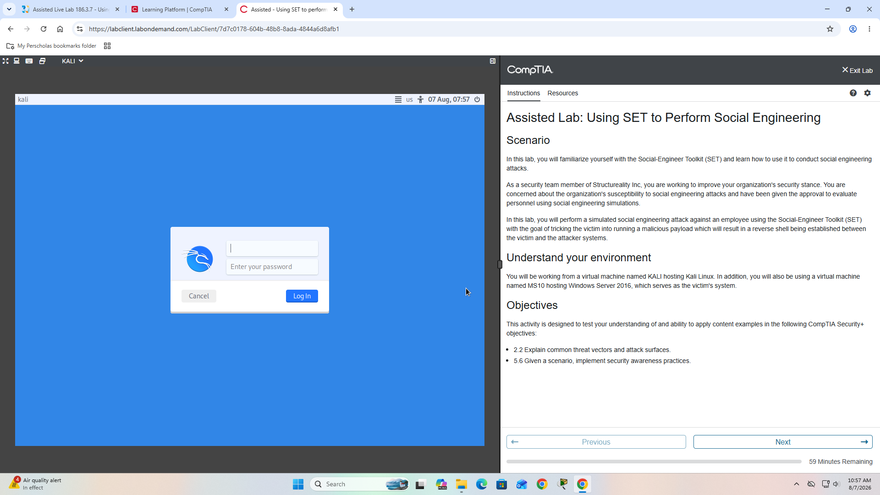
01 Lab Overview

2. SET Exploration
SET presented multiple attack-vector categories, including spear phishing, website attacks, infectious media, mass mailer, QR code, PowerShell, wireless, Arduino-based, and third-party modules.
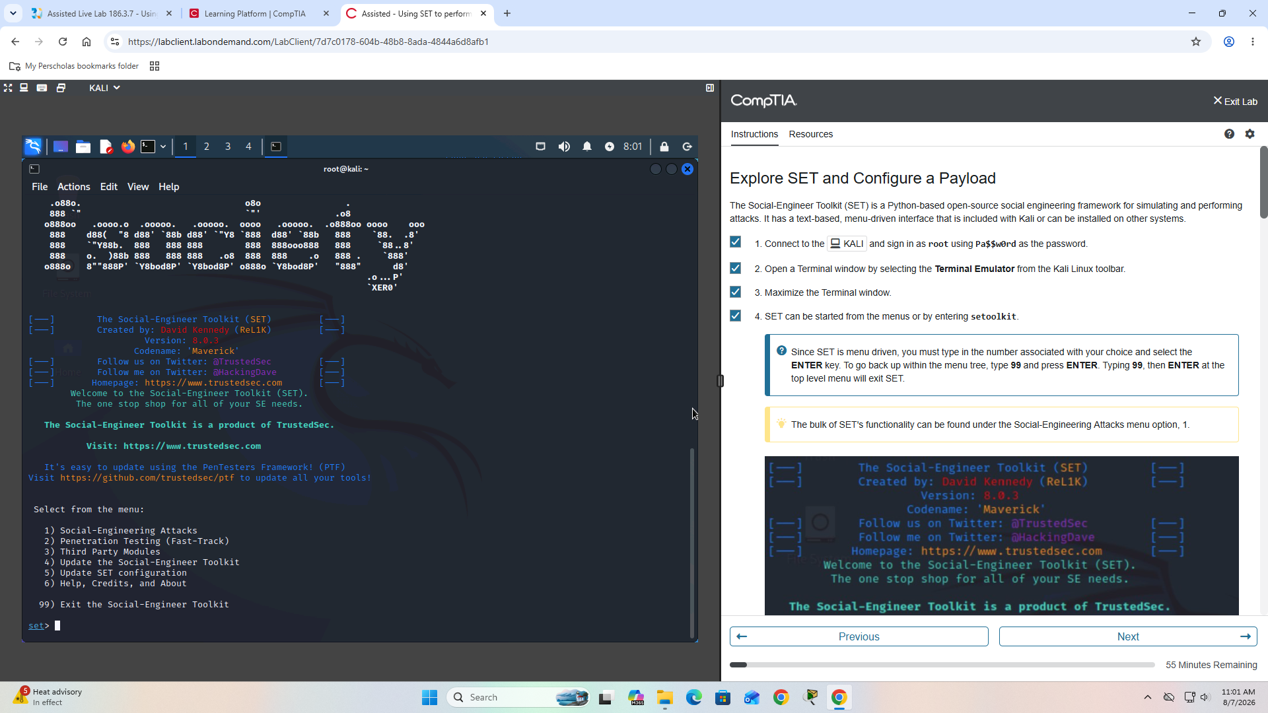
02 Set Main Menu

3. Spear-Phishing Concepts
The spear-phishing module illustrated how targeted email simulations can be created to test user susceptibility and security controls.
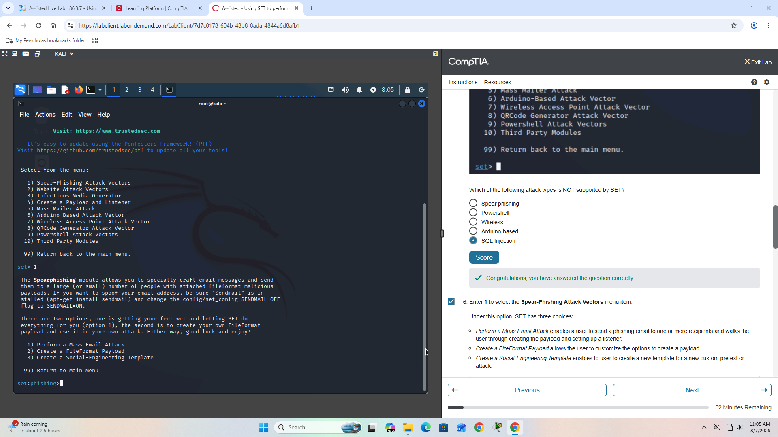
03 Spear Phishing Module

4. Mailer and Sender-Spoofing Concepts
The lab reviewed Sendmail and mass-mailer functionality, demonstrating how trusted-looking sender identities and urgent messaging can influence user behavior.
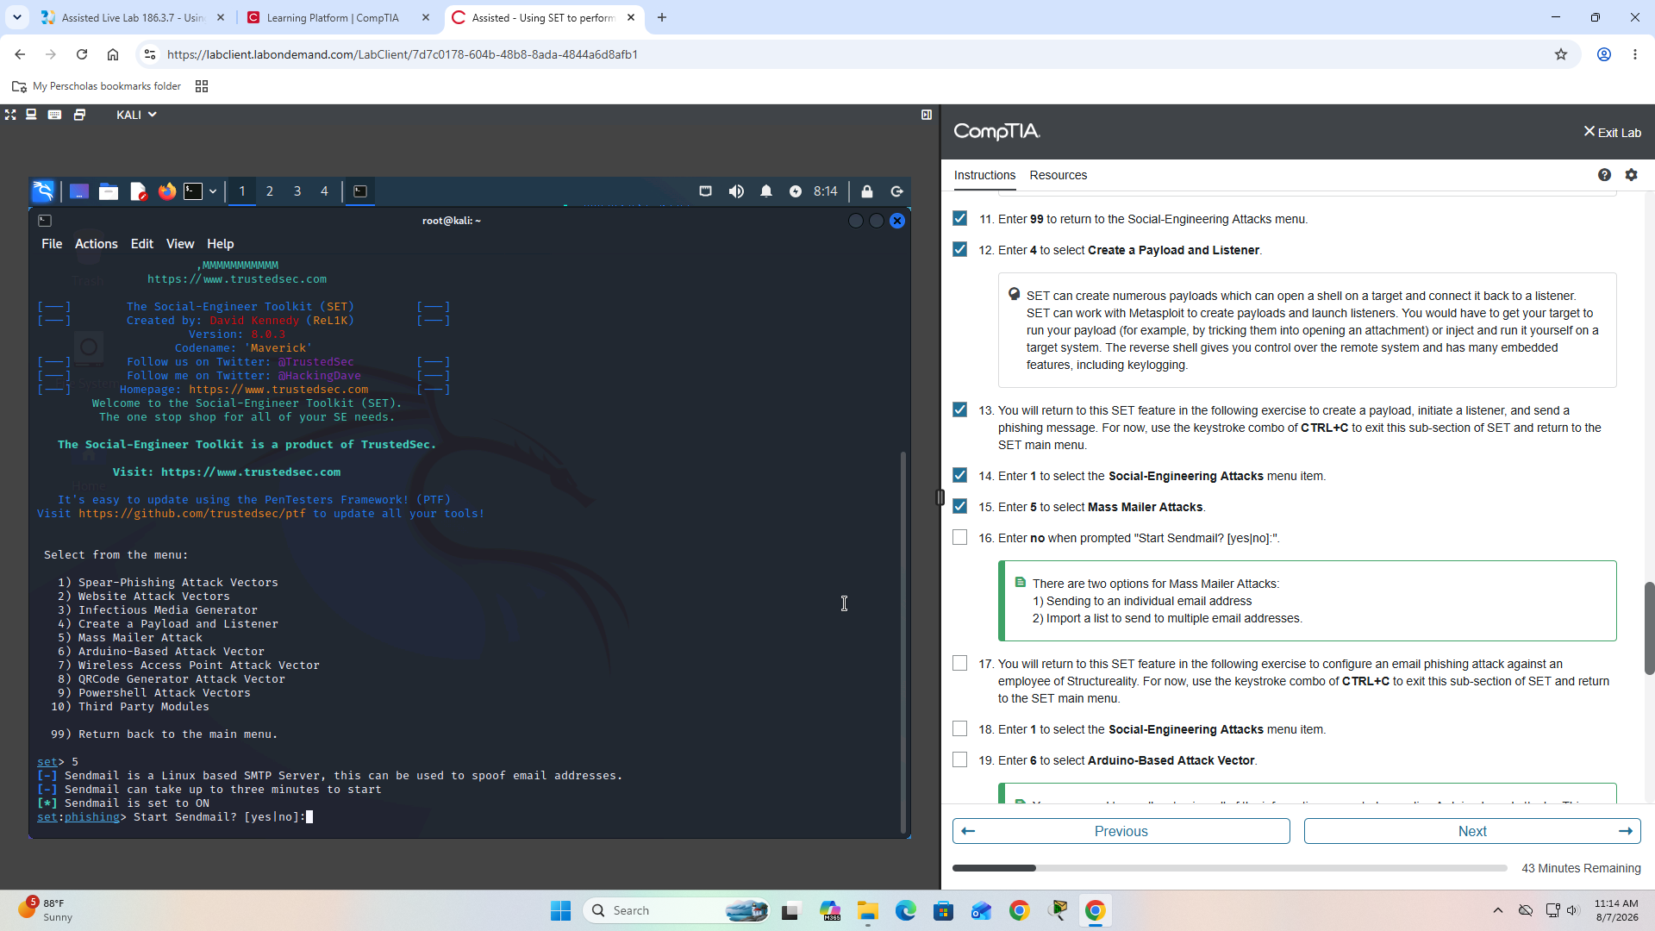
05 Sendmail Mass Mailer

5. Controlled Listener
SET integrated with Metasploit to start a controlled handler in the training environment. This stage demonstrates the importance of blocking untrusted execution before a session can be established.
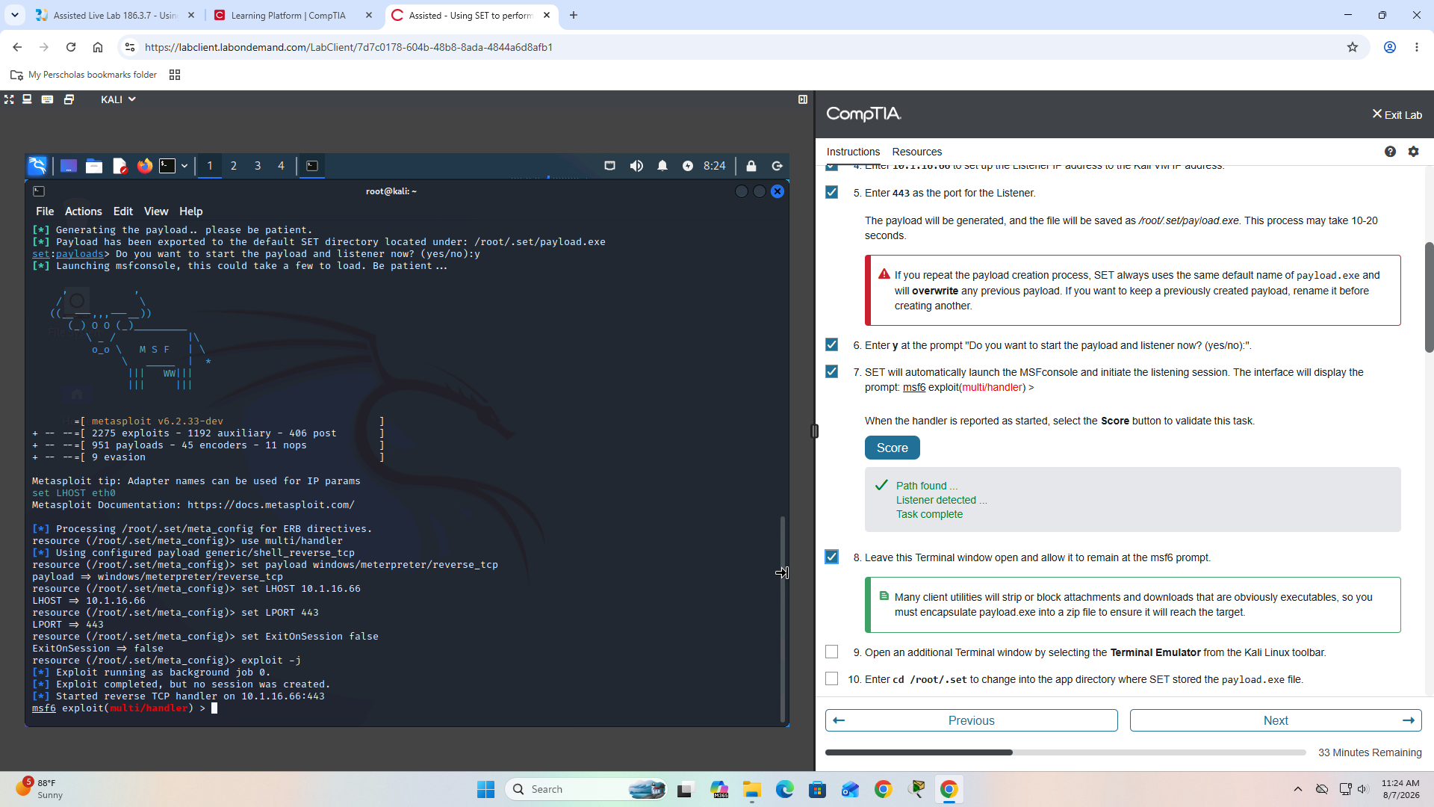
08 Listener Started

6. Simulated Phishing Email
A simulated 'Important Account Update' message was delivered to the victim mailbox. The message used urgency, authority, and a direct download link as social-engineering techniques.
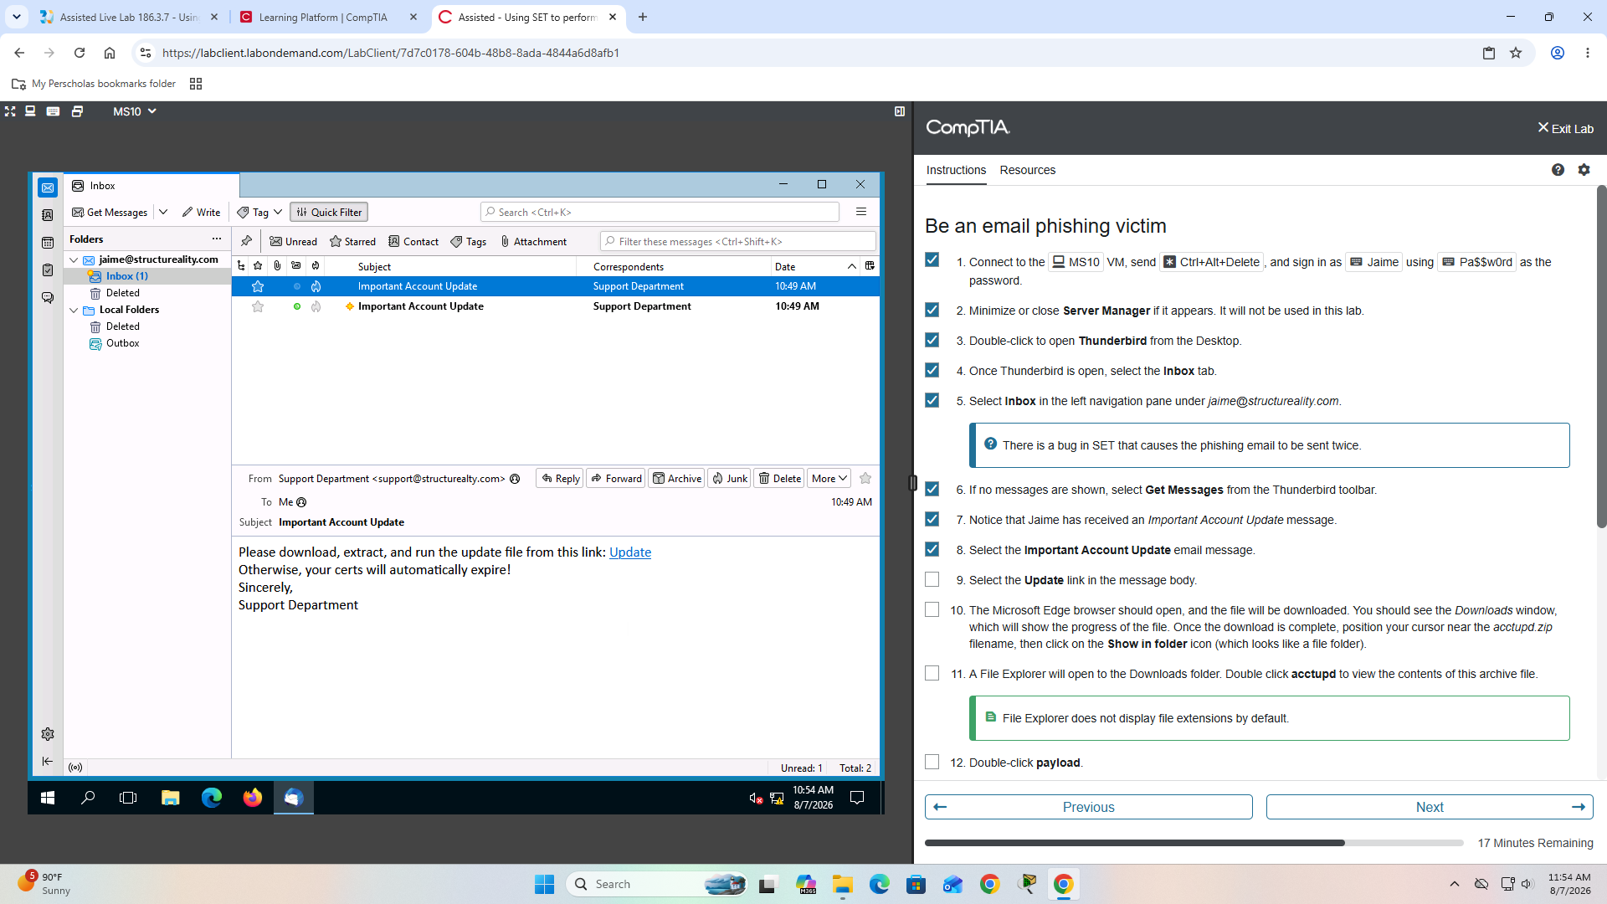
10 Phishing Email Received

7. Session Validation
After the simulated interaction, the handler became active and system information identified the lab target as MS10 running Windows Server 2016.
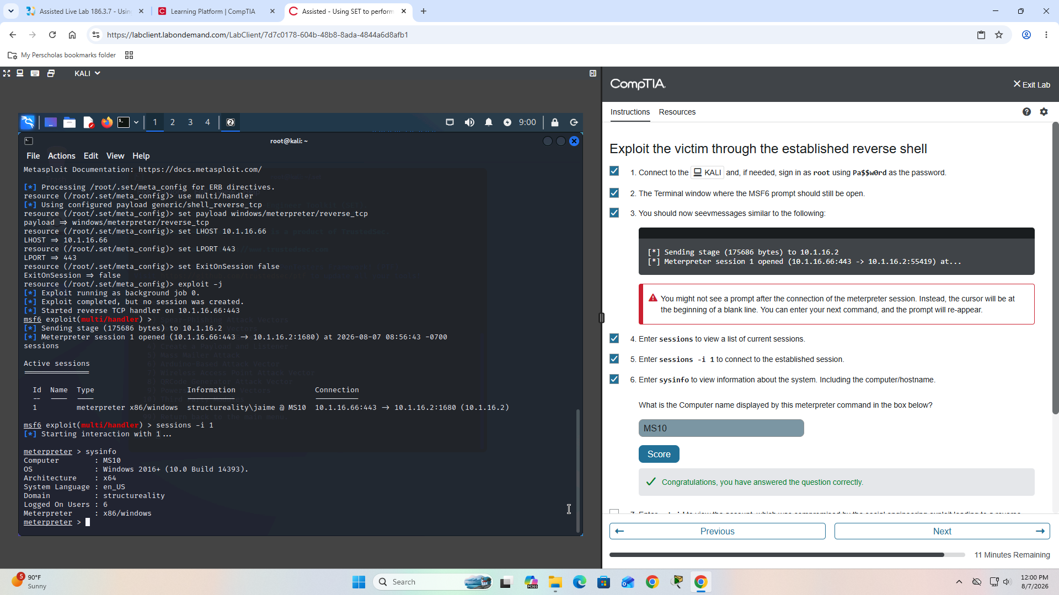
12 Meterpreter Sysinfo

Key Security Findings
Human interaction is a critical attack surface: The simulated attack depended on the victim trusting the message and interacting with supplied content. Organizations should combine awareness training with technical controls.
Trusted-looking sender identities increase credibility: Sender presentation can create false trust. SPF, DKIM, DMARC, secure email gateways, and verification procedures reduce this risk.
Client-side controls can break the attack chain: The lab score report identifies client-side security blocking execution as a key limitation. EDR, application allowlisting, attachment scanning, browser protections, and least privilege are important.
Unexpected files from email should not be executed: The lab identifies avoiding execution of files from email as the primary defense against the demonstrated scenario.
Social engineering is multi-channel: SET exposed email, web, removable-media, wireless, QR-code, PowerShell, and third-party concepts, showing that awareness programs should extend beyond traditional phishing email.

Recommended Defensive Controls
- Recurring security-awareness training and phishing simulations.
- SPF, DKIM, DMARC, secure email gateways, URL scanning, and attachment sandboxing.
- EDR/antimalware, application allowlisting, least privilege, and browser download protections.
- PowerShell logging and hardening, DNS/web filtering, IDS/IPS, and SIEM monitoring.
- Clear reporting procedures and out-of-band verification of unusual or urgent requests.

What I Learned
The lab demonstrated that social engineering succeeds by combining technical capability with human behavior. The strongest defense is layered: user awareness, email authentication, endpoint protection, network controls, monitoring, and rapid incident reporting.

Ethical Use Notice
This project documents an authorized training exercise performed in a controlled CompTIA lab environment. It is intended for cybersecurity education, defensive security learning, and professional portfolio demonstration only.

