**Rancap, Joshua A.**

**BSCS-4A**

**Import Necessary Libraries**

* The following libraries were imported to perform image processing tasks:

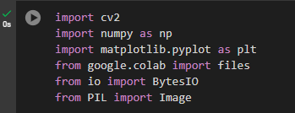

**Load the Image**

* The code to load an image from local files is used to begin the image processing steps. This setup allows for further manipulations on the uploaded image.

**Image Transformations (Scaling and Rotation)**

* **Scaling:** The **scale_image** function scales an image by a given factor. The image was scaled by 50%.

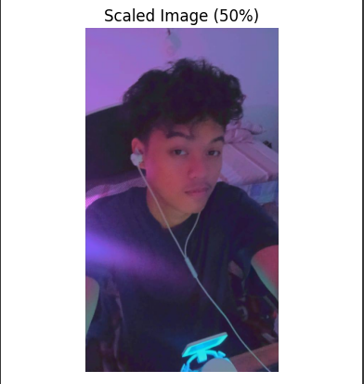

* **Rotation:** The **rotate_image** function rotates the image by a specified angle. The image was rotated by 45 degrees.

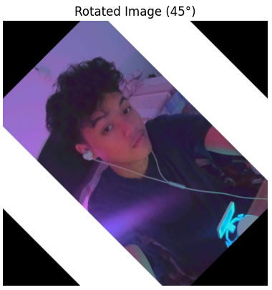

**Filtering Techniques (Blurring and Edge Detection)**

* **Gaussian Blur:** Applied a Gaussian blur with a 5x5 kernel.

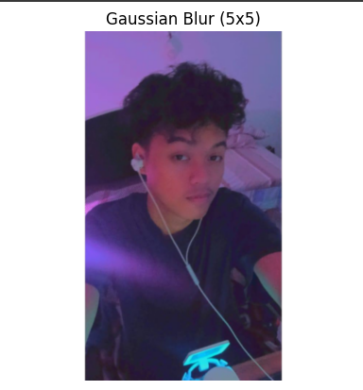

* **Median Blur:** Applied a median blur with a 5x5 kernel.

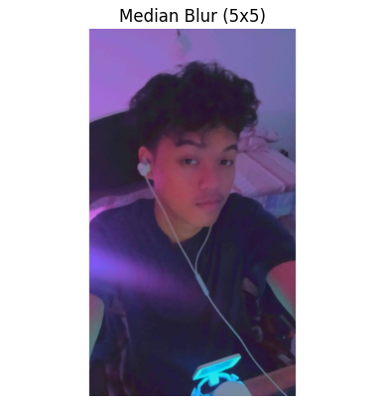

* **Canny Edge Detection:** Detected edges in the image using Canny edge detection with thresholds of 100 and 200.

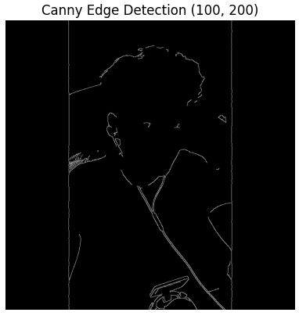

**Save Results to PDF**

* The processed images were compiled into a PDF file. The code creates a figure with subplots showing the original and processed images, and saves them to the PDF file.