1. **Incentive compatibility**: a mechanism is called incentive-compatible if every participant can achieve the best outcome to him/herself just by acting according to his/her true preferences.

There are several different degrees of incentive-compatibility:

* The stronger degree is **Dominant-strategy incentive-compatibility.** It seems that truth-telling is a weakly-dominant strategy. I.e, you fare best by being truthful, regardless of what the others do (even if they are irrational or even collude against you). In DSIC mechanism, strategy considerations cannot help any agent achieve better outcomes than the truth; (只有在说真话的情况下才能得到好的收益)
* A weaker degree is **Bayesian-Nash incentive-compatibility (BNIC).** It means that there is a Bayesian Nash equilibrium in which all participants reveal their true preferences. I.e, if all the others act truthfully, then it is also best for you to be truthful.

1. 实验结果图可以包含如下图：

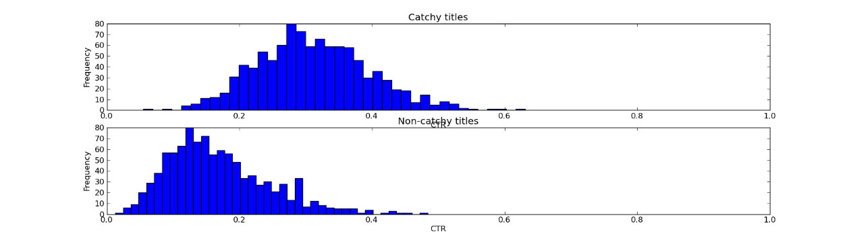

图中表示的含义是一个worker完成的概率，“完成”或者“不完成”。也就是说可以绘制节点完成任务的概率分布。

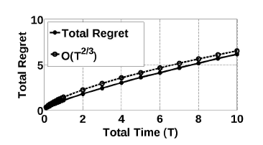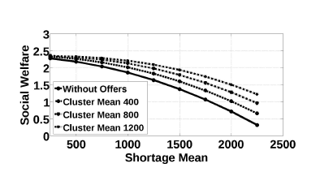

另外一个结果图是如上所示，肯定需要一个图表示Regret变化的情况。

1. Beta分布；指一组定义在(0,1) 区间的连续概率分布，有两个参数α和β。

概率密度函数：

