Lemongrass Acoustic Trio
linktr.ee/lemongrassgoa

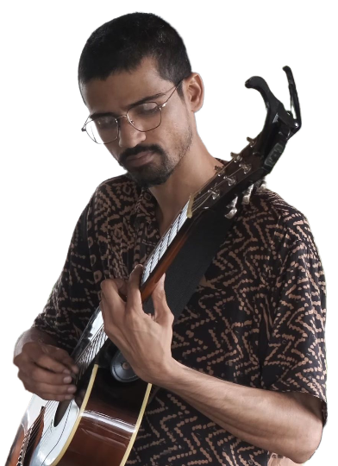

Joy Dawson
Guitar
Vocals

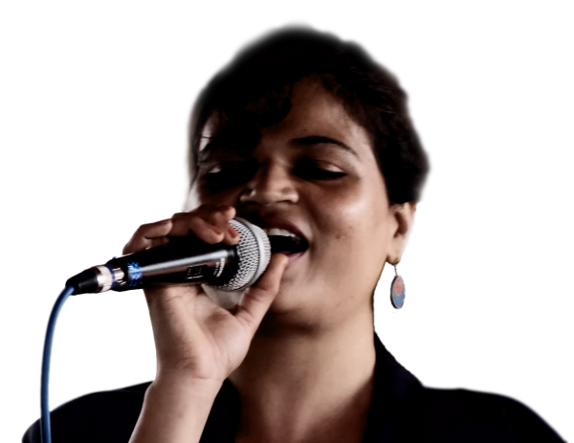

Cecilia Dawson
Vocals
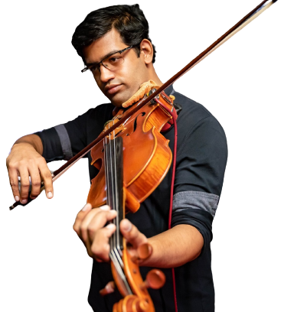

Anand Lobo
Mandolin
Viola
Vocals
Percussion

Music style: (See our complete repertoire at lemongrassgoa.com/list)
- Classic hits, “oldies”
- Assorted popular songs
- Western classical, blues
Instrumentation:
- Trio: Joy Dawson, Cecilia Dawson, Anand Lobo
- Duo: Joy Dawson, Cecilia Dawson OR Joy Dawson, Anand Lobo
- Instrumental duo (no vocals): Joy Dawson, Anand Lobo
- Solo: Joy Dawson
We can provide our own sound setup sufficient for small gatherings up to 30 people. Larger events will require additional equipment; to be discussed in advance.
Sound setup is handled by Anand Lobo.
Equipment:
- 3x vocal microphone
- 3x instruments (guitar, viola, mandolin)
- 1x PA speaker (Gemini AS-08P) *
- 1x mixer (Soundcraft Ui12)

Requirements:
- stage area 3m x 3m
- mains power outlet (for pedalboard / laptop / mixer)
- 3x tall chairs (bar stools or similar)

Contact:

Joy Dawson
+91 95616 51064
Anand Lobo
+91 75076 48215

