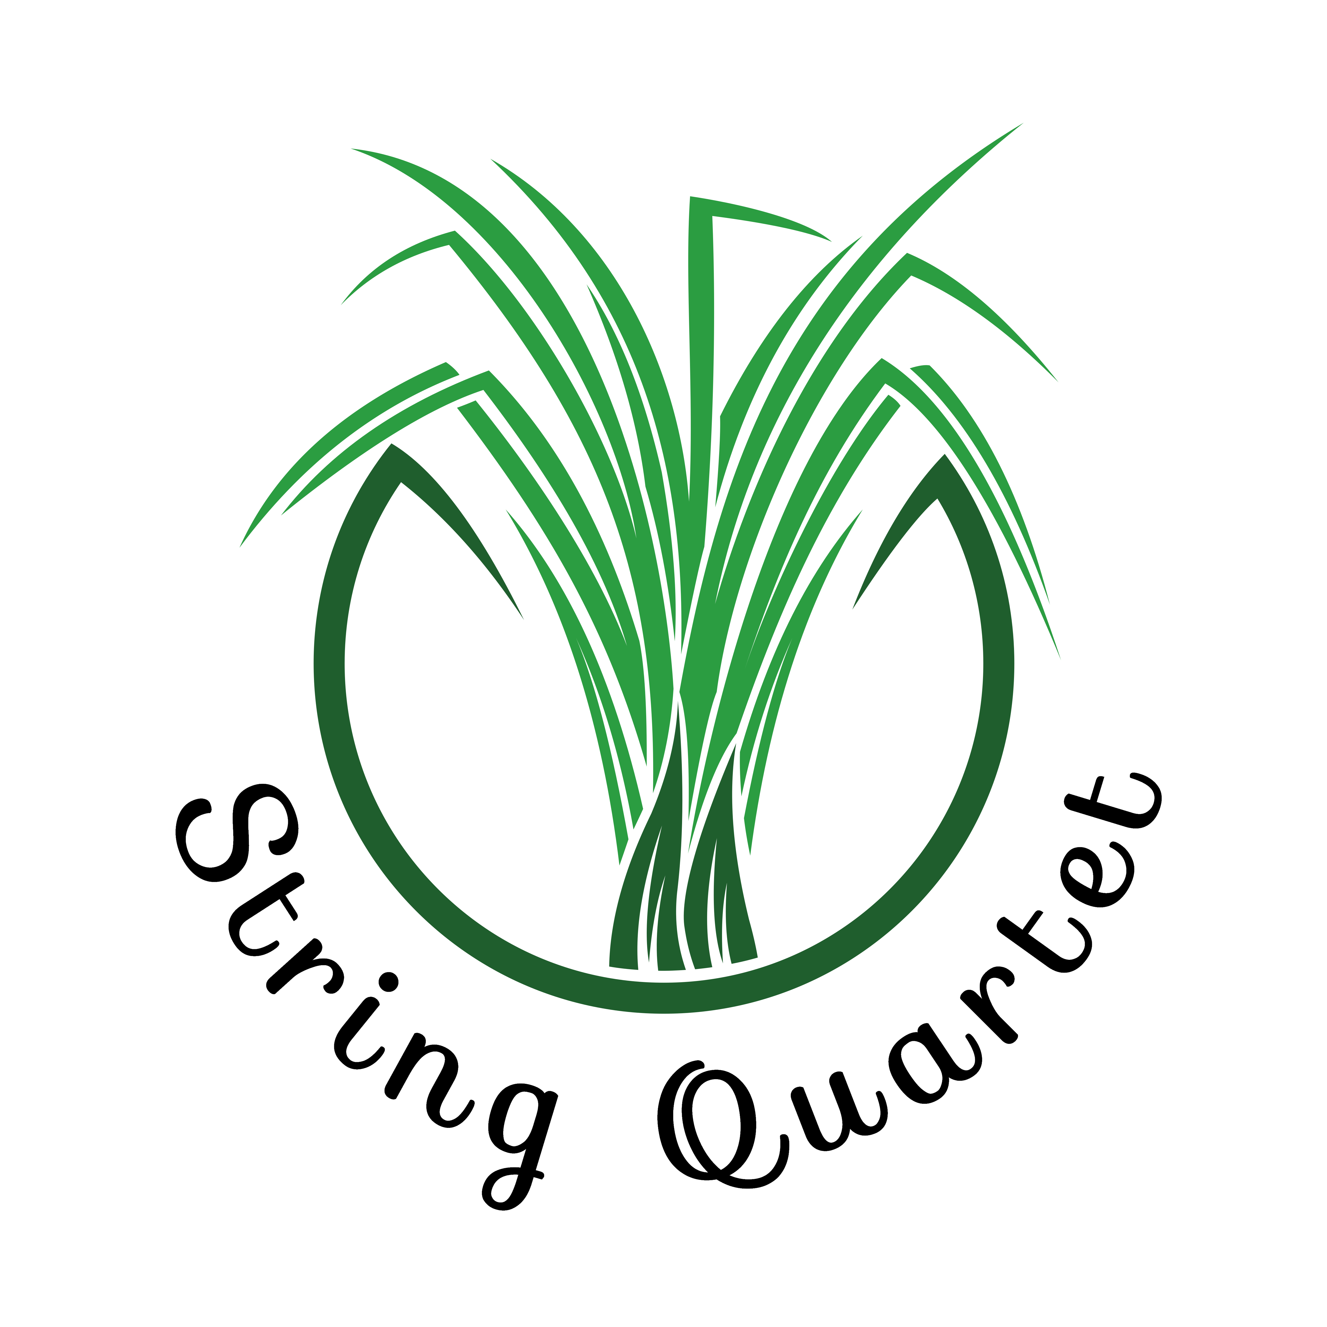


Strings and Stories

Sunday, August 30 2026

Renaissance
Robert White (1538–1574) |  | Fantasia No. 1
Richard Allison (1570?–1600?) |  | Quadro Pavane / Galliard

Other composers
Thomas Tallis, William Byrd, John Dowland, Maddalena Casulana, Caterina Assandra

Baroque
Johann Pachelbel (1653–1706) |  | Canon and Gigue, P. 37 • 2. Gigue
Antonio Vivaldi (1678–1741) |  | The Four Seasons, RV 297: Winter • 2. Largo
Johann Sebastian Bach (1685–1750) |  | Cantata BWV 147 • Jesu bleibet meine Freude
George Frideric Handel (1685–1759) |  | Water Music Suite No. 2, HWV 349 • 2. Alla hornpipe
 |  | Water Music Suite No. 3, HWV 350 • 2. Rigaudon

Other composers
Arcangelo Corelli, Georg Philipp Telemann, Domenico Scarlatti,
Barbara Strozzi, Élisabeth Jacquet de La Guerre

Classical / Romantic
Wolfgang Amadeus Mozart (1756–1791) |  | Eine Kleine Nachtmusik, K. 525 • 3. Menuett
Ludwig van Beethoven (1770–1827) |  | 6 Minuets, WoO 10 • 2. Minuet in G
 |  | Piano Sonata No. 8, Op. 13 • 2. Adagio cantabile
Fanny Hensel (née Mendelssohn) (1805–1847) |  | String Quartet in E♭, H. 277 • 1. Adagio ma non troppo
Francisco Tárrega (1852-1909) |  | Gran Vals

Other composers
Carl Philipp Emanuel Bach, Joseph Haydn, Luigi Boccherini, Marianna Martines,
Maria Theresia von Paradis, Felix Mendelssohn, Robert Schumann, Clara Schumann, Franz Schubert, Johannes Brahms, Isaac Albéniz, Enrique Granados, Camille Saint-Saëns, Antonín Dvořák, Edvard Grieg

Modern
Dmitri Shostakovich (1906–1975) |  | Suite for Variety Orchestra No. 1 • 7. Waltz II

Other composers
Igor Stravinsky, Sergei Prokofiev, Sergei Rachmaninoff, Maurice Ravel, Béla Bartók

