xmerl

Types

getURI

W

E

B

S

E

R

V

I

C

E

**W**

**S**

**D**

**L**

WSDL

Operations

*Test File*

Y

A

W

S

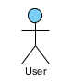

Data

Generation

SOAP Test(s)

PropEr

response(s)