Tweet-retweet social networks in the anti-vaccination community

**Introduction and Rationale**

Public health officials have been at odds with the vocal anti-vaccination minority since the inception of vaccination itself. Much research has been dedicated to understanding the determinants, predictive traits, and persuasive arguments of the anti-vaccination community in order to develop effective interventions and pro-vaccination campaigns targeting this population. However, little research has questioned the actual persuasiveness of anti-vaccination proponents, nor the susceptibility of ‘fence-sitters’ (those who have not cemented an opinion on vaccination) to believing misinformation. This dimension is a crucial one to building an effective strategy to combat anti-vaccination misinformation, because resources may be mistakenly allocated to over-insulated online communities that have low risk of persuading anybody. Using a mixture of natural language processing and social network analysis, this study uses two target tweets (one pro- and one anti-vaccination) as case studies to understand the predictive power on users who retweeted one of the target tweets.

**Literature Review**

Since the invention of vaccination in 1796, the safety of the procedure and the intentions of the medical profession has been questioned by a small, vocal few. The modern-day incarnation of these concerns now resides online, where the majority of the anti-vaccination community lives on twitter (Stahl et al., 2016). However, it’s common knowledge that vaccination has increased life expectancy, lowered infant mortality, and nearly eradicated life-threatening illnesses such as pox and polio. Furthermore, current anti-vaccination theories such as a link between the MMR vaccination and autism have been scientifically discredited and the original 1998 article has been retracted (DeStefano & Shimabukuro, 2019). Despite the mounting evidence in support of vaccination and the passing of recent laws for mandatory vaccination in the United States, the anti-vaccination community remains as an impactful subculture.

Research into the spread of health misinformation is vital because spreading misinformation can cause enormous lasting effects on both public health and politics. In the case of public health, the relationship is obvious: those who question the efficacy and safety of vaccines are less likely to vaccinate themselves or their children and therefore are placed in increased risk of preventable, life-threatening illnesses such as measles and polio. The relationship is not just conjecture, the Center for Disease Control (CDC) has been reporting on how the anti-vaccination community has contributed to measles outbreaks (Patel et al., 2019). Herd immunity, the minimum threshold of immunity that a population needs in order to decrease transmission of the infection between susceptible members, is also weakening as the anti-vaccination community grows (Fine et al., 2011). Immunity to infectious disease is best produced through vaccination, so decreasing the proportion of vaccinated members in a population increases the opportunity for viral outbreaks.

In the case of politics, the anti-vaccination community does not seem to have an express political ideology towards liberalism or conservatism (Dredze et al., 2017; Rossen et al., 2019). However, it is within the political interests of the anti-vaccination community to elect government officials that are willing to implement vaccination reducing policies. All fifty states mandate vaccinations for children to enter public school, and most universities also require vaccination. On the state level, some exemptions are available, either on philosophical/religious grounds or on medical grounds like an allergy to vaccine components. A common example of a religious exemption for mandatory vaccination is the Orthodox Jewish community, where vaccines are often not considered kosher. However, five states have eliminated their non-medical exemption policies (*States With Religious and Philosophical Exemptions From School Immunization Requirements*, n.d.), with one notable example being the SB 276 bill in California that was passed on September 9, 2019. This senate bill was a follow-up to the 2015 SB 277, which had a loophole allowing medical exemptions to be easily fabricated. Anti-vaccination lobbyists strongly opposed both SB 276 and SB 277, with Robert Kennedy Jr. acting as spokesperson (Hassan, 2019; Kluger, 2019).

Social scientists are interested in better understanding what exactly leads to ‘vaccine hesitancy,’ which is the choice to delay or reject vaccination for themselves or their children for epidemiological or political reasons. The decision to not vaccinate is a complex social and individual process that requires exploration and scientific explanation. This scientific understanding can also inform intervention and outreach, so as to avoid further lowered herd immunity and increased outbreaks. The following is an overview of the current state of scientific literature regarding the anti-vaccination on three units of analysis: the content of anti-vaccination resources (online discourse, news articles, etc.), the individual, and the community. Each level of analysis is characterized by distinct methodologies and theoretical models, but are united towards the goal of understanding what the underlying causes and predictors are of vaccine hesitancy.

*Thematic content of the anti-vaccination argument*

Dredze and colleagues researched anti-vaccination lobbying during the 2016 election using tweets containing 1) an anti-vaccination hashtag and 2) a reply/mention of one of the four major presidential candidates (Trump, H. Clinton, Stein, and Johnson). They found that anti-vaccination lobbyists had a positive sentiment for Trump, a negative sentiment for H. Clinton, and a mixed sentiment towards Stein. They also found that the majority of Trump-related tweets claimed that Trump would support anti-vaccination goals such as appoint a new CDC director, investigate the CDC, repeal mandated vaccination, and allow personal or philosophical exemptions. Though the political ideology of this vocal voter group is not inherently liberal nor conservative, they were ready to rally behind Trump as the candidate who would support their efforts.

Politics is not the only thing that the vaccine hesitant community talks about. Bradshaw and colleagues (2020) conducted a qualitative analysis of posts and comments on a private Facebook group for parents against or questioning vaccination. They were interested in what impact social influence has on the decision-making of vaccine-hesitant or fence-sitting mothers using the theoretical model of social influence theory (Kelman, 1958). Social influence theory comes in three stages: compliance, identification, and internalization. Compliance is when a person shows agreement with a belief or an opinion to a desired in-group without necessarily actually agreeing in order to gain awards or avoid punishment. Identification is a step up, where agreement comes from a desire to establish or maintain a social relationship with the desired in-group. The highest level of influence is internalization, where a person accepts influence that is congruent with their own belief system. For example, a mother that already believes that GMOs and pesticide-treated foods are unhealthy for infants might internalize the congruent belief that vaccines are chemical-based and therefore also unhealthy for infants. [NOTE: might want to move this chunk over to theoretical models’ section].

Bradshaw and colleagues found a series of interesting arguments used by group members to influence questioning parents at all three stages of social influence. Members a) used external informational resources to make their statements more credible, b) argued that good health can be achieved naturally, c) distrusted medical institutions such as doctors and the CDC, d) appealed to fears regarding side effects (often using anecdotal evidence or graphic images), e) claimed that contracting a vaccine-protected illness (measles, polio, etc.) was less risky than the vaccine itself, and f) treated maternal instinct as the best method for deciding the best for one’s child. In general, the most appealing and influential way to endorse anti-vaccination involved non-credible resources, misinformation, or anecdotal evidence within the argument.

Speaking of misinformation, a study conducted by Kang and colleagues (2017) built a semantic network of prominent themes extracted from pro-vaccination, anti-vaccination, and neutral news sources. They found that topics covered by the pro-vaccination sources were also generally covered by the anti-vaccination sources, but not vice versa. For example, both sources covered ‘SB-227’ (the full documentation of the California public school vaccination policy that SB-276 amended), but only the anti-vaccination community covered ‘mercury’ as a major topic. Generally, anti-vaccination articles were more interested in institutions and organizations such as doctors, the CDC, vaccine industry, and mainstream media than the pro-vaccination articles. Message framing also played an important role regarding the way pro- and anti-vaccination articles wrote about shared topics. Compared to pro-vaccination, anti-vaccination sources were more negative to institutions, had more fear-based terms such as ‘mandated vaccination’ or ‘side effects’, and relied on social commentary more than scientific evidence. The most central topic for the pro-vaccination community was ‘parents’, while the most central topic was ‘children’ for the anti-vaccination community. These findings support Bradshaw and colleagues’ analysis, where distrust in institutions, anecdotal evidence, appeals to fears and maternal instinct were also important to arguing against vaccination. In other words, the articles that anti-vaccination proponents cite likely also contain the same themes and arguments, as well as the same misinformation.

*Individual determinants of vaccine hesitancy*

Distrust in institutions, harm avoidance, protecting the freedom to choose, and body purity are common anti-vaccination arguments at the news level, so it’s unsurprising that these would also be common determinants of vaccine hesitancy at the individual level. Rossen and colleagues (2019) conducted a moral profile for vaccine accepters, rejectors, and fence-sitters using moral foundations theory. The theory claims that six foundational values determine a participant’s moral profile: “harm (concerned with violations to the safety and wellbeing of others), fairness (concerned with the pursuit of justice), in-group (favoring one's in-group first), authority (a preference for traditional societal structures and deference to those in positions of power), purity (an abhorrence for impurity of body or mind and ‘unnatural’ acts), and liberty (a preference for freedom and the rights of the individual),” (Rossen et al., 2019, p. 24). Vaccination rejectors and fence-sitters, in particular, were high in harm, fairness, liberty, and purity, and low in authority when compared to vaccination accepters. In other words, those who are anti-vaccination care about maintaining the autonomy to make decisions, bodily purity, avoiding harm or danger, and rejecting authority and institutions. In collaboration with Bradshaw and colleagues’ findings, fence-sitters who fit this moral profile may be more susceptible to internalization influence from the anti-vaccination community. However, Rossen and colleagues found that the majority of fence-sitters actually still intended to vaccinate; a surprising contradiction.

One thing that most researchers agree upon is that information-seeking and the quality of the information available are important factors in vaccine hesitancy (Allam et al., 2014; Bradshaw et al., 2020; Kang et al., 2017). Misinformation is a pernicious, abundant resource on the internet, and that abundancy has steadily grown since the events of the 2016 election and the coining of ‘fake news.’ Allcott and Gentzkow (2017) offer an ‘economics of fake news’ in their study of political fake news headlines in the 2016 election. From the perspective of utility, fake news is cheaper to produce and consume than real news because it requires less journalistic resources and inferring the accuracy of a claim is costly to the consumer’s resources. From the anecdotal perspective, the writers of these articles have generally admitted to two major incentives for spreading fake news: ad revenue (Dewey, 2016; Soares & Davey-Attlee, n.d.; Subramanian, 2017; Wordsworth, 2018) and political ideology (Oxenham, 2019; Sydell, 2016; Townsend, 2016). In the case of political ideology, there are both liberal and conservative fake news writers that are politically and ideologically motivated to create fake news. However, both liberal and conservative writers were motivated to write anti-Hillary Clinton articles. While one conservative writer wrote anti-Hillary Clinton fake news in order to support Donald Trump (Townsend, 2016), a group of liberal fake new writers wrote right-wing fake news stories in order to embarrass conservatives that believe and spread misinformation (Sydell, 2016) or sneak in leftist sentiment in a palatable format for conservative readers (Oxenham, 2019). Having a savvy understanding of online conventions and reliable indicators of content quality, known as media literacy, is an important trait for the modern consumer.

Most research into media literacy comes in the wake of the ‘fake news’ crisis of the 2016 United States Presidential elections, so they generally focus on political articles and headlines from that period in time. Though not inherently liberal or conservative, previous research supports the notion that the vaccine-hesitant community supported Donald Trump’s candidacy in the 2016 election (Dredze et al., 2017). Vaccine hesitancy and fake news literacy were parallel concerns during this time, where it was unclear how influential ‘fake news’ was in informing votership and how influential the small, vocal vaccination community was to Trump’s expected public health policies. Multiple studies were conducted regarding voters’ capacity to distinguish between real and fake news to better understand its impact. Allcott and Gentzkow (2017) wanted to estimate how many fake news headlines an average voter saw, as well as study what predicts accurate recognition of real and fake news headlines. They found that the average United States voter was exposed to an estimated one or more fake news headlines during the election campaign, and that education and media literacy were the primary significant predictors of fake news discernment, where lower education and media literacy predicted lower accuracy in differentiating between real and fake news.

These findings are further illuminated by the work of Effron and Raj (2020), who wanted to understand why fake news propagates online, even when obviously sensationalized. They found that, regardless if the participant believed the headline or not, seeing the headline even once made it seem less unethical to share it. These results in tandem insinuate that misinformation, even when correctly identified, may still be propagated through a social network due to the demoralizing effect of fake news headline exposure and that participants were likely exposed to a fake news headline at least once in 2016. Extrapolating these findings into the anti-vaccination context, it is possible that the same mix of exposure effects, lower media literacy, and lower education explain the spread of anti-vaccination misinformation on twitter, especially in the case of hyperlinked or quoted articles with eye-catching or shocking headlines.

*Social Network determinants of vaccine hesitancy*

Social behaviors are also a potential predictor of vaccine hesitancy, specifically online socialization. One study on recent mothers wanted to see if intention to vaccinate was related to level of socialization (Vrdelja et al., 2018). The researchers found that higher socialization was correlated with higher concern for vaccination, where seeking information online and amongst other mothers led to higher concern and vice versa, creating a feedback loop. They also found that more active communication was associated with supporting vegetarianism, seeking alternative opinions, and questioning science. From these results, the researchers concluded that the best intervention is to increase the accuracy and informational richness of communication resources online and in new mother social circles.

The internet is becoming an increasingly popular resource for health information (Allam et al., 2014). This is especially true of women, who search for medical information more frequently than men (Vrdelja et al., 2018). Vaccine-hesitant parents, especially first-time mothers, may question a doctor or pediatrician’s recommendation to vaccinate their child and will look to their social circles and the internet for alternative information. However, a study by Allam and colleagues in 2014 found evidence that search engines are incidentally predisposed to suggesting negative keywords in the case of health-related search queries. Since these questions are rarely asked in the case of perfect health on the part of the user, the underlying search engine optimization has linked health concerns with negative search results such as side effects.

The researchers used an experimental design where participants were asked to use a search engine to research vaccination. One third of the participants were given a search engine optimized towards scientific and positive medical literature and resources, another third was given a search engine optimized towards negative and threatening resources regarding side effects, and the rest were given the regular Google search engine results. It is unsurprising that participants in the positive search condition were the best educated on, and most supportive of, vaccination. Also unsurprising is that participants in the negative search condition were worse educated and most concerned regarding the safety of vaccines. However, a surprising finding is that the Google users felt as if they were more knowledgeable regarding vaccines but actually were not, and also had increased concern regarding vaccine safety. These findings are a testament to the surreptitious effect of search engine results.

When the vaccine-hesitant and fence-sitters go online seeking information through communities of anti-vaccination proponents, as these studies suggest, what do they find? As already described during the thematic content of the anti-vaccination argument section of this literature review, there is plenty of anti-vaccination news sources and other persuasive materials on the internet. However, these materials often need to propagate through online social networks in order to gain an audience. Twitter, for example, allows users to ‘retweet’ a link to a blog post or news article so that any user that follows the retweeter will also be exposed to the link. This tweet can be passed down along the chain indefinitely, but will always be constrained by the structure of the social network itself.

A study of anti-vaccine discourse on Twitter from 2010 to 2019 described the longitudinal development of the pro- and anti-vaccination community structures (Gunaratne et al., 2019). They partitioned the communities based on the hashtag score, where the score represented the arithmetic sum of pro-vaccine (+1) and anti-vaccine (-1) hashtags used within the body of the tweet. They found that 86% of users tweeting about vaccination exclusively tweeted pro-vaccine hashtags, while only 12% exclusively tweeted anti-vaccination hashtags. Amongst responses to tweets, a larger proportion were of the same alignment (ex. pro-vaccination replies to a pro-vaccination tweet) than were of different alignments. While the proportion of anti-vaccination users is diminutive, anti-vaccination tweets comprised 35% of the total sample of vaccination tweets, while pro-vaccination tweets comprised 64% of the total. So, despite being small in users, the anti-vaccination community is very active in generating tweets. Between 2016 and 2019, the anti-vaccination community had become less vocal (number of tweets has declined), but the userbase doubled in size. The pro-vaccination and anti-vaccination communities are extremely segregated on twitter, with only 0.2% of users engaging in cross-network communication. This description of the Twitter vaccination debate over time also translates to Facebook’s anti- and pro-vaccination network structure over time (Schmidt et al., 2018). These findings paint a picture that both communities are ‘ideological echo chambers’, meaning that any circulating content will only reinforce the existing ideology of the community, and that alternative ideas or opinions cannot penetrate the community due to network insulation.

**The current study**

The research question at hand is “What is the capacity for an anti-vaccination tweet (or a pro-vaccination tweet) to change the mind of those users who interact with it?” In more scientific terms, this study endeavors to understand the effect of a target tweet on a given participant’s sentiment towards vaccination (positive or negative), moderated by the social network density and structure of those who have interacted with the target tweet. The term ‘target tweet’ refers to a tweet chosen by the researcher as a case study, representing a common argument for or against vaccination.

Based on past research, there is evidence both for high and low persuasive power in anti-vaccination tweets. The argument for high persuasive power would be that social influence tactics (Bradshaw et al., 2020) and lowered resolve against spreading misinformation (Effron & Raj, 2020) has been effective in convincing others to join the anti-vaccination community. Arguments towards a more innate, rather than learned, agreement with anti-vaccination, such as the moral profile built by Rossen and colleagues (2019), can even further boost the persuasiveness of the anti-vaccination argument on twitter by appealing to those determinants.

However, previous social network analyses have found that the anti-vaccination community is highly dense and homophilic (Gunaratne et al., 2019; Schmidt et al., 2018; Stahl et al., 2016). If there are very few ‘bridges’ connecting proponents of anti-vaccination to other populations, then the effective persuasiveness of an antivaccination tweet is low. Especially with twitter, where users need to intentionally ‘follow’ an anti-vaxxer or need to search keywords/a hashtag to receive anti-vaccination content, these bridges are unlikely to form spontaneously. This ‘echo chamber’ effect may make tweets ineffective as a method for expanding the anti-vaccination following.

*Hypotheses*

H1: The social network of retweeters for the anti-vaccination target tweet will be denser than the social network of retweeters for the pro-vaccination target tweet.

H2: The average anti-vaccination participant will have more statuses, likes, followers, and users they are following than the average pro-vaccination participant.

H3: Retweeting the anti-vaccination target tweet, on average, will cause more anti-vaccination rhetoric to be used by the participant compared to before retweeting.

H4: Retweeting the pro-vaccination target tweet, on average, will cause more pro-vaccination rhetoric to be used by the participant compared to before retweeting.

**Methods**

*Data collection*

Data was collected using the free twitter API through python (tweepy). Two target tweets were isolated as case studies for the sake of this research, one anti-vaccination and the other pro-vaccination. The anti-vaccination target tweet, published on June 1st, 2020, is a retweet itself. The original tweet includes a grid of baby photos, with the description: “These are just a handful of babies who passed in 2019 from their vaccines. All within 72 hours. I worked with them personally. [breaking heart emoji] My daughter has the hood on. [heart emoji]”. The retweet content states: “Vaccines are both #CrimesAgainstChildren & an abomination against all that is sacred. None of the 72 #vaccines on the #CDC schedule have EVER been tested for safety.Kids are being injured & dying as a result of vaccinations. We have to [stop sign emoji] it NOW. #vaccinesafety”. The user describes herself as a ‘Doctor who speaks about vaccines.’ The retweet with her commentary garnered 786 retweets and comments by August 3rd, 2020.

The pro-vaccination target tweet, published on August 1st, 2020, is an original tweet from the user. The tweet’s content is: “To succeed, in addition to a vaccine against Covid, we need to immunize public health agencies around the country and around the world against political interference.” This user, like the anti-vaccination target tweet user, is also a doctor. He also describes himself as a former director of the CDC. His tweet garnered 1,300 retweets and comments by August 3rd, 2020. These two tweets were selected because 1) both users claim to be doctors, which studies have found leads to being a more trusted vaccine information source (Chung et al., 2017; Jiménez et al., 2018), 2) the tweets gained relatively similar amounts of interaction and popularity by the time of data collection, and 3) the content of the tweets were stereotypical to the content trends found in past research (Blankenship et al., 2018; Bradshaw et al., 2020; Kang et al., 2017).

The following steps were conducted for both the pro- and anti-vaccination target tweets. The unique user identification numbers of a selection of retweeters was gathered from the target tweet. Unfortunately, the twitter API only holds up to 100 of the most recent retweets at any time, so not all retweeters were able to be collected. All possible pairwise combinations of the retweeters were tested to see if any retweeters were following each other. If one followed the other, this relationship was reflected in a directional edge list used for the social network analysis component of this study. After all edges were gathered, the retweeters with no connections to any other retweeters were removed and the remaining retweeters were placed in a node list. The node list was then populated with basic metadata regarding each account, such as number of followers, number of users followed, and number of statuses tweeted.

*Natural Language Processing*

In order to understand if the target tweet swayed the opinion of the retweeters, a selection of tweets on a given retweeters profile were gathered from before retweeting the target tweet as well as after retweeting the target tweet. The size of each sample of tweets is equal between before and after but varies by node, because some users tweet more frequently than others. The intention was to treat the target tweet as an intervention, so as to compare the pre-exposure and post-exposure sentiment for every node. In this study, two different methods were used to measure pro-vaccine and anti-vaccine sentiment: a logistic classification algorithm and a vocabulary scoring.

The training and testing data for the machine learning classifier was scraped from Twitter. Two hundred tweets from four hashtags, two pro-vaccination (#vaccinessavelives and #vaccineswork) and two anti-vaccination (#vaccinesafety and #medicalfreedom) were gathered, leading to a final dataset of 400 pro-vaccination tweets and 400 anti-vaccination tweets. In the process of choosing and tuning a classifier, various decision tree models, such as random forest classifiers, support vector machine models, and logistic regression models were tested for precision, accuracy, recall, and f1-score to determine model quality. Out of the total 800 tweets, 600 were used for training and 200 were used for testing, with a relatively even split of anti-vaccination and pro-vaccination tweets in both. Ultimately, after tuning the hyperparameters, the penalized logistic regression model was the best for this case with an accuracy of 90 percent.

Previous studies on anti-vaccination semantics have developed through their own analyses a set of popular or common hashtags, hyperlinks, and terms in the community, especially on twitter. The closest to a semantic corpus is the term list developed through semantic network analysis of the most tweeted vaccination news articles (Kang et al., 2017). The researchers collected both pro-vaccination and anti-vaccination terminology, as well as fence-sitter specific terminology, which allows for more nuanced categorization of positive, negative, and mixed (fence-sitter) tweets. However, the amount of words given by the researchers is limited, and the literature tends to prefer scoring over machine learning models.

In a recent hyperlink social network analysis study, a database of vaccine hesitant and vaccine positive news sources was collected and analyzed for hyperlinks that connected to other news sources (Getman et al., 2018). They found a stark divide between pro- and anti-vaccination news sources, where they rarely refer to each other through hyperlinks. Furthermore, the anti-vaccination articles rarely linked to scientific studies or mainstream media, which indicates a distinct isolation that would be well suited for classification modelling. The hyperlinks data is also far more robust and easy-access than the keywords, but limits the data to only informational tweets when calculating vaccination sentiment. This would potentially undermine the value of the mother narrator and the importance of anecdotal evidence in the spread of misinformation.

One methodology scored tweets by the arithmetic sum of pro-vaccine (+1) and anti-vaccine (-1) hashtags used within the body of the tweet (Gunaratne et al., 2019), which is the method most suited for the needs of the current study. Instead of only hashtags, the current study used the same scoring method on a corpus of anti-vaccination and pro-vaccination vocabulary supplemented by the aforementioned hashtag, hyperlink, and semantics gathered by past researchers. Each tweet was given a score, standardized by the number of vocabulary terms used within the tweet. Then, the scores for all pre-exposure tweets were averaged together and all post-exposure tweets were averaged together, creating two standardized scores representing anti-vaccination and pro-vaccination sentiment. If the score was negative, then the sentiment was anti-vaccination. Distance from 0 also denoted the intensity of the sentiment, where values were limited between 1 and -1. The scoring equation is defined as follows:

$$\frac{\sum{\left(\frac{\sum{(}X_{1}, X_{2},...,X_{N_{w}})}{N_{w1}}, \frac{\sum{(}X_{1}, X_{2},...,X_{N_{w}})}{N_{w2}},...,\frac{\sum{(}X_{1}, X_{2},...,X_{N_{w}})}{N_{wi}}\right)}}{N_{T}}$$

Where $N_{T}$ =Total number of tweets, $N_{wi}$ =Total number of pro- or anti- vaccination words per tweet, $X_{i}$ =single score value (1 or -1) per pro- or anti-vaccination word per tweet

The assumption is that the average retweeter in this study does not exclusively tweet about vaccination. Therefore, at least one vaccination-related vocabulary word must be present in the tweet for it to be included in the vocabulary scoring or used as input for the logistic regression classifier. The final result of the logistic regression classifier is the average of the predictions (1 for anti-vaccination, 0 for pro-vaccination), where distance from 0.5 describes intensity of the sentiment.

*Social Network Analysis*

Social network analysis was conducted in the R programming language, mostly using igraph. In order to best understand the structure of the anti- and pro-vaccination networks respectively, this study focuses on metrics of density and centrality. These measures in tandem can describe the insularity and ‘echo chamber’ quality of a network, as well as isolate the influential nodes in the network. The overall density was calculated as the sum of the ties divided by the total number of possible ties. Degree, in-degree, out-degree, betweenness, closeness, and eigenvector centrality were also measured for every node.

Degree centrality, particularly out-degree centrality, is interesting because it will help illuminate the size of the active audience for the target tweet user and the retweeters. Betweenness centrality is also useful, since it describes essentially how useful of a bridge any given node is between any two other nodes. Having a high betweenness centrality may be useful for best spreading the target tweet to an otherwise unconnected segment of the network. Closeness centrality is best used in closed networks, because it measures how quickly a given node can reach all other nodes in the network. If the network is open, it is impossible for a node to reach the unconnected segments of the network. However, it is very useful for describing the nodes which are able to spread the target tweet most holistically through the network. Eigenvector centrality weighs how connected a given node is to other central nodes; in other words, how well-connected is a node to other well-connected nodes. This method takes the whole network into account.

**Results**

**Descriptive statistics**

During the original scrape, 74 retweeters were collected from the pro-vaccination target tweet and 88 retweeters were collected from the anti-vaccination target tweet. After removing retweeters with no follower or following connections to other retweeters, the size of the pro-vaccination sample was 10 and the size of the anti-vaccination sample was 64.

**Hypothesis 1**

The first hypothesis was that ‘the social network of retweeters for the anti-vaccination target tweet will be denser than the social network of retweeters for the pro-vaccination target tweet.’ Density is defined as the proportion of existing ties relative to the total number of possible ties. When including ‘standalone’ nodes that do not connect to any other node, the overall density for the pro-vaccination network and the anti-vaccination networks were both sparse but comparable. The overall density for the anti-vaccination network was 0.0165, while the overall density for the pro-vaccination network was 0.0141. With standalone nodes removed, the pro-vaccination network appears to be far denser than the anti-vaccination network. The standalone free pro-vaccination network has a density of 0.1333, while the standalone free anti-vaccination network has a density of 0.0253. Visualizations of the anti-vaccination network and the pro-vaccination network can be found in figures 9 and 10, respectively.

**Hypothesis 2**

The second hypothesis was that ‘the average anti-vaccination participant will have more statuses, likes, followers, and users they are following than the average pro-vaccination participant.’ In order to test this hypothesis, four studentized two sample t-tests were conducted. For the sake of this analysis, standalone nodes were included in the sample.

The average pro-vaccination participant has more favorited tweets (*M*=61,981) than the average anti-vaccination participant (*M*=18,828). This relationship is statistically significant (*t*=3.1429, *p*=0.0023). The average pro-vaccination participant also has tweeted more statuses (*M*=53,068) than the average anti-vaccination participant (*M*=23,268). This relationship is statistically significant (*t*=2.8683, *p*=0.005). However, there was no statistically significant difference (*t*=-1.5057, *p*=0.1349) between the average pro-vaccination participant’s number of followers (*M*=1,429) and the average anti-vaccination participant’s number of followers (*M*=2,692). There was also no statistically significant difference (*t*=0.1888, *p*=0.8505) between the average number of users that a pro-vaccination participant follows (*M*=1,826) and the average number of users that an anti-vaccination participant follows (*M*=1,746).

The studentized two sample t-test assumes a normal distribution. However, the distribution for all four popularity (followers, following) and engagement (favorites, statuses) metrics are highly right skewed and leptokurtic. See figures 1 through 4 for data visualizations of the distributions. The nonparametric equivalent to the unpaired t-test is the Wilcoxon rank-sum test, which relies on the median rather than the mean. The results of the four equivalent Wilcoxon tests don’t vary much from the results of the original t-tests.

The median pro-vaccination participant has more favorited tweets (*Mdn*=17,701) than the median anti-vaccination participant (*Mdn*=6,666). This relationship is statistically significant (*W*=4263, *p*=0.0007). The median pro-vaccination participant also has tweeted more statuses (*Mdn*=18,867) than the median anti-vaccination participant (*Mdn*=8,909). This relationship is statistically significant (*W*=4011, *p*=0.0112). However, there was no statistically significant difference (*W*=2830, *p*=0.152) between the median pro-vaccination participant’s number of followers (*Mdn*=272) and the median anti-vaccination participant’s number of followers (*Mdn*=685). There was also no statistically significant difference (*W*=3259, *p*=0.9946) between the median number of users that a pro-vaccination participant follows (*Mdn*=595) and the median number of users that an anti-vaccination participant follows (*Mdn*=741).

**Hypothesis 3**

The third hypothesis was that ‘retweeting the anti-vaccination target tweet, on average, will cause more anti-vaccination rhetoric to be used by the participant compared to before retweeting.’ This hypothesis was tested twice: once using the scoring method and once using the penalized logistic regression classification model. To test this hypothesis, a paired t-test was used. There was a statistically significant difference between pre-exposure and post-exposure sentiment scores for retweeters of the anti-vaccination target tweet, where the average difference trended negative (*M*=-0.1144); this result was statistically significant (*t*=-2.5564, *p*=0.0063). There was also no statistically significant difference between pre-exposure and post-exposure sentiment classifications (using the penalized logistic regression classifier) for retweeters of the anti-vaccination target tweet, but the average difference trended negative (*M*=-0.0186); this result was not statistically significant (*t*=-0.9892, *p*=0.3259).

**Hypothesis 4**

The fourth and final hypothesis was that ‘retweeting the pro-vaccination target tweet, on average, will cause more pro-vaccination rhetoric to be used by the participant compared to before retweeting.’ Like hypothesis 3, this hypothesis was tested twice: once using the scoring method and once using the penalized logistic regression classification model. To test this hypothesis, a paired t-test was used. The distribution of pre-sentiment scores can be found in figure 5 and the distribution of post-sentiment scores can be found in figure 6. There was a statistically significant difference between pre-exposure and post-exposure sentiment scores for retweeters of the pro-vaccination target tweet, where the average difference trended positive (*M*=0.2406); this result was statistically significant (*t*=3.4039, *p*=0.0012). There was also a statistically significant difference between pre-exposure and post-exposure sentiment classifications (using the penalized logistic regression classifier) for retweeters of the anti-vaccination target tweet, but the average difference trended negative rather than positive (*M*=-0.1324); this result was statistically significant (*t*=-3.0902, *p*=0.003). The distribution of pre-sentiment classifications can be found in figure 7 and the distribution of post-sentiment classifications can be found in figure 8.

To further compare the results of the pre- and post-exposure scores or classifications, a two-sample t-test was used to test for statistically significant difference between the results of anti-vaccination exposure and pro-vaccination exposure. The average difference in sentiment score for a participant exposed to the anti-vaccination target tweet (*M*=-0.1144) is significantly different from the average difference in sentiment score for a participant exposed to the pro-vaccination target tweet (*M*=0.2406); this relationship is highly statistically significant (*t*=4.2434, *p*<0.0001). In the case of the penalized logistic regression classifier, the average difference in sentiment classification for a participant exposed to the anti-vaccination target tweet (*M*=-0.0186) is significantly different from the average difference in sentiment score for a participant exposed to the pro-vaccination target tweet (*M*=-0.1324); this relationship is statistically significant (*t=*-2.4301, *p*=0.01722).

**Discussion**

The first hypothesis was not supported. Though it was predicted that the anti-vaccination network structure would be denser than the pro-vaccination network, the results of the study found the opposite. However, the anti-vaccination network had more nodes than the pro-vaccination network, meaning that more anti-vaccination accounts that retweeted the anti-vaccination target tweet followed each other as compared to the pro-vaccination sample. By proportions, of the 88 accounts that retweeted the anti-vaccination target tweet, 64 had some follower or following relationship with each other so 73% of the anti-vaccination retweeters sample had at minimum one connection with another anti-vaccination retweeter. Of the 74 pro-vaccination retweeters, only a mere 10 had any relationship with another pro-vaccination retweeter (14%).

The method by which this hypothesis was tested was to calculate the number of existing edges between nodes divided by the total possible number of edges. Therefore, though the pro-vaccination network had a higher density, it can still be said that the anti-vaccination community is better connected due to the larger network size. Furthermore, the anti-vaccination network structure was closed when ignoring edge directionality, meaning that every node could be reached by any other node through edge traversal. The pro-vaccination network structure was open, meaning that some nodes are unreachable by other nodes via edge traversal. The anti-vaccination network is therefore not necessarily denser, but is more populous and closed compared to the pro-vaccination network, which does partially support the idea that the anti-vaccination community is more connected to each other than the pro-vaccination community.

Still, the result that the pro-vaccination network is denser than the anti-vaccination network contradicts the consensus amongst existing literature. Previous social network analyses have found that the anti-vaccination community is highly dense and homophilic (Gunaratne et al., 2019; Schmidt et al., 2018; Stahl et al., 2016). Gunaratne and colleagues (2019) found that the pro-vaccination community was far larger than the anti-vaccination community on twitter, but the anti-vaccination community was also very active within their network. This is partially supported by the closed structure of the anti-vaccination network, which indicates that the anti-vaccination retweeters either already were connected to each other before exposure to the target tweet, or were motivated to connect after exposure to the target tweet. By contrast, the pro-vaccination network was open, so pro-vaccination retweeters were either less interconnected to begin with, or are less motivated to connect after exposure.

Based on this network analysis, the anti-vaccination target tweet could have garnered its exposure through users seeing retweets of it on their feeds, assuming that the ties between users predated the target tweet itself. Otherwise, if ties between users occurred after exposure to the target tweet, it is possible that these ties are a direct consequence of exposure. This alternative explanation would insinuate that anti-vaccination twitter users are more motivated to seek out likeminded users through navigating the list of retweeters on the target tweet and following them as compared to pro-vaccination users in this sample. Contrastingly, the pro-vaccination target tweet could have gained exposure through keyword searches, following a relevant hashtag, or algorithmic promotion instead of social network structures, since the network is not as well connected or populous as the anti-vaccination network. In other words, regardless if the network ties occurred before or after exposure to the target tweet, they would possibly be insufficient as a method of tweet propagation, because the network is too open and the number of accessible nodes is limited.

The second hypothesis was not supported. It was predicted that the average anti-vaccination participant would have more statuses, likes, followers, and users they are following than the average pro-vaccination participant. The reason that these user features are interesting is because they approximate the popularity, sociability, and engagement of a user. A user that is more popular would be reasonably expected to have more followers than a user that is less popular. By the same reasoning, a more social user would likely have more users that they follow than a user that is less social. Liking statuses is a form of passive engagement, where having a larger number of favorites indicates a larger amount of content intake. Creating statuses is a form of active engagement, where a larger number of statuses created indicates a larger amount of content creation on this platform. By understanding these four metrics, one can gain valuable insight into the general social standing of individual users and user-populated communities in aggregate.

This prediction was predicated on the findings of Blankenship and colleagues (2018). Their study analyzed the same four user features and also found that their distributions were highly skewed in the same manner as the distributions from the current study. However, their study also included a category for neutral-valence vaccination twitter users, and their analysis used this category as the reference for comparison. Therefore, since their statistics do not actually compare anti-vaccination and pro-vaccination users along these four user features directly, the descriptive statistics of the means and medians were used to inform the second hypothesis. According to Blankenship and Colleagues, their sample’s anti-vaccine users had a larger average value for all four features compared to their pro-vaccine users. The median value was larger for anti-vaccine users for follower count, friend count, status count, and favorite count when compared to pro-vaccine users. However, both the pro-vaccine and anti-vaccine users had a median retweet count of 0, likely due to the highly skewed distribution of the variable.

With Blankenship and colleagues in mind, it was hypothesized that these trends would also occur in the current study. However, this was not the case. In fact, for favorites and statuses, pro-vaccination users had statistically significant higher mean and median values as determined by the t-test and Wilcoxon rank-sum test, respectively. This directly contradicts the findings of Blankenship and colleagues. However, their study used a larger and more varied sample compared to this case study, so their findings are more likely to be accurate towards the general population features than what is described here. Taking this into account, the result of this hypothesis indicates that the findings of other hypotheses in this study should not be treated as generalizable, considering the inconsistencies in user features.

Third and fourth hypotheses were supported. Hypothesis three predicted that retweeting the anti-vaccination target tweet, on average, would cause more anti-vaccination rhetoric to be used by the participant compared to before retweeting. Hypothesis four predicted the same effect for retweeting the pro-vaccination target tweet, but in the opposite direction; that retweeting the pro-vaccination tweet, on average, would cause more pro-vaccination rhetoric to be used by the participant compared to before retweeting. As can be seen in figures 5 and 7, both the logistic regression classifier and the formulaic scoring system found that pre-exposure sentiment is fairly mixed. Visually, there is not much polarization in opinion as determined by either classification method. However, as can be seen in figures 6 and 8, users sourced from the anti-vaccination target tweet tend to cluster towards anti-vaccination sentiment classification and the users sourced from the pro-vaccination target tweet tend to cluster towards pro-vaccination sentiment classification. Statistical analysis further clarified this trend, showing mostly statistically significant evidence towards post-exposure polarization of sentiment. Therefore, the findings of this study give evidence to the claim that the target tweets had persuasive power either for or against vaccination, which then impacted the content of statuses from users after retweeting.

Both the logistic regression classifier and the scoring classifier were successful at determining the pro- or anti-vaccination sentiment of tweets, though the scoring classifier returned more statistically significant results than the logistic regression classifier did. Currently, it is unclear which method is more valid or reliable at correctly identifying the true pro- or anti-vaccination sentiment of tweets, since there was no ground truth in this study. However, it should be mentioned that the scoring classifier has been successfully employed in past research (Gunaratne et al., 2019), while the machine learning approach is still fairly new.

**Limitations**

At this time, this study is very limited. The way that edges are created (follower/following) is not particularly conducive to the question of how retweeting a perspective changes one’s own perspective. Ideally, the edges would represent the directionality of the retweets rather than the directionality of who is following whom. Unfortunately, the information necessary to build a retweet-based network structure is unavailable, because twitter links retweets back to the source rather than the retweeter. Due to this data structure, it is not possible to understand how many retweets originate from retweets themselves, rather than the source tweet. Data regarding important node attributes is also currently unavailable, such as parental status and sex.

The data is also not only small, but also not representative. Since this study is an exploratory case study, this is less of a theoretical problem and more of a technical one. It was potentially more difficult to gain significant insights through statistics, so non-significant results in this study may not be due to an incorrect hypothesis, but rather limitations to the sample size and excessive impact of random variance creating noise within the data. The natural language processing aspect of this research is also tenuous, as there is not yet a theoretically sound and verified approach to isolating vaccination sentiment through machine learning nor through scoring methods. Into the future, there needs to be more evidence supporting the decision to measure change in perspective via these methods. As this area of research develops, the hope is that the majority of these limitations will be resolved through standardization of methodology and through more extensive sampling measures.

**Recommendations for the Future**

Due to the limitations described, this case study is not generalizable to other scenarios, let alone other tweets of the same topic. However, the analysis of the social network structures paired with the sentiment analysis of the tweet content does introduce a novel perspective on the twitter anti-vaccination and pro-vaccination communities. Both communities seem to be susceptible to further polarization through the persuasive power of each target tweet, according to the results of this study. The more densely connected structure of anti-vaccination retweets to the anti-vaccination target tweet also describes a more insular and tight-knit community as compared to pro-vaccination retweets of the pro-vaccination target tweet. This means that large pro-vaccination platforms on twitter may not be effective conduits for pro-vaccination campaigns, since they would only be reaching an audience whom already actively seeks out pro-vaccination content and, therefore, are already likely to vaccinate. Likewise, anti-vaccination tweets are limited to an insular community, and therefore are unlikely to reach pro-vaccination users through retweets alone. However, a larger scale endeavor with a representative sample of tweets would be necessary to further support these claims.

The intention of this study is to spark conversation around the impact of twitter content on users’ beliefs, as well as introduce a novel perspective and methodology around the same topic. With further evidence, public health officials may need to reconsider the effectivity of twitter-based interventions on the anti-vaccination online community, especially if these interventions are conducted in community structures only populated by pro-vaccination accounts.

**References**

Allam, A., Schulz, P. J., & Nakamoto, K. (2014). The impact of search engine selection and sorting criteria on vaccination beliefs and attitudes:Two experiments manipulating Google output. *Journal of Medical Internet Research*, *16*(4), 1–20. https://doi.org/10.2196/jmir.2642

Allcott, H., & Gentzkow, M. (2017). Social media and fake news in the 2016 election. *Journal of Economic Perspectives*, *31*(2), 211–36.

Blankenship, E. B., Goff, M. E., Yin, J., Tse, Z. T. H., Fu, K.-W., Liang, H., Saroha, N., & Fung, I. C.-H. (2018). Sentiment, Contents, and Retweets: A Study of Two Vaccine-Related Twitter Datasets. *The Permanente Journal*, *22*. https://doi.org/10.7812/TPP/17-138

Bradshaw, A. S., Shelton, S. S., Wollney, E., Treise, D., & Auguste, K. (2020). Pro-vaxxers get out: Anti-vaccination advocates influence undecided first-time, pregnant, and new mothers on facebook. *Health Communication*. https://doi.org/10.1080/10410236.2020.1712037

Chung, Y., Schamel, J., Fisher, A., & Frew, P. M. (2017). Influences on Immunization Decision-Making among US Parents of Young Children. *Maternal and Child Health Journal*, *21*(12), 2178–2187. https://doi.org/10.1007/s10995-017-2336-6

DeStefano, F., & Shimabukuro, T. T. (2019). The MMR Vaccine and Autism. *Annual Review of Virology*, *6*(1), 585–600. https://doi.org/10.1146/annurev-virology-092818-015515

Dewey, C. (2016). *Facebook fake-news writer: ‘I think Donald Trump is in the White House because of me.’* Washington Post. https://www.washingtonpost.com/news/the-intersect/wp/2016/11/17/facebook-fake-news-writer-i-think-donald-trump-is-in-the-white-house-because-of-me/

Dredze, M., Wood-Doughty, Z., Quinn, S. C., & Broniatowski, D. A. (2017). Vaccine opponents’ use of Twitter during the 2016 US presidential election: Implications for practice and policy. *Vaccine*, *35*(36), 4670–4672. https://doi.org/10.1016/j.vaccine.2017.06.066

Effron, D. A., & Raj, M. (2020). Misinformation and Morality: Encountering Fake-News Headlines Makes Them Seem Less Unethical to Publish and Share. *Psychological Science*, *31*(1), 75–87. https://doi.org/10.1177/0956797619887896

Fine, P., Eames, K., & Heymann, D. L. (2011). “Herd Immunity”: A Rough Guide. *Clinical Infectious Diseases*, *52*(7), 911–916. https://doi.org/10.1093/cid/cir007

Getman, R., Helmi, M., Roberts, H., Yansane, A., Cutler, D., & Seymour, B. (2018). Vaccine Hesitancy and Online Information: The Influence of Digital Networks. *Health Education & Behavior*, *45*(4), 599–606. https://doi.org/10.1177/1090198117739673

Gunaratne, K., Coomes, E. A., & Haghbayan, H. (2019). Temporal trends in anti-vaccine discourse on Twitter. *Vaccine*, *37*(35), 4867–4871. https://doi.org/10.1016/j.vaccine.2019.06.086

Hassan, A. (2019, June 13). Here Is What Jessica Biel Opposes in California’s Vaccine Bill. *The New York Times*. https://www.nytimes.com/2019/06/13/us/california-vaccine-bill.html

Jiménez, Á. V., Stubbersfield, J. M., & Tehrani, J. J. (2018). An experimental investigation into the transmission of antivax attitudes using a fictional health controversy. *Social Science & Medicine*, *215*, 23–27. https://doi.org/10.1016/j.socscimed.2018.08.032

Kang, G. J., Ewing-Nelson, S. R., Mackey, L., Schlitt, J. T., Marathe, A., Abbas, K. M., & Swarup, S. (2017). Semantic network analysis of vaccine sentiment in online social media. *Vaccine*, *35*(29), 3621–3638. https://doi.org/10.1016/j.vaccine.2017.05.052

Kelman, H. (1958). Compliance, identification, and internalization: Three processes of attitude change. *Journal of Conflict Resolution*, *2*(1), 51–60.

Kluger, J. (2019, June 24). “They’re Chipping Away”: Inside the Grassroots Effort to Fight Mandatory Vaccines. *Time*, *193*(24). https://time.com/5606250/measles-cases-rise-fighting-vaccines/

Oxenham, S. (2019). *‘I was a Macedonian fake news writer.’* https://www.bbc.com/future/article/20190528-i-was-a-macedonian-fake-news-writer

Patel, M. K., Dumolard, L., Nedelec, Y., Sodha, S., Steulet, C., Gacic-Dobo, M., Kretsinger, K., McFarland, J., Rota, P. A., & Goodson, J. (2019). Progress Toward Regional Measles Elimination—Worldwide, 2000–2018. *MMWR. Morbidity and Mortality Weekly Report*, *68*. https://doi.org/10.15585/mmwr.mm6848a1

Rossen, I., Hurlstone, M. J., Dunlop, P. D., & Lawrence, C. (2019). Accepters, fence sitters, or rejecters: Moral profiles of vaccination attitudes. *Social Science & Medicine*, *224*, 23–27. https://doi.org/10.1016/j.socscimed.2019.01.038

Schmidt, A. L., Zollo, F., Scala, A., Betsch, C., & Quattrociocchi, W. (2018). Polarization of the vaccination debate on Facebook. *Vaccine*, *36*(25), 3606–3612. https://doi.org/10.1016/j.vaccine.2018.05.040

Soares, I., & Davey-Attlee, F. (n.d.). *The fake news machine: Inside a town gearing up for 2020*. Retrieved March 2, 2020, from https://money.cnn.com/interactive/media/the-macedonia-story/

Stahl, J.-P., Cohen, R., Denis, F., Gaudelus, J., Martinot, A., Lery, T., & Lepetit, H. (2016). The impact of the web and social networks on vaccination. New challenges and opportunities offered to fight against vaccine hesitancy. *Médecine et Maladies Infectieuses*, *46*(3), 117–122. https://doi.org/10.1016/j.medmal.2016.02.002

*States With Religious and Philosophical Exemptions From School Immunization Requirements*. (n.d.). Retrieved July 24, 2020, from https://www.ncsl.org/research/health/school-immunization-exemption-state-laws.aspx

Subramanian, S. (2017, February 15). Meet the Macedonian Teens Who Mastered Fake News and Corrupted the US Election. *Wired*. https://www.wired.com/2017/02/veles-macedonia-fake-news/

Sydell, L. (2016). *We Tracked Down A Fake-News Creator In The Suburbs. Here’s What We Learned*. NPR.Org. https://www.npr.org/sections/alltechconsidered/2016/11/23/503146770/npr-finds-the-head-of-a-covert-fake-news-operation-in-the-suburbs

Townsend, T. (2016, November 21). *The Bizarre Truth Behind the Biggest Pro-Trump Facebook Hoaxes*. Inc.Com. https://www.inc.com/tess-townsend/ending-fed-trump-facebook.html

Vrdelja, M., Kraigher, A., Verčič, D., & Kropivnik, S. (2018). The growing vaccine hesitancy: Exploring the influence of the internet. *European Journal of Public Health*, *28*(5), 934–939. https://doi.org/10.1093/eurpub/cky114

Wordsworth, W. (2018, September 26). *Confessions of a Fake News Writer*. Medium. https://medium.com/s/story/confessions-of-a-fake-news-writer-62d8c3d28c1b

**Appendix A: Tables and Figures**

Figure 1

*Distribution of total number of followers for pro- and anti-vaccination nodes*

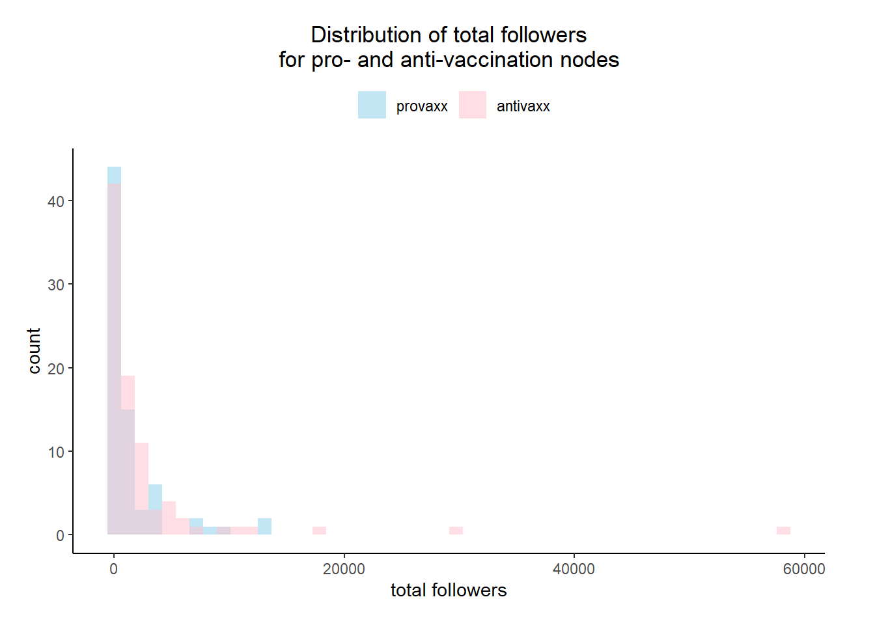

Figure 2

*Distribution of total number of accounts followed for pro- and anti-vaccination nodes*

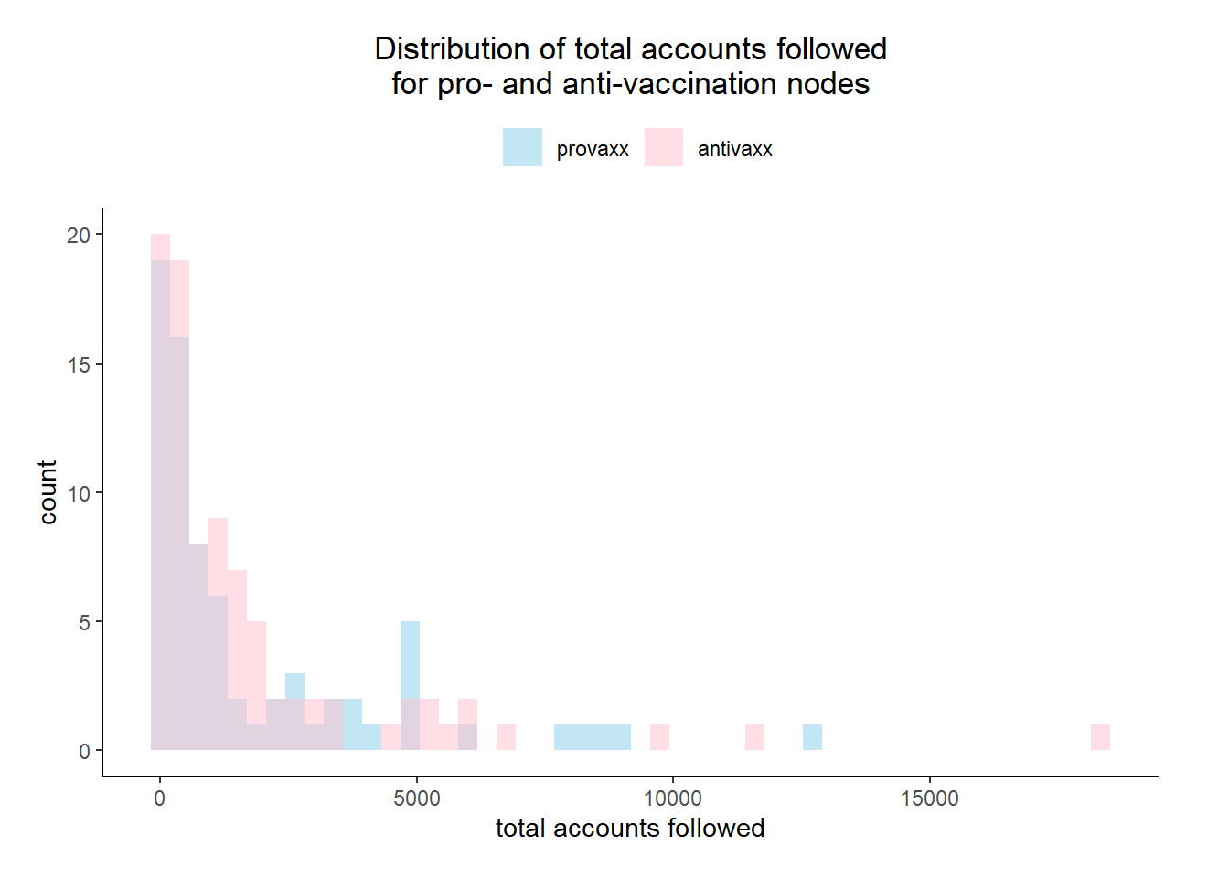

Figure 3

*Distribution of total number of tweets posted for pro- and anti-vaccination nodes*

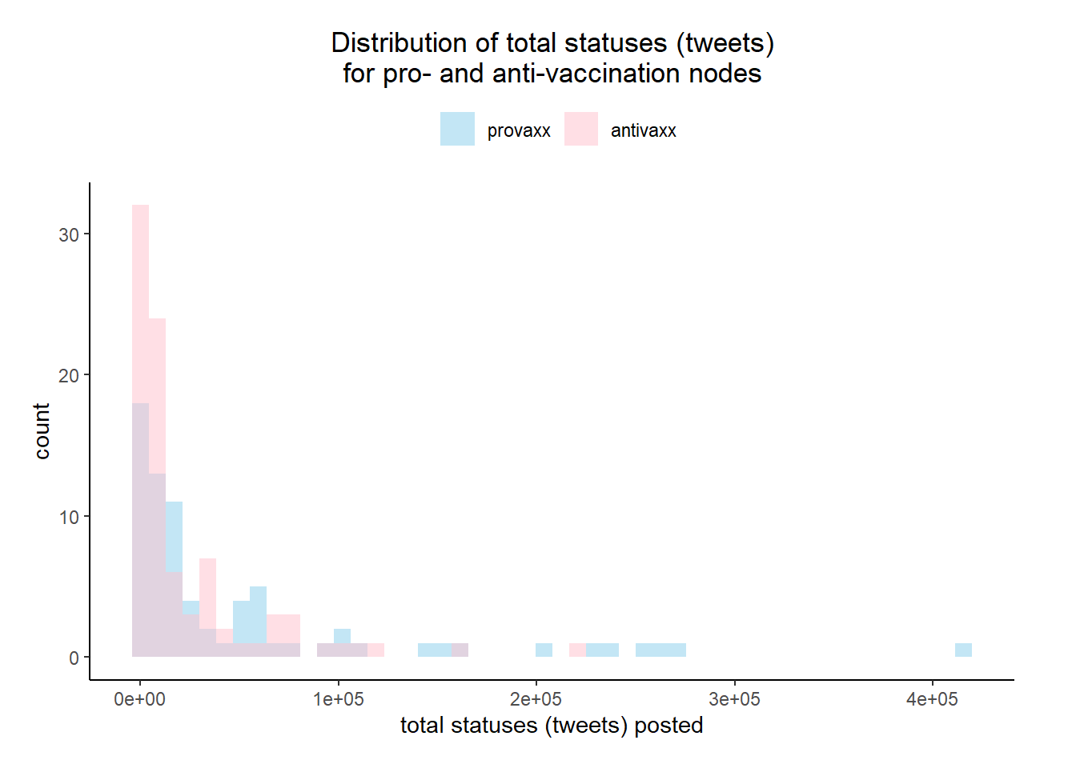

Figure 4

*Distribution of total number of favorited tweets for pro- and anti-vaccination nodes*

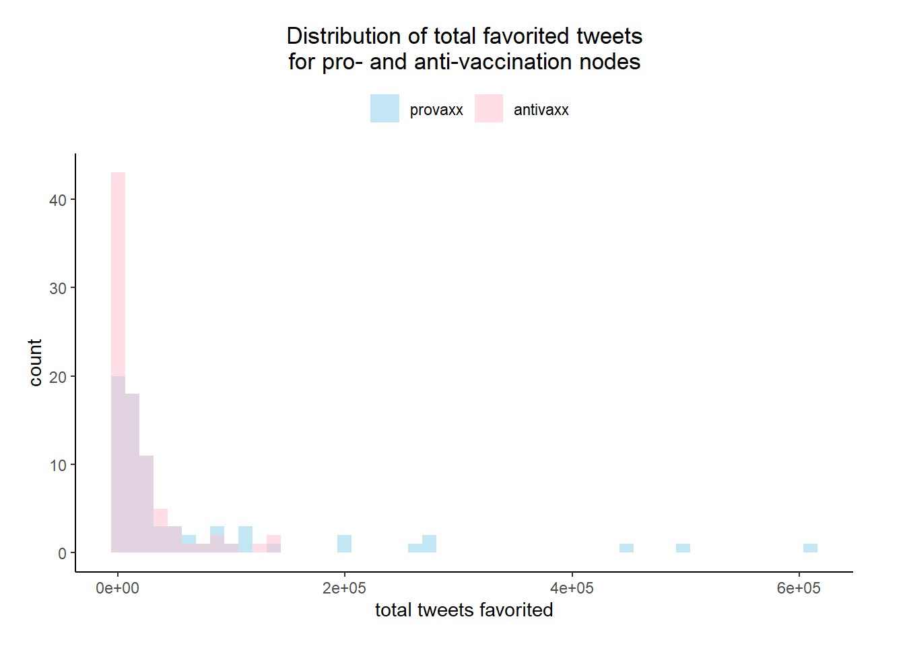

Figure 5

*Distribution of pre-exposure sentiment scores for pro- and anti-vaccination nodes*

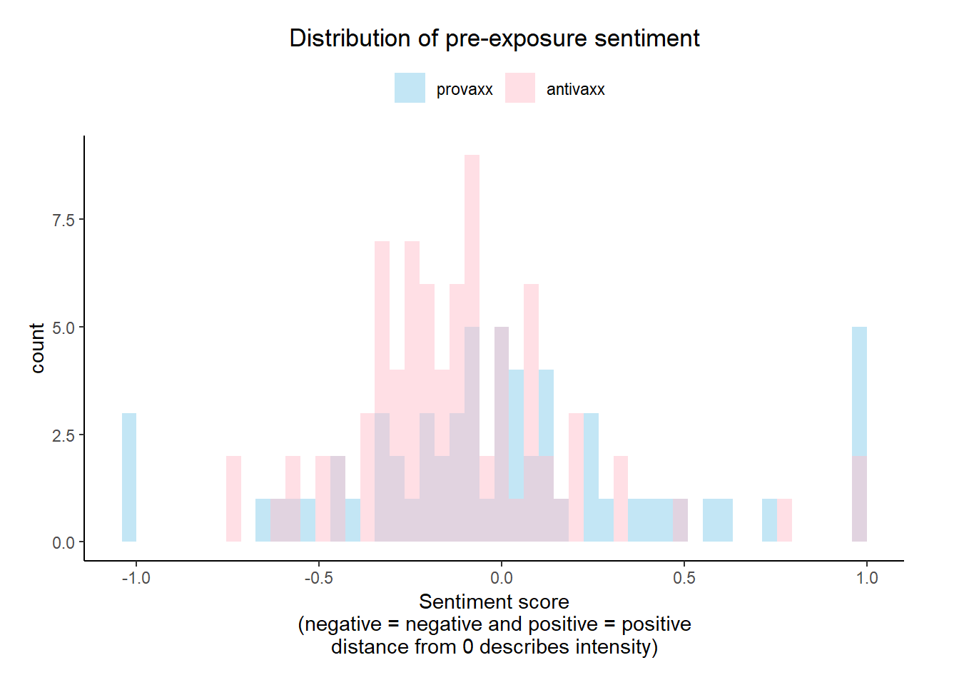

Figure 6

*Distribution of post-exposure sentiment scores for pro- and anti-vaccination nodes*

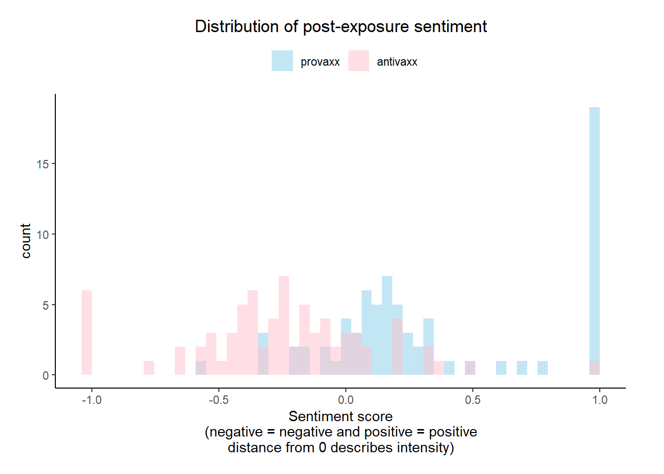

Figure 7

*Distribution of pre-exposure sentiment using logistic regression for pro- and anti-vaccination nodes*

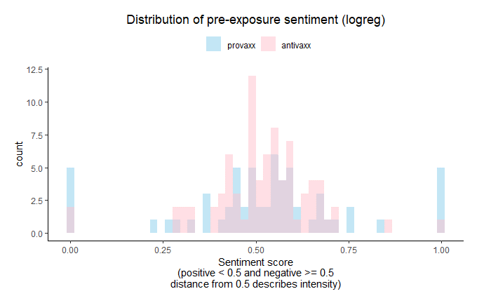

Figure 8

*Distribution of pre-exposure sentiment using logistic regression for pro- and anti-vaccination nodes*

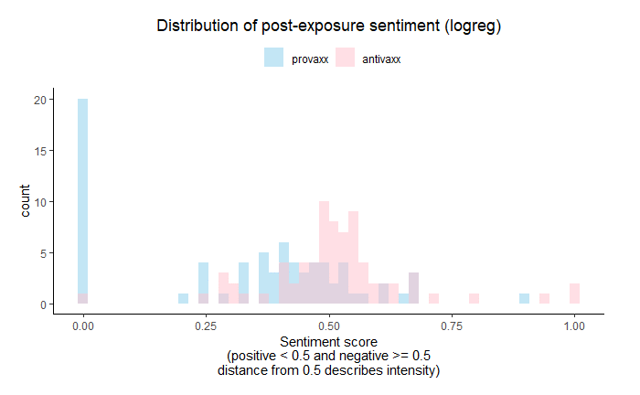

Figure 9

*Social network graph for anti-vaccination retweeters*

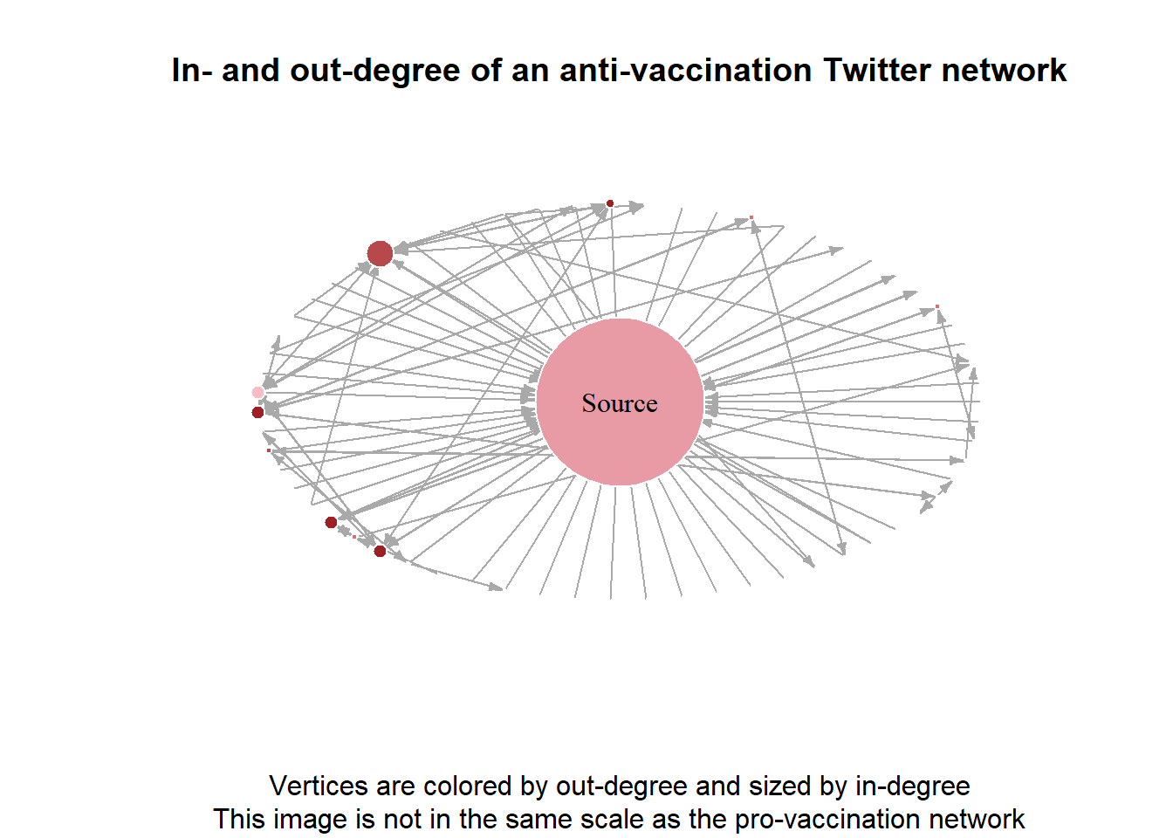

Figure 10

*Social network graph for pro-vaccination retweeters*

