# Database Systems(BCSE302L)

Guidance: [Dr L.M. Jenila Livingston](https://lms.vit.ac.in/course/view.php?id=4271" \l "section-7)

**DIGITAL ASSIGNMENT-1**

**PART-1**

**PROJECT TITLE:**

*CRICKET LEAGUE MANAGEMENT SYSTEM*



**TEAM MEMBERS:**

*ROHITH ANAND (22BAI1017)*

**ABSTRACT:**

This project introduces a Cricket Tournament Database Management System utilizing SQL for efficient and normalized data storage. The primary objective is to centralize the organization and analysis of player statistics, match details, and venue information, thereby enhancing the overall management of cricket tournaments. By focusing on creating efficient and normalized tables, the system provides a robust foundation for systematic data handling.

The implemented system facilitates rapid data retrieval and analysis, delivering valuable insights into various aspects such as player performance, team standings, match outcomes, and venue utilization. Its advanced querying capabilities enable the generation of comprehensive reports, including details on top-performing players, team statistics, and upcoming matches. This functionality caters to the diverse needs of stakeholders involved in the cricketing ecosystem.

As a centralized hub, this Database Management System significantly improves the organization and accessibility of cricket-related data. Stakeholders, including tournament organizers, team management, and analysts, benefit from a unified platform that streamlines data management and supports informed decision-making. With SQL ensuring scalability and compatibility, the system stands as a noteworthy advancement in the field, offering an efficient and comprehensive solution for cricket tournament management and analysis.

**INTRODUCTION:**

The exponential growth of cricket tournaments and leagues globally has led to a surge in the volume and complexity of data associated with the sport. Managing this influx of information effectively has become imperative to ensure the smooth functioning of tournaments and to derive valuable insights for stakeholders. In response to this evolving landscape, our project endeavors to bridge this gap by introducing a sophisticated solution - the Cricket Tournament Database Management System.

**Context:** Cricket has evolved from being a sport played sporadically to a year-round spectacle featuring numerous tournaments and leagues across the world. This proliferation has brought forth the need for advanced systems capable of handling the intricate web of data generated by player performances, match outcomes, and venue logistics. Our project recognizes this demand and proposes a tailored solution to streamline and enhance the management of cricket-related data.

**Scope and Components:** The scope of the Cricket Tournament Database Management System is broad, covering three fundamental components crucial to a comprehensive understanding of the cricketing landscape.

1. **Player Statistics:** The system delves into the intricate details of player performances, capturing not only basic metrics like runs scored and wickets taken but also nuanced statistics such as batting and bowling averages. This ensures a comprehensive and detailed analysis of player contributions throughout the tournament.
2. **Match Details:** Every aspect of a cricket match, from team line-ups to ball-by-ball information, is meticulously recorded. This includes capturing the ebb and flow of matches, highlighting turning points, and providing a comprehensive overview of the tournament's progress.
3. **Venue Information:** Recognizing the significance of the venue in the overall tournament experience, the system incorporates detailed information about each venue. This encompasses factors such as location, seating capacity, historical match data, and any other relevant details that contribute to efficient tournament planning and execution.

**Outcomes and Benefits:** The outcomes of implementing the Cricket Tournament Database Management System are tailored to cater to the diverse needs of stakeholders involved in the cricketing ecosystem.

1. **Centralized Platform:** The system acts as a centralized repository, consolidating diverse datasets into a unified platform. This facilitates easy access, retrieval, and update of information, reducing redundancy and improving overall data integrity.
2. **Efficient Data Organization:** Stakeholders can navigate through vast datasets effortlessly, thanks to the organized structure of the system. This ensures that relevant information is readily available, contributing to efficient decision-making and strategic planning.
3. **Data Analysis and Insights:** With a wealth of organized data at their disposal, stakeholders gain the ability to conduct sophisticated analyses. This ranges from assessing player and team performances to identifying trends and patterns that can inform future strategies.
4. **Enhanced Decision-Making:** Armed with insights derived from the system, decision-makers can make informed and strategic decisions. This spans areas such as team selection, match scheduling, and overall tournament management, contributing to the success and competitiveness of the cricketing events.

In summary, the Cricket Tournament Database Management System is not merely a tool for data storage; it is a comprehensive solution designed to meet the evolving needs of the dynamic world of cricket. By encompassing player statistics, match details, and venue information, the system empowers stakeholders with a centralized, efficient, and insightful platform, ensuring that the ever-expanding realm of cricket tournaments is managed seamlessly and strategically.

**PROJECT OBJECTIVES:**

The primary objectives of the Cricket Tournament Database Management System include:

* Designing and implementing a robust DBMS using SQL.
* Creating efficient and normalized tables for player statistics, match details, and venue information.
* Centralizing data for seamless organization and analysis.
* Enhancing the overall management and experience of the cricket tournament.
* Enabling efficient retrieval of information such as player performance, team standings, match outcomes, and venue utilization.
* Facilitating the execution of queries to generate reports on top-performing players, team statistics, and upcoming matches.

**ER/EER Diagram**

The ER/EER (Entity-Relationship/Enhanced Entity-Relationship) diagram visually represents the relationships and entities within the Cricket Tournament Database Management System. This graphical tool aids in understanding the structure of the database, including entities like players, matches, and venues, and their interconnections.

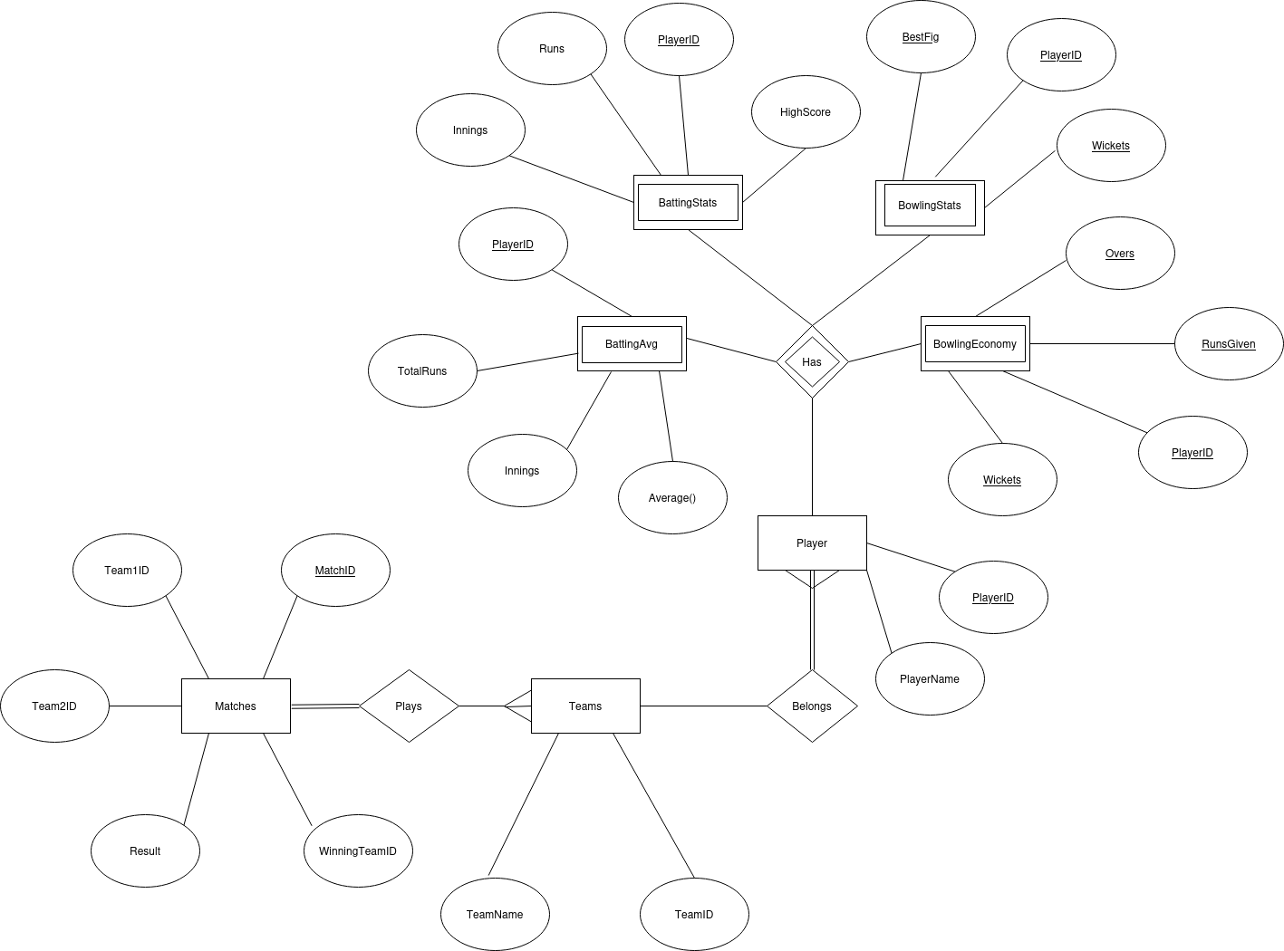.

**ER MAPPING TO RELATIONAL MODEL:**

**1. Players Table:**

• PlayerID (Primary Key)

• PlayerName

• TeamID (Foreign Key referencing Teams Table)

**2. Teams Table:**

• TeamID (Primary Key)

• TeamName

**3. Matches Table:**

• MatchID (Primary Key)

• Team1ID (Foreign Key referencing Teams Table)

• Team2ID (Foreign Key referencing Teams Table)

• Date

• Result

• WinningTeamID (Foreign Key referencing Teams Table)

**4. Batting Table:**

• PlayerID (Primary Key, Foreign Key referencing Players Table)

• Runs

• Innings

• HighScore

**5. Bowling Table:**

• PlayerID (Primary Key, Foreign Key referencing Players Table)

• Wickets

• BestBowlingFigure

**6. BattingAverages Table:**

• PlayerID (Primary Key, Foreign Key referencing Players Table)

• TotalRuns

• TotalInnings

• Average()

**7. BowlingEconomy Table:**

• PlayerID (Primary Key, Foreign Key referencing Players Table)

• TotalOvers

• RunsGiven

• WicketsTaken

**NORMALIZATION:**

### First Normal Form (1NF):

1. **Players Table:**
   * PlayerID (Primary Key)
   * PlayerName
   * TeamID (Foreign Key referencing Teams Table)
2. **Teams Table:**
   * TeamID (Primary Key)
   * TeamName
3. **Matches Table:**
   * MatchID (Primary Key)
   * Team1ID (Foreign Key referencing Teams Table)
   * Team2ID (Foreign Key referencing Teams Table)
   * Date
   * Result
   * WinningTeamID (Foreign Key referencing Teams Table)
4. **Batting Table:**
   * PlayerID (Primary Key, Foreign Key referencing Players Table)
   * Runs
   * Innings
   * HighScore
5. **Bowling Table:**
   * PlayerID (Primary Key, Foreign Key referencing Players Table)
   * Wickets
   * BestBowlingFigure
6. **BattingAverages Table:**
   * PlayerID (Primary Key, Foreign Key referencing Players Table)
   * TotalRuns
   * TotalInnings
   * Average()
7. **BowlingEconomy Table:**
   * PlayerID (Primary Key, Foreign Key referencing Players Table)
   * TotalOvers
   * RunsGiven
   * WicketsTaken

### Second Normal Form (2NF):

The tables are already in 2NF since there are no partial dependencies on the primary keys.

### Third Normal Form (3NF):

1. **Players Table:**
   * PlayerID (Primary Key)
   * PlayerName
   * TeamID (Foreign Key referencing Teams Table)
2. **Teams Table:**
   * TeamID (Primary Key)
   * TeamName
3. **Matches Table:**
   * MatchID (Primary Key)
   * Team1ID (Foreign Key referencing Teams Table)
   * Team2ID (Foreign Key referencing Teams Table)
   * Date
   * Result
   * WinningTeamID (Foreign Key referencing Teams Table)
4. **Batting Table:**
   * PlayerID (Primary Key, Foreign Key referencing Players Table)
   * Runs
   * Innings
   * HighScore
5. **Bowling Table:**
   * PlayerID (Primary Key, Foreign Key referencing Players Table)
   * Wickets
   * BestBowlingFigure
6. **BattingAverages Table:**
   * PlayerID (Primary Key, Foreign Key referencing Players Table)
   * TotalRuns
   * TotalInnings
   * BattingAverage
7. **BowlingEconomy Table:**
   * PlayerID (Primary Key, Foreign Key referencing Players Table)
   * TotalOvers
   * RunsGiven
   * WicketsTaken

The relational model has been normalized up to the Third Normal Form (3NF), eliminating redundancies and ensuring data integrity.

In conclusion, this Database Management System project not only successfully captures the intricacies of cricket tournaments by organizing player, team, and match data efficiently but also lays the groundwork for insightful analysis through the implementation of normalized tables. The interconnectivity between Players, Teams, Matches, Batting, Bowling, BattingAverages, and BowlingEconomy tables ensures a comprehensive and streamlined approach to cricket data management, empowering stakeholders with a powerful tool for informed decision-making and enhancing the overall experience of cricket tournament management.