Network fundamentals
IPv4 addresses contain 32 bits. Ethernet connects devices in a local network. A switch forwards Ethernet frames using MAC addresses. A router forwards packets between IP networks.
Device | Function
Switch | Forwards frames by MAC address
Router | Forwards packets between IP networks

Topology review
Question 1: Using only the topology diagram, how many PCs are directly connected to SW1?
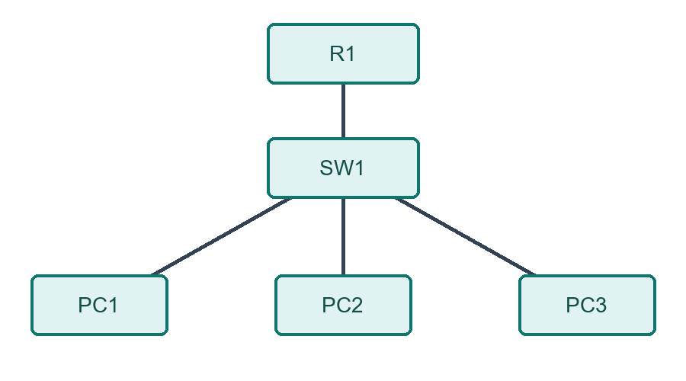
A. 2 PCs
B. 3 PCs
C. 4 PCs
D. 5 PCs

