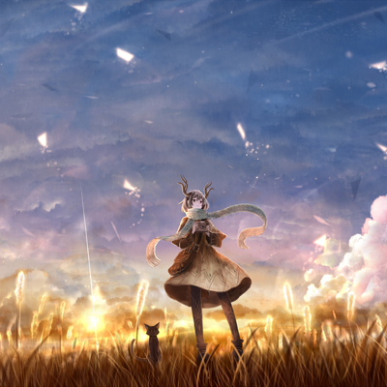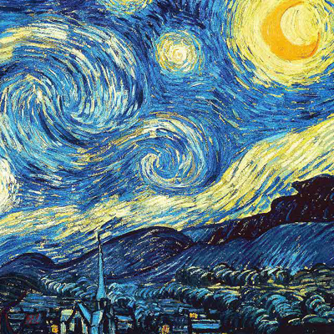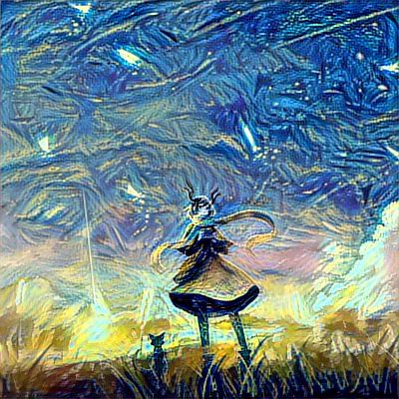

Neural Style Transfer

04.09.2018

Yue Teng

Bokun Li

* Overview

In 2015, Leon A. Gatys, Alexander S. Ecker and Matthias Bethge published a paper named “A Neural Algorithm of Artistic Style”. They introduced an artificial system based on a Deep Neural Network that creates artistic images of high perceptual quality. The system uses neural representations to separate and recombine content and style of arbitrary images, providing a neural algorithm for the creation of artistic images.

Maybe people like us can’t create artworks, but we can put art in daily pics to create our own art. Last year there was a IOS app called PRISMA which is likely to be based on this paper, but the style and transfer speed is limited. In this project, we’re trying to fix these problems and extend it to other user cases.

* Goals

Clarify the principle of the network and how to express “style” of a pic.

Implement the neural style transfer application using Keras.

Try to run the model in real-time webcam stream.

* Use Cases

**User:** Using the application with trained model to make their photos artwork.

**Advertisement Company:** Using the application to create magnificent posters quickly instead of using photoshop for a long time.

**Television & Game Company:** Using the real-time transfer, some scenes can be made very different and spectacular.

* Data
  + Artworks are scanned pictures from different artist and different time.
  + Target pictures are photos we take from daily life.
* Process Outline
* Data Preprocessing: image collecting and processing (size and quality). //week 1&2
* Build the model using Keras and test the model with different inputs. //week 1&2
* Try to create a demo allowing the model to run in real-time webcam stream. //week 3