Trabalho Final ESD

Aluno: Lucas Lemos Ricaldoni, Matheus Procópio Fonseca

Turma: 104B

Contador Gray 3 bits Crescente/Decrescente com Reinício síncrono

Tabela de transição e entrada dos FF 's.

| X | R | G2 | G1 | G0 | B2 | B1 | B0 |
| --- | --- | --- | --- | --- | --- | --- | --- |
| 0 | 0 | 0 | 0 | 0 | 0 | 0 | 1 |
| 0 | 0 | 0 | 0 | 1 | 0 | 1 | 1 |
| 0 | 0 | 0 | 1 | 1 | 0 | 1 | 0 |
| 0 | 0 | 0 | 1 | 0 | 1 | 1 | 0 |
| 0 | 0 | 1 | 1 | 0 | 1 | 1 | 1 |
| 0 | 0 | 1 | 1 | 1 | 1 | 0 | 1 |
| 0 | 0 | 1 | 0 | 1 | 1 | 0 | 0 |
| 0 | 0 | 1 | 0 | 0 | 0 | 0 | 0 |
| 1 | 0 | 1 | 0 | 0 | 1 | 0 | 0 |
| 1 | 0 | 1 | 0 | 1 | 1 | 1 | 1 |
| 1 | 0 | 1 | 1 | 1 | 1 | 1 | 0 |
| 1 | 0 | 1 | 1 | 0 | 0 | 1 | 0 |
| 1 | 0 | 0 | 1 | 0 | 0 | 1 | 1 |
| 1 | 0 | 0 | 1 | 1 | 0 | 0 | 1 |
| 1 | 0 | 0 | 0 | 1 | 0 | 0 | 0 |
| 1 | 0 | 0 | 0 | 0 | 1 | 0 | 1 |
| 0 | 1 | 0 | 0 | 0 | 0 | 0 | 0 |
| 0 | 1 | 0 | 0 | 1 | 0 | 0 | 0 |
| 0 | 1 | 0 | 1 | 1 | 0 | 0 | 0 |
| 0 | 1 | 0 | 1 | 0 | 0 | 0 | 0 |
| 0 | 1 | 1 | 1 | 0 | 0 | 0 | 0 |
| 0 | 1 | 1 | 1 | 1 | 0 | 0 | 0 |
| 0 | 1 | 1 | 0 | 1 | 0 | 0 | 0 |
| 0 | 1 | 1 | 0 | 0 | 0 | 0 | 0 |
| 1 | 1 | 1 | 0 | 0 | 1 | 0 | 0 |
| 1 | 1 | 1 | 0 | 1 | 1 | 0 | 0 |
| 1 | 1 | 1 | 1 | 1 | 1 | 0 | 0 |
| 1 | 1 | 1 | 1 | 0 | 1 | 0 | 0 |
| 1 | 1 | 0 | 1 | 0 | 1 | 0 | 0 |
| 1 | 1 | 0 | 1 | 1 | 1 | 0 | 0 |
| 1 | 1 | 0 | 0 | 1 | 1 | 0 | 0 |
| 1 | 1 | 0 | 0 | 0 | 1 | 0 | 0 |

Diagrama de Estados

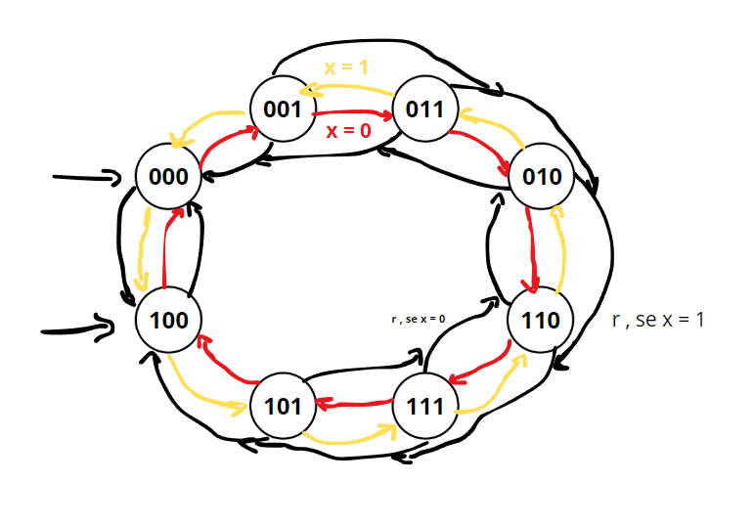

Funções Logicas

g2

((A'B'C'D')’ . (A'B'CD)’ . (AB'C'D)’ . (AB'CD')’)’

g1

((A'B'C'E)’ . (B'DE')’ . (AB'CE)’)’

g0

((AB)’ . (B'CE)’ . (AD'E')’ . (A'B'DE')’)'