南京邮电大学 2016/2017学年第二学期
《原子物理学(英)》清欠末试卷
院(系) 理 班级 学号 姓名
装 订 线 内 不 要 答 题
自 觉 遵 守 考 试 规 则，诚 信 考 试，绝 不 作 弊
题号 | 一 | 二 | 三 | 四 | 五 | 六 | 七 | 八 | 九 | 十 | 总 分
得分
Question 1 (15 marks)
得 分
If one did the Franck-Hertz experiment on atomic hydrogen vapour, which lines in the hydrogen spectrum would one see if the maximum energy of the electrons were 12.5eV? Give thevalues.

Question 2 (15 marks)
得 分
Explain the symbols for the 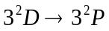 transition in sodium. How many lines can be expected in the spectrum?

Question 3 (15 marks)
得 分
In a 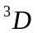 state, that deduced from the electronic configuration 2p3d for the case of LS coupling,
a) Calculate the angle between 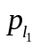and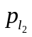.
b) Calculate the angle between 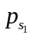and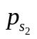

Question 4 (15 marks)
得 分
In LS coupling, determine the number of possible terms of an excited carbon atom with the electronic configuration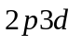? Which possible term is the ground state?

Question 5 (20 marks)
得 分
Calculate the effective magnetic moments of the
states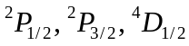and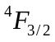.

Question 6 (10 marks)
得 分
Calculate the maximum components of the magnetic moments in the direction of the magnetic field for the vanadium (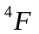), manganese (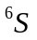) and iron (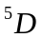), if beams of these atoms are split into 6, 6, 9 parts in a Stern-Gerlach experiment.

Question 7 (10 marks)
得 分
The spectral lines corresponding to the 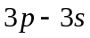transition in sodium have the wavelengths 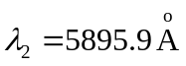and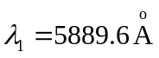.Calculate the magnetic field strength at which the lowest Zeeman level of the 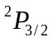term would coincide with the highest level of the 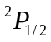term, if the conditions for the anomalous Zeeman Effect were still fulfilled

Some physical constants and formulae which may be useful:
