LEMUEL OKECHUKWU
VEPH/20B/CY082
TASK 21A

CRYPTOGRAPHY: AN ENCRYPTION TOOL FOR ALL AGES
TASK 21A:
- What is cryptography, and what are its core principles? Provide a technical overview of cryptographic concepts such as encryption, decryption, key management, and authentication. How do these principles ensure secure communication and data integrity in modern systems?
- What is encryption, and how does it function to protect data? Discuss the two primary types of encryption: symmetric and asymmetric encryption, highlighting their key differences and use cases. How do encryption algorithms ensure confidentiality and secure data transmission?
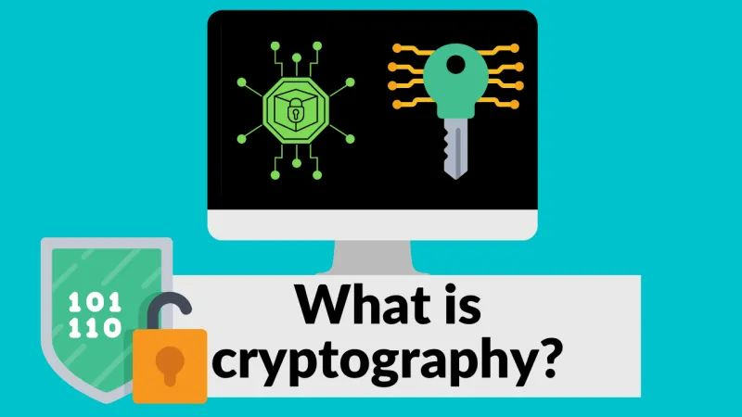

From the time of ancient hieroglyphics by the earliest users (Egyptians) to the Sumerians, cryptography has been a means of communication either through letterings or pictography. Cryptography basically means encrypting messages that only the receiver can decrypt away from the ordinary eyes. when Julius Caesar grew wary of his messengers around 50 B.C., he developed a cipher, a system for encrypting and decrypting messages, that allowed him to communicate safely with his generals on the battlefield.
Cryptography is a method used to protect data by converting it into unreadable formats, rendering it incomprehensible to humans without the appropriate keys. Modern cryptography relies on engineering concepts, software, cryptographic algorithms (also known as ciphers), and mathematical concepts to encrypt and decrypt data. It also uses cryptography techniques like digital signatures to verify a sender’s identity.
Understanding cryptography and practicing it using modern tools has four primary aims:
- Confidentiality: Confidentiality is maintained when only individuals with proper authorization can access transmitted information, with the data remaining protected from unauthorized access throughout its entire life cycle.
- Data Integrity: Data integrity refers to the accuracy, legitimacy, and consistency of information within a system. To have integrity, the information must come from a trusted source and must not have been tampered with.
- Authentication: Authentication is a process in which software is used to verify a user’s identity before granting them access to the data in a system. When a user fails authentication, they can’t access the resources in the system.
- Nonrepudiation: Nonrepudiation is a service enabled by technology that ensures the integrity and origin of data through third-party verification and validation.
Types of cryptography: Understanding cryptography requires knowing about the different types, each of which serves different purposes. The three primary types of cryptography are symmetric key cryptography, asymmetric key cryptography, and hash functions.
Symmetric Key Cryptography: This type of cryptography entails using a single key. Both the sender and receiver of a transmission use the same key to encrypt and decrypt the data. Two types of symmetric key cryptography are stream cipher algorithms, which encrypt text one bit at a time, and block cipher algorithms, which encrypt text a block at a time. Examples of block cipher algorithms include the Data Encryption Standard (DES) and the Advanced Encryption Standard (AES).
Asymmetric Key Cryptography: Like symmetric key cryptography, keys play an important role in asymmetric key cryptography. The primary difference between the two is that symmetric key cryptography uses a single key while asymmetric key cryptography uses a pair of keys. One key, the public key, encrypts the data, while the other key, the private key, decrypts the data. RSA and elliptic curve cryptography (ECC) are examples of asymmetric key cryptography algorithms. Digital signatures also use asymmetric key cryptography pairs to authenticate data.

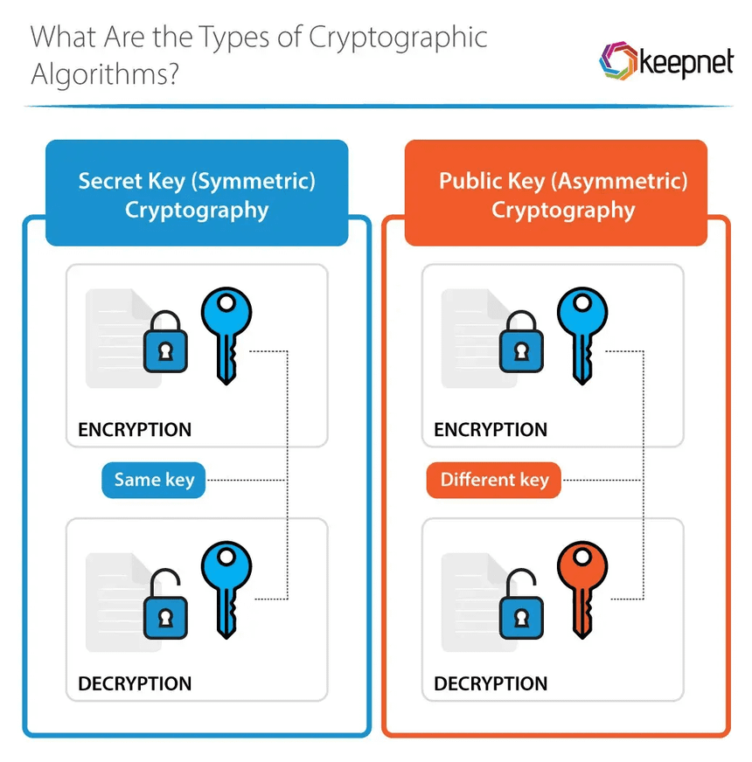
Hash Functions: A hash function is a one-way method that changes data into a hash value. Hash functions are typically used for password storage. However, instead of storing actual passwords, hash functions in applications store the hash values of passwords to reduce the likelihood that a hacker will retrieve users’ actual passwords.
Cryptography plays a crucial role in safeguarding sensitive information, making it indispensable for ensuring the security of communication channels such as email, online portals, and web and mobile phone applications. By employing cryptographic techniques, data security applications help to protect various everyday transactions, ranging from file sharing within business networks to online apps used for banking or shopping.
The scope of cryptography extends to multiple domains:
- Military and Defense: This sector uses military-grade encryption to safeguard classified information from interpretation by adversaries, ensuring the integrity and confidentiality of sensitive data.
- Health Care: Maintaining patient medical records securely is of utmost importance to protect individuals’ privacy. Cryptography ensures that medical information remains confidential and inaccessible to unauthorized individuals.
- Entertainment: Cryptography plays a significant role in digital rights management, preventing the unauthorized copying and distribution of movies and music. This helps protect intellectual property rights and combat piracy.
- Supply Chain: Cryptography techniques enable vendors and buyers to verify the authenticity of products. By employing cryptographic measures, the integrity of the supply chain can be maintained, ensuring that products are genuine and free from tampering.
- Government Communications: Encryption technology is utilized to safeguard agency-to-agency communications and citizen portals, helping to ensure the nation’s security and protecting the privacy of citizens. By employing strong encryption algorithms, government agencies help keep sensitive government information confidential and protected from unauthorized access.
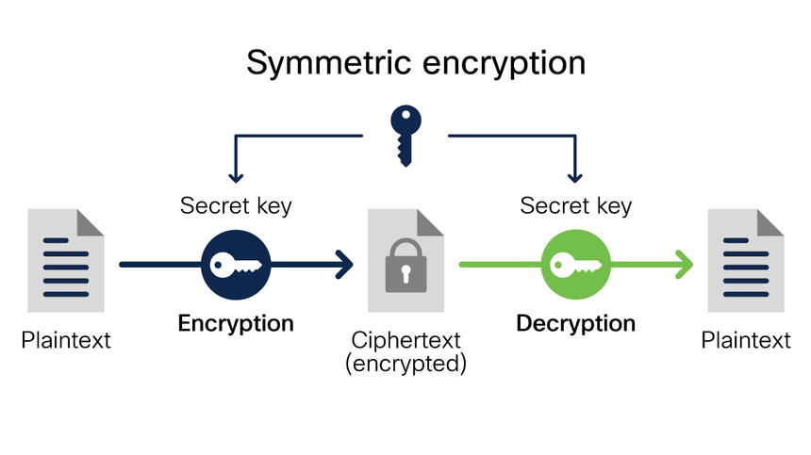
History of encryption: The word encryption comes from the Greek word kryptos, meaning hidden or secret. The use of encryption is nearly as old as the art of communication itself. As early as 1900 B.C., an Egyptian scribe used nonstandard hieroglyphs to hide the meaning of an inscription.
In a time when most people couldn't read, simply writing a message was often enough, but encryption schemes soon developed to convert messages into unreadable groups of figures to protect the message's secrecy while it was carried from one place to another. The contents of a message were reordered (transposition) or replaced (substitution) with other characters, symbols, numbers or pictures in order to conceal its meaning.
In 700 B.C., Spartans wrote sensitive messages on strips of leather wrapped around sticks. When the tape was unwound, the characters became meaningless, but with a stick of exactly the same diameter, the recipient could recreate (decipher) the message.
Later, Romans used what's known as the Caesar shift cipher, a monoalphabetic cipher in which each letter is shifted by an agreed number. So, for example, if the agreed number is three, then the message "Be at the gates at six" becomes "eh dw wkh jdwhv dw vla." At first glance, this may look difficult to decipher, but juxtaposing the start of the alphabet until the letters make sense doesn't take long. Also, the vowels and other commonly used letters, like t and s, can be quickly deduced using frequency analysis, and that information, in turn, can be used to decipher the rest of the message.
The Middle Ages saw the emergence of polyalphabetic substitution, which uses multiple substitution alphabets to limit the use of frequency analysis to crack a cipher. This method of encrypting messages remained popular, despite many implementations that failed to adequately conceal when the substitution changed -- also known as key progression. Possibly the most famous implementation of a polyalphabetic substitution cipher is the Enigma electromechanical rotor cipher machine used by Germans during World War II.
It was not until the mid-1970s that encryption took a major leap forward. Until this point, all encryption schemes used the same secret for encrypting and decrypting a message: a symmetric key.
Encryption was almost exclusively used only by governments and large enterprises until the late 1970s when the Diffie-Hellman key exchange and RSA algorithms were first published and the first PCs were introduced.

What is encryption?
Encryption is the method by which information is converted into secret code that hides the information's true meaning. The science of encrypting and decrypting information is called cryptography.
Encryption has long been used to protect sensitive information. Historically, it was used by militaries and governments. In modern times, encryption is used to protect data both at rest and in motion. At-rest data is the type stored on computers and storage devices. In-motion data refers to data in transit between devices and over networks.
Encryption is used in a variety of circumstances. Every time someone carries out a transaction on an ATM or buys something online with a smartphone, encryption protects the transmitted data. Businesses also rely on encryption to protect sensitive information from exposure in the event of a data breach or unauthorized individuals acquiring the data. Such exposure can have extensive financial implications and severely damage an organization's reputation.
The primary purpose of encryption is to protect the confidentiality of digital data stored on computer systems or transmitted over the internet or other computer networks. It is used to safeguard a wide range of data, from PII to sensitive corporate assets to government and military secrets. By encrypting their data, organizations reduce the risk of exposing sensitive information, helping to avoid costly penalties, lengthy lawsuits, reduced revenue and tarnished reputations.
Many organizations use encryption not only to protect their data, but also to meet compliance regulations that require sensitive data to be encrypted. Encryption ensures that unauthorized third parties or threat actors cannot understand the data in the event they gain access to it. For example, the Payment Card Industry Data Security Standard requires merchants to encrypt customer payment card data both at rest and when transmitted across public networks.
What are the two types of encryptions?
When setting up a system for encrypting data, a security team must determine which encryption algorithm to use to encode the data. Before doing that, however, the team should first decide on the type of algorithm. The two most common types are symmetric and asymmetric:
- Symmetric ciphers. Also referred to as secret key cyphers, these algorithms use a single key for both encrypting and decrypting data. The key is sometimes referred to as a shared secret because the sender or computing system doing the encryption must share the secret key with all entities authorized to decrypt the message. Symmetric key encryption is usually much faster than asymmetric encryption. The most widely used symmetric key cipher is the Advanced Encryption Standard (AES), which was designed to protect government-classified information.
- Asymmetric ciphers. Also known as public key encryption, these types of algorithms use two different -- but logically linked -- keys for encrypting and decrypting data. Asymmetric cryptography often uses prime numbers to create keys since it is computationally difficult to factor large prime numbers and reverse-engineer the encryption. The Rivest-Shamir-Adleman (RSA) encryption algorithm is currently the most widely used public key algorithm. With RSA, the public or the private key can be used to encrypt a message; whichever key is not used for encryption becomes the decryption key.

What are the disadvantages of encryption?
Although encryption keeps unauthorized individuals from being able to understand sensitive data, encryption can also prevent the data's owners from being able to access their own information. If the encryption keys get lost or destroyed, the data owners might be permanently locked out of that data. Cybercriminals might also go after the encryption keys, rather than the data itself. Once they've acquired the keys, they can easily decipher the data.
Key management is one of the biggest challenges of building an enterprise encryption strategy because the keys to decrypt the ciphertext have to live somewhere in the environment, and attackers often have a good idea of where to look.
Another challenge with encryption is the fact that cybercriminals can also use it for their own purposes, which has led to an increasing number of ransomware attacks. In this scenario, the criminals gain access to the sensitive data, encrypt it with their own algorithms and then hold the data hostage until the victim organization comes up with the ransom, which can be quite steep.
How does encryption work?
An encryption system is made up of three major components: data, encryption engine and key manager. In application architectures, the three components usually run or are hosted in separate places to reduce the possibility that a single component is compromised and leads to the entire system being compromised. On a self-contained device, such as a laptop, all three components run on the same system.
When an encryption system is in place, the data is always in one of two states: unencrypted or encrypted. Unencrypted data is also known as plaintext, and encrypted data is called ciphertext. Encryption algorithms, or ciphers, are used to encode and decode the data. An encryption algorithm is a mathematical method for encoding data according to a specific set of rules and logic.
During the encryption process, the encryption engine uses an encryption algorithm to encode the data. A number of algorithms are available, differing in complexity and levels of protection. The engine also uses an encryption key in conjunction with the algorithm to ensure that the ciphertext that is output is unique. An encryption key is a randomly generated string of bits that are specific to the algorithm.
After the data is converted from plaintext to ciphertext, it can be decoded only through the use of the proper key. This key might be the same one used for encoding the data or a different one, depending on the type of algorithm -- symmetric or asymmetric. If it's a different key, it's often called a decryption key.
When encrypted data is intercepted by an unauthorized entity, the intruder has to guess which cipher was used to encrypt the data and what key is required to decrypt the data. The time and difficulty of guessing this information is what makes encryption such a valuable security tool. The more extensive the encryption algorithm and key, the more difficult it becomes to decrypt the data.

Amazon Web Services, “What Is Cryptography?”
Entrust, “Who Should We Thank for Modern Cryptography? The Egyptian Monks.”
Fortinet, “What Is Cryptography?”
National Institute of Standards and Technology, Non-repudiation

