LEMUEL OKECHUKWU
VEPH/20B/CY082
TASK 38A

CYBERSECURITY ROLES: JOB GROWTH AND CAREER

TASK 38A:
- Identify and describe five key cybersecurity roles, outlining the primary responsibilities associated with each position.

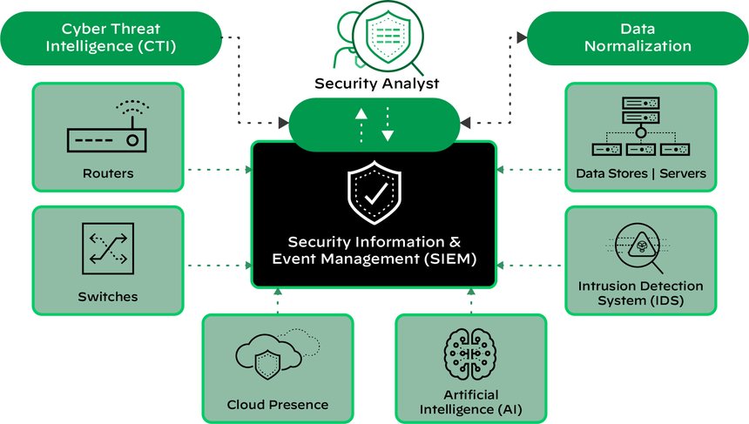

In July 2024, a faulty update from CrowdStrike's security software led to a global IT outage, causing U.S. Fortune 500 companies to incur approximately $5.4 billion in losses.
The same CrowdStrike incident disrupted over 8 million Microsoft Windows devices worldwide, affecting sectors such as airlines, banking, and healthcare, and highlighting the systemic nature of cyber risks in a globally interconnected economy.
In 2024, the European Central Bank's cyber stress test revealed significant shortcomings in banks' abilities to handle cyber-attacks, prompting calls for improved resilience and potentially impacting public trust in the financial sector.
Cybersecurity professionals are responsible for protecting the IT infrastructure and digital systems against cyber threats that aim to penetrate and steal sensitive data. By bringing security professionals together, you can create a cyber security team that helps your company understand potential risks and provide solutions for security incidents. Here are some of the cyber roles that are pertinent to the scope.
Remember that even small startups and newly-founded companies may experience cyberattacks, and they are more likely to be targeted by cybercriminals.
Many companies say, “it won’t happen to me.”
But every business needs to take cybersecurity seriously as a priority.
Here are the main reasons why your company needs a cyber security team:
- Finding vulnerabilities in your systems
- Helping employees with cyber awareness
- Educating employees by organizing timely events
- Developing the required cybersecurity policies and defense plans
- Checking regulation compliance for your business
- Protecting you and your company’s sensitive data and finances
- Providing a peaceful and consistent environment for growth and development
- Increasing productivity by minimizing the risks of cyber threats
- Updating your software tools and upgrading system devices at the right time
- Ensuring there is a reliable BYOD policy that prevents the related security issues
- Controlling sensitive data through encryption techniques and procedures
Different Roles in a Professional Cyber Security Team
Cyber security teams specialise in protecting networks, systems, and software from cyber threats and consist of different roles and responsibilities. Each role has specific responsibilities to ensure private information and sensitive data files are secure within the system. As the cybersecurity domain keeps evolving and expanding, new roles and titles are likely to emerge.
Role | Main Focus in the cyber security team | Essential Skills
CISO | Developing and implementing an information security program Establishing the right security governance plans Supervising different sectors in a cyber security team | Policy development and administration Strong technical background Strong communication skills Problem-solving
Cybersecurity Engineer | Designing, maintaining, and implementing highly secure network solutions | Secure coding practices Network architecture Ethical hacking Cybersecurity concepts and methodologies Problem solving
Cybersecurity Analyst | Identifying problems and developing plans to protect information from cyber threats and unauthorised access | Scripting Controls and frameworks Intrusion detection Networking Critical thinking Risk management
Cybersecurity Associate | Working to develop and implement a part of data security strategies | Security policies Network security systems Communication skills Strong research skills Analytical skills
Cybersecurity Responder | Responding and mitigating security incidents | Digital forensics Programming Investigation and analysis Collaboration Problem solving
Cybersecurity Incident Handler | Performing threat analysis and investigating security events according to the collected information | Analysis Network monitoring Troubleshooting Collaboration Problem solving
SOC Manager | Leading and managing the SOC team | Cybersecurity concepts and techniques Leadership Operational and management skills
Security Director | Ensuring processes are aligned with the defined strategies and policies | Risk management and assessment Project management Cybersecurity policies and concepts
SecOps Lead | Leading and managing the SecOps team | Policies and concepts Risk management Communication skills
SOC Architect | Recognising the requirements and providing practical plans and security solutions | Cybersecurity concepts Network tools and devices Problem solving Time and project management
SIEM Engineer | Designing and developing solutions for the SIEM environment | Network security technologies Software development and scripting Problem solving
SOC Engineer | Participating in the SOC tasks; maintaining, supporting, and configuring security devices and products | Network access control Scripting Collaboration Problem solving Management and reporting
Cybersecurity Consultant | Kidney Inf problems and providing expert advice for security solutions | Pen testing Programing Cybersecurity policies and concepts Communication skills Problem solving

certifications for an experienced CISO (CHIEF INFORMATION SECURITY OFFICER):
- Certified Cloud Security Professional (CCSP)
- Systems Security Certified Practitioner (SSP)
- Certified Encryption Specialist (EC-Council ECES)
- A+ (CompTIA)
- Cybersecurity Analyst Certification, CySA+ (CompTIA), etc
cyber security engineer should pass several courses and provide some specific certifications, such as:
- Certified Information Systems Security Professional – Architecture (CISSP)
- Security 5 certification
- Certified Information Systems Security Professional (CISSP)
- IT Information Library Foundations Certification (ITIL)
- Certified Information Security Manager (CISM)
- Certified Ethical Hacker (CEH)
certifications for SOC engineers:
- Juniper Networks Certified Internet Specialist JNCIS
- Cisco Certified Network Associate Security (CCNA)
- Certified Cyber Security Examiner (CCSE)
- Certificate in Network Security Expert (C-NSE)
Entry level certifications:
- CompTIA Security+
- Certified Ethical Hacker (CEH)
- Certified Information Systems Security Professional CISSP
The specific job responsibilities for any cybersecurity role can also depend on the size and resources of the employer. “At a smaller or mid-size firm, you might end up being a ‘jack of all trades,’ while at a larger firm, you’re more likely to have specialists,”

