LEMUEL OKECHUKWU
VEPH/20B/CY082
TASK 26A
CYBERSECURITY FUNDAMENTALS

TASK 26A:
- Explain the concepts of Denial of Service (DoS) and Distributed Denial of Service (DDoS) attacks. Describe the underlying attack vectors, architecture, and operational differences between the two, including their respective impact on system availability and network resources.
- Explain the mechanisms, attack vectors, and security implications of the following types of cyberattacks: Man-in-the-Middle (MitM), SQL Injection (SQLi), and Cross-Site Scripting (XSS). Compare their techniques, target environments, and common mitigation strategies.

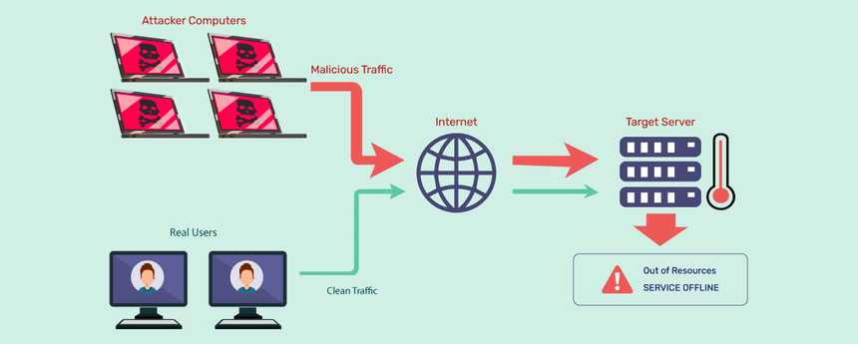

DOS and DDOS are both traffic-based attack mechanisms used by attackers to make a statement, collect ransom or just for fun. Their aim is to restrict, slow-down or log-out a user(S) from accessing the internet. DOS stands for Denial of Service while DDOS – distributed denial of service. Both types of attacks overload a server or web application with the goal of interrupting services.
A DOS (Denial of Service) attack is a type of cyberattack where one internet-connected computer floods different computer with traffic especially a server to instigate a crash. It always floods the server with requests which will cause it to either crash or be unavailable to users of the website in question. DOS attacks specifically appear when targeted at a website, making the site unavailable and causing a major disruption of online services. Teardrop, flooding, IP fragmentation, volumetric, etc. are all forms of attack that take place under DOS
Key Characteristics of a DOS Attack:
- Single Source: It is started from one system only as explained above.
- Traffic Volume: The Turnover is high; however, it is a single point of call Turnover.
- Traceability: As the attack originates from a particular system it is traceable as compared to the case of the distributed one.
- Blockability: It is more easily blocked since ALL of the traffic comes from one source as opposed to a DDOS attack.
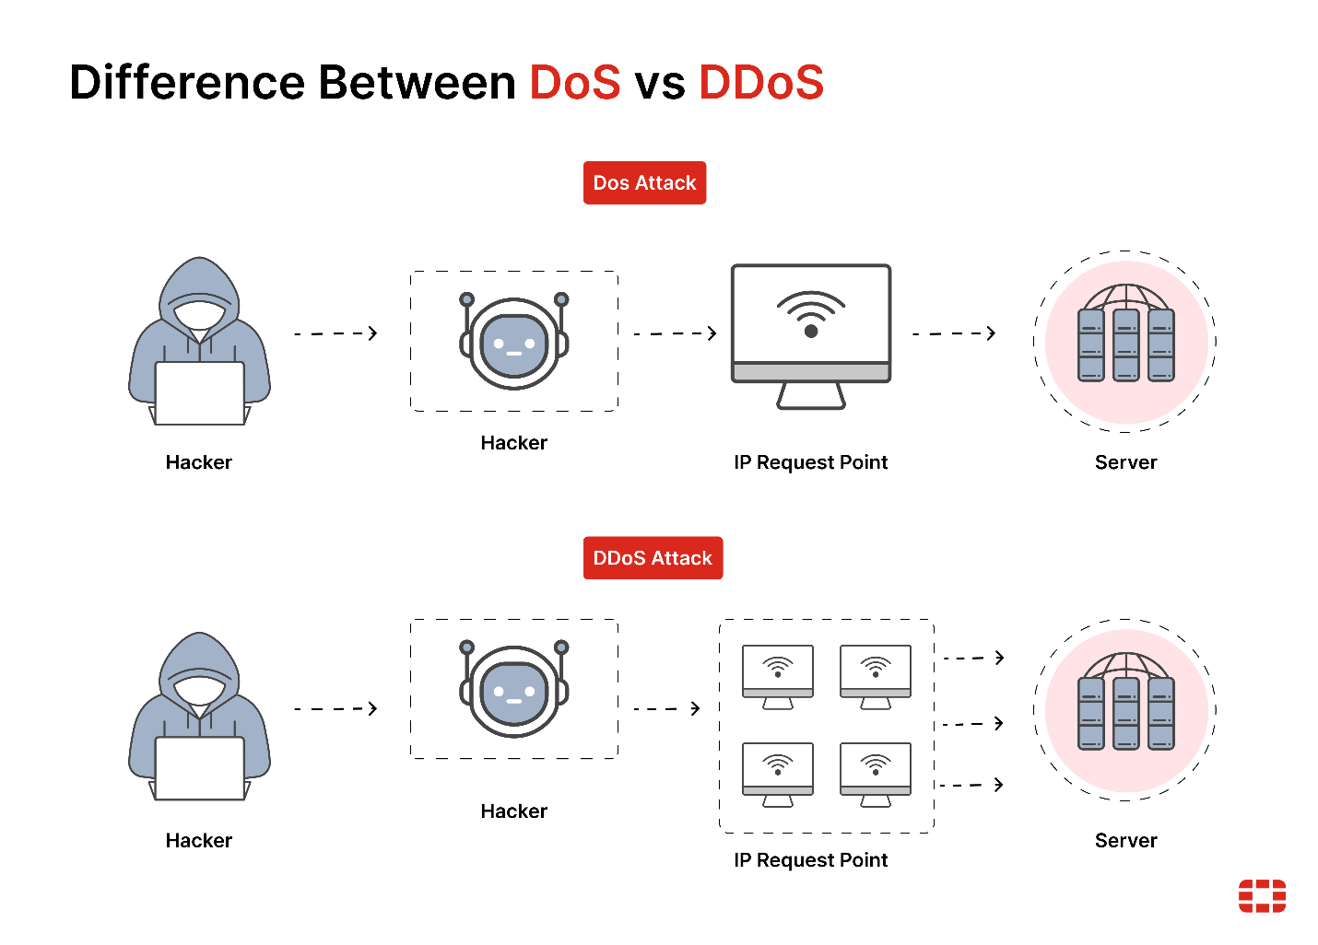

A DDOS which is a short form of Distributed Denial of Service attack works on similar lines as the DOS attack but is more complicated in that the attack is launched with the help of several systems located in different places. These systems, sometimes use fringe computers or ‘bots,’ operate in parallel in the manner of amplifying the traffic volume to a level much more difficult for the target to counter. An inherent advantage of a distributed attack is that it is difficult to track the origin and, therefore, put a stop to it.
DDoS attacks are on the rise, and even some of the largest global companies are not immune to being "DDoS'ed". The largest attack in history occurred in February 2020 to none other than Amazon Web Services (AWS), overtaking an earlier attack on GitHub two years prior. DDoS ramifications include a drop in legitimate traffic, lost business, and reputation damage.
Key Characteristics of a DDOS Attack
- Multiple Sources: The attack is initiated from the different systems; at times, originated from different environments.
- Traffic Volume: It has multiple sources and the volume of traffic is much higher and for this reason it is much more devastating.
- Difficulty in Tracing: This is because the attack is launched in several instances of computers at different locations, hence it is difficult to track its origin.
- Complexity in Blocking: It is even more challenging to block a DDOS attack because the attack originates from many different places.
SQL injection attack: A structured query language (SQL) injection attack specifically targets servers storing critical website and service data. It uses malicious code to get the server to divulge information it normally wouldn’t. SQL is a programming language used to communicate with databases, and can be used to store private customer information such as credit card numbers, usernames and passwords (credentials), or other personally identifiable information (PII) – all tempting and lucrative targets for an attacker.SQL injection attacks come in a variety of forms.
- SQLi in-band: An in-band SQLi, also known as a traditional SQLi, occurs when hackers utilize the same channel (or band) to trigger database failures and gather attack results. The most prevalent approaches for achieving an in-band SQLi are error-based and union-based attacks. Error-based injection approaches cause the database to generate error messages that disclose details about the database's structure. Prepared statements that abuse the SQL Union function, which aggregates the results of numerous searches into one result, is used in union-based attacks.
- SQLi inferential: An inferential SQL injection, also known as a blind SQL injection, occurs when hackers transmit data payloads to a database server in order to watch its reaction and behavior without being able to see what is happening inside the database. The server's response gives the attacker information they might use to fine-tune their attack plan. A Boolean or time-based inferential SQLi is possible. A Boolean SQLi asks for a response using true or false statements, whereas a time-based SQLi asks for a certain response period.



Man in the middle attack: (MITM) attack occurs when cybercriminals intercept and alter network traffic flowing between IT systems. The MITM attack impersonates both senders and receivers on the network. It aims to trick both into sending unencrypted data that the attacker intercepts and can use for further attacks or financial gain.
A man-in-the-middle attack can take various forms, and a few of them are mentioned below:
  - IP spoofing attacks: In the internet world, every system linked to a network or website has an IP address. These IP addresses are used by hackers or attackers to gain access to a network as an authorized user. The network accepts the system after the attackers replicate the IP address of an authorized system. The user believes it is connecting directly with the web application, while the man-in-the-middle intercepts all data.
  - Email Hijacking: In this hack, the attacker intends to use an email account to obtain information. The attacker gains access to the user's email account, waits for the email with the user's credentials to arrive, and then takes the information.
  - HTTPS Spoofing: While it is impossible to produce a duplicate HTTPS address, the hacker attempts to construct a comparable web address that appears to be genuine. It employs alphabets from a foreign language that resemble the HTTPS address currently in use.
  - Wi-Fi Eavesdropping: It is easy to eavesdrop on a device connected to an unencrypted Wi-Fi network, hence public Wi-Fi is not regarded as safe. Occasionally, the attacker creates an 'Evil Twin' internet hotspot that looks identical to the authorized hotspot connection.
  - DNS Spoofing: A hacker can set up a DNS (Domain Name Server) and connect the DNS name of a legitimate website to a different IP address in DNS Spoofing attack. The hacker has access to the user's personal and security information the minute the user clicks on the bogus page.
Cross-site scripting (XSS): Also involve injecting malicious code into a website, but in this case the website itself is not being attacked. Instead, the malicious code only runs in the user's browser when they visit the attacked website, where it directly targets the visitor.
One of the most common ways an attacker can deploy an XSS attack is by injecting malicious code into a comment or a script that could automatically run.


- Persistent cross-site scripting (XSS): Persistent XSS, also known as Type-I XSS and Stored CSS, happens when an attacker injects malicious material (payload) directly into the application. By exploiting their vulnerabilities or employing social engineering methods, the payload may be injected into the program, its database, or its web server. If input validations are not used, the payload (malicious code) is permanently saved by the program. Then, because the attack is immediately installed alongside the program, it spreads to all users of the app. It may be used to steal data from a user or to plan and carry out more serious attacks.
- Reflected XSS: The most prevalent kind of Cross-site Scripting is Reflected XSS, also known as Type-II XSS and Non-Persistent CSS (XSS). When an attacker embeds harmful code in a link and transmits it to the victim, this is known as phishing. The victim is duped into clicking on the link, which transmits the code to the appropriate website.

Common Mitigation Strategies:
- MitM: Use strong firewalls, secure protocols like HTTPS, and two-factor authentication (2FA) to protect against unauthorized access. Employ network segmentation and strong encryption to secure communications.
- SQLi: Implement input validation, use parameterized queries, and adopt stored procedures to prevent SQL injection. Regularly update and patch databases to mitigate vulnerabilities.
- XSS: Sanitize user inputs, use Content Security Policy (CSP) headers, and implement output encoding to prevent script execution. Regularly scan for vulnerabilities and apply security patches.

Also making sure data’s are encrypted, using 2-factor authentication, mobile device management, endpoint protection are ways for guarding against such prolifering and attacks.

DOS and DDOS both are real threats to online services and systems. A DOS attack is when a single system will be attacked while a DDOS attack will have multiple systems attacking the victim hence making it difficult to defend against the attack. Differentiation between these two sociotechnical attacks is critical when preventing-security measures and risks of harm.

