LEMUEL OKECHUKWU
VEPH/20B/CY082
TASK 22A

DATA MASKING AND TOKENIZATION

TASK 22A:
- Can you provide a technical explanation of data masking and data tokenization, highlighting their core mechanisms, differences in data protection approaches.
- Can you provide a technical explanation of salting and key stretching, detailing how they enhance password security by mitigating brute-force attacks, and outlining their role in modern cryptographic hashing algorithms?

In the cybersecurity world, protection, prevention and been able to pre-empt attacks and reduce attackers’ operation are why methods as masking and tokenization are carried out. They are like the labyrinths and puzzles attackers have to breach to gain access to our system but at the same time notifying the user of a likeable penetration before they gain access.
Without further ado I will dive into the world of Data Masking. It is the process of obscuring sensitive information by replacing it with fictional but realistic data. This approach allows developers and other users who may not have the necessary access to work with data for essential business operations, such as analytics, all while keeping customer information secure. With DM, organizations can balance the need for data usability with strong protection against unauthorized access.
Tokenization replaces sensitive data elements with non-sensitive equivalents, known as “tokens.” These tokens can be mapped back to the original data using a tokenization system. Unlike data masking, which alters the data to appear realistic, tokenization ensures that the original data cannot be recovered without the token mapping system.
While tokenization typically requires more processing than data masking, it’s important to note that data tokenization is reversible, allowing for the secure retrieval of the original information when necessary.



Common data masking techniques
Data masking techniques are specifically designed to obfuscate sensitive information while still keeping it usable for various non-production purposes. Here are some of the most common data masking techniques used to protect sensitive data:
- Substitution: This technique involves replacing real data with fictional but realistic data, making it useful for anonymizing names, addresses, and other PII in datasets.
Example: Replacing actual names with fake names in a customer database.
- Shuffling: Shuffling rearranges data within a dataset, making it challenging to trace back to the original sequence.
Example: Randomly shuffling dates of birth within a dataset.
- Masking Out: This method hides sensitive data with symbols or characters, making it partially visible.
Example: Displaying only the last four digits of a credit card number.
- Encryption: Encryption encodes data so that it cannot be read without a decryption key, ensuring data security during both storage and transmission.
Example: Encrypting a social security number to protect it from unauthorized access.
- Tokenization: Tokenization replaces sensitive data with unique identifiers or tokens that can be mapped back to the original data using a tokenization system.
Example: Replacing bank account numbers with tokens in financial transaction records.
These techniques help organizations maintain data privacy while allowing necessary access for testing, development, and analysis.
How does data masking work?
Data masking transforms sensitive data into a protected format that can be safely used in non-production environments, such as development and testing, without compromising its confidentiality. Here’s a closer look at how data masking works:
- Identify sensitive data: The first step is to pinpoint which data elements are sensitive and require masking. This includes PII, financial data, healthcare records, and other confidential information.
- Select masking techniques: Next, choose the appropriate masking techniques based on the type of data and its intended use. Common techniques include substitution, shuffling, masking, encryption, and tokenization.
- Apply masking techniques: Implement the chosen techniques to transform the sensitive data into a masked format.
- Validate masked data: Finally, ensure that the masked data retains its usability for its intended purposes — such as development, testing, or analytics — without exposing the original sensitive information.
This structured approach helps organizations protect sensitive data while still allowing necessary access for operational needs.
How Data Tokenization Works
Tokenization processes replace sensitive data with a token. The token itself has no use and it is not connected to a certain account or individual.
Tokenization involves replacing the 16-digit PAN of the customer with a custom, randomly-created alphanumeric ID. Next, the process removes any connection between the transaction and the sensitive data. This limits exposure to breaches, which is why tokenization is highly useful in credit card processing.
Tokenization processes can safeguard credit card numbers as well as bank account numbers in a virtual vault. Organizations can then safely transmit data across wireless networks. However, to ensure the tokenization process is effective, organizations need to use a payment gateway for secure storage of sensitive data. A payment gateway securely stores credit card numbers and generates random tokens.
Key Difference between Data Tokenization vs Data Masking

Understanding the nuances between Masking, Tokenization, and Encryption is pivotal for crafting data protection strategies that cater to diverse organizational needs and effectively mitigate evolving cyber threats.
Here's the comparison of Data Tokenization vs Data Masking:

Aspect | Data Tokenization | Data Masking
Purpose | Securely store or transmit without exposing | Protect sensitive information while maintaining usability
Reversible | Yes, when a mapping is available | No, once static masking is applied
Key Management | Requires tokenization system keys for mapping between tokens and original data. | Involves masking policies and keys to control the obfuscation process.
Data Security Level | Strong, original sensitive data never leaves the organization | Strong, original sensitive data remains hidden but retrievable
Complexity | Data tokenization pipelines are less complex compared to encryption. | Data masking pipelines are more intricate due to defining masking policies and managing keys for obfuscation.

Why does it matter? Data security is not simply a box to check. It is an integral component of a business’s operations. The right data privacy strategy can boost your brand’s trustworthiness, ensuring your corporate reputation is protected while facilitating the efficient use of data and the wrong data privacy method can result in significant consequences, including breaches, loss of customer trust, legal liabilities, and damage to your brand’s reputation.

Salting: basically, means adding a particular value to your Hash value. It enhances the security of hashed passwords by adding random data (a salt) before the password is hashed. This technique ensures that even if multiple users have the same password, their hashed results will be different, making it significantly more difficult for attackers to use precomputed tables (like rainbow tables) to crack the hashes.
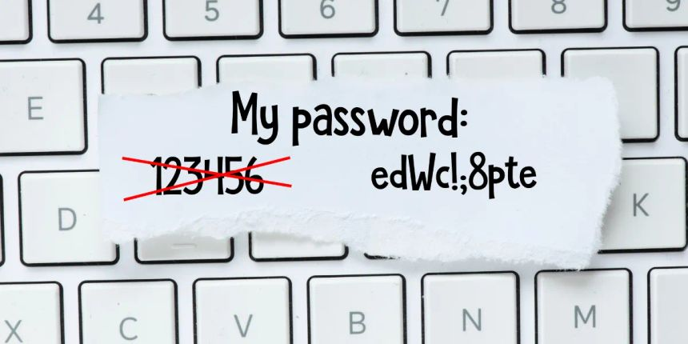

How Salting Works:
- A unique, random salt is generated for each password.
- The password and salt are combined and hashed using a secure algorithm like Bcrypt or Argon2.
- The resulting hash and salt are stored in the database.
- During login, the stored salt and password are rehashed and compared with the stored hash for authentication.
By introducing randomness, salting ensures no two hashed passwords are the same, eliminating vulnerabilities tied to duplicate or common passwords.
What is key stretching? It involves converting a simple password into a complex and longer key that is used to encrypt data and protect it from unauthorized access. The entire process increases the complexity of the password, making it harder to crack by any intruder. It prevents brute force attack as it works with a compilation of salted passwords making it complex for attackers to guess, hack or exploit.
How Key Stretching Works
Key stretching algorithms are designed to transform a password into a longer and more complex key. This process is irreversible, meaning that there is no way to recover the password from the key. Key stretching algorithms typically involve two major steps: hashing and salting.
Hashing involves transforming the password into a fixed size output. Passwords are typically not fixed in length, so hashing algorithms need to generate a consistent output regardless of the input size. Examples of popular hashing algorithms include SHA-256 and bcrypt.
Salting involves adding random data to the password before hashing. The salt value is typically stored alongside the hashed password. This makes it more difficult for attackers to precompute attacks. If every password has a unique salt, then attackers cannot precompute an attack for an entire database of passwords.
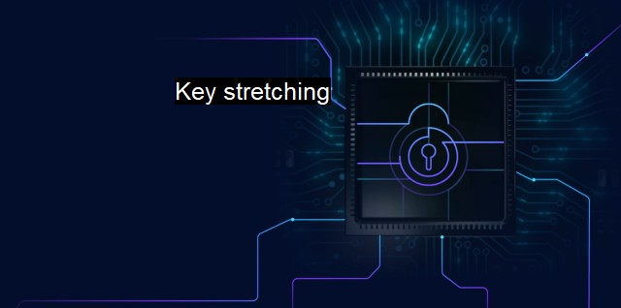
Popular Key Stretching Algorithms
There are several popular key stretching algorithms available for use, including:
- bcrypt: A widely used key stretching algorithm that involves multiple iterations of a hash function to produce a key. It also includes a salt to protect against precomputed attacks.
- scrypt: A newer key stretching algorithm that is designed to be resistant to attacks from specialized hardware like ASICs.
- PBKDF2: A key derivation function that uses multiple iterations of a hash function, similar to bcrypt.

In conclusion, key stretching is a vital aspect of securing sensitive information. By transforming passwords into longer and more complex keys, key stretching can slow down and even prevent brute-force attacks on data. It is important to follow best practices when implementing key stretching to ensure maximum security, and to consider alternatives when necessary to meet specific security requirements.
Fenton, James L.; Grassi, Paul A.; Garcia, Michael E. (June 2017). "NIST Special Publication 800-63-3" (PDF). NIST Technical Series Publications.
^ Anderson, Ross (2020). Security engineering: a guide to building dependable distributed systems (Third ed.). Indianapolis, Indiana. ISBN 978-1-119-64281-7. OCLC 1224516855.
^ Godwin, Anthony (10 September 2021). "Passwords Matter". The Bug Charmer (Blog). Retrieved 2016-12-09.
^ Boneh, Dan; Shoup, Victor (January 4, 2020). A Graduate Course in Applied Cryptography (PDF). pp. 693–695.
^ Jump up to:ª ^{b} Rosulek, Mike (January 3, 2021). "Chapter 11: Hash Functions" (PDF). The Joy of Cryptography. pp. 204–205.

