LEMUEL OKECHUKWU

VEPH/20B/CY082

TASK 29B

**Deciphering the Distinctions: Host-Based vs. Network-Based IDS and IPS**

**TASK 29B:**

* **"Could you provide a detailed explanation of Intrusion Detection Systems (IDS) and Intrusion Prevention Systems (IPS), including the distinctions between Network-based IDS (NIDS) and Host-based IDS (HIDS), along with their respective functionalities and deployment contexts?"**

[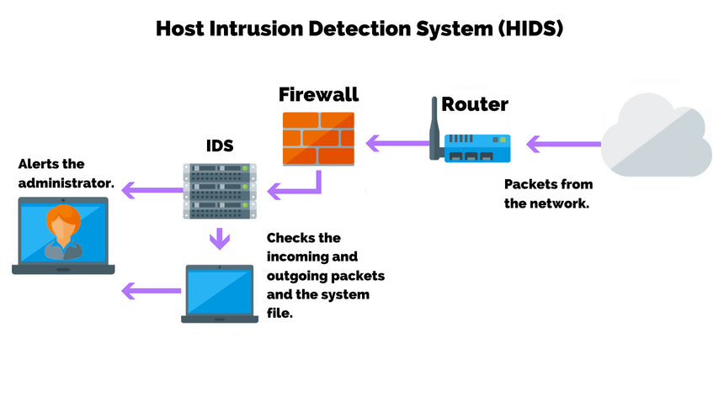](https://purplesec.us/learn/intrusion-detection-vs-intrusion-prevention-systems/)

Understanding the intricate differences between various security mechanisms is crucial for devising effective defense strategies. Among these, Intrusion Detection Systems (IDS) and Intrusion Prevention Systems (IPS) stand out as pivotal tools in identifying and mitigating threats. However, the nuances between host-based and network-based implementations of IDS and IPS often generate confusion.

**Understanding IDS and IPS**

**Intrusion Detection Systems (IDS)** are designed to detect unauthorized access or anomalies in network traffic and system behaviors, alerting security personnel to potential threats.

**Intrusion Prevention Systems (IPS)**, on the other hand, not only detect these threats but also take preemptive actions to block or mitigate them before they cause harm.

Both IDS and IPS can be deployed in two distinct manners: **host-based**and **network-based**.

**Host-Based IDS/IPS**

**Host-Based Intrusion Detection Systems (HIDS) and Intrusion Prevention Systems (HIPS)** are installed on individual devices or hosts. They monitor the system’s operations, file integrity, and log files for signs of malicious activity, focusing on internal traffic and system behavior rather than network traffic.

**Practical Use Cases**

* **Endpoint Protection:** HIDS/HIPS are crucial for monitoring and protecting endpoints from malware, unauthorized changes, and insider threats.
* **Regulatory Compliance:** Ensuring that sensitive data on individual systems is not tampered with or accessed unlawfully.

**Network-Based IDS/IPS**

**Network-Based Intrusion Detection Systems (NIDS) and Intrusion Prevention Systems (NIPS)** are deployed at strategic points within the network to monitor traffic to and from all devices on the network. They analyze network packets for signs of malicious activity, focusing on external threats before they reach individual devices.

**Practical Use Cases**

* **Perimeter Defense:** NIDS/NIPS act as the first line of defense, identifying and stopping attacks at the network perimeter.
* **Traffic Analysis:** Monitoring network traffic patterns to detect anomalies that may indicate a cyberattack or network compromise.

**Key Differences and Complementarity**

The primary distinction between host-based and network-based IDS/IPS lies in their scope of monitoring and prevention. **Host-based systems** provide in-depth analysis of what is happening on individual hosts, offering detailed insights into the behavior of specific devices and applications. In contrast, **network-based systems** offer a broader view, analyzing the data flowing across the entire network to identify potential threats before they reach the hosts.

**Integration for Comprehensive Security**

For optimal protection, integrating both host-based and network-based IDS/IPS is recommended. This layered approach ensures that both internal and external threats are identified and mitigated, providing a comprehensive security posture that safeguards the network at every level.

**Configuration Recommendations**

To maximize the effectiveness of IDS and IPS, consider the following configuration recommendations:

* **Regular Updates:** Keep the IDS/IPS signatures and anomaly detection algorithms up to date to recognize the latest threats.
* **Strategic Placement:** Deploy NIDS/NIPS at key points within the network to monitor all inbound and outbound traffic effectively.
* **Tailored Policies:** Customize HIDS/HIPS policies to suit the specific security needs of each host, considering the operating system and applications in use.

**Conclusion**

Understanding the differences between host-based and network-based IDS and IPS is essential for implementing a robust cybersecurity strategy. By leveraging the strengths of each and integrating them into a unified security framework, organizations can achieve a dynamic and resilient defense against a wide range of cyber threats.