LEMUEL OKECHUKWU

VEPH/20B/CY082

TASK 31B

**MOBILE DEVICE MANAGEMENT OVERVIEW**

**TASK 31B :**

* Can you provide a detailed technical explanation of Mobile Device Management (MDM), including its core functionalities and security capabilities? Additionally, explain and differentiate between the enterprise mobility deployment models: Bring Your Own Device (BYOD), Choose Your Own Device (CYOD), Company-Owned, Personally Enabled (COPE), and Company-Owned, Your Device (COYD), with respect to policy enforcement, security, and user experience.

[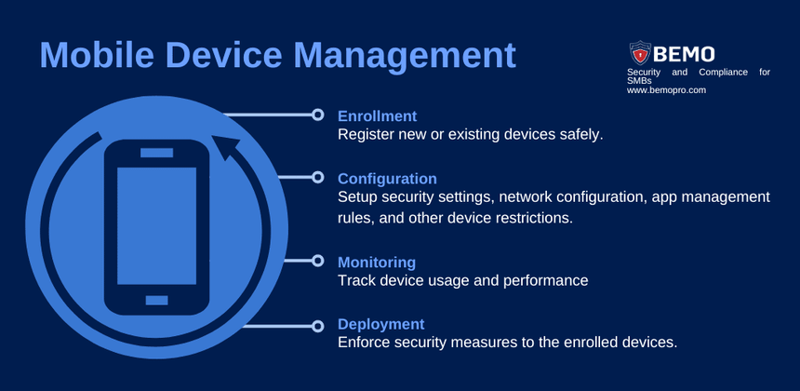](https://www.bemopro.com/cybersecurity-blog/what-is-mobile-device-management)

*"74% of global enterprise IT leaders claim their companies experienced a data breach due to mobile security issues." (Markets and Markets)*

An enterprise's most valuable asset is its data, but mobile devices accessing critical business information can create serious security risks. With remote work now essential, these devices have become key to productivity and efficiency. IT and security leaders are tasked with provisioning, managing, and securing them within corporate environments.

Mobile Device Management (MDM) is a security solution designed to monitor, manage, and secure an organization’s mobile devices, including smartphones, tablets, laptops, and computers. MDM software is a crucial solution for IT departments, helping to maintain security, streamline device management, and optimize productivity.

MDM takes a device-centric approach to managing and securing enterprise mobile devices. For example, when an employee receives a company-issued laptop, it often comes pre-configured with a corporate profile, VPN access, and essential applications. In such cases, MDM gives enterprises complete control over the device, allowing them to track, monitor, troubleshoot, and even remotely wipe data in case of theft, loss, or a security breach.

For personal (BYOD) devices, MDM enforces a role-based approach to security. Employees can securely access corporate emails, data, and apps through a protected VPN, password-enforced applications, and GPS tracking, ensuring that sensitive information remains secure without compromising personal privacy.

**Benefits of Mobile Device Management:** An MDM solution should give organization’s complete visibility into their endpoints, users, and everything in between.

* **Save time** by automating device management tasks
* **Boost efficiency** by streamlining IT operations
* **Enhance productivity** by ensuring seamless device performance
* **Strengthen security** by protecting company data and enforcing policies
* **Simplify management** with an easy-to-use, centralized control system

As companies transition to remote or hybrid working arrangements in the wake of the pandemic, there’s a lot of buzz around 'bring your own device’. Many are unaware of the fact that businesses have multiple options to consider when it comes to selecting an appropriate enterprise mobility setup. Two of the key elements influencing the selection of the best enterprise mobility approach are industry standards and an organization's own security concerns. There are four different types of mobile device management policies you may want to consider if you own a business and are looking for one that will fit with the culture and needs of your establishment, including:

1. BYOD:[Bring your own device](https://www.42gears.com/blog/what-is-byod-what-are-the-pros-and-cons-of-a-byod-model/)
2. CYOD: Choose your own device
3. COPE – Corporate owned, personally enabled
4. COBO – Corporate owned, business only

The BYOD policy mandates that all users and device owners be in charge of equipment acquisition and upkeep. Despite the fact that this has recently become a popular trend, this policy has serious security implications. This setup allows employees to remain flexible in their approaches and connect to their employers’ networks at any time, from anywhere. The BYOD policy puts devices at risk for cyberattacks, and the likelihood of human error increases this risk even more.

The CYOD policy eliminates the need for the company's IT team to take on additional management and security responsibilities by allowing employees to select hardware based on preferences from a list of devices that have already been approved. Employees can use corporate-owned devices for both personal and professional use in this alternative to the BYOD strategy.

With a COPE policy, organizations purchase the devices and pay for their maintenance. Since they control every stage of the device's lifecycle, they have more control over such devices. They can deploy MDM policies and solutions to manage such devices and to address security concerns and configuration-related issues. This policy may prove to be both useful and disturbing to employees.

Companies that use the COBO strategy provide devices to their employees and limit their use to business-related activities only. Compared to the other strategies, this one is the most stringent as employees aren't allowed to select their own devices or use them for personal work. However, in a cloud-based business environment, this strategy has become out-of-date as employees find it challenging to access various types of content using the same device.

No matter the model you choose to implement-BYOD, CYOD, COBO, or COPE-the end result will be the same: an improvement in productivity for mobile workers. The proper selection of a device management model is essential to the achievement of effective organizational mobility and a safe and sound working environment.

The strategy of "one size fits all" isn't always effective, thus in order for business organizations to reach their full potential in terms of productivity, they need to combine at least two different models into their working environment. In addition, every model features its own particular advantages and disadvantages. COBO, on the other hand, has the highest level of security of them all.