**LEMUEL OKECHUKWU**

**VEPH/20B/CY082**

**TASK 37B**

**REVIEW OF ‘’THE GREAT HACK’’ AND HOW IT RELATES TO OUR ERA**

**TASK 37B :**

* Identify and explain the cybersecurity-related procedures, techniques, or incidents depicted in the documentary *The Great Hack*, highlighting their relevance to data privacy, information security, and digital forensics

[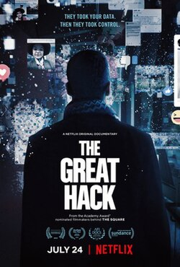](https://en.wikipedia.org/wiki/File:The_Great_Hack_poster.jpg)

The documentary "The Great Hack" explores the misuse of personal data, particularly focusing on the Cambridge Analytica scandal, where the data of millions of Facebook users was harvested without their consent and used for political advertising. The documentary focuses on David Carroll of [Parsons](https://en.wikipedia.org/wiki/Parsons_School_of_Design) and [The New School](https://en.wikipedia.org/wiki/The_New_School), [Brittany Kaiser](https://en.wikipedia.org/wiki/Brittany_Kaiser) (former business development director for [Cambridge Analytica](https://en.wikipedia.org/wiki/Cambridge_Analytica)), and British investigative journalist [Carole Cadwalladr](https://en.wikipedia.org/wiki/Carole_Cadwalladr). Their stories interweave to expose the work of Cambridge Analytica in the politics of various countries, including the United Kingdom's [Brexit](https://en.wikipedia.org/wiki/Brexit) campaign and the [2016 United States elections](https://en.wikipedia.org/wiki/2016_United_States_elections).

The SCL Group was a private research and strategic communications company interested in studying and influencing mass behavior. With alleged expertise in [psychological operations](https://en.wikipedia.org/wiki/Psychological_operations) (psyops), the company worked in military and political operations around the world in the late 1990s, including electioneering in the developing world throughout the early 2000s. To do business involving US elections, the subsidiary Cambridge Analytica was formed in 2012.

In 2015, Cambridge Analytica, a UK-based [political consulting](https://en.wikipedia.org/wiki/Political_consulting) firm, began working on behalf of [Ted Cruz's presidential campaign](https://en.wikipedia.org/wiki/Ted_Cruz%27s_presidential_campaign) to attempt to win the 2016 US Republican nomination. It used Facebook as a means for "political-voter surveillance" through the collection of user data points. Independent investigations into data mining, along with whistle-blower accounts of the firm's impact on [Brexit](https://en.wikipedia.org/wiki/Brexit), led to a scandal over the influence of social media in political elections.

The illicit harvesting of [personal data](https://en.wikipedia.org/wiki/Personal_data) by Cambridge Analytica was first reported in December 2015 by Harry Davies, a journalist for [*The Guardian*](https://en.wikipedia.org/wiki/The_Guardian). He reported that Cambridge Analytica was working for United States senator [Ted Cruz](https://en.wikipedia.org/wiki/Ted_Cruz) and used data harvested from millions of people's Facebook accounts without their consent.

Facebook refused to comment on the story other than to say it was investigating. Further reports followed in the Swiss publication *Das Magazin* by Hannes Grasseger and Mikael Krogerus (December 2016), (later translated and published by [*Vice*](https://en.wikipedia.org/wiki/Vice_(magazine))), [Carole Cadwalladr](https://en.wikipedia.org/wiki/Carole_Cadwalladr) in *The Guardian* (starting in February 2017) and Mattathias Schwartz in [*The Intercept*](https://en.wikipedia.org/wiki/The_Intercept) (March 2017). Brittany Kaiser, former director of Business Development at Cambridge Analytica, revealed that everything published involving Cambridge Analytica in the Brexit campaign and [Ted Cruz](https://en.wikipedia.org/wiki/Ted_Cruz)'s campaign was true. The scandal reached a point where even [Mark Zuckerberg](https://en.wikipedia.org/wiki/Mark_Zuckerberg), Facebook's founder, had to testify officially in front of several committees of the [United States Congress](https://en.wikipedia.org/wiki/United_States_Congress).

[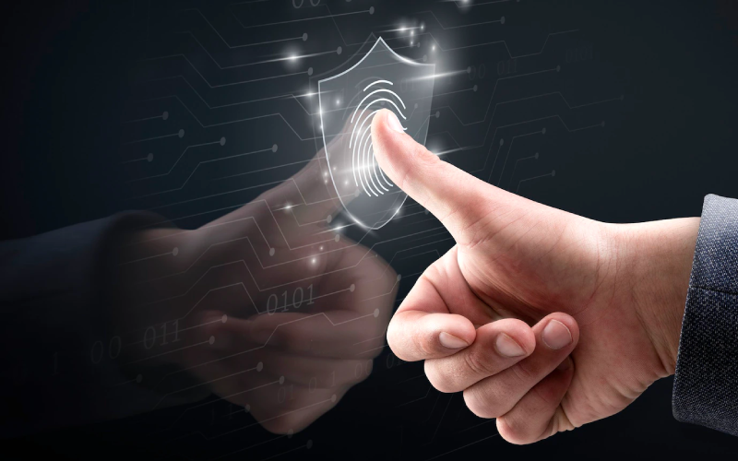](https://eccu.edu/blog/cybersecurity/fundamentals-of-information-security)

Data privacy is a critical concern in the context of the documentary, as it highlights the unauthorized collection and use of personal data. The context mentions the importance of protecting digital evidence and ensuring the integrity of digital devices and digital evidence through a chain of custody. This aligns with the need for robust data privacy measures to prevent unauthorized access and misuse of personal information.

Information security is another key aspect discussed in the context, emphasizing the need for proactive defense and the integration of digital forensics with incident response. The context highlights the importance of using digital forensics techniques and tools to examine and analyze digital evidence to understand the scope of an event and apply incident response tools and techniques to detect, contain, and recover from attacks. This is relevant to the documentary's focus on the security breaches and the subsequent investigation into the misuse of data.

Digital forensics plays a crucial role in investigating cyber incidents and identifying threat actors. The context mentions the importance of digital forensics in the aftermath of an attack, providing information required by auditors, legal teams, or law enforcement. This is directly related to the documentary's exploration of the investigation into the Cambridge Analytica scandal and the subsequent legal and regulatory actions taken.

In conclusion, while the specific procedures, techniques, or incidents depicted in "The Great Hack" are not directly mentioned in the context, the themes of data privacy, information security, and digital forensics are highly relevant to the topics discussed. The context emphasizes the importance of protecting digital evidence, ensuring the integrity of digital devices, and using digital forensics techniques to investigate cyber incidents, all of which are critical in the context of the documentary's exploration of the misuse of personal data.

1. [*"Netflix documentary The Great Hack turns the Cambridge Analytica scandal into high drama"*](https://www.theverge.com/2019/1/30/18200049/the-great-hack-cambridge-analytica-netflix-documentary-film-review-sundance-2019)*. The Verge. July 8, 2019.*
2. [*"Stream It Or Skip It: 'The Great Hack' On Netflix, A Documentary About How Cambridge Analytica Mined Our Personal Data And Who Blew The Whistle"*](https://decider.com/2019/07/24/the-great-hack-netflix-stream-it-or-skip-it/)*. Decider. 24 July 2019. Retrieved August 5, 2019.*
3. [*"Netflix's The Great Hack Brings Our Data Nightmare to Life"*](https://www.wired.com/story/the-great-hack-documentary/)*. Wired.*[*ISSN*](http://ISSN)[*1059-1028*](https://search.worldcat.org/issn/1059-1028)*. Retrieved 2019-09-13 – via www.wired.com.*