LEMUEL OKECHUKWU

VEPH/20B/CY082

TASK 31A

**Unraveling the Landscape of Cybersecurity Solutions: EDR, XDR, SIEM AND SOAR**

**TASK 31A:**

* Can you provide a detailed technical explanation of Endpoint Detection and Response (EDR) and Extended Detection and Response (XDR), including their core functionalities, operational mechanisms, and key differences? Additionally, explain how EDR and XDR integrate with Security Information and Event Management (SIEM) and Security Orchestration, Automation, and Response (SOAR) platforms in a modern cybersecurity ecosystem.
* Can you provide an in-depth technical explanation of antivirus and antimalware software, including their core functionalities, mechanisms of operation, and key differences in scope and architecture?

[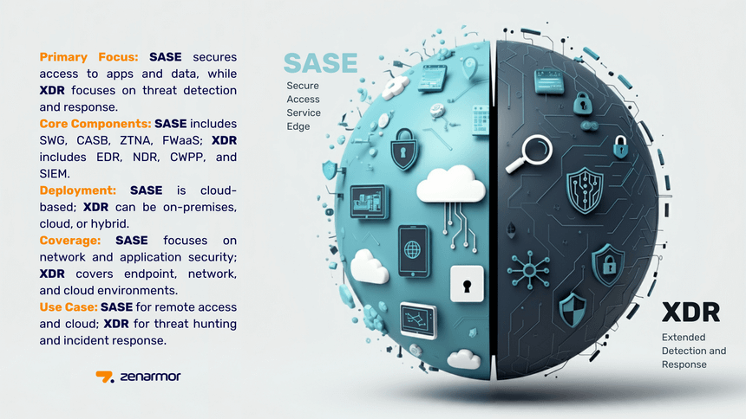](https://www.zenarmor.com/docs/network-security-tutorials/sase-vs-xdr)

Cyberattacks have become more common, more advanced and more costly, which is driving the need for a comprehensive cybersecurity strategy. Central to every security strategy is a detection and response capability which catches threats that have circumvented traditional security measures.

[Endpoint detection and response (EDR)](https://www.crowdstrike.com/en-us/cybersecurity-101/endpoint-security/endpoint-detection-and-response-edr/) is a cybersecurity solution that captures all endpoint activity and leverages advanced analytics to provide real-time visibility into the health of all endpoints; detect anomalous activity; alert the information security (Infosec) team to events; and provide remediation suggestions and capabilities to respond, stop an attack in progress or limit its spread.

Endpoint detection and response solutions have the following capabilities:

* Endpoint monitoring and event recording
* Data search, investigation and threat hunting
* Alert triage or suspicious activity validation
* Suspicious activity detection
* Data analysis
* Actionable intelligence to support response
* Remediation

[Extended detection and response (XDR)](https://www.crowdstrike.com/en-us/cybersecurity-101/endpoint-security/extended-detection-and-response-xdr/)streamline security data ingestion, analysis and workflows across an organization's entire security stack, enhancing visibility around hidden and advanced security threats and unifying the response.

On the other hand, an XDR platform collects and correlates data from across the infrastructure so it can improve threat visibility across the enterprise, accelerate security operations and reduce risk. XDR analyzes, prioritizes and streamlines this data, so it can be delivered to security teams in a normalized format through a single, consolidated console.

XDR platforms typically offer the following capabilities:

* Diverse, multi-domain security telemetry
* Threat-focused event analysis
* Threat detection and prioritization of data fidelity
* Data search, investigation and threat hunting across multi-domain telemetry
* Response to mitigate and remediate the threat

[](https://www.lumificyber.com/solutions/endpoint-detection-response-edr-xdr/)

**Implementation Scenario:** Imagine a scenario where an organization deploys EDR software on all employee laptops. If an endpoint detects suspicious activity like an unauthorized process running, EDR can isolate the endpoint from the network, collect forensic data, and trigger an alert to the security team.

**Implementation Scenario:** Suppose a SIEM solution collects logs from network devices, servers, and firewalls. When it detects a pattern of multiple failed login attempts, it can trigger an alert for a potential brute-force attack.

**Implementation Scenario:** In the case of a phishing attack, a SOAR platform can automatically isolate the affected system, notify the security team, and launch a predefined playbook to gather information, analyze the threat, and quarantine malicious emails.

**Implementation Scenario:** Consider an XDR solution that integrates EDR, SIEM, and SOAR functionalities. When a phishing email is detected, it can correlate this threat across endpoints, network logs, and orchestrate automated incident response, providing a holistic approach to threat management.

Key Differences and How They Work Together

* **EDR** focuses on endpoints and investigates threats at the individual device level.
* **SIEM** collects and analyzes data from various sources, providing a centralized view of security incidents.
* **SOAR** automates incident response and orchestrates security processes.
* **XDR** unifies data and analytics from various security products, offering a more holistic threat detection and response approach.

In the realm of cybersecurity, the implementation of EDR, SIEM, SOAR, and XDR plays a critical role in detecting, responding to, and mitigating security threats. By understanding their unique use cases and differences, organizations can effectively bolster their defenses. These solutions are available both in the cloud and on-premises, offering flexibility for different security requirements and preferences.

Antivirus and antimalware software are designed to protect computer systems from malicious software, but they have evolved to address a broader range of threats over time. Both types of software use various detection techniques to identify and neutralize threats, including signature-based detection, heuristic analysis, and behavioral monitoring.

**Core Functionalities:** Antivirus software primarily focuses on detecting and removing viruses, which are programs designed to replicate themselves and spread from one computer to another. Antimalware software, on the other hand, targets a wider range of malicious software, including spyware, ransomware, adware, and other types of malwares that do not necessarily replicate themselves.

**Mechanisms of Operation:**

* **Signature-Based Detection:** This method involves comparing files to a database of known malware signatures. When a file matches a known signature, the software flags it as malicious. However, this approach is limited because it can only detect malware for which signatures already exist.
* **Heuristic Analysis:** This technique looks for suspicious patterns and behaviors that are indicative of malware, even if the exact signature is not known. Heuristic analysis can help identify new or modified malware that signature-based detection might miss.
* **Behavioral Monitoring:** This involves observing how a program behaves when it runs. If the program exhibits suspicious behavior, such as attempting to modify system files or monitor keystrokes, the software can flag it as potentially malicious.

**Key Differences:**

* **Scope:** While antivirus software traditionally focused on viruses, antimalware software has a broader scope, targeting a wider range of threats, including spyware, ransomware, and adware.
* **Architecture:** Antivirus software often relies heavily on signature-based detection, which can be less effective against new or modified malware. Antimalware software typically incorporates more advanced techniques, such as heuristic analysis and behavioral monitoring, to detect a wider range of threats.

Both antivirus and antimalware software play crucial roles in protecting systems from malicious software. However, they differ in their scope and the specific mechanisms they use to detect and neutralize threats. As malware evolves, so too must the tools used to combat it, leading to the integration of more sophisticated detection methods in modern security software.