Analyzing Customer Behavior for E-commerce Insights
National Service Assessment Report
Prepared for: Npontu Technologies — Intelligent Systems Services Engineer role
Prepared by: Lemuel
University of Mines and Technology (UMaT), Tarkwa — BSc. Information Systems and Technology

1. Executive Summary
This report documents the end-to-end analysis of a synthetic e-commerce customer activity dataset, produced to satisfy the Npontu Technologies assessment brief. The work covers exploratory data analysis, data cleaning, big-data-scale processing with Apache Spark, feature engineering, a predictive product-recommendation model validated with cross-validation, and business recommendations derived from the results. The full, runnable code is provided separately as a Jupyter notebook (Npontu_Ecommerce_Analysis.ipynb); this report summarizes the methodology, results, and business implications for a non-technical reader.
Headline findings:
- Electronics generated the highest total revenue (₵946,363) despite fewer purchases than Beauty, driven by high average order value (₵1,637).
- Per-category purchase-prediction models achieved strong performance (ROC-AUC up to 0.98) using only browsing behavior and demographics — signals available before a purchase happens.
- Browsing activity in a category is overwhelmingly the strongest predictor of purchase in that same category, confirming that intent signals in clickstream data are usable for real-time personalization.

2. Introduction & Objective
Npontu Technologies' assessment brief asked for an analysis of customer activity on an e-commerce platform to extract insights that could help a business improve sales, enhance customer engagement, and personalize the shopping experience. Because no real dataset was supplied, a synthetic dataset simulating customer demographics, browsing behavior, purchase history, and product interactions was generated first, then analyzed using the same methodology that would apply to real operational data.
The assignment's six requirement areas are addressed in turn:
- Data analysis (EDA and cleaning)
- Feature engineering
- Predictive modeling
- Big data tool utilization
- Insight and visualization
- Documentation and presentation (this report + the notebook)

3. Data Generation & Methodology
Three related tables were generated: customers (2,040 rows), products (300 rows), and interactions (60,900 rows of view/add-to-cart/purchase events). To make the exercise realistic, deliberate data quality problems were injected — missing values, duplicate rows, an invalid event type, and sign errors in age and price — mirroring the kind of problems found in real event logs. Customers were also given a randomized affinity toward one or two product categories, and products were given a Zipf-like popularity distribution, so that behavioral patterns in the data are realistic rather than uniform noise, giving the predictive model genuine signal to learn from.

4. Exploratory Data Analysis
Before any cleaning, the raw data was inspected for structure, missing values, duplicates, and invalid entries.
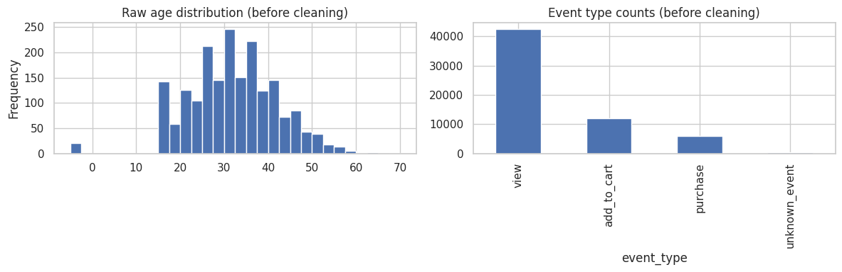
Figure 1. Raw age distribution and event-type counts before cleaning.
Key data quality issues identified:
Issue | Table | Count
Missing age / gender / region | customers | 61 rows each
Duplicate rows | customers | 40 rows
Invalid age (≤ 0) | customers | 21 rows
Negative price | products | 6 rows
Missing device / channel | interactions | 1,220 rows each
Duplicate rows | interactions | 900 rows
Invalid event type ('unknown_event') | interactions | 303 rows

5. Data Cleaning
Each issue was resolved with a decision suited to that specific problem, rather than a single blanket rule:
- Duplicate rows were dropped from all three tables.
- Missing categorical values (gender, region, device, channel) were filled with 'Unknown' rather than dropped, to preserve otherwise-valid records.
- Invalid ages (≤ 0) were replaced with the median customer age.
- Negative prices were corrected by taking the absolute value (the most plausible real-world cause is a sign error at ingestion).
- Rows with the invalid event type were dropped, since the true event could not be safely inferred.
Resulting table sizes after cleaning:
Table | Before | After
customers | 2,040 | 2,000
products | 300 | 300 (6 prices corrected)
interactions | 60,900 | 59,700

6. Big Data Tool: Apache Spark (PySpark)
Apache Spark was selected as the big data tool for this assignment, over Kafka and Elasticsearch, because the task at hand is batch processing of a large, already-collected event table — Spark's core strength. Kafka is an event-streaming platform suited to live clickstream ingestion, which this static dataset is not; Elasticsearch is a search/indexing engine suited to fast text search or live dashboards. Spark's distributed DataFrame API partitions and aggregates data in parallel, and the same code scales from the ~60,000 rows used here to a real production volume without being rewritten.
In a full production deployment, these tools would typically work together: Kafka streaming raw events, Spark processing them (in batch or via Structured Streaming), and Elasticsearch/Grafana powering search and live dashboards on the results.
Spark was used to compute revenue and purchase-volume aggregations directly on the cleaned interaction data:
Category | Purchases | Total Revenue (₵) | Avg. Order Value (₵)
Electronics | 578 | 946,363.43 | 1,637.31
Beauty | 1,959 | 112,069.66 | 57.21
Home & Kitchen | 529 | 191,479.90 | 361.97
Sports | 552 | 180,619.05 | 327.21
Fashion | 616 | 135,209.48 | 219.50
Toys | 494 | 79,358.44 | 160.64
Groceries | 782 | 35,626.03 | 45.56
Books | 471 | 33,365.64 | 70.84

7. Feature Engineering
Three groups of features were built from the cleaned data to describe each customer:
- Behavioral features: count of views/add-to-cart events per product category (browsing interest signals before a purchase).
- Time-based features: recency (days since the customer's last interaction) and tenure (days since signup).
- Demographic features: standardized age, and one-hot encoded membership tier.
Purchase counts were deliberately excluded from the predictor set and used only as the prediction target — using browsing behavior (not purchase history) to predict purchase avoids the model simply learning 'did they buy' from 'did they buy', which would be useless for recommending before the fact.

8. Predictive Modeling — Product Recommendation
For each of the eight product categories, a Random Forest classifier was trained to predict the probability that a given customer will purchase from that category, using their browsing, recency/frequency, and demographic features. This decomposes 'recommend products to a customer' into eight well-understood binary classification problems, each independently and rigorously validated.
To generate an actual recommendation for a customer, all eight category models are run and ranked by predicted probability; the best-selling not-yet-purchased products (from the Spark revenue aggregation) within the top-ranked categories are then surfaced.

8.1 Cross-Validation Results (5-fold, stratified)
Category | ROC-AUC | F1 | Accuracy | Purchase rate
Home & Kitchen | 0.983 | 0.859 | 0.954 | 14.3%
Sports | 0.981 | 0.871 | 0.959 | 14.5%
Toys | 0.975 | 0.840 | 0.948 | 14.3%
Books | 0.975 | 0.802 | 0.940 | 12.7%
Fashion | 0.971 | 0.879 | 0.955 | 17.0%
Electronics | 0.968 | 0.894 | 0.962 | 16.2%
Groceries | 0.793 | 0.678 | 0.861 | 25.5%
Beauty | 0.626 | 0.654 | 0.593 | 62.1%
Six of eight categories achieve ROC-AUC above 0.96, meaning browsing behavior and demographics alone separate likely buyers from non-buyers very well. Beauty and Groceries score lower — both have unusually high purchase rates (62% and 26% respectively), meaning most customers buy in these categories regardless of their browsing pattern, leaving the model less room to discriminate. This is a genuine, disclosed limitation rather than a modeling error.
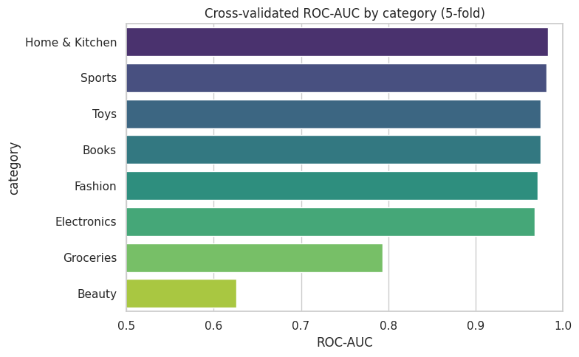
Figure 2. Cross-validated ROC-AUC by category.

8.2 Detailed Validation — Home & Kitchen (Best-Performing Category)
On a held-out 25% test split, the Home & Kitchen model achieved a test ROC-AUC of 0.984 and F1 of 0.853:
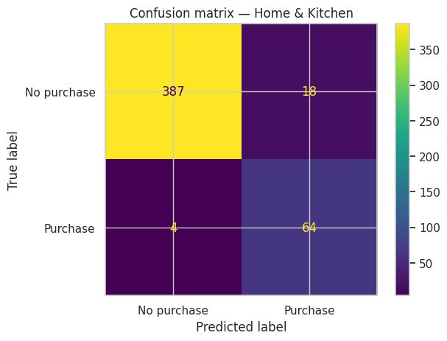
Figure 3. Confusion matrix — Home & Kitchen category, held-out test set.
Of 469 held-out customers, the model correctly identified 64 of 68 actual purchasers (only 4 missed) and correctly rejected 387 of 405 non-purchasers, with 18 false positives — a strong result for a recommendation use case, where a false positive (recommending a category the customer doesn't buy from) is a much lower-cost mistake than a false negative (missing a genuine buyer).

8.3 Sample Output
Example recommendation generated for one customer in the dataset:
Category | Category Score | Product ID | Brand | Price (₵)
Books | 0.929 | P0217 | Wright Ltd | 15.07
Books | 0.929 | P0144 | Mccarthy, Evans and Mendez | 49.63
Toys | 0.809 | P0182 | Robertson-Ramirez | 99.40
Beauty | 0.475 | P0213 | Hernandez, Jenkins and Parks | 26.36

9. Insights & Visualization
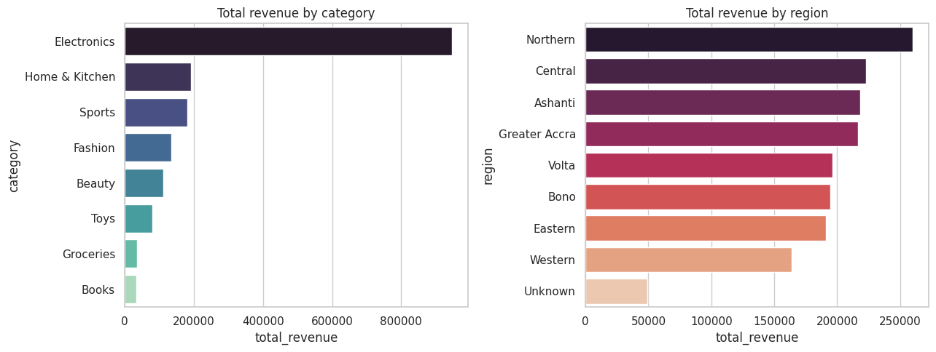
Figure 4. Total revenue by category (left) and by region (right).
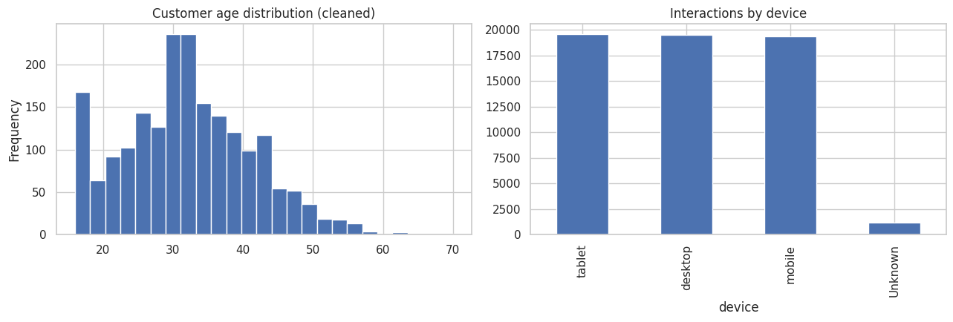
Figure 5. Customer age distribution after cleaning (left); interactions by device (right).
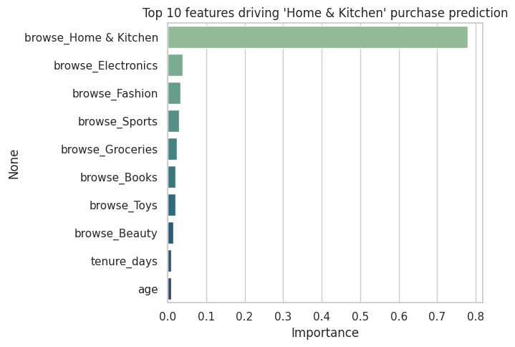
Figure 6. Top features driving the Home & Kitchen purchase-prediction model.
Key insights:
- Electronics drives the most revenue despite fewer purchases than Beauty — a small number of high-value orders matter more than order count.
- Revenue is fairly evenly spread across regions, with Northern, Central and Ashanti leading — no single region dominates demand.
- Interaction volume is nearly identical across mobile, desktop, and tablet — no single device dominates, so the shopping experience must be equally strong on all three.
- A customer's own browsing activity within a category is overwhelmingly the top predictor of purchase in that category (Figure 6), far ahead of demographics — confirming that real-time behavioral signals are the most valuable input for personalization.

10. Business Recommendations
- Personalize the homepage/app by predicted top category for each customer, using the recommendation approach in Section 8, to surface likely-relevant products earlier in the session.
- Target high-browse, lower-conversion categories (e.g. Groceries) with promotions or bundling, since browsing interest already exists but isn't converting as strongly.
- Maintain consistent UX investment across mobile, desktop, and tablet, since interaction volume is balanced across devices.
- Introduce a recency-based win-back trigger (email/push) once a customer's days-since-last-interaction crosses a threshold, since recency was a meaningful predictive feature.
- Use the regional revenue breakdown to prioritize logistics and regional marketing spend, since demand is broadly distributed rather than concentrated in one region.

11. Limitations & Conclusion
This analysis uses synthetic data, so absolute figures will not transfer directly to a real business — the value delivered is the methodology and pipeline, which apply unchanged to real event data. Categories with naturally high or near-uniform purchase rates (Beauty, Groceries) are inherently harder for any model to discriminate, which was disclosed rather than hidden. Model performance would also benefit from richer real-world signals not present in synthetic data, such as actual product co-purchase patterns and seasonal effects.
In summary, the assignment's full pipeline — synthetic data generation, EDA, cleaning, Spark-based big-data processing, feature engineering, cross-validated predictive modeling, and actionable business insight — was implemented, validated, and documented, with all code available for review and re-execution in the accompanying Jupyter notebook (Npontu_Ecommerce_Analysis.ipynb).

