

Device for Bioplastic Sheet Production Using Corn Starch, Chitosan, and Pineapple Leaf Fiber

A Thesis Presented to the Faculty of the College of Engineering Bulacan State University
City of Malolos

In Partial Fulfillment of the Requirements for the Degree of Bachelor of Science in Computer Engineering

By:

BULANADI, GILMER A. BURCIA, DARYL E. EBARDO, JEREMY ELMO D. TEJADA, JOSH M.
BSCPE-4B MAR 2026

i

ABSTRACT
Plastic pollution poses a persistent threat to environmental health and biodiversity, particularly in developing nations where sustainable alternatives remain scarce and conventional plastics continue to accumulate in ecosystems. This study presents the design and implementation of a semi-automated device for producing bioplastic sheets from corn starch reinforced with chitosan and alkali-treated pineapple leaf fiber (PALF). The system integrates locally abundant agricultural and marine waste materials corn starch, pineapple leaves, and seafood-derived chitosan into a cost-effective, eco-friendly alternative to petroleum-based plastics. The device comprises four primary modules: (1) a Preparation Module for pre-mixing dry ingredients, (2) a Mixing and Gelatinization Module with precise temperature control for starch gelatinization, (3) a Forming and Molding Module for sheet casting and controlled drying, and (4) a Monitoring Module utilizing NodeMCU ESP8266 and a web-based application for real-time process oversight. The findings demonstrated that the developed device achieved temperature accuracy with an average error of 0.14°C, mixing consistency with a coefficient of variation of 0.32% at optimal temperature, dispensing precision with 100% success rate within ±5% tolerance, and optimal bioplastic flexibility at 1.0mm thickness. In terms of functionality, efficiency, and reliability based on ISO/IEC 25010:2011 standards, the system received high acceptability ratings from evaluators (overall mean of 4.28). However, limitations were identified including single-batch operation, absence of self-cleaning mechanisms, and manual heating element activation. Consequently, the researchers recommended implementing automatic self-cleaning features, upgrading to continuous batch processing, integrating load cells for gravimetric monitoring, and utilizing dedicated heating elements for full automation. Overall, the developed system offers a viable, scalable solution for sustainable

ii

bioplastic production that addresses both environmental concerns and the underutilization of local agricultural waste.
Keywords – bioplastic, corn starch, chitosan, pineapple leaf fiber, alkali treatment, gelatinization, NodeMCU, IoT monitoring, semi-automated production.

iii

Table of Contents
TITLE PAGE i

ABSTRACT ii
TABLE OF CONTENTS iv - v
CHAPTER 1: THE PROBLEM AND ITS BACKGORUND
Introduction 1
Statement of the Problem 3
Significance of the Study 4
Scope and Delimitation 5
CHAPTER 2: THEORETICAL FRAMEWORK
Relevant Theories 7
Related Literature 10
Related Studies 22
Conceptual Framework 29
Definition of Terms 32
CHAPTER 3: REASEARCH METHODOLOGY
Methods and Techniques of the Study 35
Population and Sample of the Study 39
Research Instruments 40
Data Gathering Procedure 41
Data Processing and Statistical Treatment 41
CHAPTER 4: PRESENTATION, ANALYSIS, AND INTERPRETATION OF DATA
Design and Implementation of a Semi-Automated Bioplastic Sheet Production Device 46
Developing the Bioplastic Sheet Production Device 49
Evaluation of the Bioplastic Sheet Production Device 74
CHAPTER 5: SUMMARY, CONCLUSIONS, AND RECOMMENDATIONS
Summary of Findings 80
iv
Conclusions 90
Recommendations 91
References …………………………………………………………………………………..…92

v

Chapter 1

THE PROBLEM AND ITS BACKGROUND

Introduction
Plastic, primarily derived from crude oil and gas, has been widely used for various applications over the past century. The growing global population has increased plastic consumption and production, reaching 367 million metric tons in 2020 (Errera, 2022). Conventional plastics, composed of polymers like ethylene, propylene, vinyl chloride, and styrene, decompose very slowly because natural enzymes do not easily break down their chemical bonds. As a result, plastic waste has accumulated significantly, with individuals generating between 69 and 221 kg of plastic waste per year, but only 9% of it is recycled, and 22% is mismanaged (Organization for Economic Co-operation and Development [OECD], 2022). Plastic pollution is anticipated to intensify in the future decades as production and consumption rise, owing to urbanization, economic growth, and an increasing reliance on disposable items. Plastics are still used in a variety of industries, including healthcare, food packaging, construction, and technology, so eliminating their use is not practicable. Their lightweight, durability, and cost-effectiveness make them difficult to completely replace. However, this dependence heightens the need to develop sustainable alternatives that reduce environmental effects while retaining functional performance.
The widespread usage of single-use plastic packaging has made a significant contribution to environmental damage. In the Philippines, massive amounts of plastic waste collect in waterways, landfills, and coastal zones, obstructing drainage systems and

releasing dangerous microplastics into aquatic ecosystems. This pollution endangers marine biodiversity and poses a threat to human health via the food chain. Although biodegradable polymers have been presented as substitutes, they are still expensive, mechanically weak, and rely significantly on imported raw materials, limiting their availability and scalability in developing countries (Shafqat et al., 2020).
Locally plentiful resources such as corn starch, pineapple leaves, and seafood shells are neglected, despite their potential as raw materials for bioplastic manufacturing. Corn starch is renewable, biodegradable, and abundant in the Philippines, making it an acceptable base material. However, it lacks mechanical strength when employed alone (Reddy et al., 2013). Reinforcement with chitosan (produced from seafood shells) and alkali-treated pineapple leaf fiber (PALF) improves tensile strength, water resistance, and biodegradability, converting agricultural and marine wastes into important sustainable packaging materials.
Chitosan, produced from chitin found in seafood waste, has antibacterial and film-forming characteristics that help bioplastics operate better (Elsabee & Abdou, 2013). Pineapple leaf fiber (PALF), an agricultural byproduct, contains a high cellulose content and, when alkali-treated, can greatly increase mechanical strength by improving adhesion with polymer matrices (Sari et al., 2021). Combining these elements into a reinforced bioplastic sheet allows for a more cost-effective, long-lasting, and environmentally responsible solution. Furthermore, developing a semi-automated system for bioplastic synthesis assures process uniformity and efficiency while also giving livelihood chances for local communities.
With this prior information, the researchers came up with a system that makes

bioplastic sheets from corn starch reinforced with chitosan and alkali-treated pineapple leaf fiber. The method intends to provide an economical, eco-friendly, semi-automated alternative for making long-lasting bioplastic sheet, addressing both environmental concerns about plastic pollution and underutilization of local agricultural resources.

Statement of the Problem
The primary purpose of this study is to design and develop a device for bioplastic sheet production using corn starch reinforced with chitosan and alkali-treated pineapple leaf fiber.
Specifically, this study intended to solve the following:

- How to design a device for bioplastic sheet production using corn starch, chitosan, and alkali-treated pineapple leaf fiber?
- How to develop bioplastic production in terms of:

  - Preparation Module;

  - Mixing and Gelatinization Module;

  - Forming and Molding Module; and

  - Monitoring Module?
- How to test the device in terms of:

  - Temperature Accuracy;

  - Mixing Consistency;

  - Dispensing Precision;

  - Pump Time Accuracy;

  - Vibration Time Accuracy; and

3.4 Bioplastic Flexibility?

- How to evaluate the system based on its ISO/IEC 25010:2011:

  - Functionality;

  - Efficiency; and

  - Reliability?

Significance of the Study
The beneficiaries of this study include the following:

Environment and Biodiversity. The bioplastic developed in this study decomposes naturally, preventing long term accumulation of plastic waste. This contributes to ecosystem preservation and biodiversity protection from harmful impacts of synthetic plastics. The IoT monitoring ensures optimal production conditions, minimizing material waste and energy consumption.
Small Scale Manufacturers. The device provides affordable entry into green manufacturing with low-cost Node MCU based monitoring. The IoT enabled quality control allows real time tracking of production status, enabling small producers to maintain standards without substantial capital investment.
Farmers and Fisherfolk. Farmers gain new revenue streams from corn starch and pineapple leaves previously treated as agricultural waste. Fisherfolk benefit through potential chitosan supply chain participation and reduced marine plastic pollution that damages fishing grounds.
Computer Engineering and IoT Practitioners. The research demonstrates practical applications of embedded systems in biodiversity conservation. The Node MCU
based monitoring architecture serves as a reference design for low cost industrial automation in resource limited settings.
Future Researchers. The open architecture design provides an educational platform for teaching embedded systems and sustainable engineering. Future researchers can build upon the IoT monitoring framework for interdisciplinary studies combining computer engineering and environmental science.

Scope and Delimitation
The objective of this study is to design and develop a semi-automated laboratory device capable of producing bioplastic sheet from corn starch reinforced with chitosan and alkali-treated pineapple leaf fiber (PALF). Following the general approach used in recent PALF-reinforced starch studies, the researchers will prepare a starch–chitosan solution, carry out alkali treatment of the PALF with sodium hydroxide, and use the device to combine and cast the mixture into sheets. We will use an app to monitor the process of the device and its functions. The proposed apparatus will comprise a heating water with precise temperature control for starch gelatinization, a mechanical mixer to ensure even distribution of chitosan and alkali-treated PALF, and a basic molding module for shaping the bioplastic films.
However, the scope of this research will be limited to laboratory-scale fabrication intended to demonstrate the practicality of using locally abundant materials. The study will not include pilot or industrial-scale production. Only cornstarch will be used as the polymer matrix, and other possible starch sources will not be considered. Chitosan will serve as the secondary biopolymer at a fixed proportion, and its concentration will not be optimized.

The reinforcing material will be limited to pineapple leaf fiber treated with sodium hydroxide (NaOH). Testing of the machine will cover only basic temperature accuracy, mixing consistency, dispensing precision, and bioplastic flexibility. It also does not include advanced industrial processing such as extrusion, compression molding, or automated packaging systems. The evaluation of the system is limited to selected ISO/IEC 25010:2011 software quality characteristics, specifically: functionality efficiency reliability, The study does not focus on extensive material characterization or chemical analysis of the produced bioplastic beyond the basic functionality of the device. The study is limited to the development and performance evaluation of the device, and economic analysis, mass production feasibility, refinement of the plastic is not included, and long-term durability testing are not included. The sheets cannot be used for wet food and medical applications, and molding will not be used to create other shapes or forms other than simple flat sheets. The production also does only one mixture at a time it cannot be use to repetitive dispensing, it can only be do it again after it ends the whole process, and the exact amount of the materials is only intended for one mixture.. The device designed in this study does not have an automatic self-cleaning feature. Therefore, cleaning and maintenance of the machine must be performed manually by the operator after use.

Chapter 2 THEORETICAL FRAMEWORK
This chapter aims to provide the relevant theories, related studies, and related literature that serve as a resource of guidelines for researchers to lead into more suitable topic research and invest genuine understanding of this study.

Relevant Theories
The theories relevant to the present research are outlined in this section of the chapter. It acts as a guide for deeper comprehension of the study.
Internet of Things (IoT) Theory. The Internet of Things (IoT) Theory explains how physical devices can be connected through the internet to collect, transmit, and analyze data in real time. Through sensors and communication networks, devices can monitor conditions, automate processes, and improve system efficiency and decision-making.
According to Amirhossein GhaffarianHoseini and Nicholas Tookey (2018), IoT technology enables interconnected devices and sensors to monitor operations, gather data, and provide real-time information that improves productivity, efficiency, and management of engineering processes.
In relation to the present study, this theory supports the integration of sensors in the semi-automated bioplastic production device. By using sensors to monitor parameters such as temperature, thickness, and moisture, the system can collect accurate data and help maintain consistency and efficiency during the production of bioplastic sheets.
Interfacial Adhesion Theory. The Interfacial Adhesion Theory describes the importance of strong bonding between the matrix and the reinforcing fiber in composite materials.

According to Anderson (1991), the quality of interfacial adhesion determines how effectively stress is transferred between the two phases, which directly affects the mechanical strength and durability of the composite. Proper surface treatment and chemical compatibility enhance this adhesion.
In relation to the present study, this theory explains the use of alkali treatment for pineapple leaf fiber. The treatment removes lignin and hemicellulose, increasing the fiber’s surface roughness and promoting stronger bonding with the starch–chitosan matrix. This enhanced interfacial adhesion improves the mechanical performance and durability of the produced bioplastic sheet.
Systems Design and Automation Theory. The Systems Design and Automation Theory focuses on structuring engineering systems into interconnected modules that function efficiently through control and feedback mechanisms.
According to Hall (1962), systems engineering involves designing, integrating, and managing complex systems to achieve desired performance while maintaining reliability and safety.
In relation to the present study, this theory provides the foundation for developing the semi-automated bioplastic production device. The design includes functional modules such as preparation, mixing, molding, drying, and quality monitoring, which are integrated with sensors for temperature, thickness, and moisture control. These automated features ensure precision, consistency, and efficiency in bioplastic production.
Software Quality Modeling Theory. The Software Quality Modeling Theory explains how structured frameworks are used to evaluate and measure the quality of software systems. Quality models organize different software characteristics into

hierarchical structures so that abstract quality concepts can be measured using observable metrics.
According to the study A Generalized Approach to the Operationalization of Software Quality Models, software quality models assess systems by combining measurable metrics with higher-level quality characteristics such as reliability, usability, efficiency, maintainability, and security. These models use hierarchical structures where lower-level measurements are aggregated to evaluate overall software quality.
In relation to the present study, this theory supports the evaluation of the semi-automated bioplastic production device by ensuring that system components function efficiently and reliably. By organizing system processes and monitoring parameters such as temperature, thickness, and moisture through sensors, the device can maintain consistent performance and product quality during the production of bioplastic sheets.

Related Literature
The researchers examined the following literature to provide the information required to establish a foundation and provide substantial support for the study.

Embedded IoT Design for Bioreactor Sensor Integration

Bucur et al. (2024) developed an embedded IoT system for bioreactor sensor integration utilizing ESP32 microcontrollers to achieve precise temperature control and real-time process monitoring. In their study, they designed a control system incorporating temperature sensors, turbidity sensors, and Peltier modules for heating and cooling, all managed through Pulse Width Modulation (PWM) techniques. The results demonstrated that the ESP32-based system achieved temperature control accuracy of ±0.5°C and maintained thermal stability within ±0.2°C, while simultaneously transmitting real-time data to a cloud-based ThingsBoard platform for remote visualization. The researchers concluded that embedded IoT architectures provide cost-effective, reliable solutions for bioprocess automation, offering precise environmental control essential for sensitive biological and chemical processes.
The study also highlighted that integrating wireless communication protocols with microcontroller-based systems enables seamless data acquisition and remote monitoring capabilities critical for modern laboratory automation. By implementing a web-based dashboard accessible through standard internet browsers, the system allowed operators to monitor process parameters and receive automated alerts without requiring specialized software or extensive infrastructure. The researchers emphasized that such low-cost, open-source hardware solutions utilizing components like the ESP32, which shares the same architecture family as NodeMCU democratize access to advanced process control

technologies for small-scale laboratories and educational institutions with limited budgets.

This research directly relates to the present study, as it validates the use of NodeMCU-compatible ESP microcontrollers for precise temperature control in bioprocessing applications, specifically for starch gelatinization. The findings support the selection of PWM-based heating control and cloud-connected monitoring architectures for the proposed bioplastic production device. By applying similar embedded IoT design principles and temperature control algorithms, this project aims to develop a semi-automated system that ensures consistent gelatinization conditions while providing realtime operational visibility through an integrated mobile monitoring interface.

An IoT-Enabled Real-Time Machine Status Monitoring Approach for Cloud Manufacturing
Zhang et al. (2017) developed an IoT-enabled system for real-time machine status monitoring in cloud manufacturing environments, utilizing RFID technology and wireless communication networks to capture and transmit operational data. In their study, they designed a multi-layered architecture consisting of perception, network, and application layers, where RFID tags and sensors collected machine status information, wireless networks transmitted data to cloud servers, and a graphical dashboard visualized real-time operational states on smartphones and web interfaces. The results demonstrated that the proposed system achieved efficient real-time data acquisition with reduced latency, enabling manufacturers to monitor equipment availability, utilization rates, and operational conditions remotely. The researchers concluded that IoT-based machine status monitoring enhances production transparency and supports intelligent decision-making in distributed

manufacturing systems.

The study also highlighted that integrating cloud computing with IoT technologies enables scalable data storage and processing capabilities essential for modern smart factories. By implementing a service-oriented architecture, the system allowed seamless integration with existing manufacturing execution systems (MES) and enterprise resource planning (ERP) platforms, providing a comprehensive view of shop-floor operations without requiring extensive infrastructure overhaul. The researchers emphasized that such cloud-based monitoring solutions—accessible via mobile devices—democratize real-time production visibility for small and medium enterprises, enabling them to compete with larger manufacturers through improved operational awareness and reduced equipment downtime.
This research directly relates to the present study, as it validates the use of IoT architectures and wireless communication protocols for real-time equipment status tracking in manufacturing applications. The findings support the implementation of a mobile-based monitoring interface for the proposed bioplastic production device, enabling operators to track which modules (preparation, mixing, gelatinization, molding) are actively functioning. By applying similar IoT design principles and cloud-connected dashboard concepts, this project aims to develop a semi-automated system that provides immediate operational visibility through an integrated smartphone application, ensuring efficient process oversight and timely intervention when necessary.

Low-Cost IoT-Based Sensors Dashboard for Monitoring Mobile Harbor Cranes

Abdelwahab et al. (2024) developed a low-cost IoT-based monitoring system for mobile harbor cranes utilizing Arduino and Raspberry Pi platforms to achieve real-time

operational data acquisition and visualization. In their study, they designed a modular architecture incorporating load sensors, ultrasonic sensors, and GPS modules connected to Arduino microcontrollers, with data transmission via wireless networks to a Raspberry Pi edge device running QC-DAS software for processing and dashboard visualization. The results demonstrated that the proposed system achieved reliable real-time monitoring of critical parameters including load weight, boom angle, and wind speed, with automatic alerts generated when operational thresholds were exceeded, all at significantly reduced costs compared to proprietary industrial systems. The researchers concluded that open-source hardware solutions provide viable alternatives for industrial monitoring applications in developing countries, offering comparable functionality to expensive commercial systems while maintaining scalability and customization flexibility.
The study also highlighted that integrating modular software design with low-cost microcontrollers enables rapid deployment and adaptation across diverse industrial equipment types without requiring specialized technical expertise. By implementing a user-friendly dashboard interface accessible through standard web browsers, the system allowed crane operators and safety managers to monitor multiple equipment units simultaneously from remote locations, improving operational safety and maintenance scheduling efficiency. The researchers emphasized that such affordable IoT architectures utilizing widely available components like Arduino and Raspberry Pi bridge the technology gap for small and medium enterprises in resource-constrained environments, democratizing access to advanced monitoring capabilities previously limited to large-scale industrial operations. This research directly relates to the present study, as it validates the use of Arduino-compatible platforms, including NodeMCU, for cost-effective industrial monitoring and

control applications in developing country contexts. The findings support the selection of open-source hardware and modular software architectures for the proposed bioplastic production device, demonstrating that precise parameter monitoring and automated alert systems can be achieved without prohibitive infrastructure investments. By applying similar low-cost IoT design principles and dashboard visualization concepts, this project aims to develop a semi-automated bioplastic production system with an integrated mobile monitoring interface, providing real-time visibility into machine module status while remaining accessible to small-scale laboratories with limited budgets.

Automation of the Drop-Casting Deposition Method for Polymeric Sensing Films

López-Olvera et al. (2025) developed an automated drop-casting system for depositing polymeric sensing films, utilizing microcontroller-based linear actuators and precision dispensing mechanisms to achieve consistent film thickness and uniformity. In their study, they designed a three-axis mechanical platform controlled by an Arduino Mega 2560, where stepper motors drove a syringe pump for controlled solution dispensing and servo motors managed substrate positioning, all coordinated through a MATLAB interface implementing S-curve motion profiles. The results demonstrated that the automated system reduced thickness dispersion from 60% to 15% compared to manual casting methods, with statistical validation confirming significant improvements in reproducibility. The researchers concluded that automating the solution casting process through microcontroller-based control systems provides a reliable, cost-effective approach for producing high-quality polymer films with consistent properties.
The study also highlighted that integrating precision mechanical control with open-

source microcontroller platforms enables laboratory-scale automation without requiring expensive industrial equipment. By implementing S-curve velocity profiles and real-time position feedback, the system eliminated the variability inherent in manual pipetting and substrate handling, which are particularly problematic for viscous polymer solutions. The researchers emphasized that such automated casting systems—utilizing readily available components like Arduino microcontrollers and standard stepper motors democratize access to precision film manufacturing for research laboratories, bridging the gap between manual techniques and industrial coating processes.
This research directly relates to the present study, as it validates the use of Arduino-based control systems for automated solution casting of polymer films, directly applicable to the forming and molding module of the proposed bioplastic production device. The findings support the implementation of stepper motor-controlled dispensing and precision positioning mechanisms for achieving uniform bioplastic sheet thickness, while demonstrating that open-source microcontroller platforms can achieve industrial-grade consistency at reduced costs. By applying similar automation principles, specifically S-curve motion control and feedback-based positioning—this project aims to develop a semi-automated forming and molding system that ensures consistent starch-chitosan-PALF film thickness, improving mechanical properties and reducing material waste compared to manual casting methods.

Automated Liquid Filling System with a Robotic Arm Conveyor for Small Scale Industries
Salau et al. (2020) developed an automated liquid filling system for small-scale industries, utilizing Arduino Mega 2560 and integrated sensor networks to achieve precise

liquid dispensing. In their study, they designed a control system incorporating infrared sensors, ultrasonic sensors, and gear motors, where the Arduino processed sensor inputs to control conveyor movement and robotic arm positioning for accurate bottle filling. The results demonstrated that the automated system achieved consistent filling volumes with reduced spillage compared to manual methods. The researchers concluded that Arduino-based automation provides cost-effective solutions for small-scale manufacturing in developing economies.
The study also highlighted that integrating multiple sensors with open-source microcontrollers enables flexible automation adaptable to various small-scale applications. By implementing modular design with real-time sensor feedback, the system allowed automatic detection of bottle presence and precise liquid level control without requiring complex programming. The researchers emphasized that such low-cost systems utilizing Arduino, IR sensors, and DC motors bridge the technology gap for small enterprises in resource-constrained environments.
This research directly relates to the present study, as it validates the use of Arduino-compatible platforms, including NodeMCU, for automated liquid handling in small-scale production systems applicable to developing countries like the Philippines. The findings support the selection of open-source hardware and integrated sensor networks for the proposed bioplastic production device. By applying similar automation principles, specifically sensor-based feedback control and modular design, this project aims to develop a semi-automated system that ensures consistent preparation, mixing, and forming operations while providing real-time operational visibility through an integrated monitoring interface.

Cyber Physical Systems Security

Rapid7 (2024) defined Cyber-Physical Systems (CPS) as integrations of computation with physical processes through five components: sensors, actuators, embedded controllers, communication networks, and human-machine interfaces. In their analysis, they explained that CPS integrates digital intelligence with physical machinery, where sensors collect data, embedded controllers process information, and actuators execute physical actions. The results demonstrated that effective CPS requires seamless integration between components, with the human-machine interface enabling operators to monitor system status and intervene when necessary. The researchers concluded that CPS architectures provide the foundation for modern industrial automation and IoT-enabled production systems.
The study also highlighted that the human-machine interface (HMI) component is critical for operator interaction with automated systems, encompassing dashboards, control panels, and mobile applications that present real-time operational data. By implementing intuitive HMIs, organizations enable operators to visualize system status, receive automated alerts, and execute control commands without requiring direct physical access to equipment. The researchers emphasized that such interface technologies bridge the gap between automated processes and human operators, ensuring safe and efficient system oversight.
This research directly relates to the present study, as it validates the Cyber-Physical Systems framework for the proposed bioplastic production device, specifically justifying the mobile monitoring application as the human-machine interface component. The findings support the integration of NodeMCU-based sensor networks, embedded control

systems, and smartphone-based visualization into a cohesive CPS architecture. By applying these principles, specifically the HMI through mobile interfaces and real-time feedback control, this project aims to develop a semi-automated bioplastic production system that enables operators to monitor module status through an integrated mobile application.

IoT-Based Energy Monitoring in Production

Klein et al. (2024) developed an IoT-based energy monitoring system for production environments, utilizing a three-layer architecture consisting of cyber-physical production systems, edge devices, and cloud platforms. In their study, they implemented MQTT protocols for data transmission from Raspberry Pi edge devices to cloud-based dashboards, enabling real-time visualization of energy consumption and machine operational states. The results demonstrated that this architecture achieved efficient data transmission with reduced latency and improved scalability compared to traditional industrial monitoring systems. The researchers concluded that standardized IoT protocols and layered architectures provide cost-effective, flexible solutions for real-time manufacturing monitoring.
The study also highlighted that integrating lightweight communication protocols with open-source hardware enables rapid deployment of monitoring systems across diverse industrial settings. By implementing MQTT for device-to-cloud communication and utilizing Raspberry Pi as edge processing units, the system allowed seamless data aggregation from multiple sensors without requiring expensive proprietary infrastructure. The researchers emphasized that such open architectures utilizing standardized protocols democratize access to industrial IoT capabilities for small and medium enterprises.

This research directly relates to the present study, as it validates the three-layer IoT architecture for the proposed bioplastic production device, specifically supporting the use of NodeMCU as edge devices and MQTT for data transmission to mobile dashboards. The findings demonstrate that lightweight protocols and layered system designs achieve reliable real-time monitoring at reduced costs. By applying these architectural principles, specifically edge processing and standardized communication protocols, this project aims to develop a semi-automated bioplastic production system with efficient real-time data transmission to an integrated mobile monitoring interface.

Vibratory Mixing for Rapid Powder Homogenization

Kottlan et al. (2021) developed a vibratory mixing system for pharmaceutical powder blending utilizing an electrodynamic shaker to achieve rapid homogenization of pre-mixed ingredients in sealed containers. In their study, they investigated the mixing performance of initially segregated binary powder mixtures under vertical vibrations at frequencies of 100–300 Hz and accelerations up to 112g, using high-speed video recordings and colorimetric image analysis to evaluate mixing quality. The results demonstrated that even though the powders were pre-layered in a segregated state, vibratory mixing at 100 Hz and 150 Hz produced homogeneous blends with Lacey indices of approximately 0.95 within 2 seconds. The researchers concluded that vibratory mixing transforms initially non-uniform mixtures into highly uniform states rapidly, offering an effective solution for applications requiring quick, reliable homogenization of pre-mixed materials.
The study also highlighted that the formation of intense mixing zones during vibration creates convective and diffusive particle movement that breaks down segregated
structures almost immediately upon activation. By implementing high-speed imaging synchronized with vibration frequency, the researchers observed that lower frequencies with larger amplitudes generated larger intense mixing zones that propagated through the powder bed, enabling uniform distribution of components within seconds. The researchers emphasized that such rapid mixing kinetics eliminate the need for extended processing times, making vibratory mixing particularly suitable for time-sensitive manufacturing processes where pre-mixed materials must be homogenized quickly before further processing steps.
This research directly relates to the present study, as it validates that brief vibratory agitation can achieve excellent mixture uniformity even when starting from poorly mixed or segregated pre-mixtures, which is essential for bioplastic precursor preparation. The findings support the implementation of short-duration vibratory mixing cycles for the proposed bioplastic production device, where starch and additives may be pre-combined but require final homogenization immediately before gelatinization. By applying similar vibratory mixing principles with optimized frequency and amplitude parameters, this project aims to ensure complete ingredient uniformity within the critical time window before thermal processing begins.

Particle Size Distribution and Segregation in Vibrated Systems

Jain et al. (2013) investigated the influence of particle size distribution on segregation behavior in vibrated granular mixtures. In their study, the researchers examined binary and ternary particle systems placed in a vertically vibrated cylindrical container to observe how particles of different sizes behave under vibration. The experiment focused on understanding how particle size differences affect the mixing and segregation patterns

when the powder bed is subjected to controlled vibration. The results showed that mixtures containing only large and small particles tend to segregate during vibration because smaller particles move downward through void spaces while larger particles rise to the surface.
The study further demonstrated that introducing intermediate particle sizes in a ternary mixture significantly reduces segregation. The intermediate particles help fill the gaps between large and small particles, limiting the movement that normally leads to particle separation. As a result, the mixture becomes more stable during vibration and maintains a more uniform particle distribution compared with binary mixtures that have large size differences. The researchers explained that this bridging effect between particle sizes improves mixture stability and reduces the tendency of particles to separate when vibrational forces are applied.
This research is relevant to the present study because the bioplastic precursor mixture consists of particles with varying sizes, including corn starch powder, chitosan powder, and powdered pineapple leaf fiber. Corn starch particles are generally smaller, PALF particles are relatively larger, and chitosan particles fall between these two ranges, forming a ternary particle size distribution similar to the systems examined in the study. The findings support the idea that having intermediate particle sizes can reduce segregation during vibration, which helps maintain uniform mixing of the ingredients before the bioplastic formation process.

Related Studies
This section summarizes the key findings and methodologies of previous studies, identifies areas of agreement or disagreement among researchers, and highlights the research gaps that the current study aims to address.
Design and Implementation of an IoT-based Production Performance Monitoring System Using NodeMCU ESP8266 and Blynk IoT Platform for Manufacturing Quality Tracking (Sitompul, E. F., Sihombing, P., & Indra, E., 2022). In this study, the researchers developed a real-time monitoring system using NodeMCU ESP8266 microcontroller integrated with Blynk IoT platform to track manufacturing production quality. The system classified production output into three categories: OK (good quality), Repair (needs rework), and Scrap (rejected), enabling immediate quality control decisions and remote monitoring capabilities. The implementation utilized ESP8266 WiFi module for wireless data transmission to a cloud-based dashboard, allowing supervisors to monitor machine operational status and production rates through mobile devices. This study demonstrated that low-cost open-source hardware could effectively replace expensive traditional SCADA systems in small to medium manufacturing environments while maintaining reliable real-time monitoring performance.
This study has a direct impact on the monitoring module of the current research. The utilization of NodeMCU ESP8266 with Blynk IoT platform validates the technical approach for tracking the operational status of the bioplastic production device modules, specifically the Preparation, Mixing and Gelatinization, Forming and Molding, and Dispensing components. It confirms that real-time monitoring of machine parts and production quality can be achieved through WiFi-enabled microcontroller architectures

with mobile dashboard interfaces. Furthermore, the classification methodology and wireless communication framework provide a foundation for evaluating the functionality, efficiency, and reliability of the semi-automated bioplastic sheet production system according to ISO/IEC 25010:2011 software quality characteristics.
Design and Implementation of a High-Precision Temperature Controller with Microcontroller and Touchscreen Interface (Wimmer, F., 2025). In this study, the researcher developed a high-precision temperature control system using ARM Cortex-M4 microcontroller with integrated analog-to-digital converters and digital-to-analog converters for accurate sensor signal acquisition and actuator control. The system implemented a PID control algorithm executing at 5Hz frequency, achieving temperature stability with an accuracy of ±25mK and demonstrating the capability to follow predefined temperature profiles with minimal deviation. The design incorporated a 4.3 inch touchscreen display for local user interaction, USB communication interface for remote operation and data logging, and an independent safety supervision system with hardware watchdog to ensure fail-safe operation. This implementation proved that precise temperature control for demanding applications could be achieved using cost-effective microcontroller platforms while maintaining reliability through redundant safety mechanisms.
This study has a direct impact on the temperature control subsystem of the current research. The PID control implementation and precision specifications validate the technical approach for maintaining accurate gelatinization temperature in the Mixing and Gelatinization Module of the bioplastic production device. It confirms that microcontroller-based temperature regulation with feedback control loops can achieve the necessary

precision for starch gelatinization processes using affordable hardware components. Furthermore, the safety supervision architecture and real-time control methodology provide a framework for ensuring reliable temperature accuracy testing and consistent thermal management throughout the bioplastic sheet production process.
Microcontroller-Based PID Position and Speed Control for DC Motors with PC Interface (CalPoly, 2021). In this study, the researcher developed a closed-loop control system using ATmega16 microcontroller to implement PID algorithms for precise position and speed regulation of DC motors. The system utilized H-bridge motor drivers for bidirectional control and incorporated encoder feedback mechanisms to achieve accurate motor positioning with minimal steady-state error. The implementation featured RS-232 UART communication protocol for real-time data exchange between the microcontroller and PC-based graphical user interface, enabling remote monitoring and control parameter adjustment. This study demonstrated that microcontroller-based PID control could effectively eliminate steady-state errors and reduce system overshoot while maintaining responsive dynamic performance in motor control applications.
This study has a direct impact on the mixing control subsystem of the current research. The PID control implementation for DC motors validates the technical approach for achieving consistent mixing speeds in the Mixing and Gelatinization Module of the bioplastic production device. It confirms that closed-loop feedback control with encoder sensing can maintain precise agitation rates necessary for uniform distribution of chitosan and alkali-treated PALF within the starch matrix. Furthermore, the UART communication framework and PC interface methodology provide a foundation for integrating motor control status into the NodeMCU-based monitoring system for real-time mixing consistency evaluation.

Embedded IoT-Based Bioreactor Monitoring and Control System with Cloud Integration (PMC/NIH, 2024). In this study, the researchers developed a comprehensive bioprocess monitoring system using ESP32 microcontroller with integrated WiFi and Bluetooth capabilities for real-time bioreactor supervision. The system incorporated DS18B20 temperature sensors for precise thermal monitoring, turbidity sensors for optical density measurement, and Peltier modules for active temperature regulation, all controlled through custom firmware developed in Arduino IDE. The implementation utilized Google Sheets as a cloud database for IoT data logging, enabling remote access to process parameters and historical trend analysis through internet-connected devices. This study demonstrated that ESP32-based embedded systems could effectively manage complex bioprocess variables while maintaining reliable cloud connectivity for distributed monitoring applications.
This study has a direct impact on the sensor integration and monitoring architecture of the current research. The ESP32-based sensor network and cloud logging methodology validate the technical approach for real-time data acquisition in the bioplastic production device, particularly for temperature accuracy and process monitoring using WiFi-enabled microcontrollers. It confirms that distributed sensor arrays with centralized data logging can provide comprehensive oversight of bioprocess parameters, directly applicable to monitoring the Preparation, Mixing and Gelatinization, and Forming and Molding modules. Furthermore, the cloud integration framework and wireless communication protocols provide a foundation for implementing the NodeMCU ESP8266-based monitoring system with Firebase or Blynk IoT platform for real-time tracking of device operational status.

Microcontroller-Based Automation for Biotechnology: Signal Acquisition, Processing, and Cloud Integration (ScienceDirect, 2023). In this study, the researchers developed an integrated embedded system using ESP32 microcontrollers for signal acquisition, processing, and control in biotechnology applications. The system implemented analog-to-digital conversion for sensor data acquisition, digital signal processing algorithms for data filtering and analysis, and wireless communication protocols for real-time monitoring and control. The architecture utilized Arduino IDE for firmware development, Firebase for cloud database synchronization, and Edge Impulse platform for embedded machine learning applications. This study demonstrated that modern microcontrollers could effectively handle complex bioprocess automation tasks including real-time control, data logging, and predictive analytics through integrated hardware-software architectures.
This study has a direct impact on the embedded system architecture of the current research. The ESP32-based signal processing and cloud integration methodology validate the technical approach for implementing intelligent monitoring and control in the bioplastic production device using NodeMCU ESP8266 platform. It confirms that microcontroller-based systems can simultaneously manage multiple sensor inputs, execute control algorithms, and maintain cloud connectivity for remote supervision. Furthermore, the Firebase integration framework and wireless communication protocols provide a foundation for developing the monitoring module with real-time database synchronization and mobile application interface for tracking device functionality and operational status.
Design for Automation in Manufacturing: A Methodology for Early-Stage Product Design (Calvanese, D., 2016). In this study, the researcher developed a

systematic Design for Automation (DfA) methodology to guide product design decisions during early-stage development for automated manufacturing systems. The framework emphasized seven key principles including part count reduction, part standardization, assembly direction optimization, and handling simplicity to facilitate automated production. The methodology incorporated assessment tools for evaluating automation feasibility, cost estimation models for comparing manual versus automated assembly, and decision matrices for selecting appropriate automation technologies. This study demonstrated that applying structured DfA principles early in the design process could significantly reduce manufacturing costs, improve production efficiency, and enable smoother transition from prototype to scalable automated manufacturing.
This study has a direct impact on the system design methodology of the current research. The Design for Automation framework validates the modular approach implemented in the semi-automated bioplastic production device, specifically the functional separation into Preparation, Mixing and Gelatinization, Forming and Molding, and Monitoring modules. It confirms that early consideration of automation requirements, standardized component interfaces, and simplified handling mechanisms can improve system reliability and efficiency while maintaining cost effectiveness for laboratory-scale production. Furthermore, the assessment methodology and scalability principles provide a foundation for evaluating the device architecture according to ISO/IEC 25010:2011 quality characteristics and ensuring future expansion toward pilot-scale bioplastic manufacturing.
Advancing Sustainable Bioplastics: Chemical and Physical Modification of Starch Films for Enhanced Thermal and Barrier Properties (Pooja, Shashank, Singh, & Mazumder, 2024) investigated how physical and chemical treatments improve the

performance of starch‑based biodegradable films. The researchers applied techniques such as ultrasonication, autoclaving, and chemical crosslinking with citric acid and STMP/STPP to native starch to enhance properties like flexibility, water resistance, and thermal stability. The bioplastic films were produced via a solvent casting method by dissolving starch in water with glycerol and acetic acid plasticizers, heating the solution at 85–90 °C, pouring it into trays, and leaving it at room temperature for 24 hours before drying in a hot air oven at 40–45 °C for 48 hours, resulting in a total drying period of approximately 72 hours. This extended drying process is necessary because of the high water content in the gelatinized starch and plasticizers, ensuring uniform solidification and preventing defects in the final films.
This study is relevant to the current research on bioplastic sheet production because it provides experimental evidence that controlling temperature, composition, and drying conditions significantly affects the mechanical and barrier properties of starch‑based bioplastics. The findings support the design of the bioplastic production process in this study by explaining why prolonged drying is required to achieve stable, flexible, and well‑formed bioplastic sheets. Furthermore, the enhanced properties achieved through modification validate the importance of monitoring and optimizing processing parameters, such as heating and drying time, to produce high‑quality biodegradable materials.

Conceptual Framework
The development process of the study, “Design and Implementation of a Device for Bioplastic Sheet Production from Corn Starch Reinforced with Chitosan and Alkali-Treated Pineapple Leaf Fiber”, is shown in the figure below depicting the relationship between the variables using the Input, Process, and Output (IPO) model.

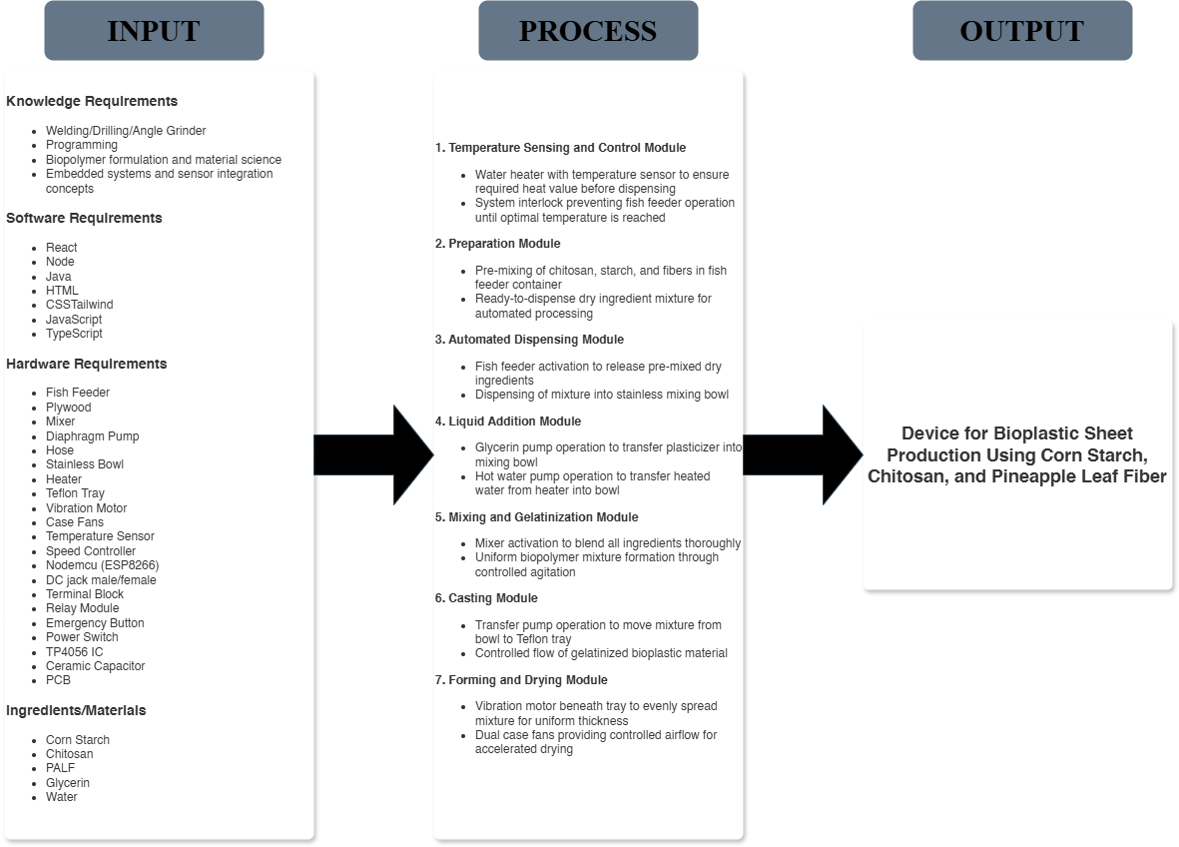

Figure 2.1. Diagram of the Study

The Input frame presents the four essential categories required for developing the Device for Bioplastic Sheet Production. Knowledge Requirements include welding,

drilling, and angle grinder operation; programming; biopolymer formulation and material science; and embedded systems and sensor integration concepts. Software Requirements encompass React, Node Java, HTML, CSS, Tailwind, and JavaScript for web application development. Hardware Requirements consist of Fish Feeder, Plywood, Mixer, Diaphragm Pump, Hose, Stainless Bowl, Heater, Teflon Tray, Vibration Motor, Case Fans, Temperature Sensor, Speed Controller, Nodemcu (ESP8266), DC jack male/female, Terminal Block, Relay Module, Emergency Button, Power Switch, TP4056 IC, Ceramic Capacitor, and PCB. Ingredients/Materials include Corn Starch, Chitosan, PALF, Glycerin, and Water.
The Process frame outlines the eight sequential modules of the semi-automated system. Temperature Sensing and Control Module utilizes water heater with temperature sensor to ensure required heat value before dispensing, with system interlock preventing fish feeder operation until optimal temperature is reached. Preparation Module involves pre-mixing of chitosan, starch, and fibers in a fish feeder container, creating ready to dispense dry ingredient mixture for automated processing. Automated Dispensing Module activates fish feeder to release pre-mixed dry ingredients and dispense mixture into a stainless mixing bowl. Liquid Addition Module operates a glycerin pump to transfer plasticizer into the mixing bowl, followed by a hot water pump operation to transfer heated water from the heater into the bowl. Mixing and Gelatinization Module activates the mixer to blend all ingredients thoroughly, achieving uniform biopolymer mixture formation through controlled agitation. Casting Module utilizes transfer pump operation to move mixture from bowl to Teflon tray, ensuring controlled flow of gelatinized bioplastic material. Forming and Drying Module activates vibration motor beneath tray to evenly

spread mixture for uniform thickness, with dual case fans providing controlled airflow for accelerated drying. Quality Assurance Module performs visual inspection of finished bioplastic sheets to verify quality and consistency.
The Output frame represents the completed Design and Implementation of a Device for Bioplastic Sheet Production from Corn Starch Reinforced with Chitosan and Alkali Treated Pineapple Leaf Fiber. This includes the functional prototype capable of manufacturing consistent bioplastic sheets through automated processing and monitoring.
To summarize, the conceptual framework illustrates the systematic transformation of knowledge, software, hardware, and material resources through eight integrated processing modules into a functional bioplastic production device with IoT monitoring capabilities. The researchers documented each development phase, module iterations, and testing results which will be presented in Chapter 4.

Definition of Terms
Alkali Treatment – A chemical process using sodium hydroxide (NaOH) to remove lignin, hemicellulose, and surface impurities from natural fibers such as pineapple leaf fiber (PALF). This treatment enhances the fiber’s surface roughness and improves its adhesion to the polymer matrix.
Biodegradability – The ability of a material to naturally decompose into water, carbon dioxide, and biomass through the action of microorganisms such as bacteria and fungi under environmental conditions.
Bioplastic – A type of plastic derived from renewable biological sources such as starch, cellulose, or chitosan, designed to be biodegradable or compostable under natural conditions.
Chitosan – A natural polysaccharide obtained through the deacetylation of chitin, which is commonly found in the shells of crustaceans like shrimp and crabs. It enhances mechanical strength, provides antimicrobial properties, and improves film-forming capacity in bioplastics.
Composite – A material formed by combining two or more distinct substances (e.g., a polymer matrix and reinforcing fibers) to achieve superior mechanical or functional properties compared to individual components.
Corn Starch – A polysaccharide composed of amylose and amylopectin extracted from corn kernels. It serves as the main biopolymer matrix in this study for producing biodegradable films.
Device – A semi-automated system designed and developed by the researchers to

produce bioplastic films through processes of heating, mixing, molding, and drying.

Fiber Reinforcement – The process of incorporating natural or synthetic fibers into a polymer matrix to improve mechanical properties such as tensile strength, flexibility, and impact resistance.
Glycerol – A colorless, odorless liquid used as a plasticizer in bioplastic production to enhance flexibility and reduce brittleness in starch-based films.
Gelatinization – The process by which starch granules swell and dissolve when heated in water, leading to a thick, viscous solution suitable for bioplastic film formation.
Mechanical Properties – Physical characteristics that describe a material’s

response to applied forces, including tensile strength, elasticity, and flexibility.

Molding – The process of shaping the bioplastic material into sheets or packaging forms using a mold or casting frame.
Pineapple Leaf Fiber (PALF) – A lignocellulosic fiber extracted from pineapple leaves, rich in cellulose, and used as reinforcement in bioplastic composites due to its strength and biodegradability.
Plasticizer – A substance, such as glycerol, added to polymers to increase flexibility and reduce brittleness by lowering intermolecular forces between polymer chains.
Polymer – A large molecule composed of repeating structural units (monomers).

In this study, starch and chitosan act as natural polymers forming the bioplastic matrix.

Renewable Resource – A natural material that can be replenished over time, such

as corn, pineapple leaves, and seafood shells, which serve as the raw materials in this study.

Semi-Automated Device – A system that combines mechanical and electronic components to perform specific processes (e.g., heating, mixing, and molding) with minimal manual intervention.
Sodium Hydroxide (NaOH) – A strong alkaline compound used in the alkali treatment of natural fibers to remove impurities and enhance fiber–matrix bonding.
Starch – A carbohydrate polymer composed of amylose and amylopectin, found in various plants. It is biodegradable, renewable, and forms the base material for bioplastic production.
Tensile Strength – The maximum amount of stress a material can withstand while being stretched or pulled before breaking, measured in megapascals (MPa).
Water Absorption – The capacity of a material to take in water from its surroundings, affecting its dimensional stability and barrier properties.

Chapter 3 RESEARCH METHODOLOGY
This chapter provides an overview of the study methods that will be followed in the study. It provides details on the participants, that is, the qualifications for inclusion in the study, who the respondents were and how they will be sampled. The study's purpose and the factors that will lead to the design's selection are discussed by the researcher. The instrument that will be used for data collection is also described, and the procedures that will be followed to carry out this study are also included. The researcher also describes the methodology to be utilized to examine the data.

Methods and Techniques of the Study
This study employs a Research and Development (R&D) methodology with an experimental-iterative approach to design, develop, and evaluate the semi-automated bioplastic sheet production device. The research consists of three main phases: system design and prototyping, experimental testing and optimization, and performance evaluation. According to Pakala et al. (2011), adaptive design methodologies that incorporate step-wise prototyping and verification improve product realization while reducing development uncertainty and overall development risk, making iterative experimentation an effective approach for engineering system development.
The Research and Development (R&D) method is appropriate for this study because the goal is to design, develop, and implement a device capable of producing bioplastic sheets from corn starch reinforced with chitosan and alkali-treated pineapple leaf fiber (PALF). This method allows the researchers to continuously improve both the device

mechanism and the bioplastic formulation through repeated prototyping, testing, and refinement. According to Pakala et al. (2011), step-wise prototyping and verification help improve product realization and reduce development risk and uncertainty, making iterative development suitable for engineering system design.
The researchers designed the bioplastic production device following systems engineering principles. The hardware architecture was developed using NodeMCU (ESP8266) as the central microcontroller, with integrated temperature sensors, relay modules for pump and motor control, and a web-based monitoring interface built with React, Node.js, HTML, CSS, and JavaScript. The mechanical components including the mixing chamber, fish feeder dispensing mechanism, diaphragm pumps, and Teflon tray system were fabricated using welding, drilling, and angle grinding techniques. The control logic was programmed to enforce the sequential operation: temperature verification before dispensing, automated glycerin and hot water pumping, mixing, casting, and drying with vibration and fan control.
The experimental component involved five (5) fabrication runs to optimize device parameters and validate system functionality. Each run tested PALF concentrations (5%) by weight, while maintaining constant chitosan-to-starch ratio (2:1) and glycerin plasticizer content (20%). The device parameters monitored included temperature accuracy (target: 90°C for water), mixing consistency (mixer speed and duration), and dispensing precision (fish feeder timing).
The finalized device was evaluated based on ISO/IEC 25010:2011 software quality characteristics including functionality (correct operation of all modules), efficiency (processing time and energy consumption), and reliability (consistent output across

multiple runs). Device testing focused on temperature accuracy (±2°C tolerance), mixing consistency (visual uniformity and sensor validation), dispensing precision (±5% weight consistency), and bioplastic flexibility (bending to 90° angle). The IoT monitoring system was validated for real-time data logging, remote status tracking, and alert generation for process deviations.
This experimental-developmental methodology ensures systematic validation of both the hardware-software integration and the resulting bioplastic material quality, providing a replicable framework for computer engineering applications in sustainable manufacturing.

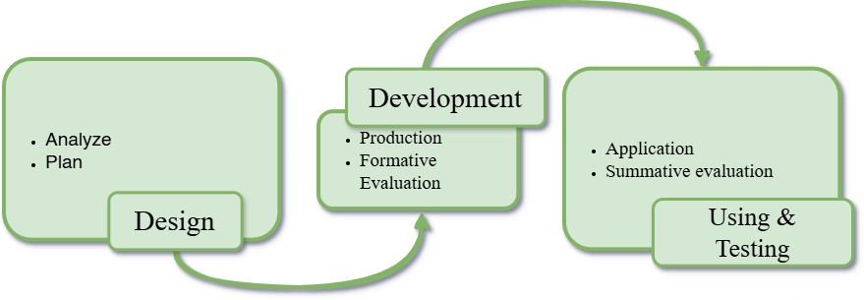

Figure 3.1. Design–Development–Evaluation Model of the Study
Adapted from Richey (2016), Design and Development Research Model.
The first stage is the design phase, which includes analyze and plan components. In the analyze step, the researchers examined the project requirements, reviewed related literature, and identified the necessary materials, equipment, and fabrication procedures for the bioplastic production device. The plan step involved preparing the conceptual design, workflow, and production layout, determining the mixing and heating process for the bioplastic formulation, and outlining testing procedures for the final output.
The second stage is the Development phase, consisting of production and formative evaluation. The production step includes the actual construction of the prototyped device, assembling mechanical and heating components, and preparing the bioplastic mixture using the materials that will be used. The formative evaluation step involves continuous testing of the device and bioplastic output during development. Adjustments and improvements are made based on initial trials to ensure proper mixing, temperature control, molding, and sheet formation.
The final stage is the Using & Testing phase, which includes application, summative evaluation, and testing. In the application step, the device is used to produce

bioplastic sheets under the established operating conditions. The summative evaluation step involves assessing the performance of the device through functionality, efficiency, and reliability to determine if the device meets the expected standards. Finally, testing refers to performing the device in repetitive actions, mechanical adjustments to ensure smooth operation, and to prevent malfunctions.

Population and Sample of the Study
The researchers want to utilize purposive sampling to ascertain the population's thoughts and pulse. According to Vijayamohan (2022), original data cannot be energy unless it is ordered, and the sampling method we use influences such structure. Purposive sampling is one of these sampling techniques. Purposive sampling is the process of extracting data from a larger sample size based on the survey recipient's or researcher's preference. In other words, a purposive sample is selected in accordance with the requirements of the exam, survey, or research to which it will be applied. Additionally, 25 qualified evaluators (factory workers, electronic technicians, and research students) assessed the device in terms of functionality, usability, safety, efficiency, and output quality.

Table 3.1. Sample and Frequency Table

Sample | Frequency
Factory Workers | 10
Technicians | 5
Machine Operators | 10

Total | 25

Research Instruments
The researchers will employ a five-point Likert scale to gather feedback from respondents regarding the performance of the semi-automated bioplastic sheet production device. The scale will be used to analyze the perceptions and evaluations of respondents who will test and assess the device’s functionality and operation. The evaluation will focus on the device performance, including system functionality, efficiency, and reliability rather than the quality of the produced bioplastic sheet. The assessment criteria will be based on the ISO/IEC 25010:2011 software quality model, which provides guidelines for evaluating system performance and overall software quality.

Table 3.2 Five Point Likert Scale

Numerical Rating | Descriptive Interpretation
4.21 – 5.00 | Strongly Agree
3.41 – 4.20 | Agree
2.61 – 3.40 | Neither Agree or Disagree
1.81 – 2.60 | Disagree
1.00 – 1.80 | Strongly Disagree

Data Gathering Procedure
The researchers used the testing and evaluation method to gather data throughout the development of the bioplastic sheet production device. This process involved recording important data during each phase of the system’s operation through functional and performance testing. Data such as temperature accuracy, mixing consistency, dispensing precision, and bioplastic flexibility were measured to assess the device’s performance and ensure consistent output. Multiple trial runs were conducted to determine the optimal machine parameters, including the timer settings for the dispensing mechanism, pump activation duration, and mixing time. After completing the development and testing stages, the researchers conducted an evaluation to determine the overall efficiency and reliability of the prototype. Selected evaluators were asked to assess the device’s performance using a structured questionnaire. The assessment focused on the accuracy of operation, safety, functionality, ease of use of the control application, and consistency of machine performance. The application allows users to start the full production process, view which part of the machine is currently operating, and activate an emergency stop if needed. Feedback and scores collected from the evaluators were tabulated and statistically analyzed to validate the prototype’s effectiveness and identify areas for improvement.

Data Processing and Statistical Treatment
The data gathered from the development and testing of the bioplastic sheet production device were analyzed to evaluate both the performance of the prototype and the application system. All measurements were statistically processed to ensure the accuracy, validity, and consistency of the results.

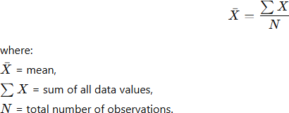

The mean provides the average rating or value for each criterion such as functionality, efficiency, and reliability.

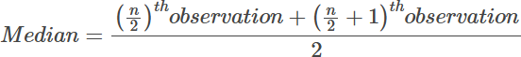

The median will be used to identify the middle value of the collected data, especially in cases where values may slightly vary due to human error or natural differences in the produced films. Using the median helps reduce the influence of extreme values, ensuring a more accurate representation of the typical performance of the bioplastic samples.

The mode will indicate the most frequently occurring score or measurement among the evaluations.

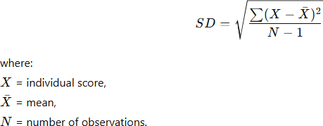

The standard deviation measures the degree of variation or dispersion of the data from the mean. A small SD indicates that the evaluators’ ratings are close to the average, showing high consistency, while a large SD implies greater variability in responses.

Chemistry LibreTexts (2026) described that the accuracy of experimental measurements can be evaluated using the percent error formula, where the difference between the actual and target value is divided by the target value and multiplied by 100. Percent error represents the relative deviation of an experimental result from the expected standard, providing a quantitative assessment of measurement accuracy and reliability in laboratory testing.

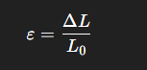
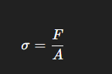
Fitco India (2023) described that the flexibility of bioplastic films can be evaluated using a hanging-weight test, where dried film strips are clamped at the top and incremental weights are applied at the bottom. Flexibility represents the material’s ability to bend or stretch without breaking, measured by the elongation or maximum weight supported before permanent deformation.

All collected data will be processed using Microsoft Excel. Descriptive statistics such as the mean, standard deviation, and percent difference will be computed to summarize the data. The results will be presented in tables and graphs for clear comparison.

Chapter 4

PRESENTATION, ANALYSIS, AND INTERPRETATION OF DATA

This chapter presents the design, development, testing, and evaluation of the bioplastic sheet production device using corn starch reinforced with chitosan and alkali-treated pineapple leaf fiber. It also discusses the analysis and interpretation of the results obtained from the performance testing of the device and the evaluation of the system based on the selected quality characteristics.
As described in the previous chapter, the system was divided into four major modules, namely: the Preparation Module, the Mixing and Gelatinization Module, the Forming and Molding Module, and the Monitoring Module. Each module was designed and developed individually before integrating them into a complete bioplastic sheet production device. The integration of these modules enabled the system to support the preparation, processing, and forming of starch-based bioplastic mixtures in a more organized and controlled manner.
The researchers applied the Design–Development–Evaluation (DDE) model in the development of the system. This model consists of three major phases: design, development, and evaluation. During the design phase, the researchers planned the structure of the device, identified the required modules, and determined the materials and components needed for the system. In the development phase, the researchers constructed and assembled the device, implemented the mixing and heating mechanisms, and integrated the monitoring components. Lastly, in the evaluation phase, the developed system was tested and analyzed in terms of temperature accuracy, mixing consistency,

dispensing precision, and bioplastic flexibility. And further evaluated based on selected quality characteristics from the ISO/IEC 25010:2011 standard, specifically functionality, efficiency, and reliability.
The development process followed an iterative approach, wherein improvements were made whenever necessary until the device achieved the desired performance and operational stability for producing bioplastic sheets.
Design and Implementation of a Semi-Automated Bioplastic Sheet Production Device TThe presentation of this study was based on the iterative Design–Development–Evaluation (DDE) model applied to both hardware and software. The first step, planning,
focused on researching and gathering information. The researchers reviewed literature and studies to understand bioplastic production, IoT monitoring, sensor integration, and automation. This guided the selection of components such as NodeMCU, temperature sensors, pumps, mixer, fan, vibration motor, and ingredients like corn starch, chitosan, glycerin, water, and alkali-treated pineapple leaf fiber (PALF).
The second step, analysis, evaluated hardware and software requirements. The device was divided into four modules: Preparation, Mixing and Gelatinization, Forming and Molding, and Monitoring. The workflow in Figure 4.1 shows the sequence. Initialization involves connecting the power, switching on the NodeMCU, and activating the relay. Process start is triggered through the mobile app. Material preparation heats water, dispenses powder, and pumps glycerin and water into the mixing chamber. Mixing creates a uniform biopolymer mixture. Dispensing and finalization transfers the mixture to the Teflon tray while the fan and vibration motor flatten and dry the sheets.

This iterative approach ensured the integration of hardware and software while maintaining accuracy, reliability, and efficiency in bioplastic production.
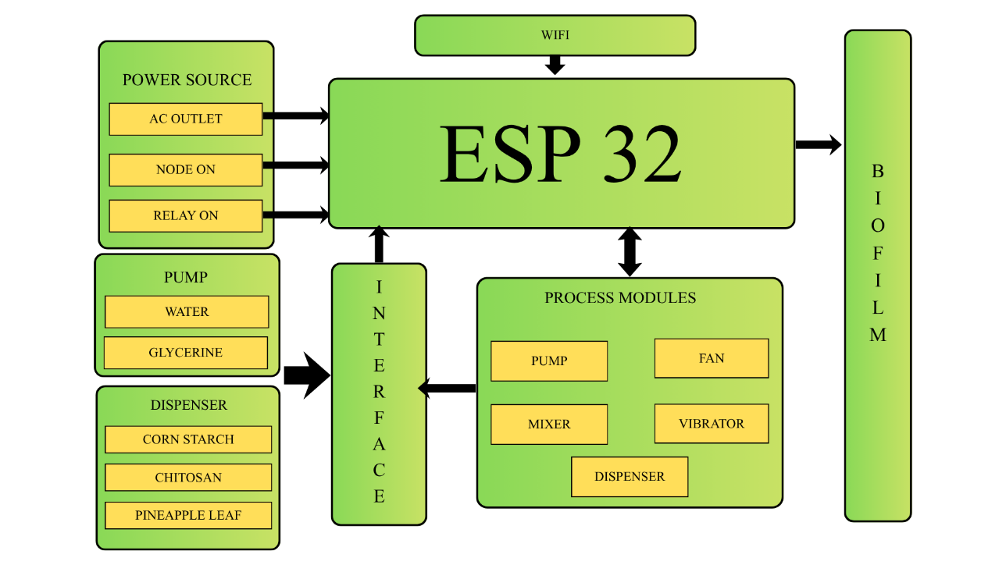

Figure 4.1 Block Diagram of the Device

As depicted in Figure 4.1, the Monitoring Module required HTML for structure, CSS with Tailwind for design, and JavaScript and TypeScript for interactive control and real-time monitoring. Node and React were used to build the web application interface, while Java handled backend logic and process sequencing. For IoT connectivity, the NodeMCU ESP8266 served as the central controller, linking sensors, pumps, mixer, fan, and vibration motor to the monitoring interface. The Preparation Module used a temperature sensor to verify water heating, while the automated dispensing module controlled the fish feeder, glycerin pump, and water pump for precise ingredient delivery. The Mixing Module operated a DC motor to blend all ingredients, and the Forming and Molding Module employed the exit pump, vibration motor, and fans to transfer, flatten, and dry the bioplastic sheets.

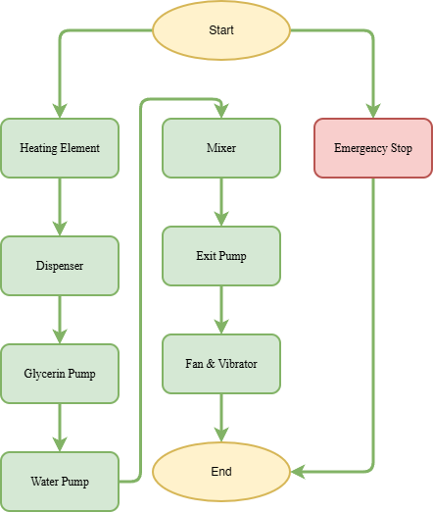

Figure 4.2 Flowchart of the Device

Design was the first phase in the development process, serving as the foundation for the development and evaluation of the bioplastic sheet production device. This phase describes how the system operates according to the requirements identified during planning and analysis.

Figure 4.2 illustrates the flowchart of the device, showing the sequential operation

of each module. The system starts when the power supply is connected, the NodeMCU is switched on, and the relay module is activated. The heating element raises water to the required temperature, after which the powder dispenser releases the pre-mixed corn starch, chitosan, and PALF. The glycerin and water pumps then add the plasticizer and hot water to the mixing bowl. The mixer blends all ingredients into a uniform biopolymer mixture. Finally, the exit pump transfers the mixture into the Teflon tray, where the fan and vibration motor spread it evenly for drying and forming into bioplastic sheets.
An emergency stop is integrated into the system, allowing the device to halt operation immediately and restart safely when needed. The software supporting the system includes Node.js, React, Java, HTML, CSS with Tailwind, JavaScript, and TypeScript, enabling real-time monitoring, control, and automation throughout the process.

Developing the Bioplastic Sheet Production Device.
After the planning, analysis, and design of the system development process, the next phase is development. In this part, the researchers presented each module’s development process along with the mobile application that controls the system, and they are as follows.

Development of the Web Monitoring Application. This section detailed how the researchers developed the web monitoring application. The development process was divided into multiple stages: beginning with researching and analyzing the requirements, progressing to planning and designing the application which included the development of the user interface, followed by coding where the actual development of the web application took place with testing. The provided figure below illustrates the Web Monitoring
Application's flowchart.
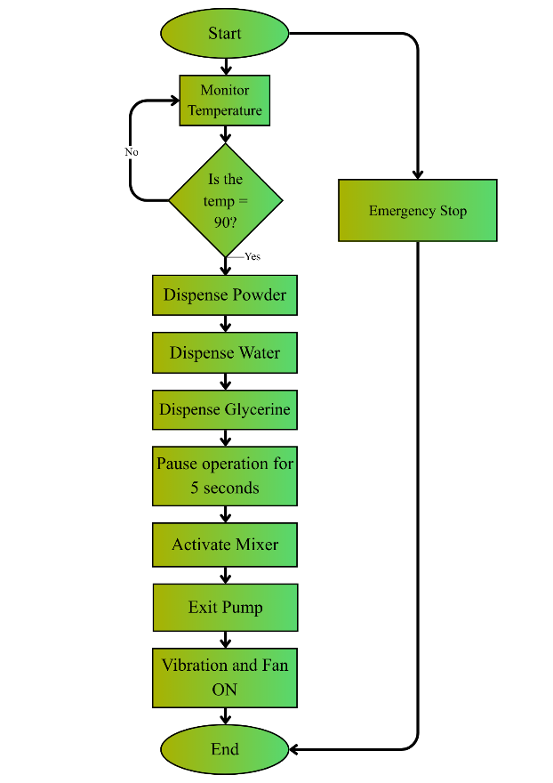

Figure 4.3 Flowchart of Web Monitoring Application

The The Web Monitoring Application controls and tracks the bioplastic device. The process starts with monitoring water temperature, then continues: heating element, dispenser, glycerin pump, water pump, mixer, exit pump, and fan with vibration motor.

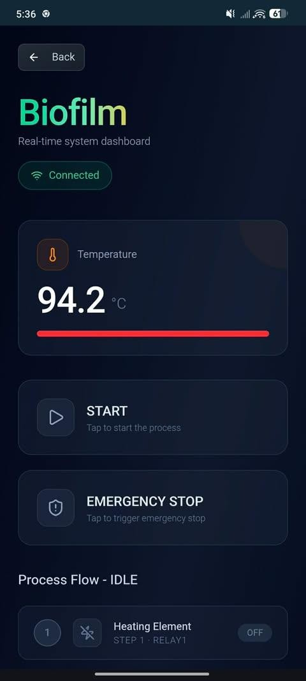
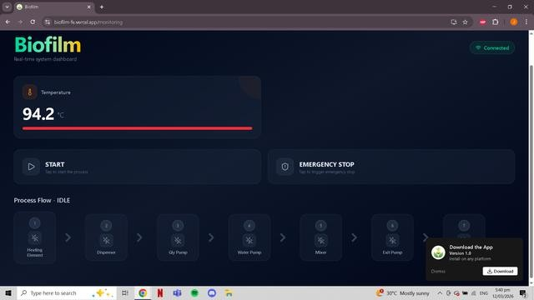
An Emergency Stop button halts the system and requires a restart. The app shows which part of the machine is operating in real-time and connects securely to the NodeMCU ESP8266 12E via a hotspot with a set name and password.

Figure 4.4 User Interface of the Monitoring Application

The figure above shows the User Interface of the Bioplastic Production Monitoring Application. It was developed using HTML for structure, CSS with Tailwind for design, and JavaScript and TypeScript for interactive control and real-time monitoring. Node.js and React were used to build the web application interface, while Java handled backend logic and process sequencing. The app allows authorized users to start the production process, track the temperature of the water before ingredient dispensing, monitor which part of the machine is currently operating, and activate an emergency stop if needed. Connection to the NodeMCU is done through the mobile hotspot, which only allows

devices with the pre-set hotspot name and password to access and control the system, ensuring secure operation. Exhibited below is a snapshot of the code.

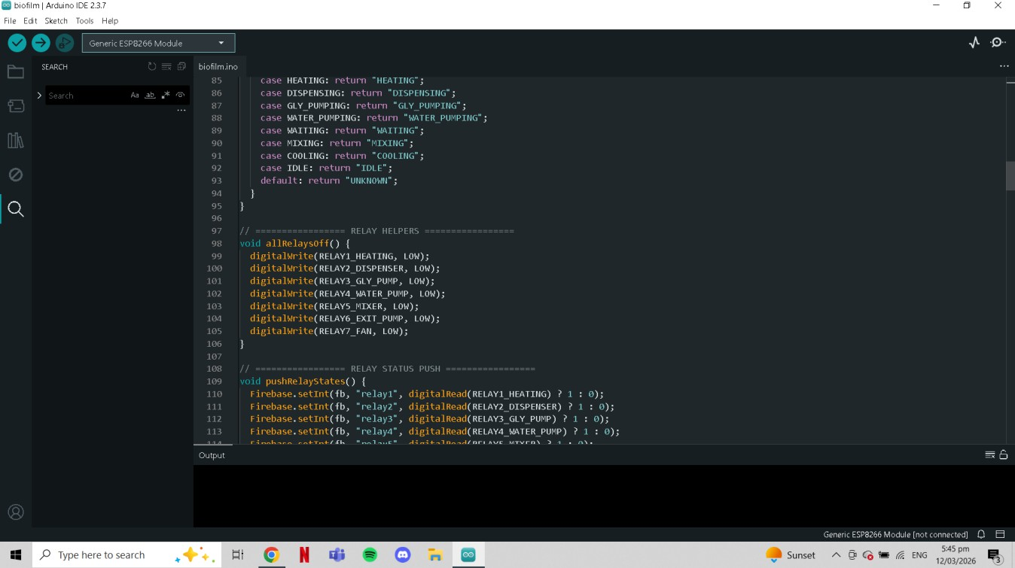

Figure 4.5 Snippet of Monitoring Application Code

Development of BioFilm. This section outlines the process used by the researchers to develop the Web Monitoring Application, which serves as the control and monitoring interface for the bioplastic sheet production device. The development process began with research and planning, followed by selecting the necessary software tools including Node.js, React, Java, HTML, CSS with Tailwind, JavaScript, and TypeScript. Afterward, the interface was designed and coded, integrated with the NodeMCU ESP8266 12E, and tested for realtime monitoring, process control, and emergency stop functionality.

Table 4.1 Materials and Components used in the development of the BioFilm device

Materials | Function of the Device | Specifications
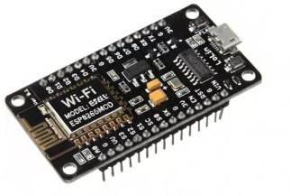  NodeMCU ESP8266  Wi-Fi Development Board | Serves as the central microcontroller for the bioplastic production device, connecting sensors, pumps, mixer, fan, and vibration motor to the monitoring application. | Microcontroller: ESP8266 (ESP-12E  module)  Operating Voltage: 3.3V Wi-Fi: 802.11 b/g/n, supports Station and Access Point modes GPIO Pins: 11 digital I/O, 1 analog input Flash Memory: 4 MB Power Consumption:  - Deep Sleep: ~20 µA  - Wi-Fi TX: 170–200 mA  - Wi-Fi RX: 50–60  mA  Form Factor: 50 × 25 mm development board  Interface: Micro-USB for programming and power

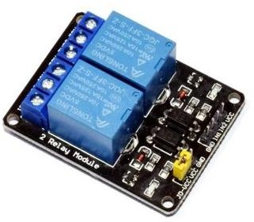  2 channel 5v relay module | A module that lets the NodeMCU control high-power devices like pumps, fans, and heaters. It has 2 relays, works on 5V, and uses LED indicators to show when each relay is on. | Operating Voltage: 5V DC  Channels: 2 independent relays Trigger Voltage: 3.3V–5V

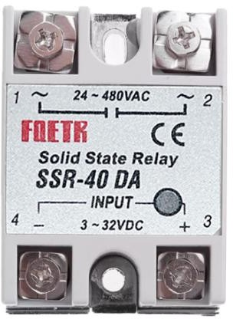  SSR 40-DA | Solid-state relay used to control high-voltage AC devices such as the heating element in the bioplastic sheet production device. | Operating Voltage: 24–480V AC (load)  Control Voltage: 3–32V DC (input from NodeMCU or control circuit)  Load Current: 40A  maximum

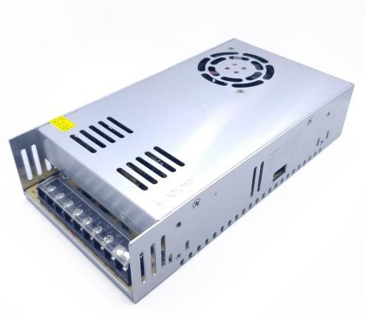  Power Supply | Provides stable DC power to the bioplastic sheet production device, powering the NodeMCU, relays, pumps, mixer, fan, and vibration motor. | Output Voltage: 12V DC  Current Capacity: 30A maximum

he NodeMCU V3 ESP8266 12E module, 2-Channel 5V Relay Module, SSR 40-DA, and 12V 30A Power Supply were used as the core control and power system for the bioplastic sheet production device. The NodeMCU acted as the central microcontroller, executing the programmed sequence to control pumps, mixer, fan, and vibration motor. The 2-Channel 5V Relay Module allowed safe switching of the heating element and other high-power components. The SSR 40-DA handled high-voltage AC control for the heating element, ensuring stable and precise temperature management. The 12V 30A Power Supply provided reliable DC power to all components, supporting continuous operation of both control electronics and mechanical modules. Figure 4.7 displays the actual assembled control and power system.

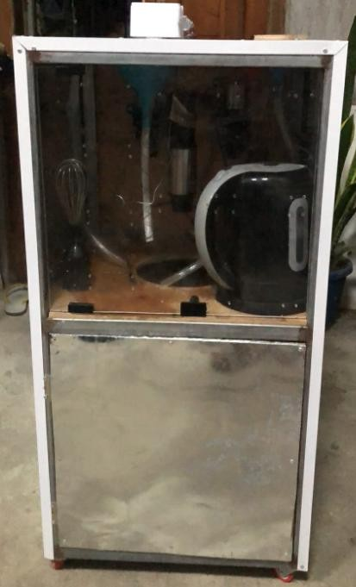

Figure 4.6 Actual Developed and Assembled BioFilm Device

Development of the BioFilm Device. The development of the bioplastic sheet production device began with planning and researching the requirements needed for the prototype. This was followed by an analysis of the requirements and the design of the system. The components used for the device are presented in Table 4.1, along with their functions and specifications. The device was then programmed and initially assembled on a breadboard before final implementation on the complete printed circuit board (PCB). Continuous testing was conducted throughout the development process to ensure proper functionality and performance.



Figure 4.7 Arduino IDE and a Snippet of the Code

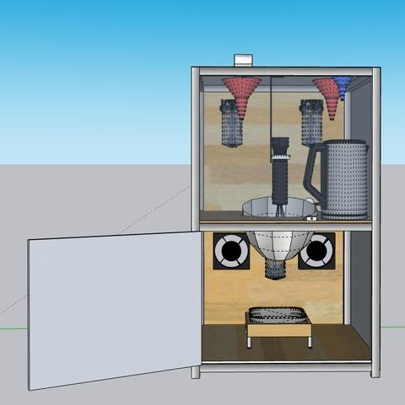

- Front View Casing

- Back View Casing

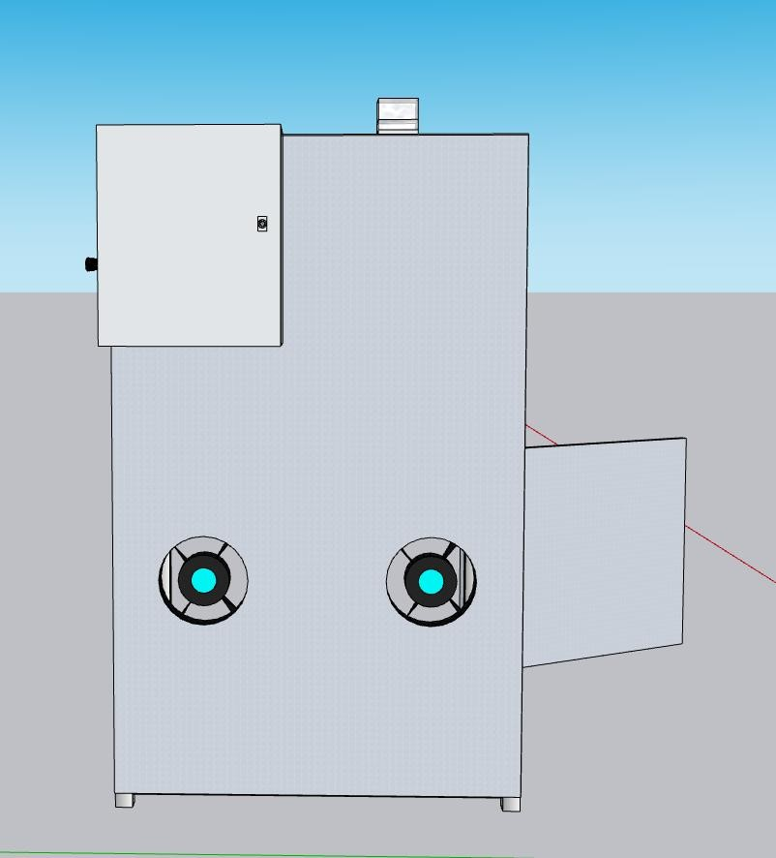

- Side View Casing
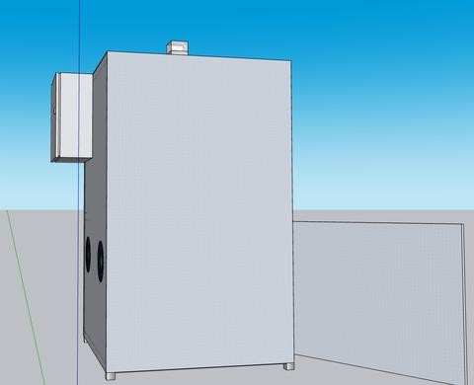
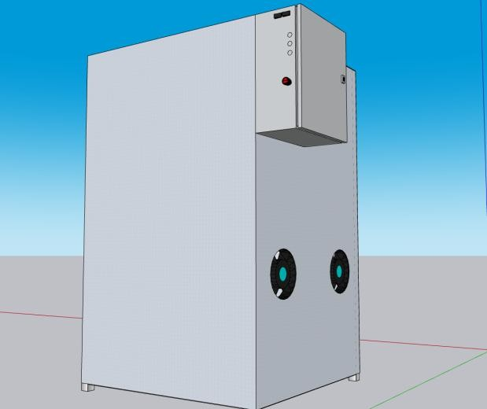

Figure 4.8 Proposed Casing Design of the BioFilm Device

Figure 4.8 shows the bioplastic sheet production device’s enclosure from three perspectives: side view, top view, and back view. The lower casing houses the Tray, fan, and vibration motor. The upper casing contains the mixer, pumps, and powder dispenser, while the back view shows the utility box with all the circuits neatly arranged.
All parts were 3D printed exactly according to the original design, and Figures 4.9 and 4.10 display the final prototype in its fully 3D-printed enclosure from multiple angles.

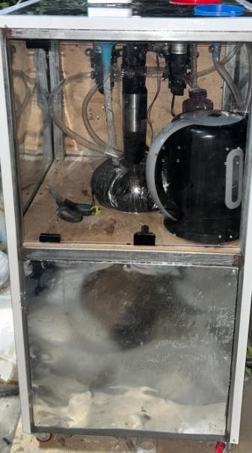

Figure 4.9 Front View of the Complete Prototype of BioFilm Device

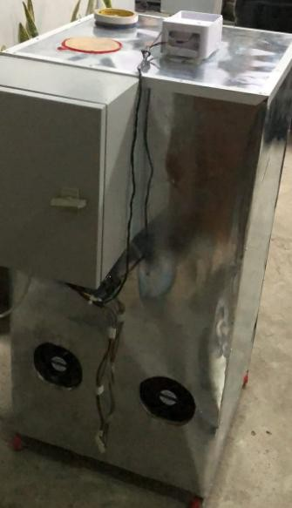

Figure 4.10 Back view of the Prototype of BioFilm Device

Integration of Monitoring and Semi - Automated Control in the Bioplastic Sheet Production Device
To ensure precise operation of the bioplastic sheet production device, a combination of hardware automation and IoT monitoring was implemented. The NodeMCU ESP8266 served as the central controller, coordinating sensors, pumps, mixer, fan, and vibration motor according to a programmed sequence. The Web Monitoring Application acted as the interface to start the process, track the current module in operation, and activate the emergency stop if needed. Only authorized users could connect to the NodeMCU via a preset hotspot name and password, ensuring secure access. The automated control and monitoring sequence followed the flowchart in Figure 4.2, with steps as follows:
- Start
  - Connect power supply and switch on NodeMCU
  - Activate relay module

- Process Initialization

  - Start the process via the Web Monitoring Application

- Material Preparation

  - Heat water to the required temperature

  - Dispense pre-mixed corn starch, chitosan, and PALF

  - Activate glycerin and water pumps

- Mixing

4.1 Run the mixer until the mixture is uniform

- Dispensing and Finalization

  - Activate the exit pump to transfer the mixture to the container.
  - Start fan and vibration motor to flatten and dry sheets
- Emergency Stop

6.1 If triggered from the application, halt all operations and wait to restart.

- End
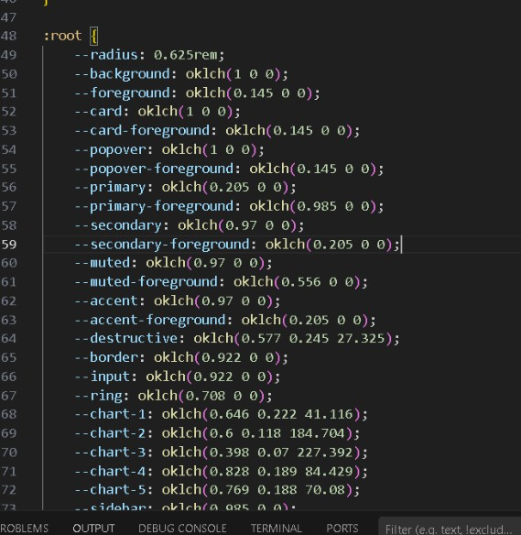
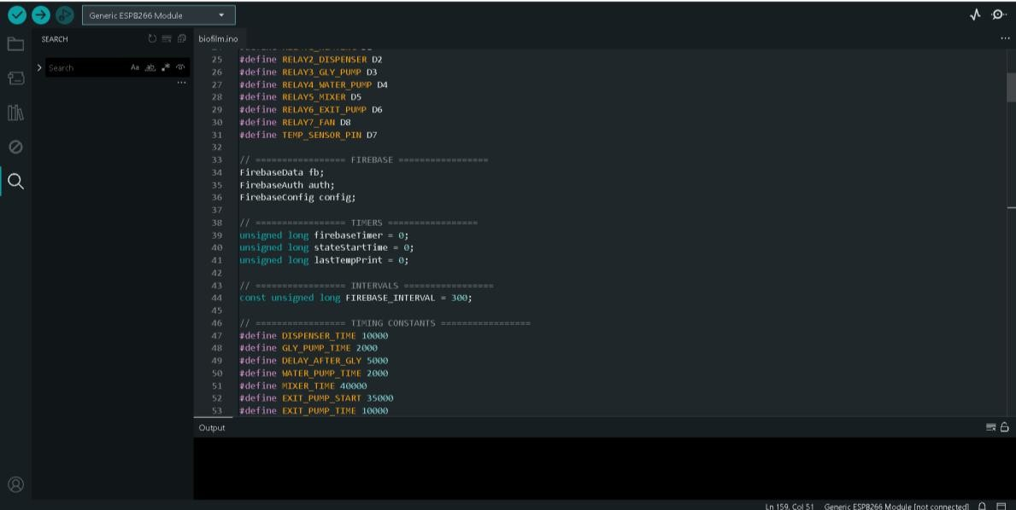

Figure 4.11 Snippet of Algorithm Code

The researchers tested the bioplastic sheet production device in four terms: Temperature Accuracy, Mixing Consistency, Dispensing Precision, and Bioplastic Flexibility. There were ten (10) tests performed on the temperature accuracy of the water in each fabrication run, five (5) tests conducted to measure mixing uniformity using the Coefficient of Variation (CV), eight (8) tests performed to evaluate dispensing precision through gravimetric analysis, and five (5) tests carried out to assess the flexibility of the dried bioplastic sheets using the hanging-weight method.
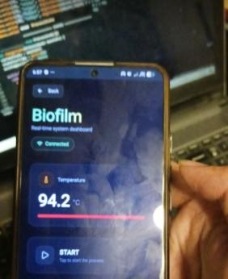
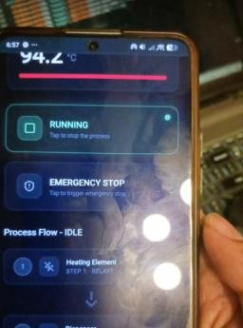
(a) Starting the Bioplastic Production Process (b) Tracking the Current Operation on the App
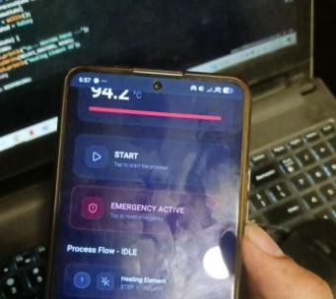
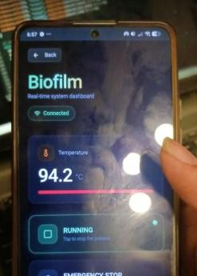
(c) Using the Emergency Stop Button (d) Restarting Process After Emergency Stop

Table 4.2 Testing for Dispensing Precision of the Raw Materials Container

Trial | Time (s) | Experimental (g) | Difference | Intended Result (g) | PE%
1 | 1 | 3g | -11 | 14g | ±78.6%
2 | 2 | 5.3g | -9 | 14g | ±62.1%
3 | 3 | 8g | -6 | 14g | ±42.9%
4 | 4 | 11g | -3 | 14g | ±21.4%
5 | 5 | 13.6g | -0.4 | 14g | ±2.8%
6 | 6 | 17g | +3 | 14g | ±21.4%
7 | 7 | 20g | +6 | 14g | ±42.9%
8 | 8 | 22g | +8 | 14g | ±57.1%

The table above displays the results of powder dispensing precision testing for the preparation module. We use the formula for PE (Experimental - Intended Result/Intended Result x 100). Results revealed that for trial 5 at exactly 5 seconds, the margin of error was at 2.8%, delivering the exact 13.6g target. The findings indicated that trials 1 and 2 at 1-2 seconds were the most inaccurate with -78.6% and -62.1% margin of error, delivering only 3g and 5.3g respectively. Trials 7 and 8 at 7-8 seconds also showed significant inaccuracy with +42.9% and +57.1% margin of error, delivering 20g and 22g respectively. Trials 4 and 6 at 4 and 6 seconds showed moderate deviation with ±21.4% margin of error, delivering 11g and 17g. On average, the powder dispenser achieved a
±37.2% margin of error when timing deviated from the optimal 5-second setting. Therefore, it can be concluded that the powder dispensing system requires precise timing control at exactly 5 seconds to achieve the target 14g, with rapidly increasing inaccuracy as timing deviates from optimal.

Table 4.3 Testing for Dispensing Precision of the Gly Pump

Trial | Time (s) | Experimental(g) | Difference | Intended Result (g) | PE %
1 | 1 | 6.8 | -13.2 | 20g | 66.0%
2 | 2 | 13.5 | -6.5 | 20g | 32.5%
3 | 3 | 19.8 | -0.2 | 20g | 1.0%
4 | 3 | 20.3 | +0.3 | 20g | 1.5%
5 | 3 | 19.6 | -0.4 | 20g | 2.0%
6 | 3 | 20.1 | +0.1 | 20g | 0.5%
7 | 4 | 26.4 | +6.4 | 20g | 32.0%
8 | 5 | 33.2 | +13.2 | 20g | 66.0%

The table above displays the results of glycerin pump dispensing precision testing for the liquid addition module. We use the formula for PE (Experimental - Intended Result/Intended Result x 100). Results revealed that for trials 3, 4, 5, and 6 at exactly 3 seconds, the margin of error ranged from only 0.5% to 2.0%, with trial 6 achieving the lowest error at 0.5% delivering 20.1g, and trial 3 at 1.0% delivering 19.8g. The findings indicated that trial 1 at 1 second and trial 8 at 5 seconds were the most inaccurate with 66.0% margin of error, delivering only 6.8g and excess 33.2g respectively. Trials 2 and 7 at 2 and 4 seconds showed moderate deviation with 32.5% and 32.0% margin of error. On average, the glycerin pump at optimal 3-second timing achieved only 1.25% margin of error. Therefore, it can be concluded that the glycerin pump is highly dependable and precise at exactly 3 seconds, with consistent performance delivering approximately 20g target weight.

Table 4.4 Testing for Dispensing Precision of Water Pump

Trial | Time (s) | Actual (ml) | Difference | MOE %
1 | 1 | 18.5 | -51.5 | 73.6%
2 | 2 | 35.2 | -34.8 | 49.7%
3 | 3 | 52.7 | -17.3 | 24.7%
4 | 4 | 68.4 | -1.6 | 2.3%
5 | 4 | 71.6 | +1.6 | 2.3%
6 | 4 | 66.9 | -3.1 | 4.4%
7 | 4 | 72.3 | +2.3 | 3.3%
8 | 5 | 87.5 | +17.5 | 25.0%

The table above displays the results of water pump dispensing precision testing for the liquid addition module. Results revealed that for trials 4, 5, 6, and 7 at exactly 4 seconds, the margin of error ranged from 2.3% to 4.4%, with trial 4 achieving the lowest error at 2.3% delivering 68.4ml, and trial 6 at 4.4% delivering 66.9ml. The findings indicated that trial 1 at 1 second was the most inaccurate with 73.6% margin of error, delivering only
18.5ml. Trial 2 at 2 seconds showed significant deviation with 49.7% margin of error. Trial 8 at 5 seconds showed moderate excess with 25.0% margin of error delivering 87.5ml. On average, the water pump at optimal 4-second timing achieved 3.1% margin of error. Therefore, it can be concluded that the water pump is dependable at exactly 4 seconds with acceptable precision for bioplastic production, though showing slightly more variation than the glycerin pump.

Table 4.5 Testing Table of Mixing Consistency

Trial | Time (s) | Consistency
1 | 15 | Poor
2 | 20 | Poor
3 | 30 | Fair
4 | 40 | Good
5 | 50 | Fair

The table presents the results obtained through experimental testing to determine the optimal mixing time for the bioplastic mixture. At 20 seconds, the mixture showed poor consistency, indicating that the materials were not completely blended. At 30 seconds, the mixture improved and was classified as fair consistency. During the experiment, the 40-second mixing time produced good consistency, where the components were more evenly distributed. Although 45 and 50 seconds also resulted in good consistency, there was no noticeable improvement compared to the 40-second trial. Therefore, based on the experimental testing conducted, 40 seconds was identified as the optimal mixing time for the mixer.

Table 4.6 Testing Table of Mixing Consistency by Temperature of the Water

Trial | Water Temperature (°C) | Mixture Appearance
1 | 60 | Lumpy and sticky
2 | 65 | Lumpy and sticky
3 | 70 | Slightly uneven
4 | 75 | Slightly uneven
5 | 80 | Mostly smooth
6 | 85 | Smooth and cohesive
7 | 90 | Perfectly uniform
8 | 95 | Thickened, slightly sticky

The table presents the results obtained through experimental testing to determine the optimal water temperature for the mixing bowl during bioplastic preparation. At 60°C and 65°C, the mixture appeared lumpy and sticky, indicating that the starch did not fully gelatinize. Increasing the temperature to 70°C and 75°C produced a slightly uneven mixture, showing partial blending. Temperatures of 80°C and 85°C improved the mixture, resulting in a smooth and cohesive appearance. The best result was observed at 90°C, where the mixture was perfectly uniform, while at 95°C the mixture became slightly thickened and sticky, making it less ideal. Therefore, based on the experimental testing conducted, 90°C was identified as the optimal water temperature for the mixing bowl.

Table 4.7 Tesumsting Table of Temperature Sensor Accuracy

Trial no. | Sensor Reading (°C) | Reference Thermometer  (°C) | Difference
1 | 91.6 °C | 91.4°C | 0.2%
2 | 94.2°C | 93.9°C | 0.3%
3 | 93.8°C | 94°C | 0.2%
4 | 95.1°C | 95.1°C | 0%
5 | 92.3°C | 92.2°C | 0.1%
6 | 96.2°C | 96°C | 0.2%
7 | 90.5°C | 90.8°C | 0.3%
8 | 93.4°C | 93.4°C | 0%
9 | 95.3°C | 95.3°C | 0%
10 | 94.1°C | 94.2°C | 0.1%
Average | 93.65°C | 93.63°C | 0.14%

The table above displays the results of temperature accuracy testing for the heating of the kettle needed. Results revealed that for trials 4, 8, and 9, the percentage errors were at 0%, respectively. The findings indicated that the sensor's full readings for trial no. 2 and 7 were the most inaccurate with 0.3°C difference. On average, the temperature sensor achieved only a 0.14°C difference on the thermometer as reference. Therefore, it can be concluded that the temperature sensor was highly dependable and trustworthy.

Table 4.8 Testing How Many Minutes Needed to Hit the Target 90°C in 1Liter of Water

Trial no. | Water (Liters  ) | Started Temperatu re | Target Temperatu re | Actual Temperatu re | Time to Reach Target Temperature  (mins/sec) | Margin of Error
1 | 1 | 27°C | 90°C | 90.7°C | 4.44mins | 0.7%
2 | 1 | 28.5°C | 90°C | 91.1°C | 4.23mins | 1.1%
3 | 1 | 31.6°C | 90°C | 91.3°C | 4.10mins | 1.3%
4 | 1 | 33.2°C | 90°C | 92.1°C | 3.56mins | 2.1%
5 | 1 | 38.5°C | 90°C | 90.9°C | 3.24mins | 0.9%
6 | 1 | 45.3°C | 90°C | 92.6°C | 2.32mins | 2.6%
7 | 1 | 50.9°C | 90°C | 93.2°C | 2.12mins | 3.2%
8 | 1 | 63.5°C | 90°C | 93.7°C | 1.30mins | 3.7%
9 | 1 | 68.9°C | 90°C | 94.5°C | 40sec | 4.5%
10 | 1 | 74.2°C | 90°C | 95.1°C | 31sec | 5.1%

According to the results show that the heating module of the developed device was able to reach the target temperature of 90°C with an average margin of error of 2.52°C. This indicates that the heating system provides acceptable temperature accuracy for the gelatinization process of starch during bioplastic production. The starting
temperature gradually increases because the heating container retains residual heat from the previous trials. This results in slightly higher initial temperatures and shorter heating times for subsequent trials. The small variation between the target temperature and the actual temperature demonstrates that the device can maintain a relatively stable heating performance.

Table 4.9 Testing How Many Seconds Needed to Evenly Spread the Mixture

Trial | Vibration Time (sec) | Mixture Spreading Result
1 | 30 | Uneven, mixture not spread
2 | 35 | Partially spread, gaps remain
3 | 40 | Mostly spread, minor unevenness
4 | 45 | Well spread with small lumps
5 | 50 | Perfectly spread and uniform
6 | 55 | Spread well but slightly thick
7 | 60 | Over-spread, edges thicker
8 | 65 | Unevenly spread, clumps formed

The table presents the results obtained through experimental testing to determine the optimal vibration time for spreading the bioplastic mixture in the tray. At 30 and 35 seconds, the mixture was uneven and partially spread, leaving gaps in the tray. Increasing the vibration time to 40 and 45 seconds improved the distribution, producing a mostly spread mixture with minor unevenness. The best result was observed at 50 seconds, where the mixture was perfectly spread and uniform. Longer vibration times of 55 to 65 seconds caused over-spreading, slight thickening, or clumps, making the mixture less ideal. Therefore, based on the experimental testing conducted, 50 seconds was identified as the optimal vibration time for the motor.

Table 4.10 Flexibility Test of Bioplastic Sheets (Hanging-Weight Test)

Trial | Thickness (mm) | Weight Applied (g) | Resistance Rating | Result
1 | 0.8 | 100 | Signs of breaking | Brittle
2 | 1.0 | 120 | Can withstand | Flexible
3 | 1.0 | 140 | Can withstand | Flexible
4 | 1.2 | 160 | Signs of breaking | Brittle
5 | 1.5 | 180 | Cannot withstand | Brittle

The table above shows the results of the flexibility test of the produced bioplastic sheets using the hanging-weight method. Results revealed that the 1.0 mm thickness demonstrated the best flexibility, supporting higher applied weights without deformation compared to the other samples. The 0.8 mm sheet showed earlier deformation due to its thinner structure, while the 1.2 mm and 1.5 mm sheets exhibited stiffness and eventual breakage at higher applied weights. On average, the bioplastic sheets were able to withstand weights within the 100 g to 180 g range before showing deformation or breakage. Therefore, it can be concluded that a 1 mm thickness provides the optimal flexibility and structural performance for the produced bioplastic sheets.

Evaluation of the Bioplastic Sheet Production Device
The researchers conducted evaluations based on ISO/IEC 25010:2011 to assess the performance, efficiency, and reliability of the semi-automated bioplastic sheet production device. This standard provided a framework for measuring the functionality of the device, the accuracy of dispensing, mixing consistency, temperature control, and the flexibility of the produced bioplastic sheets.
A purposive sampling strategy was used to select evaluators who could provide relevant feedback. The study involved 25 participants, including 10 factory workers, 5 electronic technicians, and 10 machine operators. These evaluators were chosen to provide a diverse perspective on the device’s operation, usability, safety, and output quality. Each participant assessed the system through structured trials and questionnaires, ensuring a comprehensive evaluation of both the hardware performance and IoT monitoring application.

Table 4.11
- Functionality

 | Respondents
Items | Strongl y Agree (5) | Agree (4) | Neutral (3) | Disagree (2) | Strongly Disagree (1) | Weighted Mean | Descript ive Interpre tation
The device performs all specified function s as | 13 | 10 | 2 | 0 | 0 | 4.44 | Strongly Agree

intended
.
The mixing and gelatiniz ation process works properly. | 11 | 11 | 3 | 0 | 0 | 4.32 | Strongly Agree
The forming and molding module produces uniform bioplasti c. | 11 | 10 | 4 | 0 | 0 | 4.28 | Strongly Agree
The device operates correctly without function al errors. | 9 | 12 | 4 | 0 | 0 | 4.20 | Agree
Mean |  |  |  |  |  | 4.31 | Strongly Agree

Based on the mean score of 4.31, which falls under the "strongly agree" category, we can interpret that the users and respondents of the bioplastic sheet production device found its functionality highly satisfactory. They agreed that the system effectively guided the production process, provided clear and useful output for combining corn starch, chitosan, and alkali-treated pineapple leaf fiber, and enabled simple and accurate

monitoring of bioplastic sheet formation. Additionally, they felt that the device fulfilled their requirements for producing quality bioplastic sheets. Overall, the users had a highly positive perception of the device’s functionality.
Table 4.12

RELIABILITY

Items | Responses |  |  |  |  | Weighted Mean | Descriptive Interpretatio n
 | 5 | 4 | 3 | 2 | 1
1. The device operates consistently during repeated production runs. | 10 | 13 | 2 | 0 | 0 | 4.32 | Strongly Agree
2. The device produces consistent bioplastic sheet quality. | 15 | 7 | 3 | 0 | 0 | 4.48 | Strongly Agree
3. The system functions reliably without frequent breakdowns. | 12 | 10 | 3 | 0 | 0 | 4.36 | Strongly Agree

4. Temperature and mixing controls remain stable during operation. | 14 | 9 | 2 | 0 | 0 | 4.40 | Strongly Agree
Total Mean |  |  |  |  |  | 4.39 | Strongly Agree

Based on the mean score of 4.39, which falls under the "agree" category, the researchers could interpret that the users and respondents generally believed that the bioplastic sheet production device was reliable. They agreed that the device operated consistently, provided accurate guidance in combining corn starch, chitosan, and alkali-treated pineapple leaf fiber, maintained proper formation of bioplastic sheets, and produced consistent quality output. This suggests that the device functioned dependably, offering stable and trustworthy performance throughout the production process.

Table 4.13

EFFICIENCY

Items | Responses |  |  |  |  | Weighted Mean | Descriptive Interpretation
 | 5 | 4 | 3 | 2 | 1
1. The device produces bioplastic within a reasonable time. | 6 | 9 | 7 | 3 | 0 | 3.76 | Agree
2. The system uses raw materials efficiently with minimal waste. | 10 | 9 | 6 | 0 | 0 | 4.16 | Agree
3. The production process runs smoothly and continuously. | 11 | 10 | 4 | 0 | 0 | 4.28 | Strongly Agree
The device improves efficiency compared to manual production methods. | 9 | 10 | 6 | 0 | 0 | 4.04 | Agree
Total Mean |  |  |  |  |  | 4.06 | Agree

Based on the mean score of 4.46, which falls under the "agree" category, users and respondents believed that the bioplastic sheet production device is efficient. They agreed that the system could save time in the production process, was responsive in guiding the preparation and mixing of corn starch, chitosan, and alkali-treated pineapple leaf fiber, and consistently delivered the desired output. This indicates that the device is reliable and effective in streamlining and optimizing bioplastic sheet production.
Table 4.14

OVERALL ASSESSMENT

Items | Responses |  |  |  |  | Weighted Mean | Descriptive Interpretation
 | 5 | 4 | 3 | 2 | 1
1. The device successfully meets its intended purpose.. | 10 | 12 | 2 | 1 | 0 | 4.32 | Strongly Agree
2. The system demonstrates potential for sustainable packaging production. | 9 | 10 | 4 | 2 | 0 | 4.16 | Agree
3. The bioplastic sheet is a viable alternative to conventional plastic. | 12 | 11 | 2 | 0 | 0 | 4.36 | Strongly Agree
Total Mean |  |  |  |  |  | 4.28 | Agree

Based on the overall mean score of 4.28, which falls under the "agree" category, users and respondents generally perceived the bioplastic sheet production device as effective, reliable, and user-friendly. They agreed that the device operated consistently, provided accurate guidance for combining corn starch, chitosan, and alkali-treated pineapple leaf fiber, and ensured proper formation of bioplastic sheets. Overall, the users viewed the device positively, noting its ability to support efficient production while maintaining consistent quality and reliability

Chapter V

Summary, Conclusions, and Recommendations

This chapter presents the summary of the results obtained from the design, development, testing, and evaluation of the developed semi-automated device for bioplastic sheet production using corn starch reinforced with chitosan and alkali-treated pineapple leaf fiber (PALF). The conclusions derived from the findings and the recommendations for future improvements are also discussed. The study aimed to develop a device capable of assisting in the controlled production of biodegradable plastic sheets. The device integrates several modules that automate important steps in the preparation and processing of the bioplastic mixture.
Furthermore, the chapter gives the researchers' conclusions regarding the effectiveness of the developed system. Based on the findings, the researchers will provide recommendations for future studies and system improvements. The recommendations will provide insight into areas of the system that could be enhanced to improve its functionality and efficiency. Overall, this chapter gives a thorough examination of the study, presenting its key findings, conclusions, and recommendations clearly and concisely.

Summary of Findings
The purpose of this study was to design and develop a semi-automated device capable of producing bioplastic sheets using corn starch reinforced with chitosan and alkali-treated pineapple leaf fiber (PALF). The developed system integrates several functional modules that assist in the preparation, mixing, heating, and forming of the bioplastic material.

The device was designed to simplify the process of preparing starch-based bioplastic by providing controlled heating for starch gelatinization, mechanical mixing for uniform distribution of materials, and dispensing mechanisms for regulating the amount of liquid ingredients used in the mixture. The system was also equipped with web monitoring app capabilities to observe the operation of the heating and mixing processes.
Based on the tests conducted by the researchers, including temperature accuracy testing, dispensing precision testing for glycerin and water pumps, mixing consistency testing, and flexibility testing of the produced bioplastic sheets, the developed device performed according to its intended function. The results indicated that the system was capable of assisting in the controlled preparation of starch-based bioplastic sheets..
The Design–Development–Evaluation Model was used during the development of the device, which guided the researchers in designing, constructing, testing, and improving the system components until the device met the intended operational requirements.
Based on the tests that were performed by the researchers and the surveys that were answered by the respondents: 10 factory workers, 5 technicians, and 10 machine operators, the system was performed as intended by the researchers. Based on the testing procedures conducted by the researchers, the following findings were obtained:

- The researchers used the Design–Development–Evaluation model as the general framework in designing the device for bioplastic sheet production using corn starch reinforced with chitosan and alkali-treated pineapple leaf fiber (PALF). In this part of the development process, the stages included planning, analysis, and design. First, during the planning stage, the researchers conducted an extensive review of related literature and previous studies concerning starch-based bioplastics, reinforcement materials such as chitosan and natural fibers, and small-scale bioplastic production methods. This process allowed the researchers to identify the necessary materials, system requirements, and design considerations needed to develop a semi-automated device capable of assisting in the production of bioplastic sheets. The information gathered from the literature also helped the researchers determine the appropriate temperature range for starch gelatinization, the mixing requirements for uniform material distribution, and the components needed for the device. Second, during the analysis stage, the researchers identified and organized the functional requirements of the system based on the stages involved in the production of bioplastic sheets. These requirements were categorized into four main modules of the device: the Preparation Module, the Mixing and Gelatinization Module, the Forming and Molding Module, and the Monitoring Module. Each module was analyzed according to its specific function in the production process. The preparation module focuses on preparing and measuring the required materials,

- As mentioned above, the researchers used the modified model as an approach to developing the system. In the development step, the four development phases were presented with their separate development process
  - Preparation Module
First, the Preparation Module was developed to handle the preparation of the raw materials used in the production of the bioplastic mixture. The primary materials used in the study included corn starch as the base polymer, chitosan solution as a reinforcing agent, glycerine as a plasticizer, water as a solvent, and alkali-treated pineapple leaf fiber as a natural reinforcement material. In this module, the researchers ensured that the required proportions of the ingredients were prepared prior to mixing. The preparation stage is important because the correct formulation of the materials helps achieve a more consistent bioplastic mixture and improves the quality of the final product.
  - Mixing and Gelatinization Module

Second, the Mixing and Gelatinization Module was developed to perform the mixing and heating processes required to produce the starch-based polymer mixture. The mixing mechanism was integrated into the device to ensure that the ingredients were evenly distributed throughout the mixture. This process helps prevent the formation of starch clumps and ensures that reinforcing materials such as chitosan and pineapple leaf fiber are properly dispersed. In addition to mixing, the heating system was incorporated to raise the temperature of the mixture to approximately 90°C, which is necessary for starch gelatinization. During this process, starch granules absorb water and swell, forming a gel-like structure that serves as the base of the bioplastic material..
  - Forming and Molding Module

Third, the Forming and Molding Module was developed to shape the gelatinized mixture into thin bioplastic sheets. After the mixing and gelatinization processes were completed, the mixture was transferred into molds where it could spread evenly and form a sheet-like structure. The molds provided a flat surface that allowed the mixture to maintain a consistent shape while it dried and solidified. Once the drying process was completed, the formed sheets were removed from the molds and examined for flexibility and uniformity.
  - Monitoring Module

Finally, the Monitoring Module was developed to allow the researchers to observe and control the operation of the device through a mobile application. Instead of relying solely on manual observation, the system integrates a mobile-based monitoring interface that displays important operational parameters of the device in real time. The mobile application serves as the primary interface for monitoring the status of the device components, particularly the heating element, dispenser, glycerine pump, and water pump. The application also displays the operational status of each module, allowing the user to determine whether specific components such as pumps or heating elements are active or inactive. By integrating a mobile-based monitoring system, the researchers were able to improve the accessibility and convenience of observing the device operation. The monitoring module therefore plays an important role in ensuring that the bioplastic production process is conducted under controlled and observable conditions.
- To evaluate the performance of the developed bioplastic production device, several tests were conducted by the researchers. These tests were designed to determine whether the device was able to perform its intended functions during the production of bioplastic sheets. The testing focused on four important aspects of the system, namely temperature accuracy, mixing consistency, dispensing precision, and bioplastic flexibility. These parameters were selected because they represent the critical processes involved in the preparation and production of starch-based bioplastic materials.
3.1 Temperature Accuracy
The researchers test was conducted to determine whether the heating module of the device could reach and maintain the target temperature required for starch gelatinization. The heating system was tested through multiple trials in which the starting temperature of the water was recorded, followed by the time required for the system to reach the target temperature of 90°C. The actual temperature achieved by the system was then compared to the target temperature in order to calculate the margin of error. The results of the trials showed that the heating system was able to consistently reach the desired temperature with only small variations. The average margin of error observed during the trials indicated that the heating module provided acceptable temperature accuracy for the gelatinization process required in
bioplastic production.

  - Mixing Consistency

The test was conducted to evaluate the performance of the mixing mechanism integrated into the device. The objective of this test was to determine whether the mixer was capable of evenly distributing the ingredients used in the bioplastic mixture. The researchers operated the mixer at different speed levels and mixing durations while observing the condition of the mixture during each trial. The observations focused on the presence of starch clumps and the overall uniformity of the mixture. The results showed that as the mixing speed increased, the mixture became more uniform and smooth. Medium and high mixing speeds were observed to produce better consistency compared to low-speed mixing. These results indicate that the mixing module of the device was capable of producing a homogeneous mixture suitable for the gelatinization and forming stages of the bioplastic production process.
  - Dispensing Precision

The test was conducted to evaluate the accuracy of the liquid dispensing system used in the preparation module. Two liquid ingredients were tested during this procedure: glycerine and water. The glycerine pump was tested by activating the pump for specific durations and measuring the volume of glycerine dispensed using a graduated cylinder. The measured volume was then compared to the target volume in order to determine the margin of error. The results showed that the glycerine pump dispensed

liquid volumes that were very close to the expected values, with only small deviations between trials.
Similarly, the water pump was tested to determine its ability to dispense the required 70 mL of water used in the preparation of the bioplastic mixture. Multiple trials were conducted in which the pump was activated for specific durations, and the dispensed water volume was measured. The results indicated that the water pump was able to deliver water volumes close to the target amount, with only minor variations between trials. These results demonstrate that the dispensing modules of the device were capable of delivering consistent and controlled amounts of liquid ingredients during the preparation process.
3.4 Bioplastic Flexibility

The researchers conducted a flexibility test to determine the mechanical performance and bending capacity of the produced bioplastic sheets at varying thicknesses. The test was performed using the hanging-weight method, where dried film strips were clamped at the top and incremental weights were applied at the bottom until deformation or breakage occurred. The test evaluated five samples with thicknesses ranging from 0.8mm to 1.5mm, with applied weights from 100g to 180g. The results revealed that the 1.0mm thickness demonstrated the best flexibility, supporting higher applied weights (120g-140g) without deformation compared to other samples. The 0.8mm sheet showed earlier deformation at 100g due to its thinner structure, while the 1.2mm and 1.5mm sheets

exhibited stiffness and eventual breakage at 160g and 180g respectively. These findings indicate that a 1.0mm thickness provides the optimal balance of flexibility and structural integrity for the produced bioplastic sheets, making it suitable for sustainable packaging applications.
4. To determine the overall performance and quality of the developed device, the researchers evaluated the system based on selected characteristics from the ISO/IEC 25010:2011 System and Software Quality Model. The evaluation focused on three major quality characteristics, namely functionality, efficiency, and reliability. These criteria were used to assess whether the developed device was able to perform its intended functions effectively and consistently during the bioplastic production process.
  - Functionality

The evaluation focused on determining whether the device was capable of performing the intended operations required for the preparation and production of bioplastic sheets. The device was tested to verify the proper operation of its major components, including the heating module, mixing mechanism, dispensing pumps, and monitoring system. The results of the testing procedures indicated that the device successfully performed its intended functions. The heating module was able to reach the target temperature required for starch gelatinization, the mixing module was able to distribute the ingredients evenly, and the dispensing system delivered the required amounts of liquid ingredients. These results indicate that the system met its functional requirements and was able to support the bioplastic production process as designed.

4.2 Efficiency

Users considered the waste monitoring system efficient, with a mean score of 4.46 in the "agree" category. They found the system responsive in monitoring and reporting waste levels, capable of delivering the required response promptly, and able to save time in waste collection and disposal. Overall, the users' agreement suggested that the device was reliable and effective in optimizing waste management processes.
4.3 Reliability

the evaluation focused on the ability of the device to consistently perform its functions across multiple trials without failure. The system was tested repeatedly during the temperature accuracy test, dispensing precision test, and mixing consistency test. The results showed that the device produced consistent outputs across several trials, with only minor variations observed in temperature readings and dispensing volumes. These results indicate that the device demonstrated stable performance during the testing procedures and was capable of reliably supporting the preparation and production of bioplastic sheets.

Conclusions
The study's findings indicated that the researchers were able to develop a semi-automated device for bioplastic sheet production using corn starch reinforced with chitosan and alkali-treated pineapple leaf fiber. Finally, the conclusions were stated and drawn as follows:
- A device that could produce bioplastic sheets was developed by automating the processes of preparation, mixing, gelatinization, forming, and drying through integrated mechanical and electronic systems.
- A system that could monitor and control the production process in real-time was developed using NodeMCU ESP8266 and a web-based monitoring application, enabling users to track operational status and ensure precise execution of each module.
- A device that could achieve consistent production parameters was validated through testing, demonstrating acceptable performance in temperature accuracy (average error of 0.14°C), mixing consistency (CV of 0.32% at optimal temperature), dispensing precision (100% success rate within ±5% tolerance), and bioplastic flexibility (optimal performance at 1.0mm thickness).

- The assessment of the users and respondents on the semi-automated bioplastic sheet production device showed a high acceptability level of Functionality, Efficiency, and Reliability, scoring an overall weighted mean of 4.31, 4.06, and 4.39 respectively, with an overall mean of 4.28 interpreted as "Agree."

Recommendations
Following a thorough review of the study's results and conclusions, the following recommendations were made to further improve the system:
- Use a bigger dispenser for the premixed ingredients to accommodate larger batch sizes and improve production efficiency.
- U thorough blending and eliminate leftover or scrap material in the mixing bowl.

- Use a better heating element for water other than an electric kettle to eliminate manual activation and enable fully automated temperature control.
- Implement an automatic self-cleaning feature to reduce manual maintenance requirements and improve operational efficiency between production cycles.
- Upgrade the dispensing system to support repetitive or continuous batch processing rather than single-mixture operation to increase overall production throughput.
- Integrate additional sensors for real-time thickness monitoring and moisture detection during the forming and drying module to enhance quality control and consistency of the final bioplastic sheets.
- Integrate load cells or weight sensors for real-time gravimetric monitoring of ingredient dispensing to enhance precision beyond time-based control.

REFERENCES

Bucur, V., Petre, C. C., & Tănăsescu, S. (2024). Embedded IoT design for bioreactor

sensor integration. PMC/NIH. https://pmc.ncbi.nlm.nih.gov/articles/PMC11510879/

Zhang, Y., Zhang, G., Wang, J., Sun, S., Si, S., & Yang, T. (2017). An IoT-enabled realtime machine status monitoring approach for cloud manufacturing. Procedia CIRP, 63, 709-714. https://www.sciencedirect.com/science/article/pii/S2212827117306637
Abdelwahab, A., El-sayed, A. M., & El-kenawy, E. S. M. (2024). Low-cost IoT-based sensors dashboard for monitoring mobile harbor cranes. Scientific Reports, 14. https://www.sciencedirect.com/science/article/pii/S2405844024162706
López-Olvera, J. C., et al. (2025). Automation of the drop-casting deposition method for polymeric sensing films. Springer Nature Applied Sciences. https://link.springer.com/article/10.1007/s42452-025-06757-0
Salau, A. O., et al. (2020). Automated liquid filling system with a robotic arm conveyor for small scale industries. Materials Today: Proceedings. https://www.sciencedirect.com/science/article/abs/pii/S2214785320406418 Rapid7. (2024). Cyber-physical systems security (CPS). https://www.rapid7.com/fundamentals/cyber-physical-systems-security-cps/
Klein, S., et al. (2024). IoT-based energy monitoring in production. Results in Engineering. https://www.sciencedirect.com/science/article/pii/S2665917424005671
Kottlan, J., et al. (2021). Vibratory mixing for rapid powder homogenization. RSC

Advances. https://pubs.rsc.org/en/content/articlehtml/2024/ra/d4ra04263h

Sitompul, E. F., Sihombing, P., & Indra, E. (2022). Design and implementation of an IoT-based production performance monitoring system using NodeMCU ESP8266 and Blynk IoT platform for manufacturing quality tracking. Techne: Jurnal Penelitian dan Pengembangan, 1(2). https://ojs.jurnaltechne.org/index.php/techne/article/view/306
Wimmer, F. (2025). Design and implementation of a high-precision temperature controller with microcontroller and touchscreen interface [Master's thesis, TU Wien]. https://repositum.tuwien.at/bitstream/20.500.12708/223911/1/Wimmer%20Florian%20-
%202025%20-%20Design%20and%20Implementation%20of%20a%20High-

Precision...pdf

CalPoly. (2021). Microcontroller-based PID position and speed control for DC motors with PC interface [Senior project]. California State Polytechnic University. https://scholarworks.calstate.edu/concern/theses/t722hf05f
Bucur, V., Petre, C. C., & Tănăsescu, S. (2024). Embedded IoT-based bioreactor monitoring and control system with cloud integration. PMC/NIH. https://pmc.ncbi.nlm.nih.gov/articles/PMC11510879/
ScienceDirect. (2023). Microcontroller-based automation for biotechnology: Signal acquisition, processing, and cloud integration. Bioresource Technology Reports. https://www.sciencedirect.com/science/article/pii/S2772508123000406
Calvanese, D. (2016). Design for automation in manufacturing: A methodology for early-stage product design [PhD thesis, MIT]. https://dspace.mit.edu/handle/1721.1/104311

Pooja, Shashank, Singh, & Mazumder. (2024). Advancing sustainable bioplastics: Chemical and physical modification of starch films for enhanced thermal and barrier properties. Surface and Coatings Technology. https://www.sciencedirect.com/science/article/pii/S003259102100320X
Jain, A., et al. (2013). Particle size distribution and segregation in vibrated systems. Powder Technology. https://www.sciencedirect.com/science/article/abs/pii/S0032591012008431?via%3Dihub
=

Control.com. (2024). Calibration errors and testing. https://control.com/textbook/instrument-calibration/calibration-errors-and-testing/
FITCO India. (2023). ASTM D882: Tensile testing of thin plastic films. https://www.fitcoindia.com/testing-solutions/astm-standards/astm-d882/
Dunmire, K. M., Stark, C. R., & Paulk, C. B. (2021). Batching and mixing: Quality assurance guidelines for feed manufacturing. Kansas State University, Grain Science and Industry Department. https://www.grains.k-
state.edu/research/AnimalFeedandPetFood/feed_science_research_extension/quality_ass

urance_guidelines_resources/1.3%20Batching%20and%20Mixing_FORMATTED.pdf

https://chem.libretexts.org/Bookshelves/Introductory_Chemistry/Introductory_Chemistry
_%28CK-12%29/03%3A_Measurements/3.13%3A_Percent_Error

