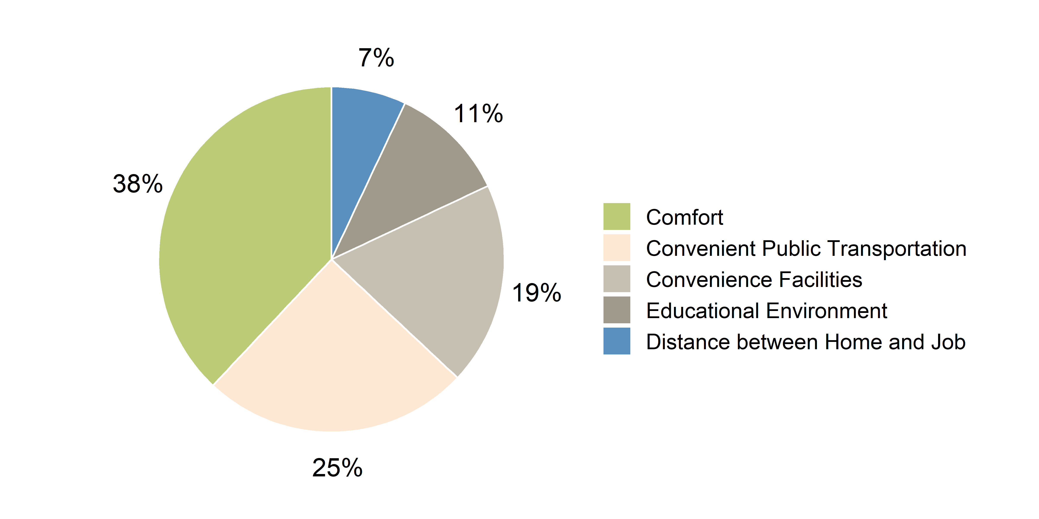

Figure 7. The factors in considering future housing

*Source: Korea Housing Institute, 2016*

Figure 8. The conceptual range of UGS (%)

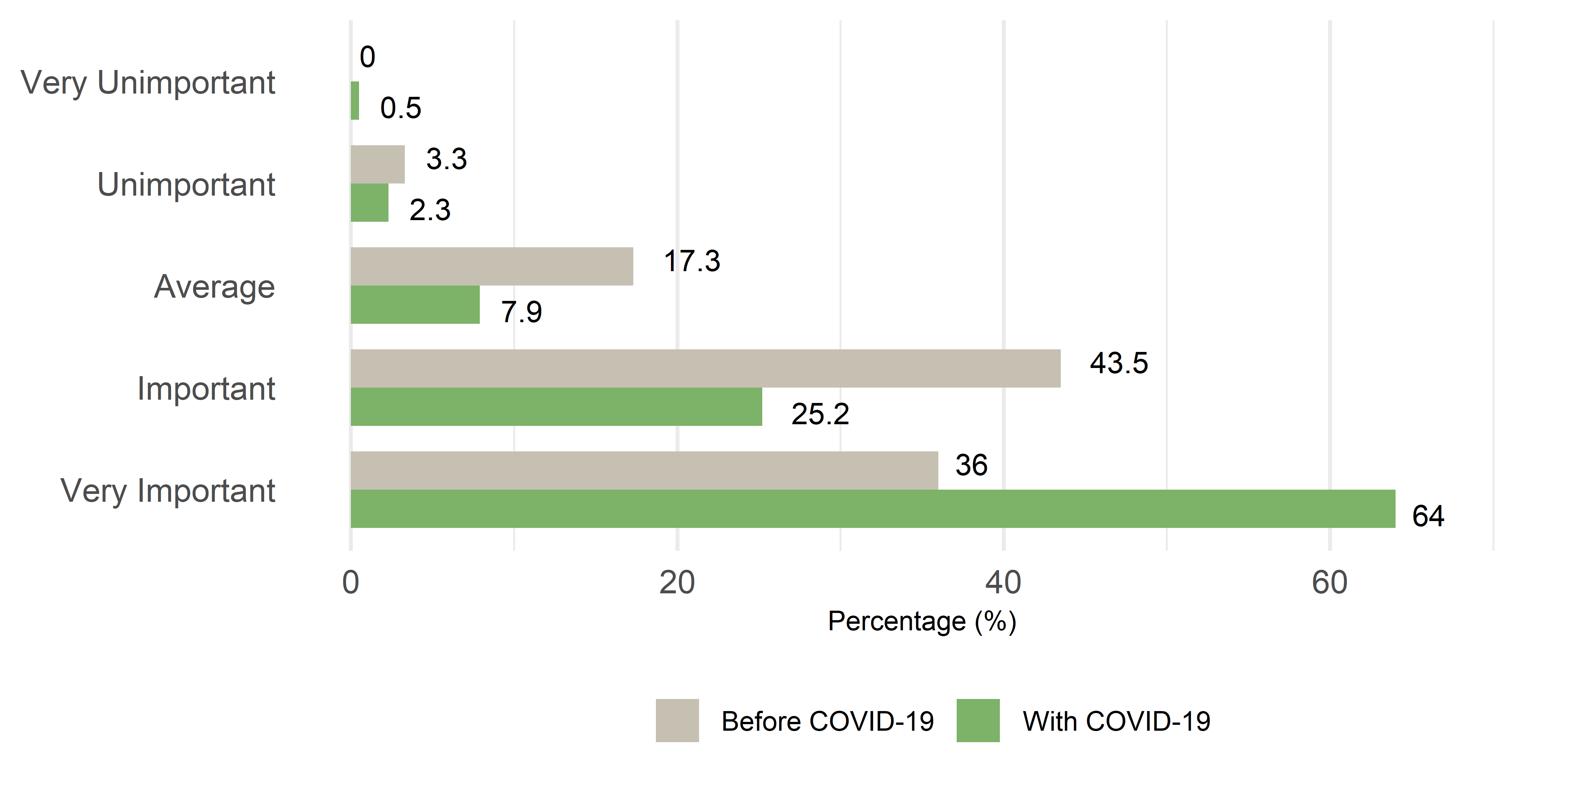

**Figure 9**. The importance of UGS before and with COVID-19

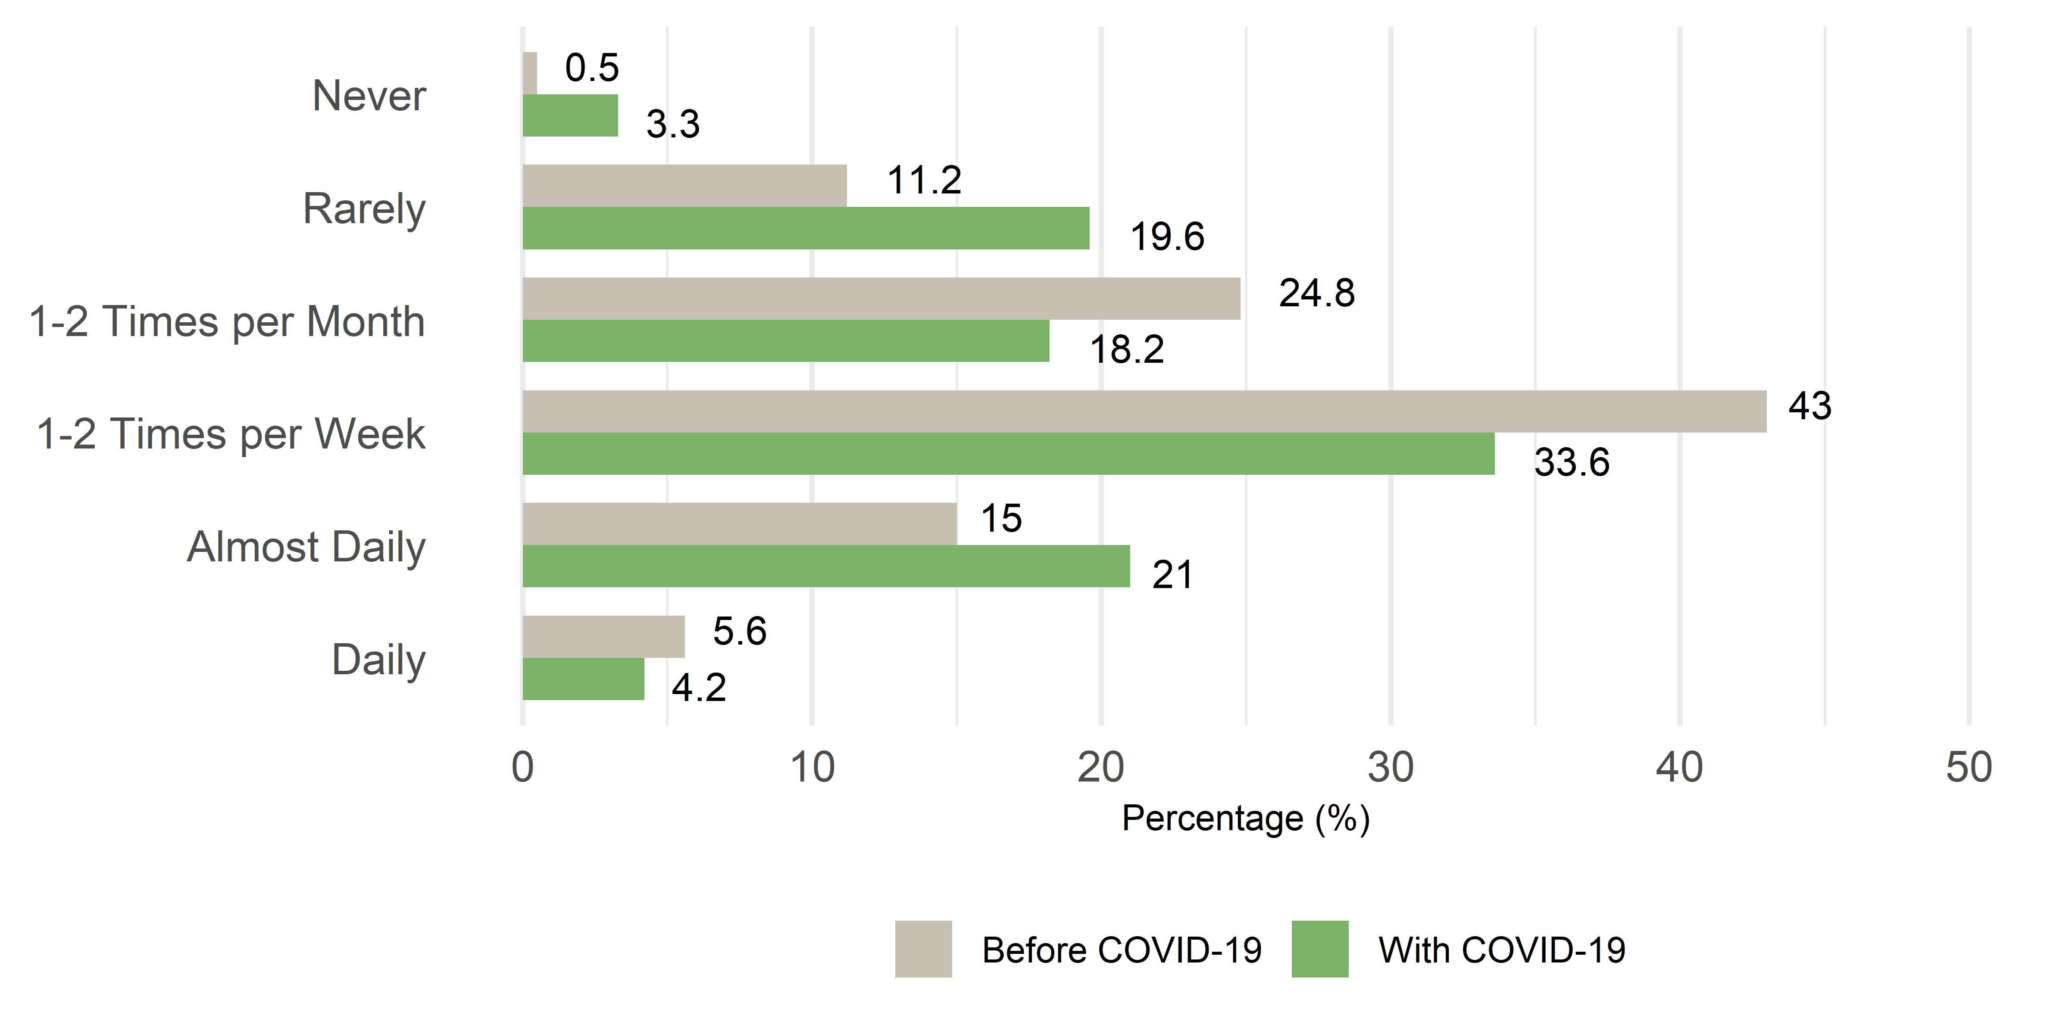

**Figure 10**. The Frequency of utilization of UGS before and in the wake of Covid

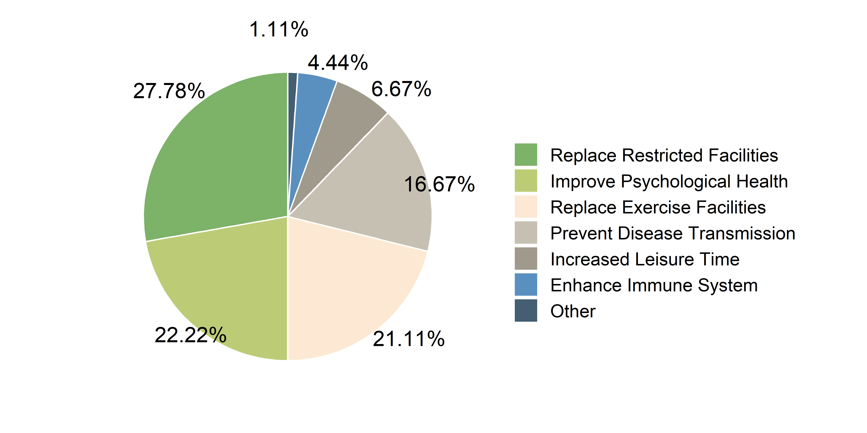

Figure 11. Reasons for increasing the use of UGS in the wake of Covid-19

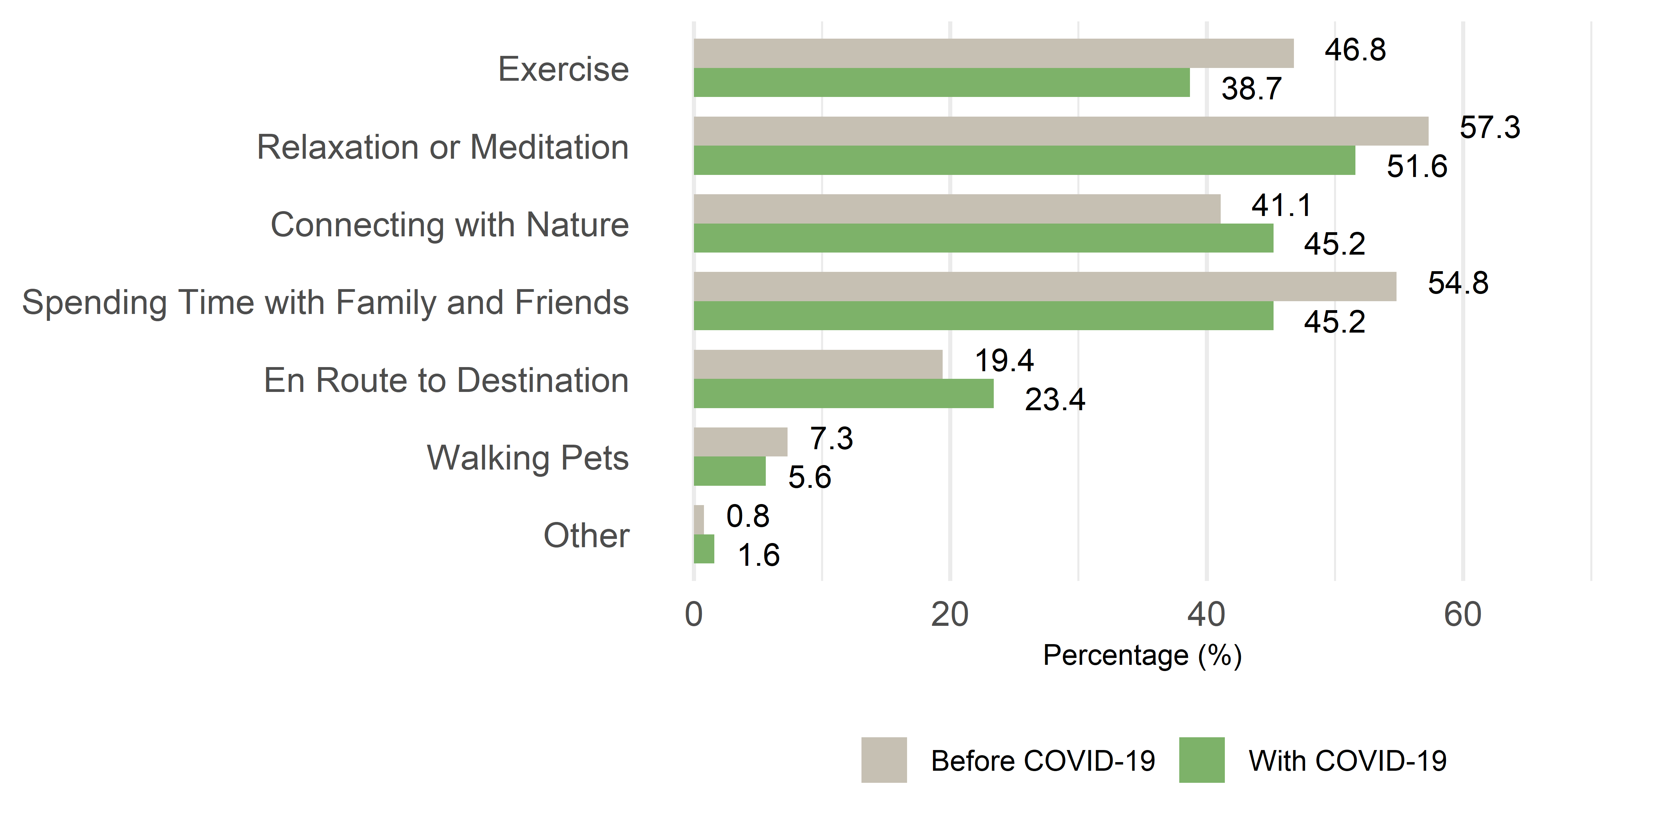

Figure 12. Reason for using UGS before and after COVID-19 among respondents who reduced their visit to UGS

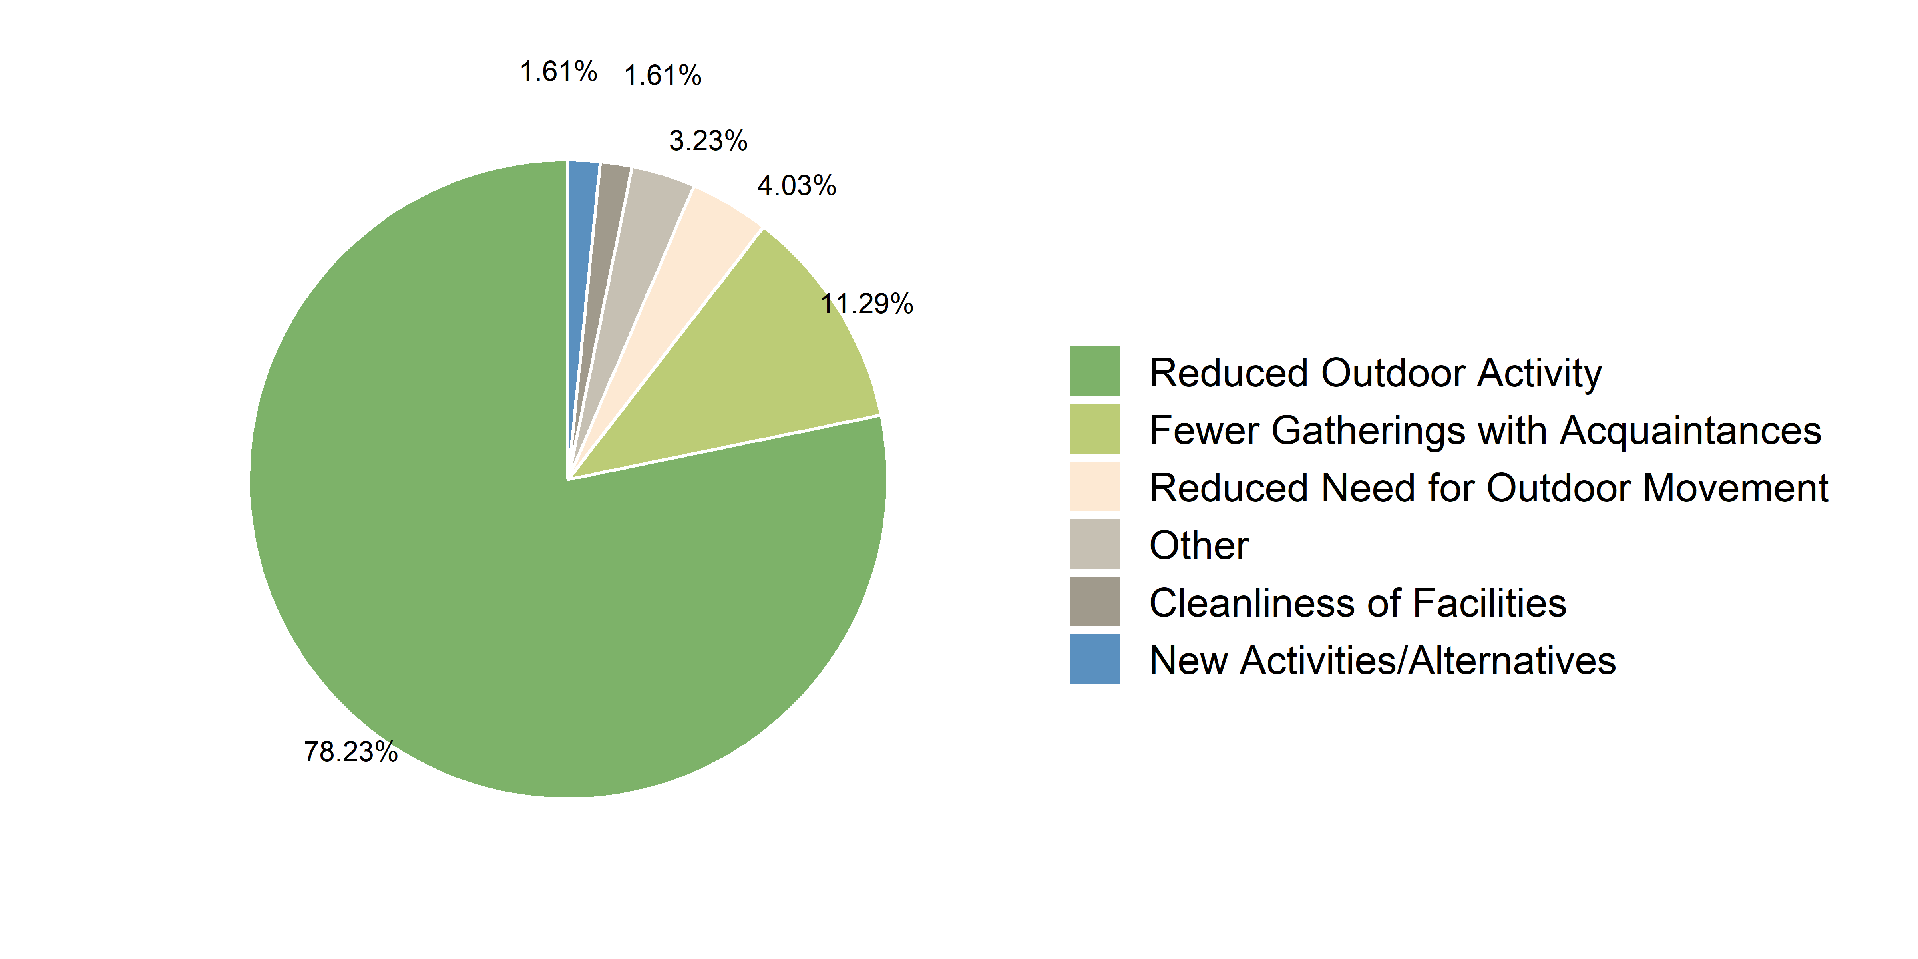

Figure 13. Reasons for reducing the use of UGS in the wake of Covid-19

|  |  |
| --- | --- |
|  |  |

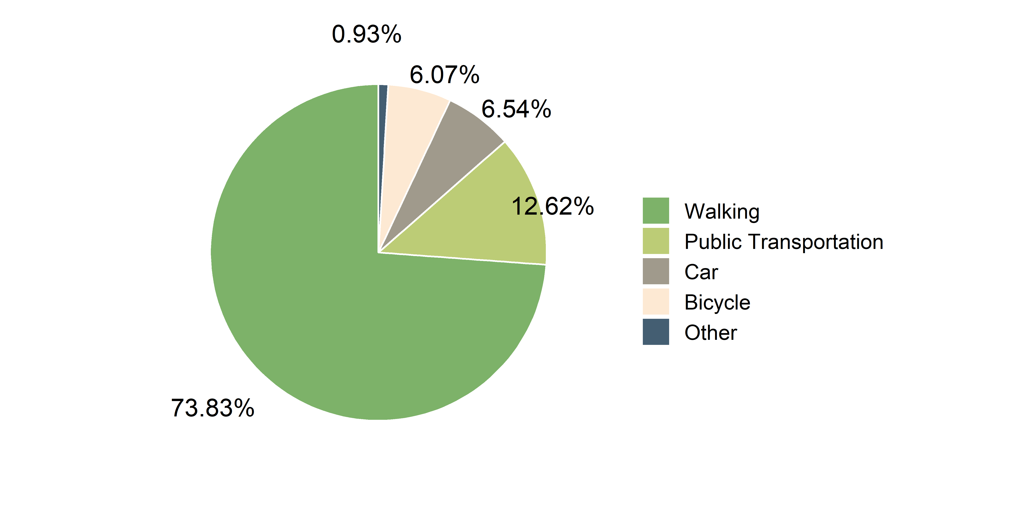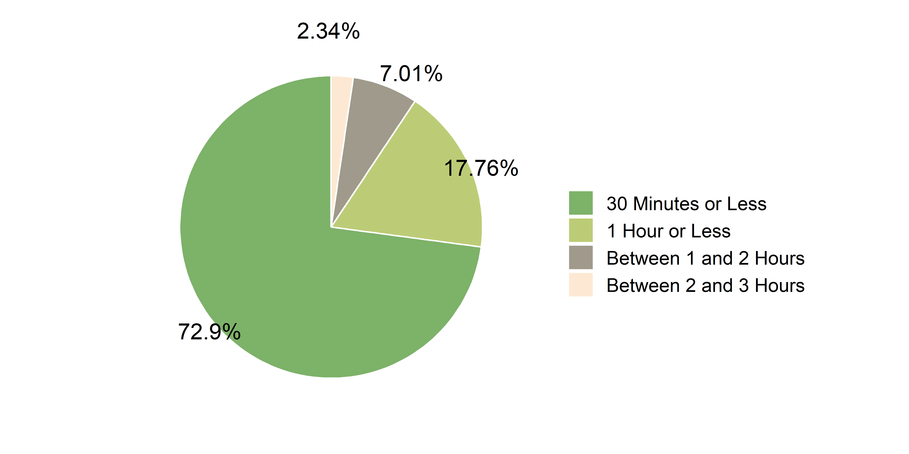

**Figure 14**. Preferred transportation for visiting UGS  **Figure 15**. Preferred time needed to visit UGS

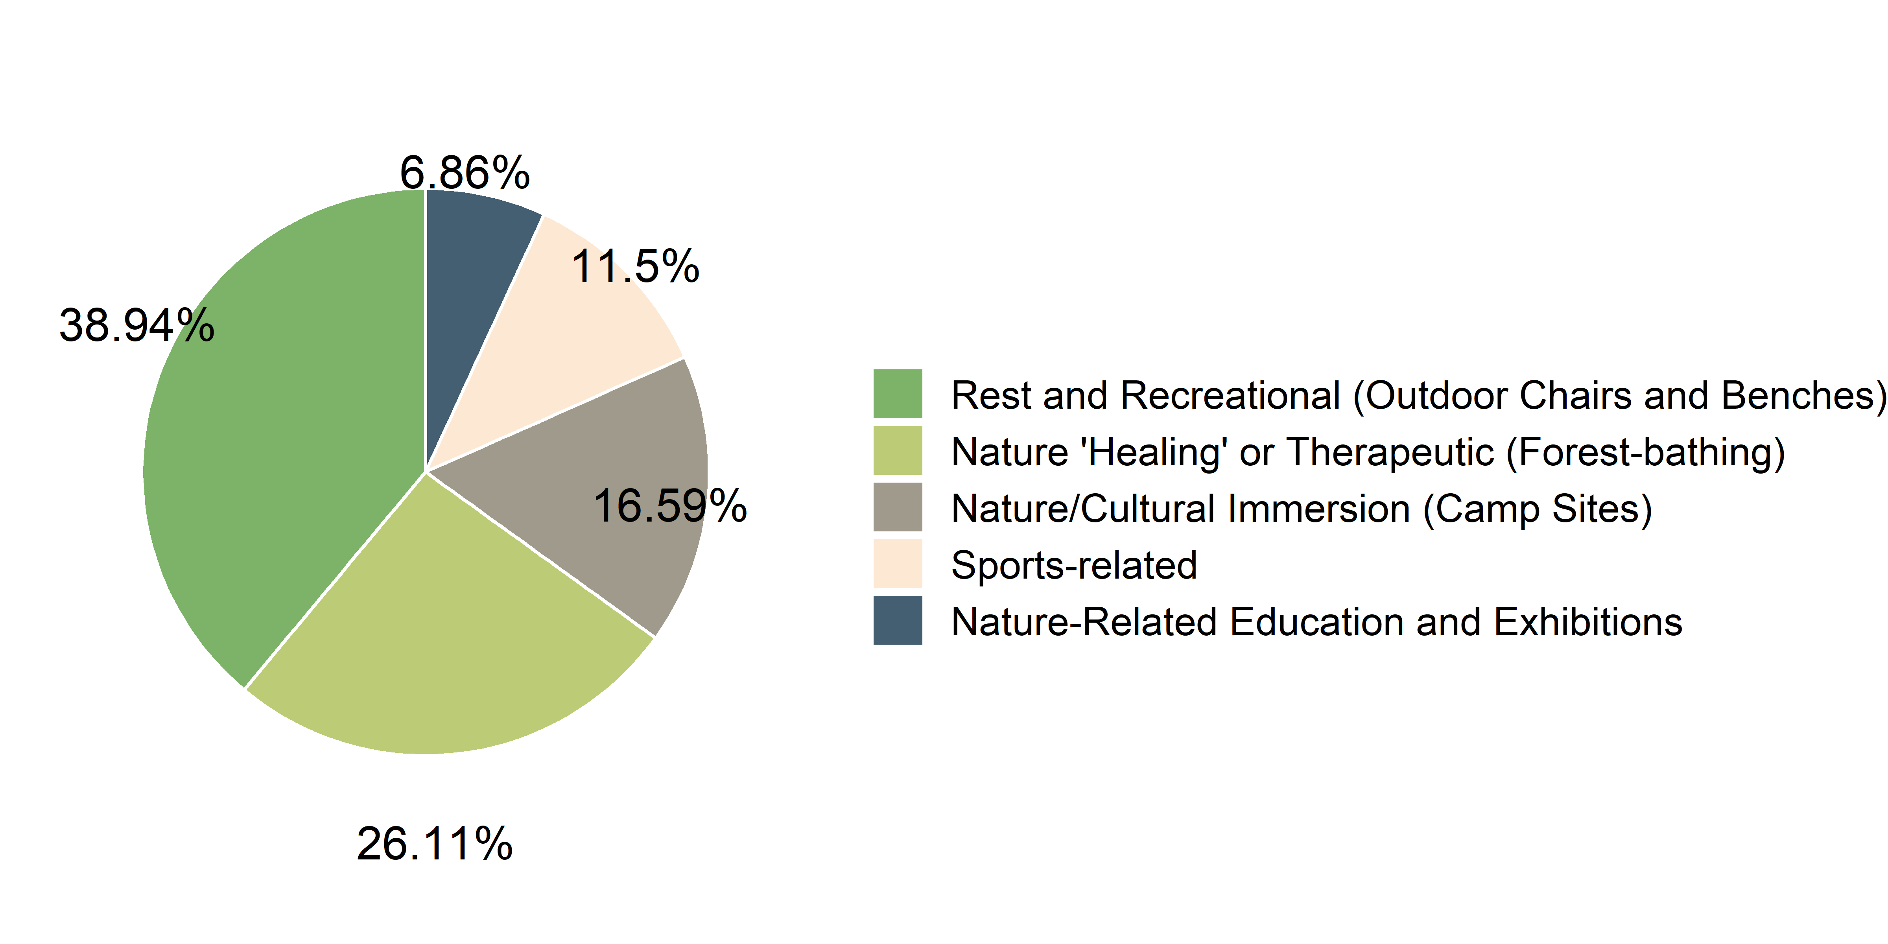

Figure 16. Facilities to encourage usage of UGS

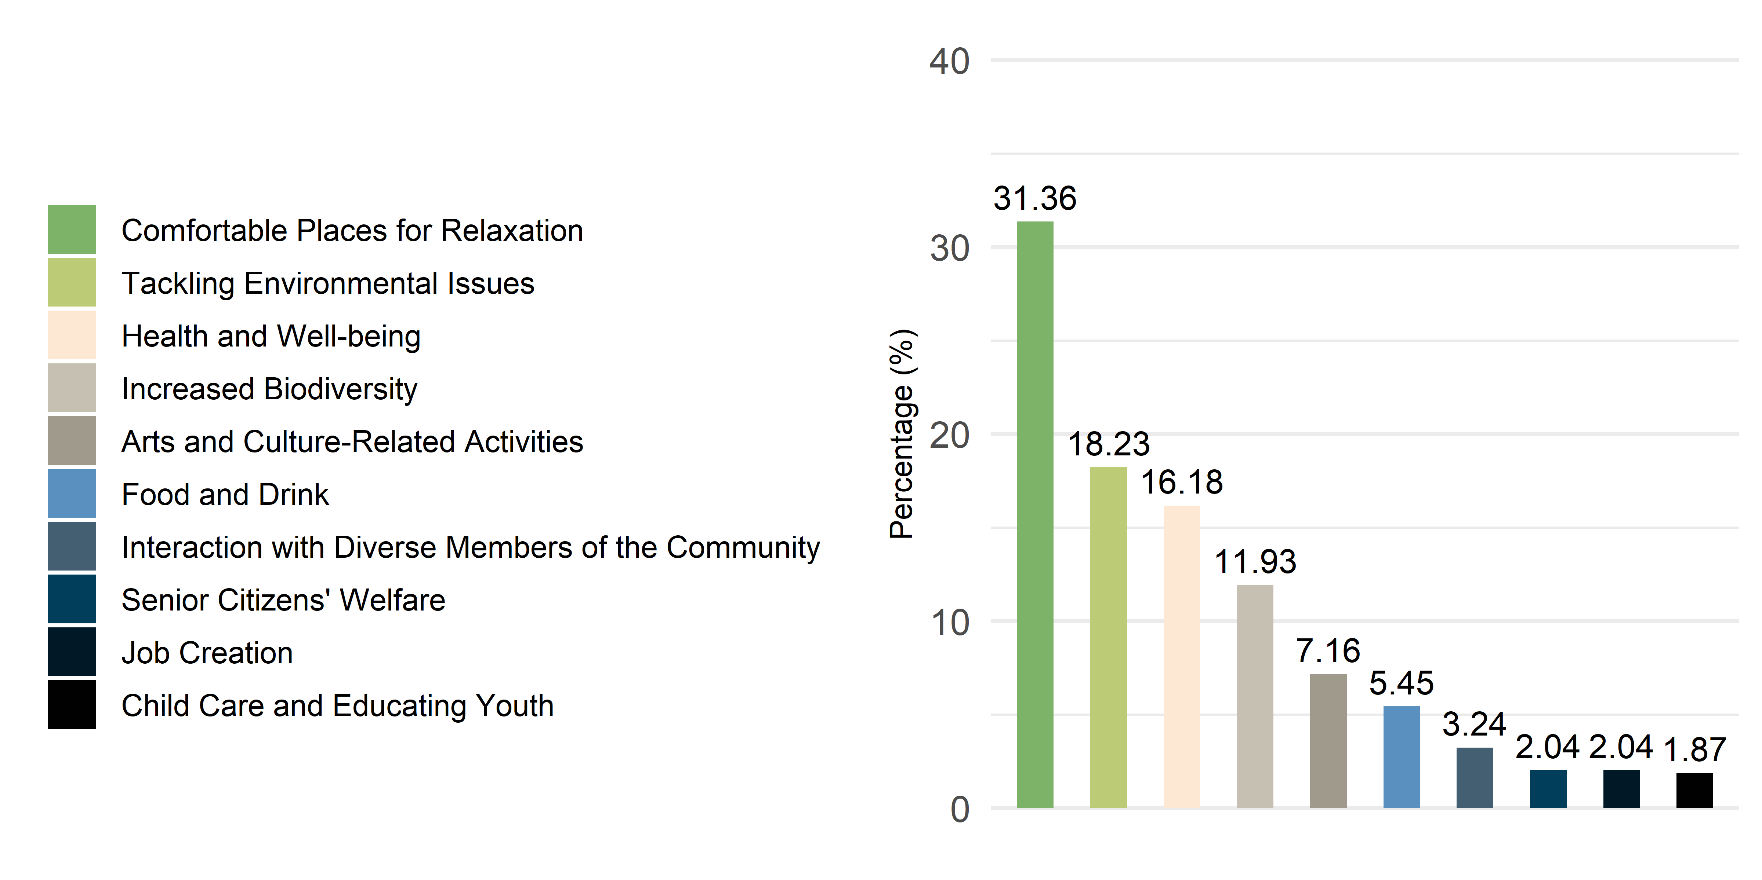

Figure 17. Services to encourage usage of UGS

|  |  |
| --- | --- |
| **Period** | **The number of visitors** |
| ’19. 5 ~ ’19. 12 (monthly average of 8 months after official opening) | 268,223 |
| ’20. 2 (outbreak and spread of COVID-19) | 109,933 |
| ’20. 6 | 331,766 |
| ’20. 7 | 305,907 |
| ’20. 8 | 348,974 |
| ’20. 9 | 313,856 |
| ’20. 10 | 602,063 |
| ’20. 11 | 437,443 |

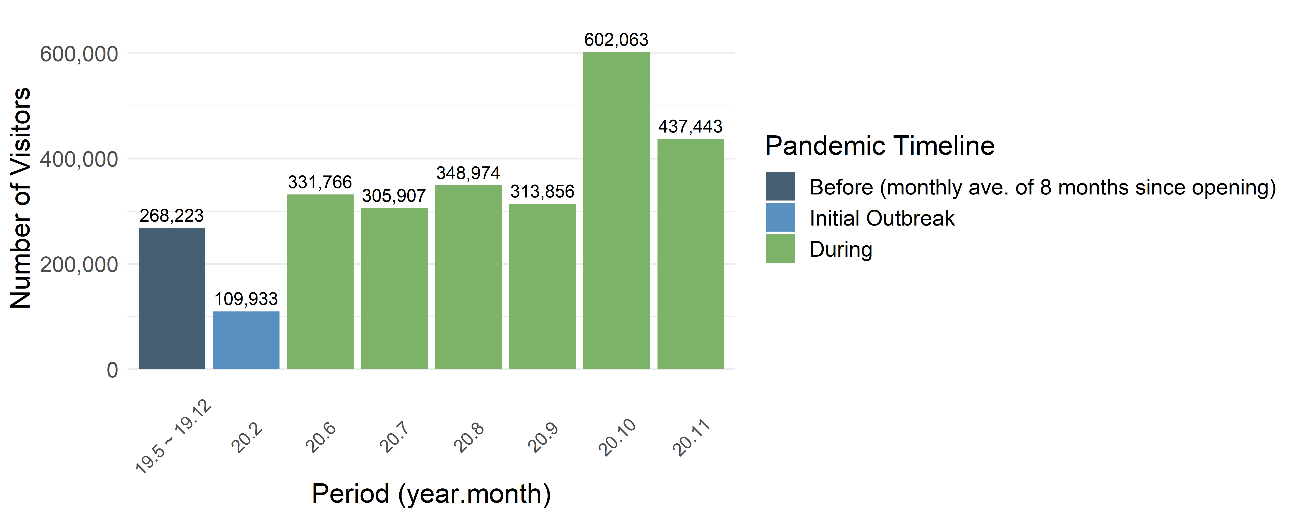

**Table 9.** The number of visitors to the Seoul Botanical Gardens since its official opening

*Source: Seoul Information Communication Plaza*