Titre : JDBC+Servlet/Jsp
Prérequis
- Installation de Java JDK 1.6.x, Eclipse, Tomcat 6.x
- Installation de wamp, easyPHP, myqsl…
Objectifs
- Connection à une base de donnée

- Configurer la base de donnée
- Base : test
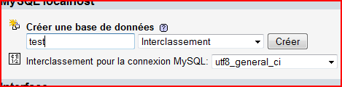
- Exécuter
CREATE TABLE IF NOT EXISTS `client` (
`id` int(5) NOT NULL AUTO_INCREMENT,
`nom` varchar(200) DEFAULT NULL,
`prenom` varchar(200) DEFAULT NULL,
`adresse` varchar(200) DEFAULT NULL,
`poste` varchar(200) DEFAULT NULL,
PRIMARY KEY (`id`)
) ENGINE=MyISAM DEFAULT CHARSET=latin1 AUTO_INCREMENT=4 ;

--
-- Contenu de la table `Client`
--

INSERT INTO `Client` (`id`, `nom`, `prenom`, `adresse`, `poste`) VALUES
(1, 'Laure', 'Bourgeois', 'Rue de Paris', 'MOA'),
(2, 'Didier', 'Pelat', 'Rue de Medon', 'Professeur'),
(3, 'Tiger', 'Wood', 'New York', 'Golfeur');

- Créez un nouveau Projet
- Ajouter le driver(mysql) dans WEB-INF/lib
- Crée Client.java
package com.domaine;

import java.io.Serializable;

public class Client implements Serializable {

private int id;
private String nom;
private String prenom;
private String adresse;
private String poste;

public Client() {
super();
}

public Client(String nom, String prenom, String adresse, String poste) {
super();
this.nom = nom;
this.prenom = prenom;
this.adresse = adresse;
this.poste = poste;
}

// get+set+toString

}

- Crée une page JSP index.html
<!DOCTYPE HTML PUBLIC "-//W3C//DTD HTML 4.01 Transitional//EN"
"http://www.w3.org/TR/html4/loose.dtd">

<html>
<head>
<meta http-equiv="Content-Type" content="text/html; charset=UTF-8">
<title>JSP Page</title>
</head>
<body>
<table border="1">
<thead>
<tr>
<th>
<h1>Menu</h1>
</th>
</tr>
</thead>
<tbody>
<tr>
<td><a href="affiche">AFFICHER</a></td>
</tr>
</tbody>
</table>
</body>
</html>
- Créez la servlet AfficheServlet.java

package com.controleur;

....
/**
* Servlet implementation class AfficheServlet
*/
public class AfficheServlet extends HttpServlet {
private static final long serialVersionUID = 1L;

public AfficheServlet() {
super();
// TODO Auto-generated constructor stub
}

protected void doGet(HttpServletRequest request,
HttpServletResponse response) throws ServletException, IOException {
doPost(request, response);
}

protected void doPost(HttpServletRequest request,
HttpServletResponse response) throws ServletException, IOException {
List<Client> clients = new ArrayList<Client>();
try {
Class.forName("com.mysql.jdbc.Driver");

Connection con = DriverManager.getConnection("jdbc:mysql://localhost/test?user=root&password=");
Statement st = con.createStatement();
String sql = "SELECT * FROM client";
ResultSet rs = st.executeQuery(sql);
while (rs.next()) {

String nom = rs.getString("nom");
String prenom = rs.getString("prenom");
String adresse = rs.getString("adresse");
String poste = rs.getString("poste");

clients.add(new Client(nom, prenom, adresse, poste));
}

rs.close();
st.close();

} catch (ClassNotFoundException e) {
// TODO Auto-generated catch block
e.printStackTrace();
} catch (SQLException e) {
// TODO Auto-generated catch block
e.printStackTrace();
}

request.setAttribute("clients", clients);
// redirection
RequestDispatcher disp = request
.getRequestDispatcher("ListeClients.jsp");
disp.forward(request, response); }

}
- Editer le fichier web.xml et changer le code en bleu
….

<servlet>
<description></description>
<display-name>AfficheServlet</display-name>
<servlet-name>AfficheServlet</servlet-name>
<servlet-class>com.controleur.AfficheServlet</servlet-class>
</servlet>
<servlet-mapping>
<servlet-name>AfficheServlet</servlet-name>
<url-pattern>/affiche</url-pattern>
</servlet-mapping>
……

- Crée une page JSP ListeClients.jsp

<%--
Document : affiche
Created on : 12 janv. 2009, 15:11:08
Author : Doum
--%>

<%@page contentType="text/html" pageEncoding="UTF-8"%>

<!DOCTYPE HTML PUBLIC "-//W3C//DTD HTML 4.01 Transitional//EN"
"http://www.w3.org/TR/html4/loose.dtd">

<html>
<head>
<meta http-equiv="Content-Type" content="text/html; charset=UTF-8">
<title>JSP Page</title>
</head>
<body>
<%-- On va chercher le bean en request --%>
<jsp:useBean id="clients" scope="request"
type="java.util.List<com.domaine.Client>" />

<table border="1">
<thead>
<tr>
<th>Nom</th>
<th>Prénom</th>
<th>Adresse</th>
<th>Poste</th>
</tr>
</thead>
<tbody>

<%
java.util.Iterator<com.domaine.Client> l = clients.iterator();

while (l.hasNext()) {
com.domaine.Client client = (com.domaine.Client) l.next();
%>

<tr>
<td><%=client.getNom()%></td>
<td><%=client.getPrenom()%></td>
<td><%=client.getAdresse()%></td>
<td><%=client.getPoste()%></td>
</tr>
<%
}
%>

</tbody>
</table>

</body>
</html>
- Test Exemple: http://localhost:8080/lab/
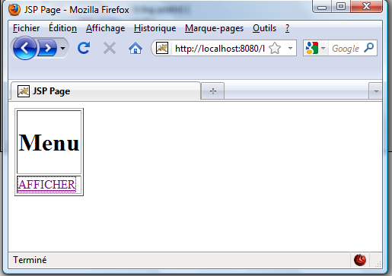
- Remplir et envoyer
